Module Design Document
For
CDDInterface10

VERSION: 6
DATE: 21-May-18

Revision History
Sl. No. | Description | Author | Version | Date
1 | Initial Version | Owen Tosh | 1 | 29-Aug-2014
2 | Updates for new customer services | Owen Tosh | 2 | 09-Oct-2014
3 | Added MtrPosPolarity to Init1 | Owen Tosh | 3 | 04-Feb-2015
4 | Added ESCConfig Selected for Turns Counter implementation | Akilan Rathakrishnan | 4 | 01-Apr-2017
5 | Added TurnsCounterSelected output implementation | Mateusz Bartocha | 5 | 30-Apr-18
6 | Fixed Init chart | Mateusz Bartocha | 6 | 21-May-18

Table of Contents
1 Abbrevations And Acronyms 5
2 References 6
3 CDD & High-Level Description 7
4 Design details of software module 8
4.1 Graphical representation of CDDInterface 8
4.2 Data Flow Diagram 8
4.2.1 Module level DFD 8
4.2.2 Sub-Module level DFD 8
4.3 COMPONENT FLOW DIAGRAM 8
5 Variable Data Dictionary 9
5.1 User defined typedef definition/declaration 9
5.2 Variable definition for enumerated types 9
6 Constant Data Dictionary 10
6.1 Program(fixed) Constants 10
6.1.1 Embedded Constants 10
6.1.1.1 Local 10
6.1.1.2 Global 10
6.1.2 Module specific Lookup Tables Constants 10
6.1.3 Library Functions / Macros 10
6.1.4 Data Hiding Functions 10
7 Software Module Implementation 11
7.1 Initialization Functions 11
7.1.1 Init: CDDInterface10_Init1 11
7.1.1.1 Design Rationale 11
7.1.1.2 Module Outputs 11
7.1.1.3 Module Internal 11
7.1.1.4 PROCESSING OF INIT FUNCTION 11
7.2 PERIODIC FUNCTIONS 11
7.2.1 Per: CDDInterface10_Per1 11
7.2.1.1 Design Rationale 11
7.2.1.2 Store Module Inputs to Local copies 12
7.2.1.3 Processing of function 12
7.2.1.4 Store Local copy of outputs into Module Outputs 12
7.3 Interrupt Functions 12
7.4 TRANSIENT FUNCTIONS 12
7.5 Serial Communication Functions 13
7.6 Local Function/Macro Definitions 13
7.7 GLObAL Function/Macro Definitions 13
8 Known Limitations With Design 14
9 UNIT TEST CONSIDERATION 15
10 Appendix 16

Abbrevations And Acronyms
Abbreviation | Description
DFD | Design functional diagram
MDD | Module design Document

References
This section Lists the title & version of all the documents that are referred for development of this document
Sr. No. | Title | Version
1 | MDD Guidelines | 1
2 | Software Naming Conventions | 1
3 | Coding standands | 1

CDD & High-Level Description
CDD Interface is a part of Complex Device Driver (CDD) in AUTOSAR which is an interface for data transfer between application layer and motor control Interrupt Service Routine(ISR). CDD Interface acts as a proxy for software components without a developer model, or connection to the RTE, to provide data to the RTE and be passed to other software components.

Design details of software module

Graphical representation of CDDInterface
None

Data Flow Diagram
None

Module level DFD
None

Sub-Module level DFD
None

COMPONENT FLOW DIAGRAM
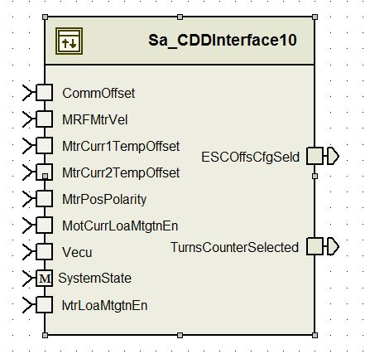

Variable Data Dictionary

User defined typedef definition/declaration
Typedef Name | Element Name | User Defined Type | Legal Range  (min) | Legal Range  (max)
None

Variable definition for enumerated types
Enum Name | Element Name | Value
None

Constant Data Dictionary

Program(fixed) Constants

Embedded Constants

Local
Constant Name | Resolution | Units | Value
None

Global

Constant Name
None

Module specific Lookup Tables Constants
Constant Name | Resolution | Value | Software Segment
None

Library Functions / Macros
None

Data Hiding Functions
None

Software Module Implementation

Initialization Functions

Init: CDDInterface10_Init1

Design Rationale
None

Module Inputs
MtrPosPolarity_Cnt_T_s08 = Rte_IRead_CDDInterface10_Init1_MtrPosPolarity_Cnt_s08()

Module Outputs
None

Module Internal
CDD_AppDataFwdPthAccessBfr_Cnt_G_u16 = 0

PROCESSING OF INIT FUNCTION
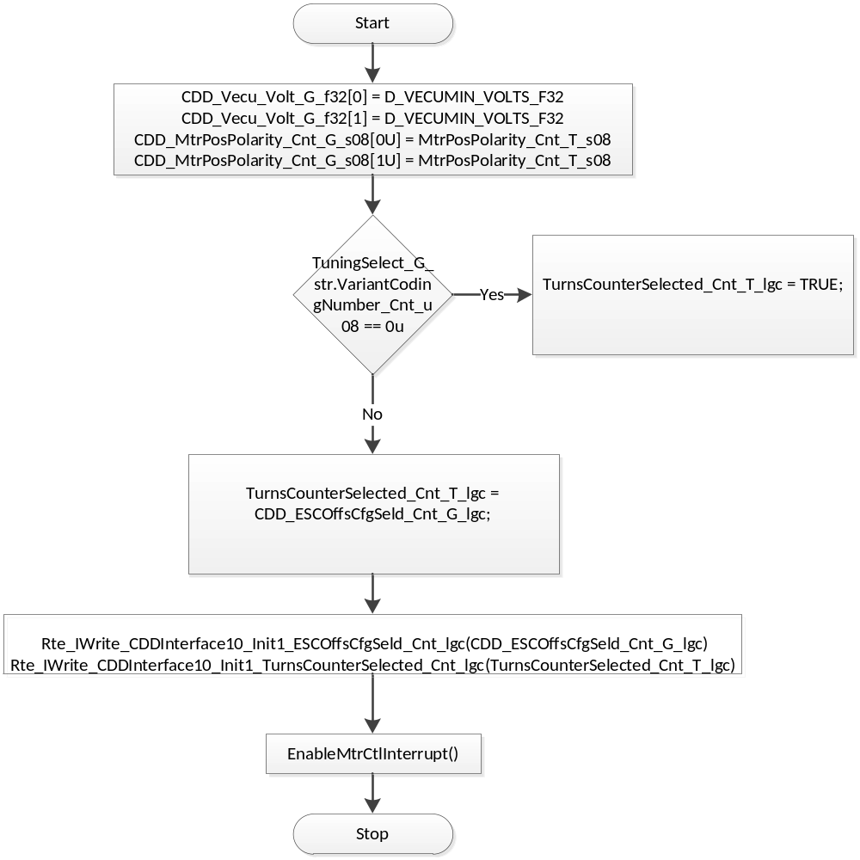
Flowchart 1: CDD Init1

PERIODIC FUNCTIONS

Per: CDDInterface10_Per1

Design Rationale
As the CDDInterface module is the interface between RTE-level and lower-level software, a mechanism is needed to ensure data consistency across different time bases. To achieve this, CDDInterface implements a so-called “double buffer” system in which the shared variables are written and read from two separate buffers. CDDInterface controls which buffer is read from by use of the CDD_AppDataFwdPthAccessBfr_Cnt_G_u16 variable, writing to the buffer that is not being read from by the faster time base loop.

Store Module Inputs to Local copies
WriteBuffer_Cnt_T_u16 = (CDD_AppDataFwdPthAccessBfr_Cnt_G_u16 & 1u) ^ 1u
CommOffset_Cnt_T_u16 = Rte_IRead_CDDInterface10_Per1_CommOffset_Cnt_u16()
MRFMtrVel_MtrRadpS_T_f32 = Rte_IRead_CDDInterface10_Per1_MRFMtrVel_MtrRadpS_f32()
MtrCurr1TempOffset_Volt_T_f32 = Rte_IRead_CDDInterface10_Per1_MtrCurr1TempOffset_Volt_f32()
MtrCurr2TempOffset_Volt_T_f32 = Rte_IRead_CDDInterface10_Per1_MtrCurr2TempOffset_Volt_f32()
MtrPosPolarity_Cnt_T_s08 = Rte_IRead_CDDInterface10_Per1_MtrPosPolarity_Cnt_s08()
MtrTrqCmdSign_Cnt_T_s16 = Rte_IRead_CDDInterface10_Per1_MtrTrqCmdSign_Cnt_s16()
SysState_Cnt_T_Enum = Rte_Mode_SystemState_Mode()
Vecu_Volt_T_f32 = Rte_IRead_CDDInterface10_Per1_Vecu_Volt_f32()

Processing of function
None

Store Local copy of outputs into Module Outputs
CDD_MtrCurrOffComOffset_Cnt_G_u16[WriteBuffer_Cnt_T_u16] = CommOffset_Cnt_T_u16
CDD_MRFMtrVel_MtrRadpS_G_f32[WriteBuffer_Cnt_T_u16] = MRFMtrVel_MtrRadpS_T_f32
CDD_MtrCurr1TempOffset_Volt_G_f32[WriteBuffer_Cnt_T_u16] = MtrCurr1TempOffset_Volt_T_f32
CDD_MtrCurr2TempOffset_Volt_G_f32[WriteBuffer_Cnt_T_u16] = MtrCurr2TempOffset_Volt_T_f32
CDD_MtrPosPolarity_Cnt_G_s08[WriteBuffer_Cnt_T_u16] = MtrPosPolarity_Cnt_T_s08
CDD_MtrTrqCmdSign_Cnt_G_s16[WriteBuffer_Cnt_T_u16] = MtrTrqCmdSign_Cnt_T_s16
CDD_SysState_Cnt_G_Enum[WriteBuffer_Cnt_T_u16] = SysState_Cnt_T_Enum
CDD_Vecu_Volt_G_f32[WriteBuffer_Cnt_T_u16] = Vecu_Volt_T_f32
CDD_AppDataFwdPthAccessBfr_Cnt_G_u16 = WriteBuffer_Cnt_T_u16
Rte_IWrite_CDDInterface10_Per1_ESCOffsCfgSeld_Cnt_lgc(CDD_ESCOffsCfgSeld_Cnt_G_lgc)

Interrupt Functions
None

TRANSIENT FUNCTIONS
None

Serial Communication Functions
None

Local Function/Macro Definitions
None

GLObAL Function/Macro Definitions
None

Known Limitations With Design
None

UNIT TEST CONSIDERATION
None

Appendix
None

