Module Design Document
For
IoHwAb10

VERSION: 1
DATE: 29-Aug-2014

Revision History

Sl. No. | Description | Author | Version | Date
1 | Initial Version | Owen Tosh | 1 | 29-Aug-2014

Table of Contents
1 Abbrevations And Acronyms 5
2 References 6
3 IoHwAbstractionUsr & High-Level Description 7
4 Design details of software module 8
4.1 Graphical representation of IoHwAb10 8
4.2 Data Flow Diagram 8
4.2.1 Module level DFD 8
4.2.2 Sub-Module level DFD 8
4.3 COMPONENT DIAGRAM 8
5 Variable Data Dictionary 9
5.1 User defined typedef definition/declaration 9
5.2 Variable definition for enumerated types 9
6 Constant Data Dictionary 10
6.1 Program(fixed) Constants 10
6.1.1 Embedded Constants 10
6.1.1.1 Local 10
6.1.1.2 Global 10
6.1.2 Module specific Lookup Tables Constants 10
6.1.3 Library Functions / Macros 10
6.1.4 Data Hiding Functions 10
7 Software Module Implementation 11
7.1 Initialization Functions 11
7.1.1 Init: IoHwAb_Init 11
7.1.1.1 Design Rationale 11
7.1.1.2 PROCESSING OF INIT FUNCTION 11
7.1.1.3 Module Outputs 12
7.2 PERIODIC FUNCTIONS 12
7.2.1 Per: IoHwAb_ReadAdc 12
7.2.1.1 Design Rationale 12
7.2.1.2 Store Module Inputs to Local copies 12
7.2.1.3 Processing of function 13
7.2.1.4 Store Local copy of outputs into Module Outputs 14
7.3 Interrupt Functions 14
7.4 TRANSIENT FUNCTIONS 14
7.5 Serial Communication Functions 14
7.6 Local Function/Macro Definitions 14
7.7 GLObAL Function/Macro Definitions 14
8 Known Limitations With Design 15
9 UNIT TEST CONSIDERATION 16
10 Appendix 17

- Abbrevations And Acronyms
Abbreviation | Description
DFD | Design functional diagram
MDD | Module design Document

- References
This section Lists the title & version of all the documents that are referred for development of this document
Sr. No. | Title | Version
1 | MDD Guidelines | 1
2 | Software Naming Conventions | 1
3 | Coding standands | 1

IoHwAbstractionUsr & High-Level Description
IoHwAbstractionUsr is an application module which performs ADC conversion .

- Design details of software module

Graphical representation of IoHwAb10
None

Data Flow Diagram
None

Module level DFD
None

Sub-Module level DFD
None

COMPONENT DIAGRAM
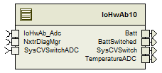
Figure 1: IoHwAb10 Component Diagram

Variable Data Dictionary

User defined typedef definition/declaration

Typedef Name | Element Name | User Defined Type | Legal Range  (min) | Legal Range  (max)
None

Variable definition for enumerated types
Enum Name | Element Name | Value
None

- Constant Data Dictionary

Program(fixed) Constants

Embedded Constants

Local
Constant Name | Resolution | Units | Value
D_ADCRESULTMASK_CNT_U16 | 1 | Count | 0x0FFFu
D_ADCVOLTSPERCNT_ULS_F32 | Single Precision  Float | Unitless | 5.0/4095.0
D_MTRCTRLLIMIT_US_U16 | 1 | Microsecond | 125
D_ADCLIMIT_US_U16 | 1 | Microsecond | 20

Global

Constant Name
D_TEMPSNSRCHN_CNT_U16
D_BATTCHN_CNT_U16
D_BATTSWITCHEDCHN_CNT_U16
D_VREF_CNT_U16

    - Module specific Lookup Tables Constants
Constant Name | Resolution | Value | Software Segment
None

Library Functions / Macros
NONE

Data Hiding Functions
Rte_Call_NxtrDiagMgr_SetNTCStatus()

- Software Module Implementation

Initialization Functions

Init: IoHwAb_Init

Design Rationale
None

PROCESSING OF INIT FUNCTION

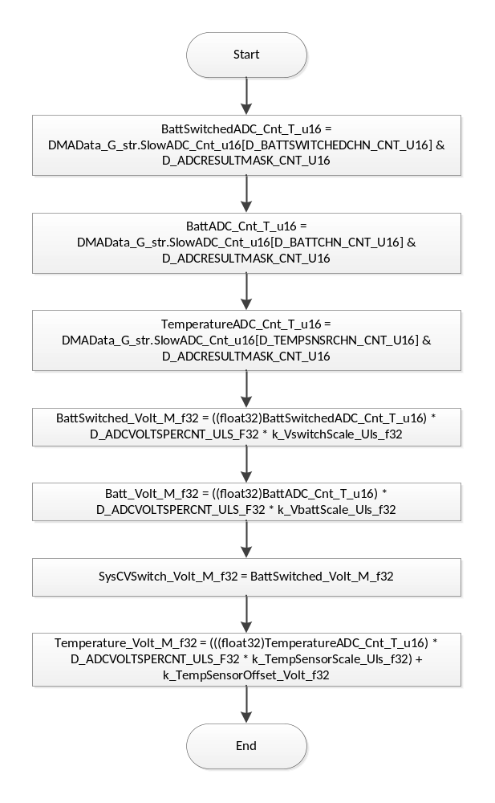
Flowchart 1: IoHwAbstractionUser Init

Module Outputs
Rte_IWrite_IoHwAb_Init_BattSwitched_Volt_f32(BattSwitched_Volt_M_f32)
Rte_IWrite_IoHwAb_Init_Batt_Volt_f32(Batt_Volt_M_f32)
Rte_IWrite_IoHwAb_Init_SysCVSwitch_Volt_f32(SysCVSwitch_Volt_M_f32)
Rte_IWrite_IoHwAb_Init_TemperatureADC_Volt_f32(Temperature_Volt_M_f32)

PERIODIC FUNCTIONS

Per: IoHwAb_ReadAdc

Design Rationale
None

Store Module Inputs to Local copies
None

Processing of function
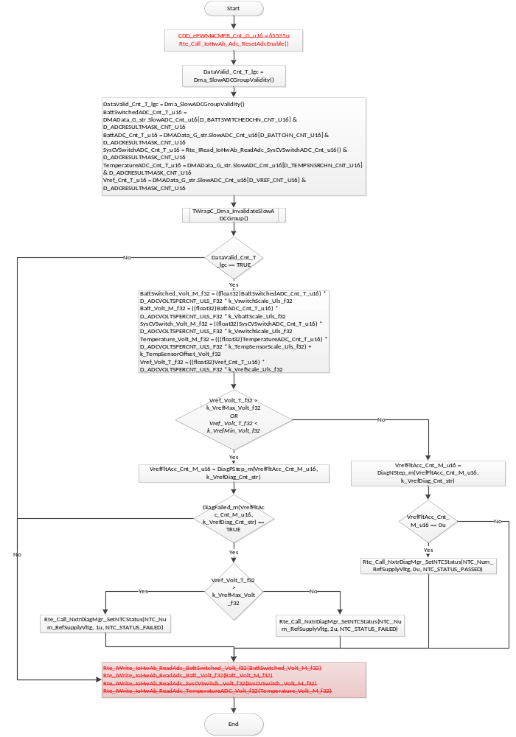

Store Local copy of outputs into Module Outputs
Rte_IWrite_IoHwAb_ReadAdc_BattSwitched_Volt_f32(BattSwitched_Volt_M_f32)
Rte_IWrite_IoHwAb_ReadAdc_Batt_Volt_f32(Batt_Volt_M_f32)
Rte_IWrite_IoHwAb_ReadAdc_SysCVSwitch_Volt_f32(SysCVSwitch_Volt_M_f32)
Rte_IWrite_IoHwAb_ReadAdc_TemperatureADC_Volt_f32(Temperature_Volt_M_f32)

Interrupt Functions
None

TRANSIENT FUNCTIONS
None

Serial Communication Functions
None

Local Function/Macro Definitions
None

GLObAL Function/Macro Definitions
None

Function #1

Known Limitations With Design
None

UNIT TEST CONSIDERATION
None

- Appendix
None

