Module Design Document
For
IoHwAb9

VERSION: 1
DATE: 29-Aug-2014

Revision History

Sl. No. | Description | Author | Version | Date
1 | Initial Version | Owen Tosh | 1 | 29-Aug-2014

Table of Contents
1 Abbrevations And Acronyms 5
2 References 6
3 IoHwAbstractionUsr & High-Level Description 7
4 Design details of software module 8
4.1 Graphical representation of IoHwAb9 8
4.2 Data Flow Diagram 8
4.2.1 Module level DFD 8
4.2.2 Sub-Module level DFD 8
4.3 COMPONENT FLOW DIAGRAM 8
5 Variable Data Dictionary 9
5.1 User defined typedef definition/declaration 9
5.2 Variable definition for enumerated types 9
6 Constant Data Dictionary 10
6.1 Program(fixed) Constants 10
6.1.1 Embedded Constants 10
6.1.1.1 Local 10
6.1.1.2 Global 10
6.1.2 Module specific Lookup Tables Constants 10
6.1.3 Library Functions / Macros 10
6.1.4 Data Hiding Functions 10
7 Software Module Implementation 11
7.1 Initialization Functions 11
7.2 PERIODIC FUNCTIONS 11
7.2.1 Per: IoHwAb_StartAdc 11
7.2.1.1 Design Rationale 11
7.2.1.2 Store Module Inputs to Local copies 11
7.2.1.3 Processing of function 11
7.2.1.4 Store Local copy of outputs into Module Outputs 11
7.3 Interrupt Functions 11
7.4 TRANSIENT FUNCTIONS 11
7.5 Serial Communication Functions 11
7.6 Local Function/Macro Definitions 11
7.7 GLObAL Function/Macro Definitions 12
7.7.1 Capture ADC from Fast Loop 12
7.7.1.1 Description 12
8 Known Limitations With Design 13
9 UNIT TEST CONSIDERATION 14
10 Appendix 15

Abbrevations And Acronyms
Abbreviation | Description
DFD | Design functional diagram
MDD | Module design Document

- References
This section Lists the title & version of all the documents that are referred for development of this document
Sr. No. | Title | Version
1 | MDD Guidelines | 1
2 | Software Naming Conventions | 1
3 | Coding standands | 1

IoHwAbstractionUsr & High-Level Description
IoHwAbstractionUsr is an application module which performs ADC conversion .

- Design details of software module

Graphical representation of IoHwAb9
None

Data Flow Diagram
None

Module level DFD
None

Sub-Module level DFD
None

COMPONENT DIAGRAM
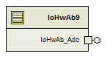
Figure 1: IoHwAb9 Component Diagram

Variable Data Dictionary

User defined typedef definition/declaration

Typedef Name | Element Name | User Defined Type | Legal Range  (min) | Legal Range  (max)
None

Variable definition for enumerated types
Enum Name | Element Name | Value
None

- Constant Data Dictionary

Program(fixed) Constants

Embedded Constants

Local
Constant Name | Resolution | Units | Value
None

Global

Constant Name
D_SYSCVSWITCHCHN_CNT_U16

    - Module specific Lookup Tables Constants
Constant Name | Resolution | Value | Software Segment
None

Library Functions / Macros
None

Data Hiding Functions

None

- Software Module Implementation

Initialization Functions
None

PERIODIC FUNCTIONS

Per: IoHwAb_StartAdc

Design Rationale
None

Store Module Inputs to Local copies
None

Processing of function
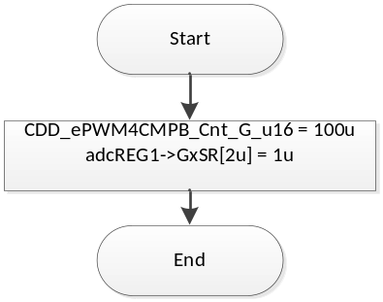

Store Local copy of outputs into Module Outputs
None

Interrupt Functions
None

TRANSIENT FUNCTIONS
None

Serial Communication Functions
None

Local Function/Macro Definitions
None

GLObAL Function/Macro Definitions

Function #1

Reset ADC Enable Signal
Function Name | IoHwAb_Adc_ResetAdcEnable | Type | Min | Max
Arguments Passed | None
Return Value | None

Description
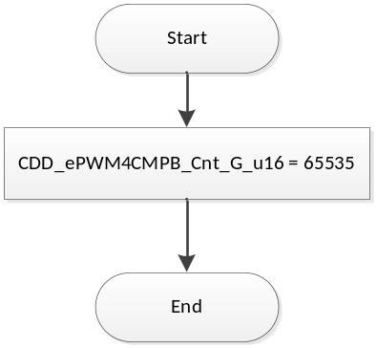
Flowchart 4: IoHwAb_Adc_ResetAdcEnable

Capture ADC from Fast Loop
Function Name | IoHwAb_CaptureADC | Type | Min | Max
Arguments Passed | None
Return Value | None

Description

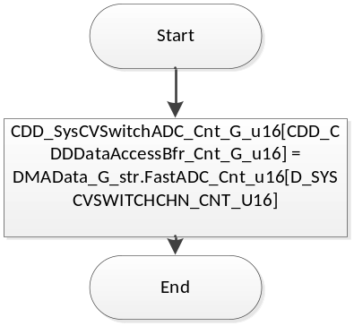
Flowchart 5: IoHwAb_CaptureADC

- Known Limitations With Design
None

UNIT TEST CONSIDERATION
None

- Appendix
None

