同济大学计算机系

数字逻辑课程实验报告



学 号 2251934
姓 名 何锦洋
专 业 计算机科学与技术
授课老师 郭玉臣

- 实验内容
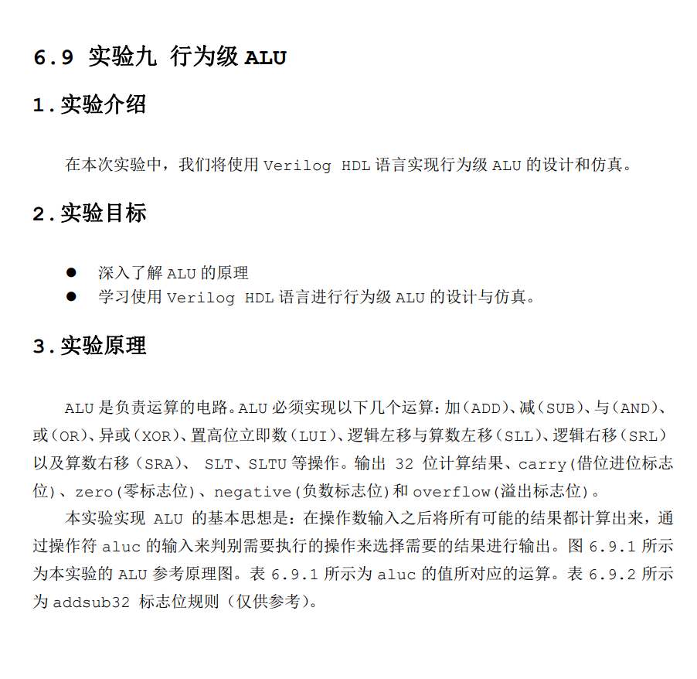
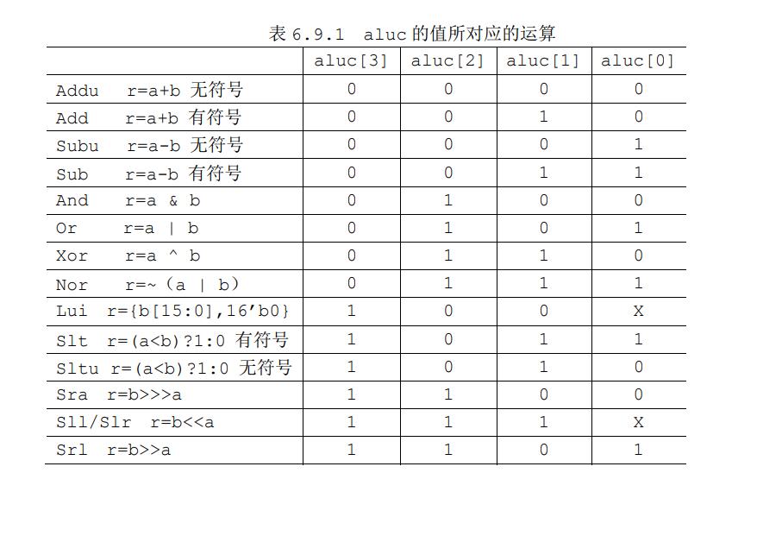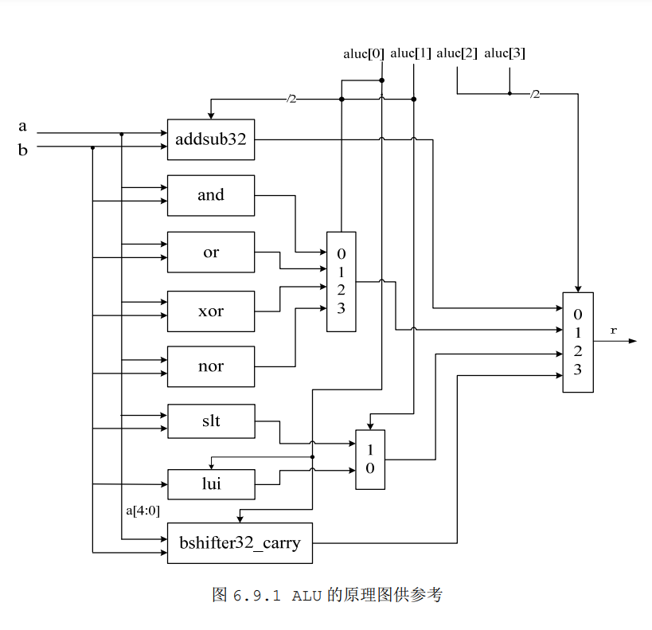
- 硬件逻辑图
（实验步骤中要求用logisim画图的实验，在该部分给出logisim原理图，否则该部分在实验报告中不用写）

- 模块建模
（该部分要求对实验中建模的所有模块进行功能描述，并列出各模块建模的verilog代码）
module alu(
input [31:0] a, //32 位输入，操作数 1
input [31:0] b, //32 位输入，操作数 2
input [3:0] aluc, //4 位输入，控制 alu 的操作
output reg [31:0] r, //32 位输出，由 a、b 经过 aluc 指定的操作生成
output reg zero, //0 标志位
output reg carry, // 进位标志位
output reg negative, // 负数标志位
output reg overflow // 溢出标志位
);
wire signed [31:0] a1;
wire signed [31:0]b1;
assign a1=a;
assign b1=b;

wire [31:0] r_addu;
assign r_addu = a+b;//无符号加法
wire signed [31:0] r_add;
assign r_add= a1+b1;//有符号加法
wire [31:0] r_subu;
assign r_subu = a-b;//无符号减法
wire signed [31:0] r_sub;
assign r_sub=a1-b1;//有符号减法

wire [31:0] r_and;
assign r_and = a&b;

wire [31:0] r_or;
assign r_or =a|b;

wire [31:0] r_xor;
assign r_xor =a^b;

wire [31:0] r_nor;
assign r_nor=~(a|b);

wire[31:0] r_lui;//高位置立即数
assign r_lui={b[15:0],16'b0};

wire[31:0] r_slt;
assign r_slt=(a1<b1)?1:0;

wire[31:0]r_sltu;
assign r_sltu=(a<b)?1:0;

wire[31:0]r_sra;//算数右移
reg [31:0] r_sra_t;
assign r_sra=b1 >>>a;

wire[31:0]r_slr;//逻辑左移
reg [31:0] r_slr_t;
assign r_slr=b<<a;

wire[31:0]r_srl;//逻辑右移
reg [31:0] r_srl_t;
assign r_srl=b>>a;

reg [32:0] an,bn,cn; //无符号数
always @ (*)
begin
an={1'b0,a[31:0]};
bn={1'b0,b[31:0]};

if (aluc == 4'b0000)
begin
r = r_addu;
if(r_addu == 0)
zero = 1'b1;
else
zero = 1'b0;
cn = an + bn;
carry = cn[32];
negative <= r_addu[31];//使用有符号来判断最高位来决定N是否为1或0
overflow <= 1'bz;
end
else if(aluc==4'b0001)
begin
r<=r_subu;
if(r_subu==0)
zero<=1'b1;
else
zero<=1'b0;
cn = an - bn;
carry = cn[32];
negative = r_subu[31];
overflow<=1'b0;

end
else if (aluc == 4'b0010)
begin //有符号+
r = r_add;
if(r_add == 0)
zero = 1'b1;
else
zero = 1'b0;
carry = 1'b0;
negative <= r_add[31];

if( a1[31]== 1 && b1[31]==1 && r_add[31] == 0)
overflow <= 1'b1;
else if ( a1[31]== 0 && b1[31]==0 && r_add[31] == 1)
overflow <= 1'b1;
else
overflow <= 1'b0;
end
else if (aluc == 4'b0011)
begin //有符号-
if(r_sub == 0)
zero = 1'b1;
else
zero = 1'b0;
carry <= 1'b0;
negative <= r_sub[31];
if( a1[31]== 0 && b1[31]==1 && r_sub[31] == 1)
overflow = 1'b1;
else if ( a1[31]== 1 && b1[31]==0 && r_sub[31] == 0)
overflow = 1'b1;
else
overflow = 1'b0;

end
else if (aluc == 4'b0100)
begin //and
r <= r_and;
if(r_and == 0)
zero = 1'b1;
else
zero = 1'b0;

carry <= 1'b0;
negative <= r_and[31];
overflow <= 1'b0;
end
else if (aluc == 4'b0101)
begin //or
r <= r_or;
if(r_or == 0)
zero <= 1'b1;
else
zero <= 1'b0;
carry <= 1'b0;
negative <= r_or[31];
overflow <= 1'b0;
end
else if (aluc == 4'b0110)
begin //xor
r <= r_xor;
if(r_xor == 0)
zero <= 1'b1;
else
zero <= 1'b0;
carry <= 1'b0;
negative <= r_xor[31];
overflow <= 1'b0;
end
else if (aluc == 4'b0111)
begin //nor
r <= r_nor;
if(r_nor == 0)
zero <= 1'b1;
else
zero <= 1'b0;
carry <= 1'b0;
negative <= r_nor[31];
overflow <= 1'b0;
end
else if (aluc == 4'b1000||aluc==4'b1001)
begin //lui
r = {b[15:0],16'b0};
if(r == 0)
zero <= 1'b1;
else
zero <= 1'b0;
carry <= 1'b0;
negative <= r[31];
overflow <= 1'b0;
end
else if (aluc == 4'b1011)
begin //slt
r <= r_slt;
if(a==b)
zero <= 1'b1;
else
zero <= 1'b0;
carry <= 1'b0;
overflow <= r_slt[31];
if (a1-b1<0)
negative <= 1'b1;
else
negative <= 1'b0;
end
else if (aluc == 4'b1010)
begin //sltu
r <= r_sltu;
if(a == b)
zero = 1'b1;
else
zero = 1'b0;

if(r)
carry = 1'b1;
else
carry = 1'b0;
overflow <= 1'b0;
negative <= r_sltu[31];

end
else if (aluc == 4'b1100)
begin //sra
r <= r_sra;
if(r_sra)
zero = 1'b0;
else
zero = 1'b1;

// 进行符号扩展
r_sra_t = b1 >>> (a - 1);
carry <= r_sra_t[0];
negative <= r_sra[31];
overflow <= 1'b0;
end
else if (aluc == 4'b1110 || aluc==4'b1111)
begin //sll/slr
r <= r_slr;
if(r_slr == 0)
zero = 1'b1;
else
zero = 1'b0;
r_slr_t=b<<(a-1);
overflow <= 1'bz;
negative <= r_slr[31];
carry <= r_slr_t[31];
end
else if (aluc == 4'b1101)
begin //srl
r <= r_srl;
if(r_srl)
zero <= 1'b0;
else
zero <= 1'b1;

r_srl_t = b>>(a-1);
carry <= r_srl_t[0];
overflow <= 1'bz;
negative <= r_srl[31];

end
end

endmodule

- 测试模块建模
- module ALU_tb();
- reg [31:0] a;
- reg [31:0] b;
- reg [3:0] aluc;
- wire [31:0] r;
- wire zero;
- wire carry;
- wire negative;
- wire overflow;

- alu ALU(.a(a), .b(b), .aluc(aluc), .r(r), .zero(zero), .carry(carry), .negative(negative), .overflow(overflow));

- //ADDU
- /*initial
- begin
- //ADDU
- aluc = 4'b0000;
- a = 15; b = 16;
- #40
- a = 5; b = 7;

- end*/

- /*
- initial
- begin
- //ADD
- aluc = 4'b0010;
- a = -5; b = 15;
- #40
- a = 10; b = 15;
- #40
- a = -15; b = -17;
- #40
- a = 32'b0; b = 32'b0;
- end*/

- /*
- initial
- begin
- //SUBU
- aluc = 4'b0001; a = 20; b = 15;
- #40
- a = 100; b = 99;
- #40
- a = 5; b = 10;
- end
- */
- /*
- initial
- begin
- //SUB
- aluc = 4'b0011;a = 20; b = 10;

- #40
- a = -5; b = -8;

- #40
- a = -7;b = -5;

- end
- */

- /*
- initial
- begin
- //AND OR XOR NOR
- a = 32'b10001000100010001000100010001110;
- b = 32'b01001000110010011000100010001110;

- aluc = 4'b0100;
- #40 aluc = 4'b0101;
- #40 aluc = 4'b0110;
- #40 aluc = 4'b0111;

- end
- */
- /*
- initial
- begin
- //LUI
- aluc = 4'b1001;
- a = 32'b1;
- b = 32'b1;

- aluc = 4'b1000;
- a = 32'b1;
- b = 32'b1;

- end
- */

- /* initial
- begin
- //SLT, SLTU
- aluc = 4'b1011;
- a = 32'hffffffff;
- b = 32'h80000000;

- #40
- aluc = 4'b1110;
- a = 32'h00000008;
- b = 32'hffffffff;

- #40
- a = 5;
- b = 10;
- end */
- initial
- begin //SRA SLL/SLR SRL
- b = 32'b000000111000000011111111000000011;
- a = 32'b101;
- //aluc = 4'b1110;
- #40 aluc = 4'b1111;
- #40 aluc = 4'b1101;

- end
- endmodule

（要求列写各建模模块的test bench模块代码）

