**Students Performance Analysis: Plot Results**

1. **Distribution of Math, Reading, and Writing Scores**:

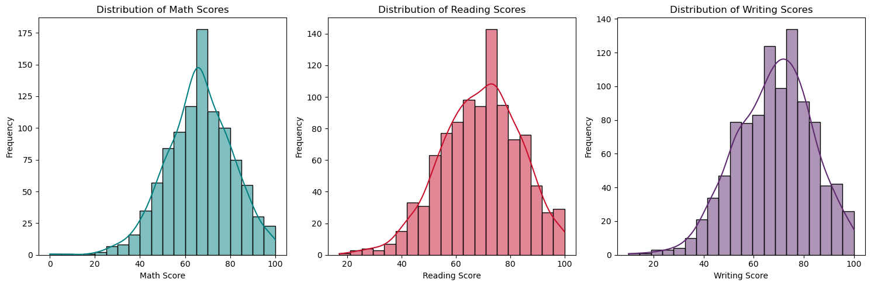

* **Math Score Distribution**: The plot shows that most students scored between 60 and 80 in math. The curve indicates a roughly normal distribution with few students scoring at the extremes (either very low or very high). The data peaks around the mid-60s, indicating this is the most common score range.
* **Reading Score Distribution**: This plot reveals that reading scores are also centered around the 60–80 range, with more students scoring higher in reading compared to math. The distribution is slightly skewed, with a significant number of students scoring above 80, indicating stronger performance in reading.
* **Writing Score Distribution**: Writing scores follow a similar pattern to reading scores, showing that students tend to perform similarly in writing as in reading. The distribution peaks around the 70s, showing a high concentration of students with average to above-average writing skills.

1. **Comparison of Math, Reading, and Writing Scores by Gender**:

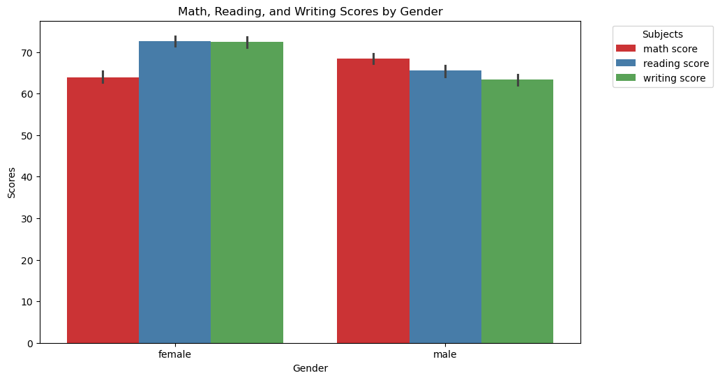

* The bar plot shows that female students tend to outperform male students in reading and writing, as indicated by higher average scores in these subjects. However, male students perform slightly better in math compared to females. This gender-based performance gap highlights a trend where females excel in language-based subjects, while males show a marginal advantage in math.

1. **Relationships Between Math Scores and Other Subjects by Gender**:

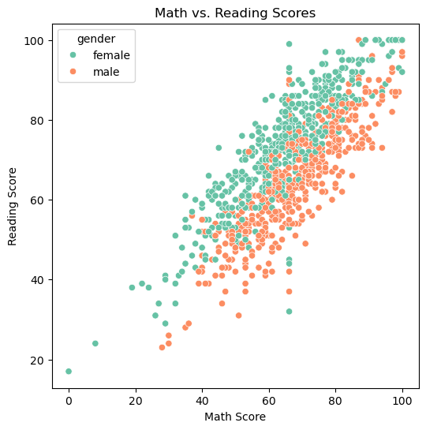 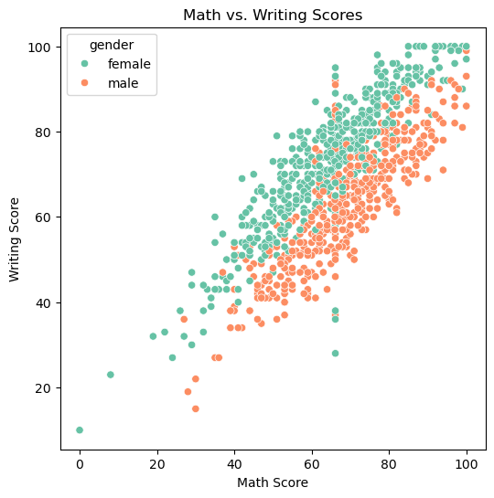

* **Math vs. Reading Scores**: This scatter plot shows a positive correlation between math and reading scores, meaning students who perform well in one subject tend to perform well in the other. The plot also shows that female students generally have higher reading scores compared to males, while their math scores are more spread out.
* **Math vs. Writing Scores**: Similarly, this plot indicates a positive relationship between math and writing scores. Female students show stronger writing performance, even among those with lower math scores, while male students tend to have a more even distribution between the two subjects. The plot suggests that writing and math skills may be less directly correlated than math and reading.