
University of Engineering and Technology,
Lahore
Department of Computer Science
Project Report
Team Members
Name | Roll Number | Email
Amreeha Eman | 2025-CS-24 | amreehaeman@gmail.com
Manahil Shahzad | 2025-CS-28 | manahiluno12@gmail.com

Session: Fall’25 Morning | Section: A | Semester: 1st

Course: CSC101 - Discrete Mathematics | Teacher: Mr. Waqas Ali
January 1, 2026

Table of Contents
Table of Contents 3
Project Report 4
1. Project Title 4
2. Chosen Track 4
3. Overview 4
4. Summary 4
5. Technology Stack & Libraries Utilized 4
6. List of Features 4
7. Mathematical Foundations 5
8. Examination of Key Functions/Methods 5
9. Limitations 5
10. User Interface 6
10.1 Interface Overview 6
10.2 Screen-by-Screen Documentation 6
11. Future Improvements 7
12. Conclusion 7
13. References & Learning Sources 7

P

roject Report

Project Title:
Digital Logic Circuit Simulator

Chosen Track:
- Track 1: Foundations of Logic

Overview:
This project is a comprehensive tool for modeling basic digital circuit. It allows the user to enjoy the luxury of:
- Input bool numbers and apply basic logic Gates (AND, OR, NOT, XOR).
- Design and stimulate HALF ADDER.
- Design and stimulate FULL ADDER.
- Do circuit combinations of gates.
- Circuit Minimization
Generation of truth table automatically after every option.

Summary:
This project addresses the difficulty of transferring from theoretical Boolean algebra to practical digital circuit design. Discrete mathematics introduces logical operators, truth tables, and Boolean laws, but if we don’t implement them, they remain an abstract.
“The main problem our project define is implementing the Boolean laws into practice”
Our approach was to design an interactive, menu-driven C++ program that simulates digital logic gates and circuits using Boolean operations. The system validates binary input, applies logical operations, displays ASCII-based circuit diagrams, and automatically generates truth tables for verification.
Key achievements include the successful implementation of basic logic gates (AND, OR, NOT, XOR), half-adder and full-adder circuits, combinational logic designs, and a circuit minimization module based on Boolean algebra laws. The simulator also emphasizes correctness by validating inputs and displaying complete truth tables.

The Signification of this project is how it demonstrates propositional logic, Boolean algebra, and logical equivalence directly translate into working computational systems. It reinforces the idea that discrete mathematical structures form the backbone of digital hardware and computer systems.

Technology Stack & Libraries Utilized:
- Programming Languages:
C++:
The main purpose of selecting C++ language was to deep root our concepts into the shape Motivation of using C++ is that it strongly supports bitwise operation, Boolean manipulation. It has Fast execution speed which makes it more reliable. Also, the hardware closeness of this language makes it more functionable and reliable to use.

- Libraries: iostream, windows.h, limits.
Iostream: for input and output terminologies.
Windows.h: for cursor movement and console formatting by gotoxy function
Limits: used to safely clear the input buffer by providing the maximum possible size that can be ignored using cin.ignore().

- Development Environment: (VS code, Minimalist GNU, GIT)
VS code: We have used this IDE to write and execute our code.
Minimalist GNU: it is a system that provides g++ compiler for C++ code execution.
GIT: It coordinates the files to the git repository.

List of Features:
The type of function ad features the project used and its description is below:
FEATURE | DESCRIPTION | TYPE
Basic Logic Gates | AND, OR, NOT, XOR operations with Truth Tables | Module (Core feature)
Half Adder | Stimulates sum and carry for two input bits | Module (Core feature)
Full Adder | Stimulates sum and carry-out with carry-in | Module (Core feature)
Combinational Circuit | User defined gate combinations | Module (Core feature)
Circuit Minimization | Demonstrate Boolean Simplification | Module (Core feature)
Input Validation | Ensures only valid binary input | Module (Core feature)
ASCII Circuit Diagram | Visual Representation of logic flow | Enhancement

Mathematical Foundations:
The foundation of our project is based on the concepts of discrete mathematics theme no.1 -Mathematical Reasoning.
- Relevant Concepts:
- BOOLEAN ALGEBRA: Its foundation was used for AND, OR, NOT operations and gates.
- Truth Table: Mapping out the possibilities of truthfulness or falseness of given parameters in visual format.
- Logical Equivalences: This concept was used for expressions producing identical output.
- De-Morgan’s Law: It was used for simplification of expressions involving basic gates.
- Formal Definitions:
- AND: $A⋅B=1 ⟺ A=1∧B=1$
- OR : $A+B=1⟺ A=1∨B=1$
- NOT: $A^{'}=1 ⟺ A=0$
- XOR: $A⊗B=1⟺A≠B$
- Proofs & Correctness:
Following are some of the explanations of this project being logically, mathematically and principally correct.
  - Gates Implementation Correctness:

- AND Gate:
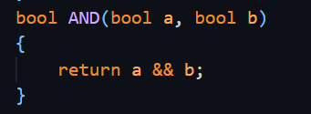
Proof:
According to Boolean algebra,
$$A⋅B=1 ⟺ A=1 \text{AND} B=1$$
The C++ logical operator && returns true only when both operands are true, hence the implementation is correct.

- OR Gate:
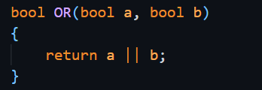
Proof:
Boolean law states:
$$A+B=1 ⟺ A=1\text{ OR }B=1$$
The || operator directly matches this definition.

- NOT Gate:
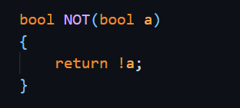
Proof:
$$A^{'}=1 ⟺ A=0$$
The logical NOT operator negates the input, fulfilling the complement law.

- XOR Gate:
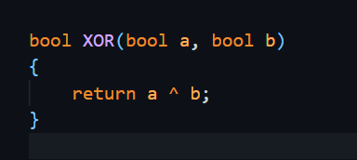
Proof:
XOR outputs true only when inputs differ:
$$A⊕B=1 ⟺ A≠B$$
The bitwise XOR operator ^ correctly models this behavior for boolean values.

  - Correctness of Truth Table Generation:
Truth Tables are generated using nested loops iterating over all the possible combination of valid input.
for (int i = 0; i <= 1; i++)
for (int j = 0; j <= 1; j++)

Proof:
For a circuit with n inputs, there are $2^{n}$possible input combinations.
The loops iterate over all binary values {0,1}, ensuring complete coverage of the input space.
Therefore, every possible case is tested and displayed, proving correctness of the truth table output

  - Correctness of half &full adder:
HALF ADDER:
• Sum:
$$\text{Sum}=A⊕B$$
• Carry:
$$\text{Carry}=A⋅B$$
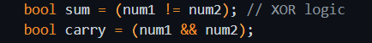
Proof:
By Boolean arithmetic:
- XOR correctly produces the sum bit
- AND correctly produces the carry bit
The generated truth table exactly matches the theoretical Half-Adder truth table, confirming correctness.

Full ADDER:
  - Sum:
$$\text{Sum}=A⊕B⊕C_{in}$$
  - Carry-out:
$$\text{Carry}=(A⋅B)+(A⊕B)$$
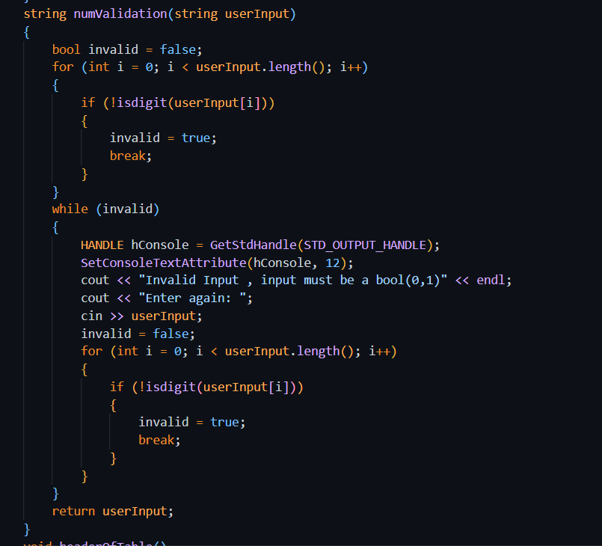
Proof:
The program evaluates both parts of the carry independently and combines them using OR. And thus, it suits the Boolean laws perfectly.
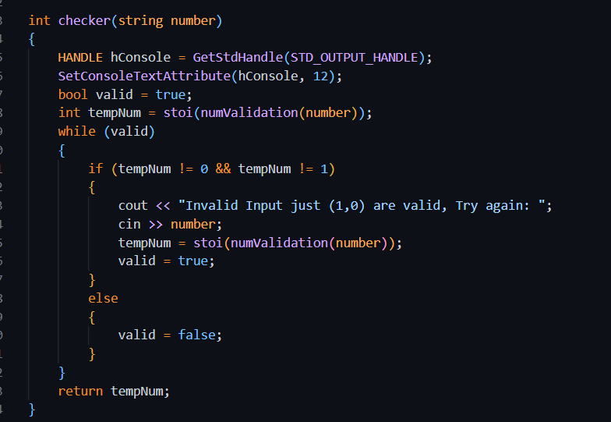
  - Input Validation Check:

• All user inputs are validated to ensure they are binary (0 or 1)
• Non-numeric or invalid inputs are rejected
• This guarantees correctness by preventing undefined or illegal states

  - Time and Space Complexity Analysis:
  - Time Complexity:
- Basic gates:
O(1)
- Truth table generation for n inputs:
O(2ⁿ)
  - Space Complexity:
- Uses constant memory
- No dynamic or global arrays used

Examination of Key Functions/Methods:
- Combinational Circuit:
- Function Name / Parameters: CombinatorialCircuit / void handleCombinatorialCircuit();
- Purpose: This function allows the user to simulate different combinational logic circuits using basic logic gates. It takes three binary inputs (A, B, and C), applies selected Boolean expressions, displays the result, and generates a complete truth table for the selected circuit. This function is central to the project as it integrates logic gate operations with user interaction and visualization.
- Algorithmic Description:
START
Input bit A
Input bit B
Input bit C

WHILE user does not choose Exit //loop starts
Display circuit menu
Read user choice

IF choice is (A AND B) OR C
Compute AND of A and B
Compute OR of result with C
Display result and truth table

ELSE IF choice is (A XOR B) AND C
Compute XOR of A and B
Compute AND of result with C
Display result and truth table

ELSE IF choice is (A OR B) AND C
Compute OR of A and B
Compute AND of result with C
Display result and truth table

ELSE IF choice is Exit
BREAK loop

ELSE
Display invalid input message
END WHILE
END

- Time/Space Complexity:
Time Complexity:
Circuit evaluation: O(1) (constant number of logic operations)
Truth table generation: O(2³) = O(8)
Since the number of inputs is fixed, the overall complexity is constant.

Space Complexity:
O(1)

- Implementation Details:
- Boolean data type (bool) is used to represent binary logic values (0 or 1).
- Menu-driven design allows easy selection of different combinational circuits.
- Nested loops are used to generate all possible input combinations for the truth table.
- ASCII-based circuit diagrams are used for visualization to keep the program console-based and simple.
- Input validation ensures that only valid binary values are processed.

- Code Snippet:
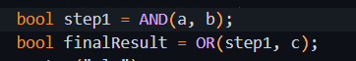

- Full Adder:
- Function Name & Parameters: FullAdder __ void handleFullAdder().

- Purpose: The full adder function extends the half adder by including a carry-in input. It adds three binary inputs and produces a Sum and Carry-out. This function demonstrates how simple circuits can be combined to form more complex arithmetic circuits.

- Algorithmic Description:
START
Input A, B, Carry-in
Sum = A XOR B XOR Carry-in
Carry = (A AND B) OR (Carry-in AND (A XOR B))
Display Sum and Carry
END
- Time/Space Complexity:
- Time Complexity is: O(1)
- Space Complexity is: O(1)
- Implementation Details:
-The function uses two XOR operations and multiple AND/OR gates.
-Boolean algebra laws are applied to correctly compute Carry-out.
-The design reflects the real hardware implementation of a full adder.
-The function helps demonstrate circuit composition in digital logic.
- Code Snippet:
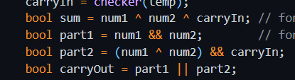

- Circuit Minimization:
Circuit Minimization __ voidhandleCircuitMinimization()
- Purpose:
• This function is designed to help the user to simplify combinational logic circuits using Boolean algebra laws.
• It allows users to:
- View key Boolean algebra laws.
- See a visual example of circuit minimization with truth table verification.
- Verify Boolean laws live by entering custom input values.
• It demonstrates how complex circuits can be minimized to simpler equivalents, improving efficiency and reducing gate usage.
- Algorithmic Description:
START
WHILE true //loop starts
Display Circuit Minimization Menu: //displays menu
1. View Boolean Algebra Laws
2. Minimization Example (Visual + Truth Table)
3. Live Law Verifier (Verify Multiple Laws)
4. Return to Main Menu
Read user selection
IF selection == 1
Display key Boolean algebra laws (Identity, Annulment, Complement, De Morgan)
ELSE IF selection == 2
Display complex circuit example: (A AND B) OR (A AND NOT B)
Display minimized circuit: A
Show truth table comparing complex vs minimized

ELSE IF selection == 3
Prompt user to select law to verify (Absorption, Identity, Idempotent)
Ask for input bits
Compute both sides of the law (complex vs simplified)
Display results and success verdict

ELSE IF selection == 4
BREAK loop

ELSE
Display invalid input message
END WHILE
END
- Time/Space Complexity:
Time Complexity:
- Viewing laws: O(1)
- Minimization example: O(2²) = O(4) for generating truth table (2 inputs)
- Live law verifier: O(1) per verification

Space Complexity:
- O(1) for single Boolean computations
- O(2²) for truth table storage during example
- Implementation Details:
• Uses bool data type for binary values.
• Menu allows user to select between viewing laws, examples, or live verification.
• Nested loops generate all input combinations for truth tables.
• ASCII-based circuit diagrams visualize the minimization result.
• Input validation (checker()) ensures only 0 or 1 is entered for each variable.
• Demonstrates practical Boolean algebra application: simplifying circuits, verifying laws, and comparing complex vs minimized expressions.

- Code Snippet:
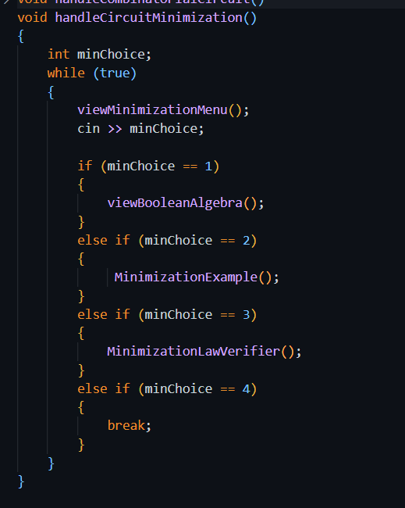

9. Limitations:
- Scope Limitations:
- Fixed Combinational Circuits:
The project currently only supports three pre-defined combinational "recipes" (e.g.((A AND B) OR C). It does not allow a user to build a custom circuit from scratch by connecting any number of gates
- No Multi-bit Arithmetic:
While it has a Half-Adder and Full-Adder, it cannot perform multi-bit addition (like a 4-bit or 8-bit ripple carry adder)
- Sequential Logic:
The simulator only covers Combinational Logic; it does not support Sequential Logic like Flip-Flops, Latches, or Counters.

- Algorithmic Limitations:
- Input Size:
The code is designed for small-scale logic (mostly 2 or 3 inputs). It cannot handle massive Boolean expressions with dozens of variables due to the hard-coded nature of the truth table loops.

- Text-Based Graphics:
Since the "visual design" is created using ASCII characters in the console, it cannot represent very complex or overlapping circuit diagrams clearly.
- Manual Minimization:
-We are using fixed rules and tools. The user cannot enter any gates on his own.
-This project cannot simplify arbitrary expressions using K-Maps or Quine–McCluskey.
- Design Trade-offs:
READABILILTY and FLEXIBILITY:
I chose to hard-code specific circuits to make the console output look neat and easy to understand rather than creating a complex system where users type in formulas.

- Known Issues:
OS DEPEDENCY:
The code uses <windows.h> and system("cls"), which means it will not run on Linux or macOS without modification.

10. User Interface:

10.1 Interface Overview:
The project uses a menu-driven console interface (CLI) to allow the user to interact with different digital logic modules.

The design emphasizes clarity, simplicity, and step-by-step guidance, making it easy to navigate between circuits, minimization tools, and verification features.
Users always have the option to return to the main menu from any sub-menu.

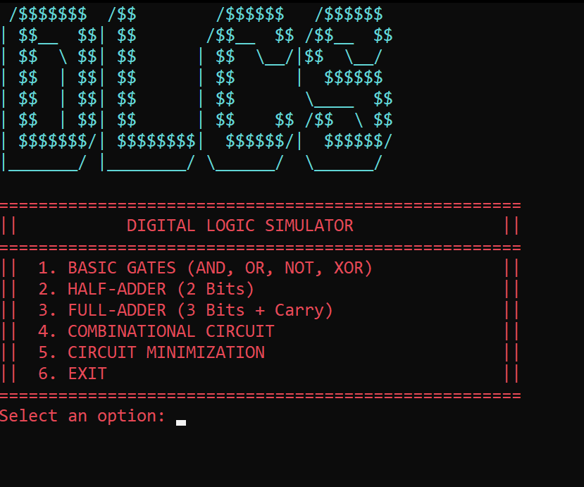
10.2 Screen-by-Screen Documentation:
1.MAIN MENU:

Purpose:
Entry point for the project, it lets the user
decides which module to choose.

- User Actions:
- Enter 1 → Go to Combinational Circuit menu
- Enter 2 → Go to Full Adder module
- Enter 3 → Go to Circuit Minimization tools
- Enter 4 → Exit the program

- Input Description:
Integer selection (1–4)
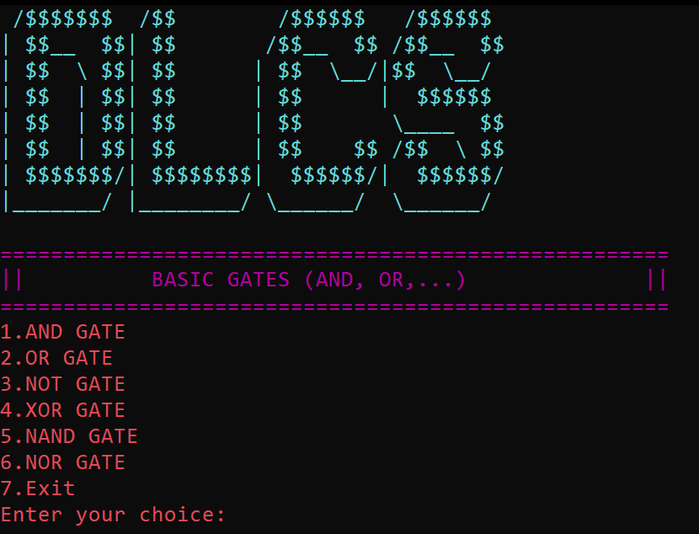
2.Upon selecting [1]:
BASIC GATES MENU:
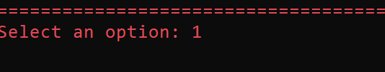

Purpose:
This screen let the user select the gate and after selecting the gate. It leads the user into the selected gate menu upon entering the choice.
- User Actions:
- Enter 1 → Go to AND Gate module
- Enter 2 → Go to OR module
- Enter 3 → Go to NOT module
- Enter 4 → Go to XOR Gate module
- Enter 5 → Go to NAND Gate module
- Enter 6 → Go to NOR module
- Enter 7 → Exit the program
- Input Description:
Integer selection (1–7)

AND GATE:
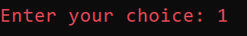

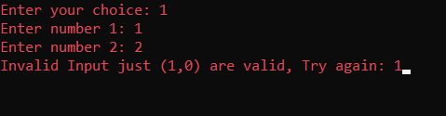
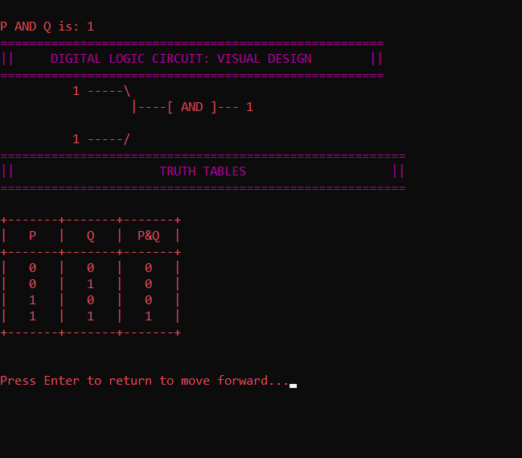

PURPOSE:
The purpose of this section is to take two bool values from the user and displaying the result, visual representation of the respective gate according to the input and finally the truth table of it.
- User Actions:
- Enter 1 → Go to AND Gate module
- Enter Number 1 → takes a bool value
- Enter Number 2 → takes a bool value

- Input Description:
The user will enter two value bool values. If the entered value isn’t (0,1), the user will have to entered that value again.

- Output Description:
It will display the resultant value of P AND Q along with its visual representation and truth table of AND gate.
- Navigation:
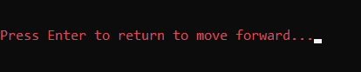
After doing its task the user will type any keyboard key to return to the Logic Gates Menu.

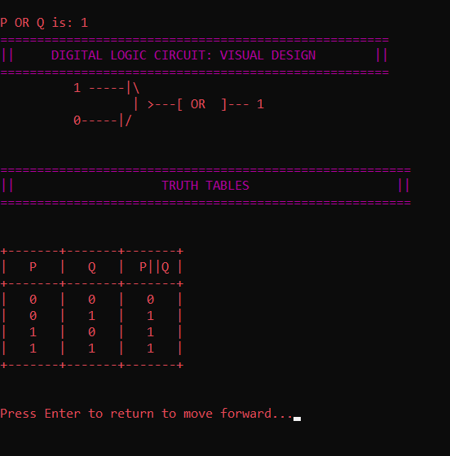

2.OR GATE:
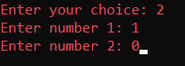

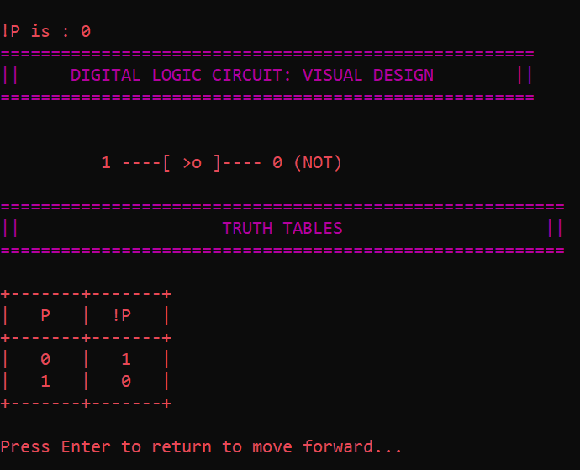
3.NOT GATE:

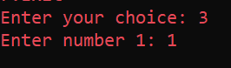

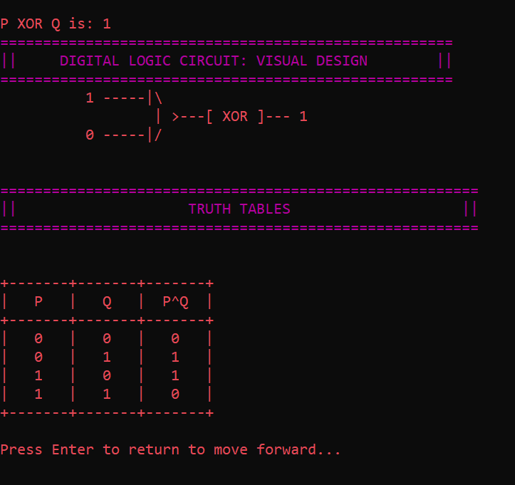
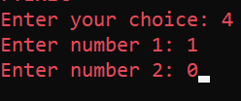
4.XOR:

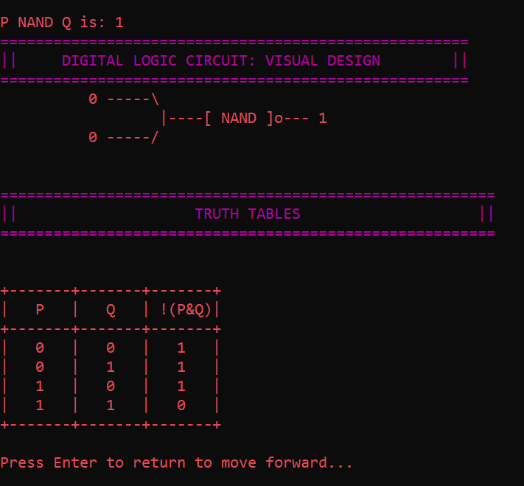
5.NAND
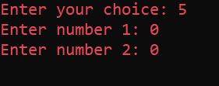

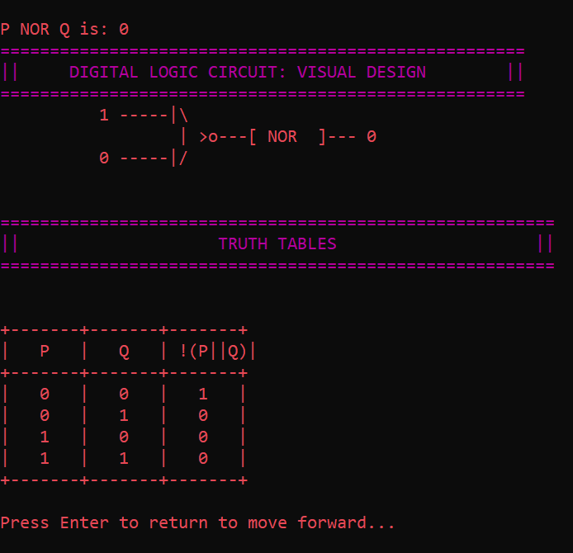

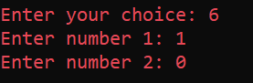
6.NOR:

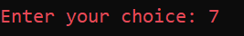
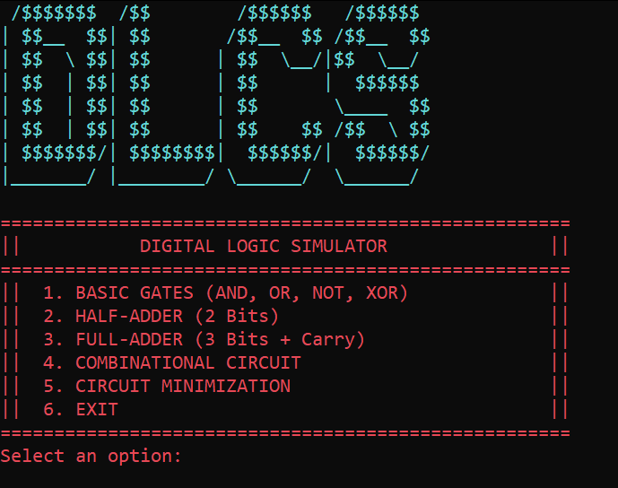
7.EXIT:

BACK TO THE MAIN MENU

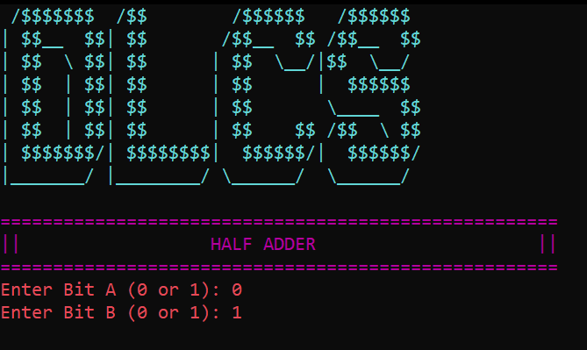
3.Upon selecting [2]:
Half Adder
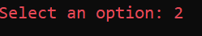

PURPOSE:
To perform half adder arithmetic circuit.
• User Actions:
o Enter 2 → Go to Half Adder menu
• Input Description:
In the half Adder function, Enter the two bits as input. It also performs input validation and if the user enters anything other than 0,1 it shows invalid parameters and ask the user to enter the data again.

• Output Description:
It performs the half adder operation on it and shows the output of sum and carry in along with its visual representation and truth table.
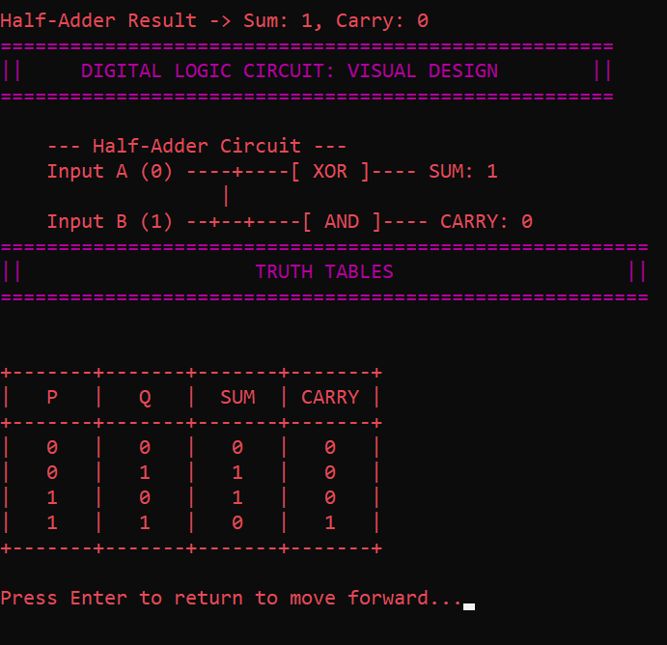
• Navigation:
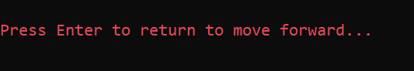
After doing its task the user will type any keyboard key to return to the Logic Gates Menu.

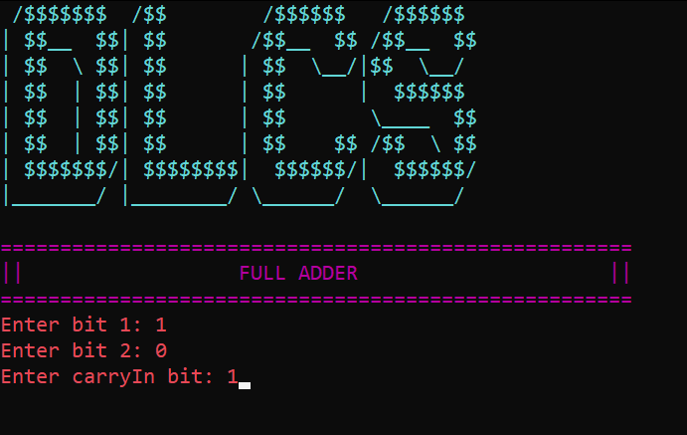
4.Upon selecting [3]:
FULL ADDER:
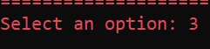

PURPOSE:
To perform full adder arithmetic circuit.
• User Actions:
o Enter 3 → Go to Full Adder menu
• Input Description:
In the half Adder function, Enter the two bits as input. It also performs input validation and if the user enters anything other than 0,1 it shows invalid parameters and ask the user to enter the data again.
• Output Description:
It performs the full adder operation on it and shows the output of sum and carry in along with its visual representation and truth table.
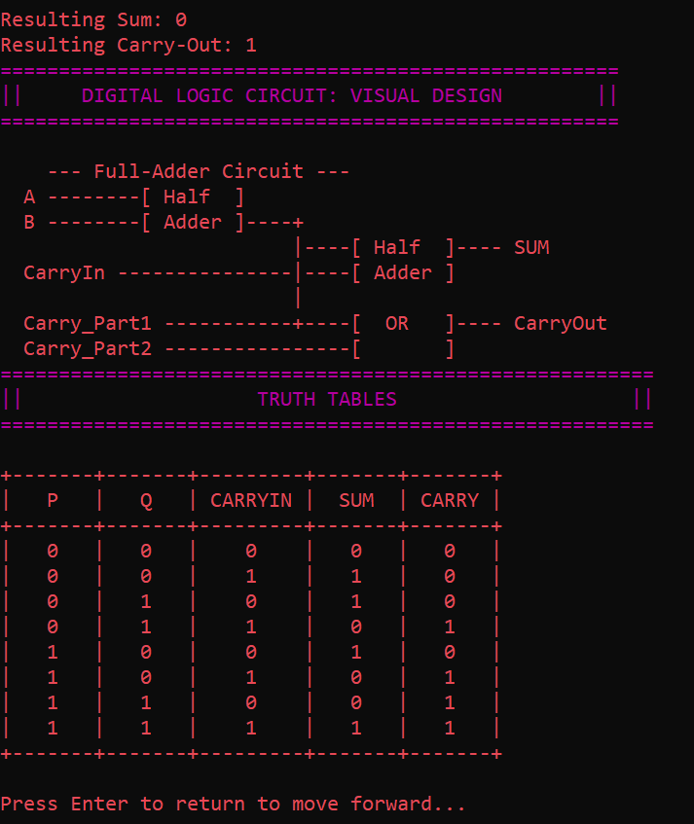

• Navigation:
After doing its task the user will type any keyboard key to return to the Logic Gates Menu.

5.Upon selecting [4]:
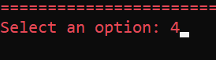
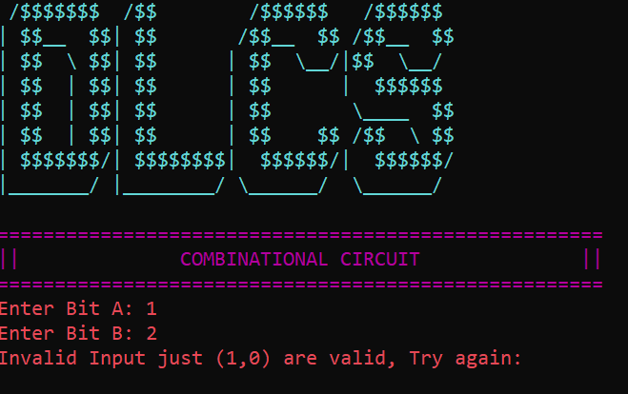
COMBINATIONAL CIRCUIT:

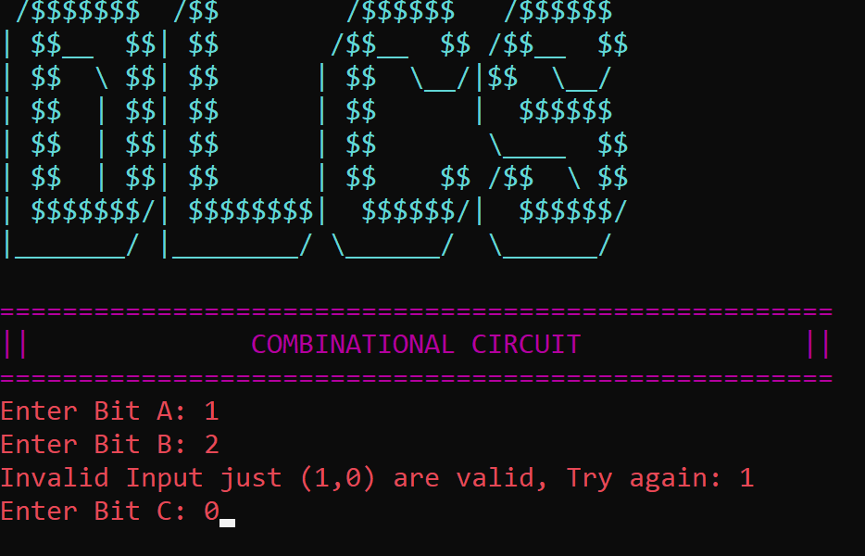

PURPOSE:
Taking three bits from user and displaying three options to the user to select the type of combination he wants to do and performing relevant task with the inputs given.

• User Actions:
1. Circuit (A AND B) OR C
2. Circuit Logic (A XOR B) AND C
3. Circuit Gate (A OR B) AND C
4. Exit
• Input Description:
The user will enter the three inputs bits and if he enters something others bit value it displays invalid and he will have to enter again
• Output Description:
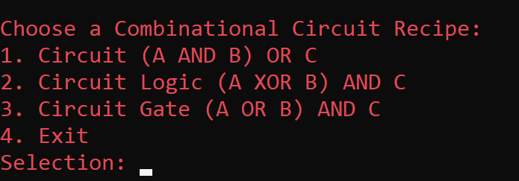
• Navigation:
After the user is done and select an option it will take it to its respective destination.

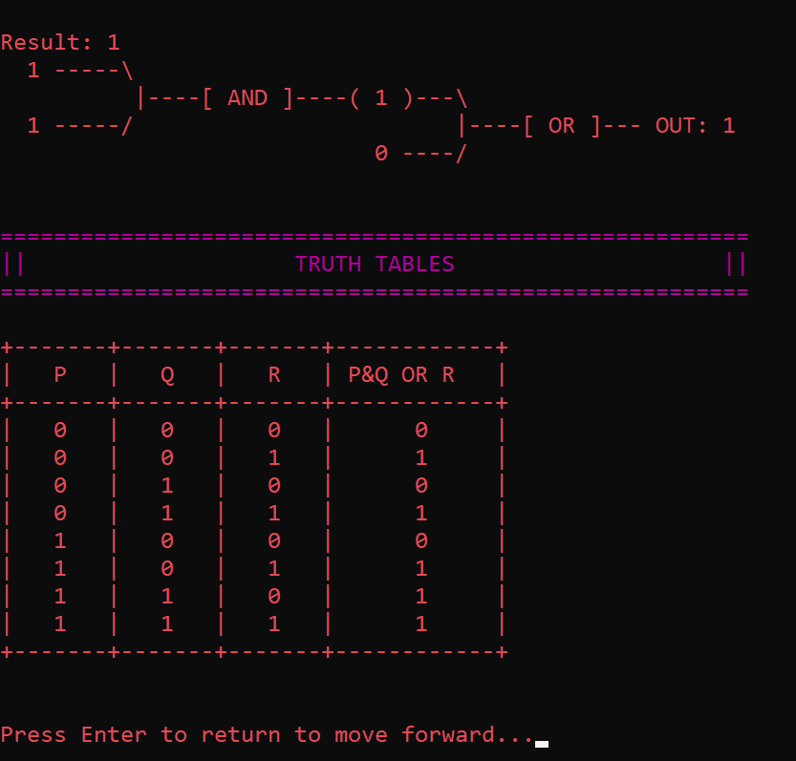
Selection of 1:
Circuit (A && B)|| C:
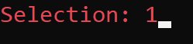

Selection of 2:
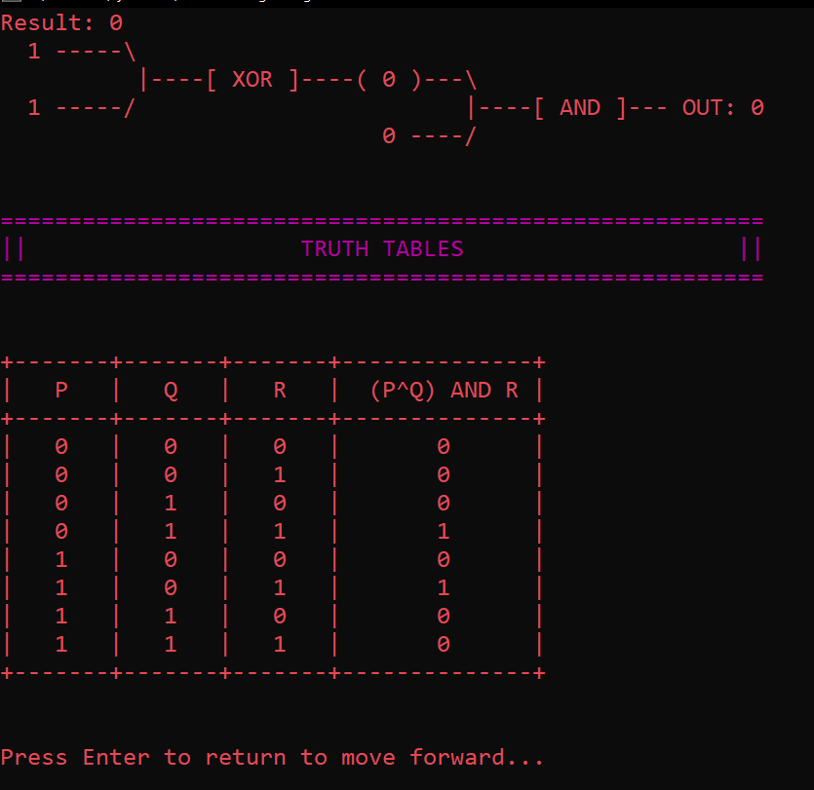
Circuit Logic (A $⊗$ B) && C:

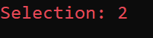

Selection of 3:
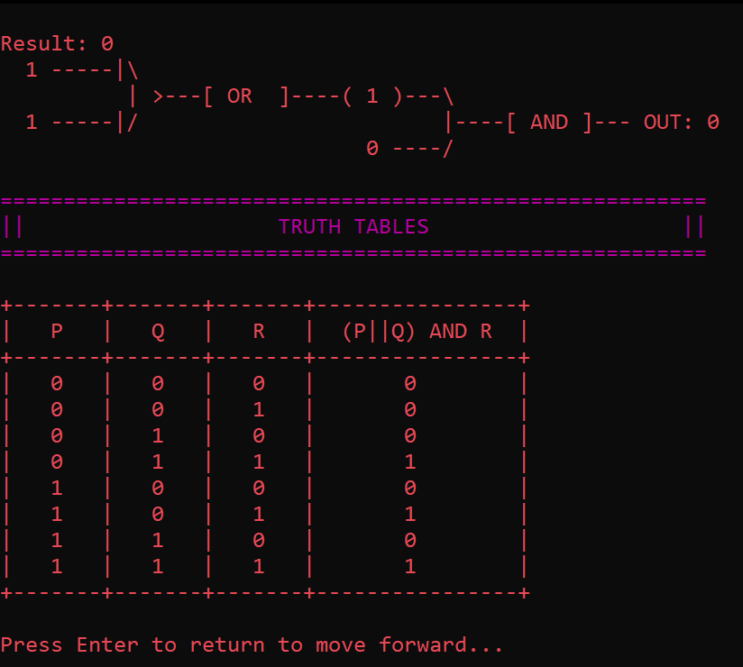
Circuit Gates (A|| B) && C:

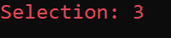

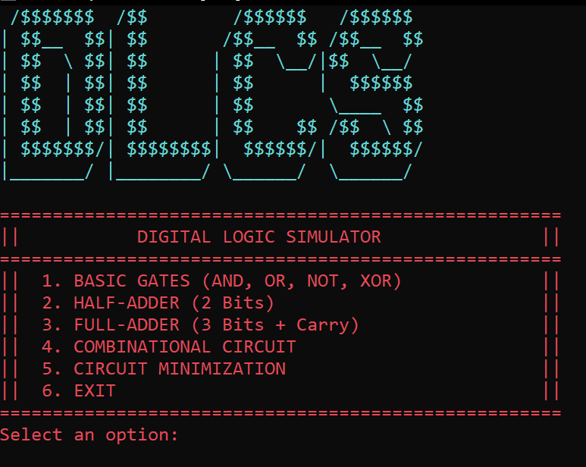
Selection of 4:
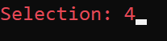
EXIT:

It returns the user back to
the main menu

6.Upon selecting [5]:
CIRCUIT MINIMIZATION:
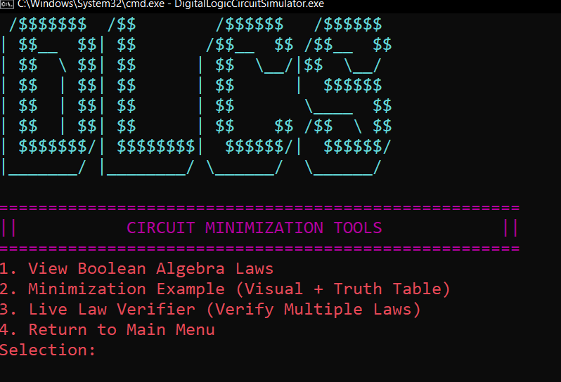

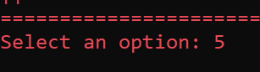

PURPOSE:
To show the user Boolean laws, minimization examples for the user to enhance its understanding and truth tables and lastly doing law verification by taking user input and minimizing the expression to prove its both sides to be equal.
• User Actions:
o Enter 1 → Go to Boolean laws viewing
o Enter 2 → Go to Minimization Examples
o Enter 3 → Go to Live Law Verifier
o Enter 4 → Exit the circuit Minimization menu
• Input Description:
Upon entering the circuit minimization menu, the user will have 4 options to select. When he would select the 3rd option, he will have to pass some bits parameters to the function to see the minimized form of expression.

• Output Description:
In the 1st option, the user will only view the Boolean laws.
In the 2nd option, the user will see minimization example along with truth tables.
In the 3rd option, the user will see the live verification of expression by its given parameters.
• Navigation:
The user will select options from 1-4. When they will select options between 1 to 3, it will lead him to its respective side but when the user type 4 selection it will exit the minimization menu and return to main menu.
1.SELECTION OF 1:
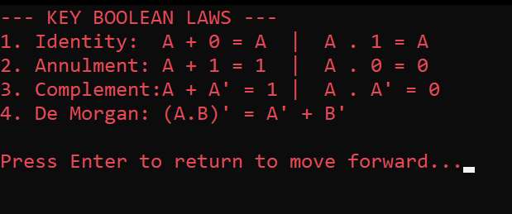
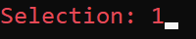

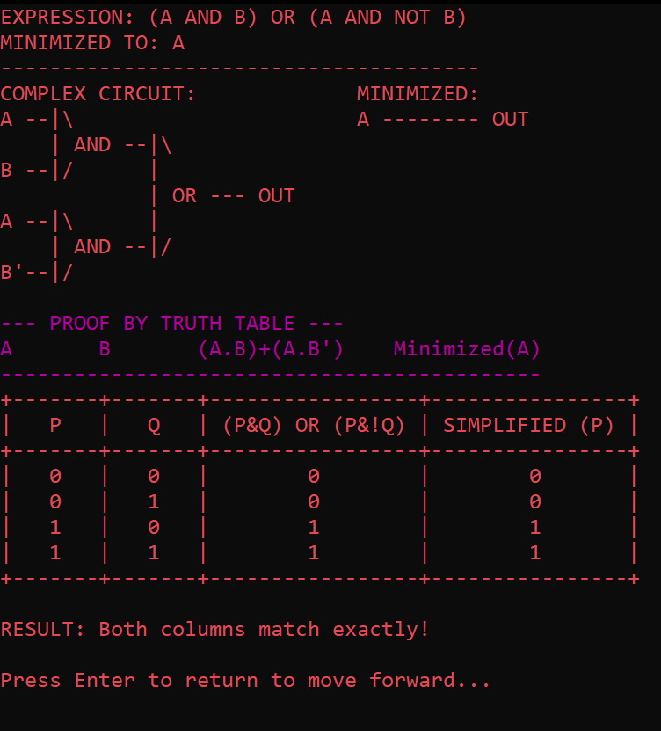
2.SELECTION OF 2:

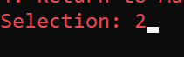

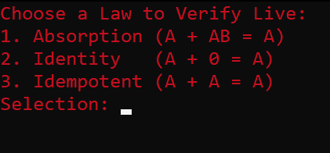
3.SELECTION OF 3:
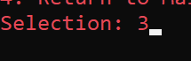

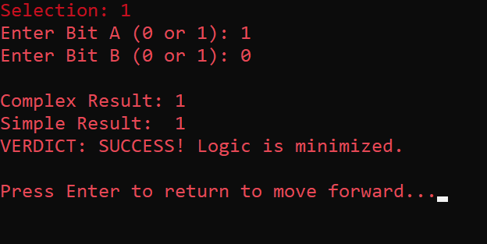
a.ABSORPTION:

b.IDENTITY:
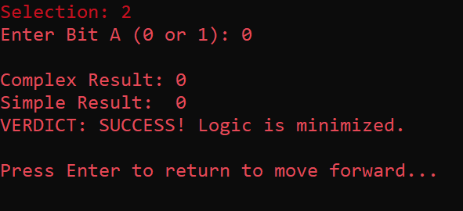

c.IDEMPOTENT:
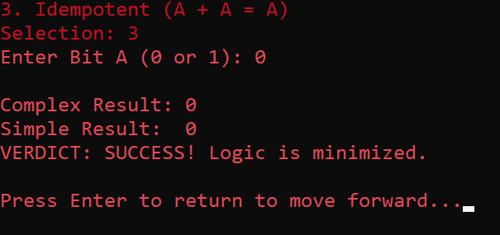
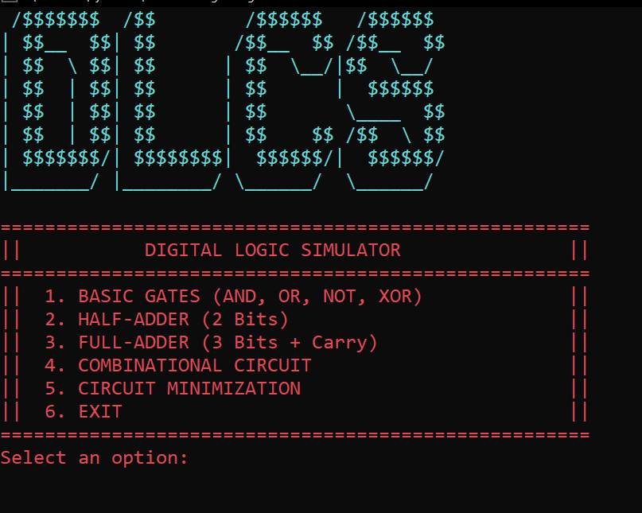
4.SELECTION OF 4:
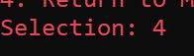

7.Upon selecting [6]:
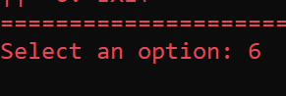

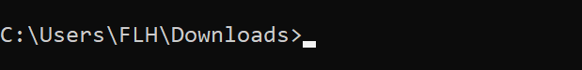

11. Future Improvements:
- Performance Optimizations: GUI- Move beyond ASCII art to a professional visual interface using Graphics libraries for better user Interface.
- Dynamic Expression: Enable users to type any custom Boolean string (e.g., (A + B). C) so, the program can build custom circuits on the fly instead of using fixed "gates".
- Automated Minimization Engine: Instead of fixing the gates, in future we will try for the feature in which user can enter gates or we can tell them it’s minimization.
- Customizable Truth Tables: Implementation of feature in which user can enter its own specific input (for truth table rows) to see truth tables, instead of hardcoding.

12. Conclusion:
Conclude your report by synthesizing your work. Discuss:
- Key Achievements: We successfully implemented a functional DIGITAL LOGIC CIRCUIT SIMULATOR in C++that process basic gates, half adder, full adder, combinatorial circuits or also circuit minimization. The program features a terminal-based visual interface that renders circuit diagrams using ASCII characters and generates real-time truth tables.
- Challenges Overcome: S significant technical hurdle was input validations that simulator inly take 0,1. To overcome this we have created a roboust numValidation and checker function.
Checker function:
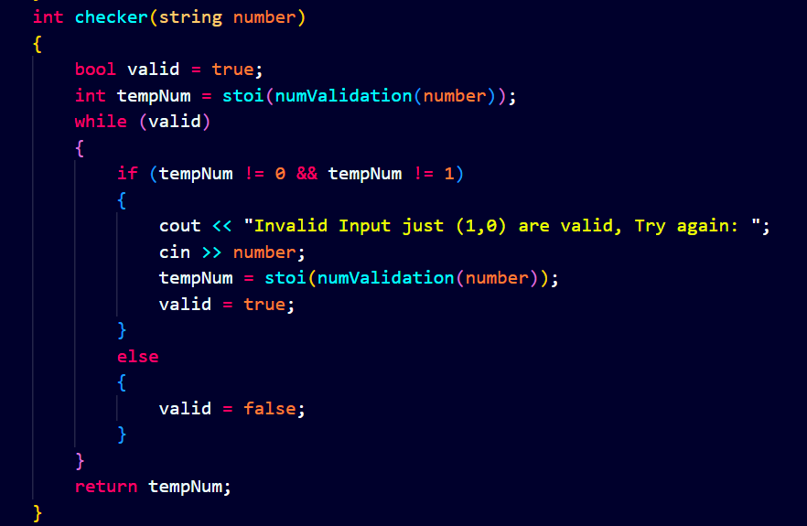
AND numValidation function:
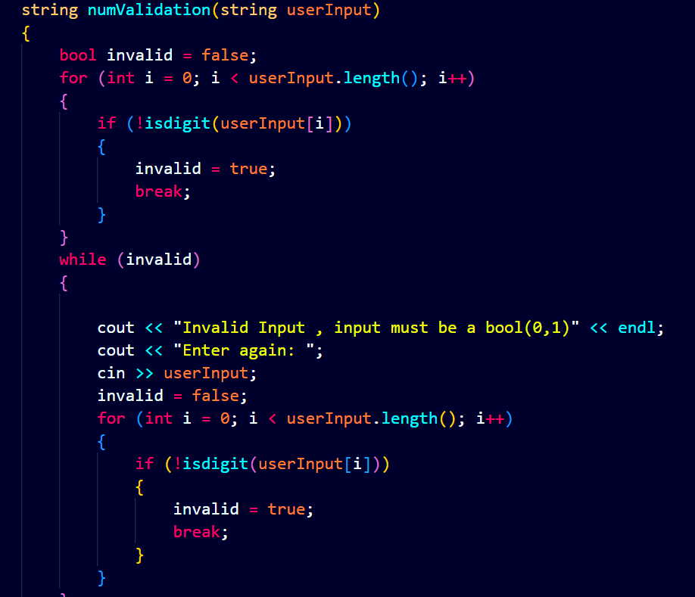

- Reflection: This project highlights the importance of logic-based design. Building a tool that can verify its own logic through a "Law Verifier" demonstrated the reliability of mathematical proofs in software development.
- Final Remarks: We always learnt truth tables or gates in theory or maths classes by this project we gate chance to learn gates not only theoretically but also practical. In that project we successfully implemented basic circuits or also arithmetic circuits (Half Adder and Full Adder). So overall, this project has solidified our foundation as a software engineer and my ability to translate complex logic into functional code.

13. References & Learning Sources:
- GitHub: https://github.com/AmreehaEman/Digital-Logic-Simulator-CPP

- Video Demo: Link to a demonstration video, preferably uploaded on LinkedIn.
- Textbooks: We have consulted course book: Rosen, Discrete Mathematics and Its Applications, 8th ed.
- Tutorials & Guides: We have seen videos for Half adder or Full adder to code their functions or to learn what is his about or where these gates are used.

- AI Assistance:
I utilized the Gemini AI model to assist in the following areas of the project:
- Visual Logic: At first, we were not understating how we should represent diagrams so, I used AI to help design the ASCII art representations for the gates and the formatting for the truth tables to ensure they were readable in the console. Or for table consistent printing like table borders or alignments.
- Circuit Minimization: While writing code for circuit minimization , we were not getting how to add this feature as minimization has a lot of laws or rules so AI gives us idea to cout few of them or represent one example and ask user to test few of them.
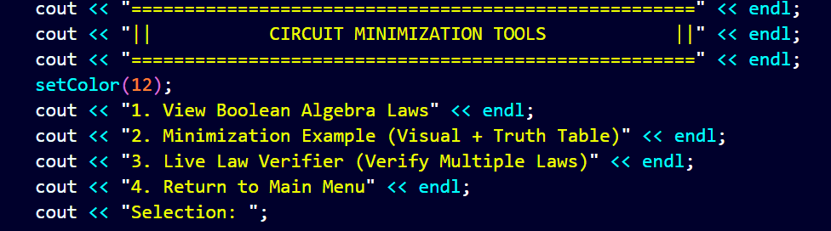
- Combinatorial Circuits: We were not understanding how to add combinatorial function , because we were stuck whether user will enter gates . So this could be very challenging so AI gives us Idea to fixed the circuits or ask from user to add values.
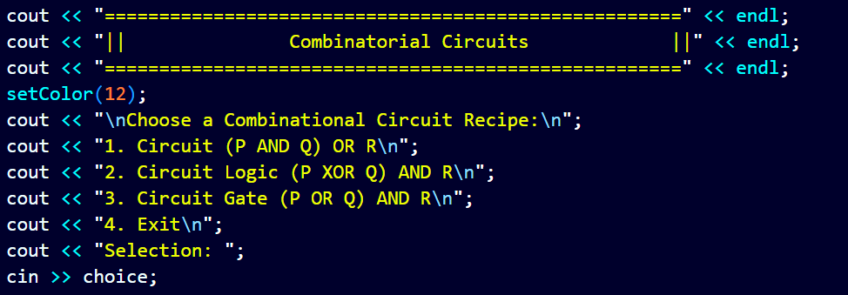
- Debugging: While coding when we stuck like during the color adding I took help from Ai to implement for colors consistency. Like:
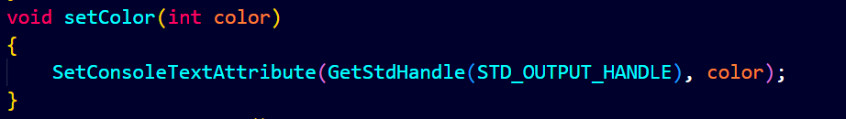
- Documentation: As this is our first project or first time we are writing documentation so we used AI to understand how to write or how to describe our project.

