PROJECTWORKBASE(PWB) APPLICATION:

Relational schema:

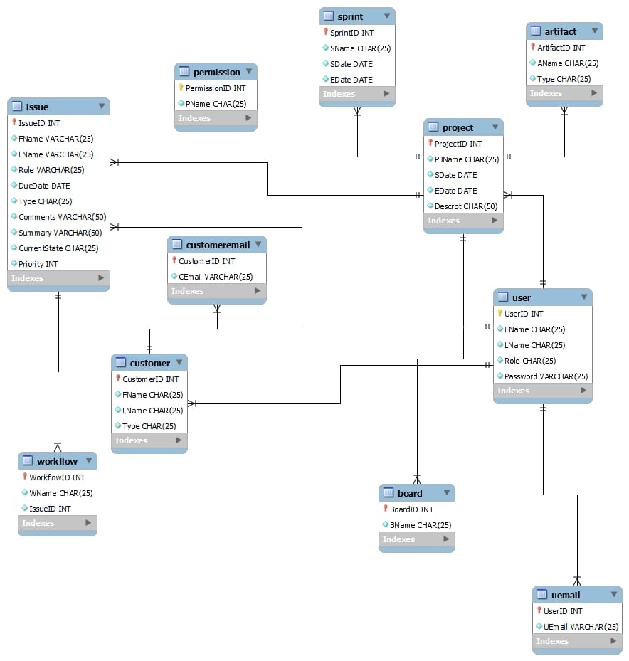

ERD:

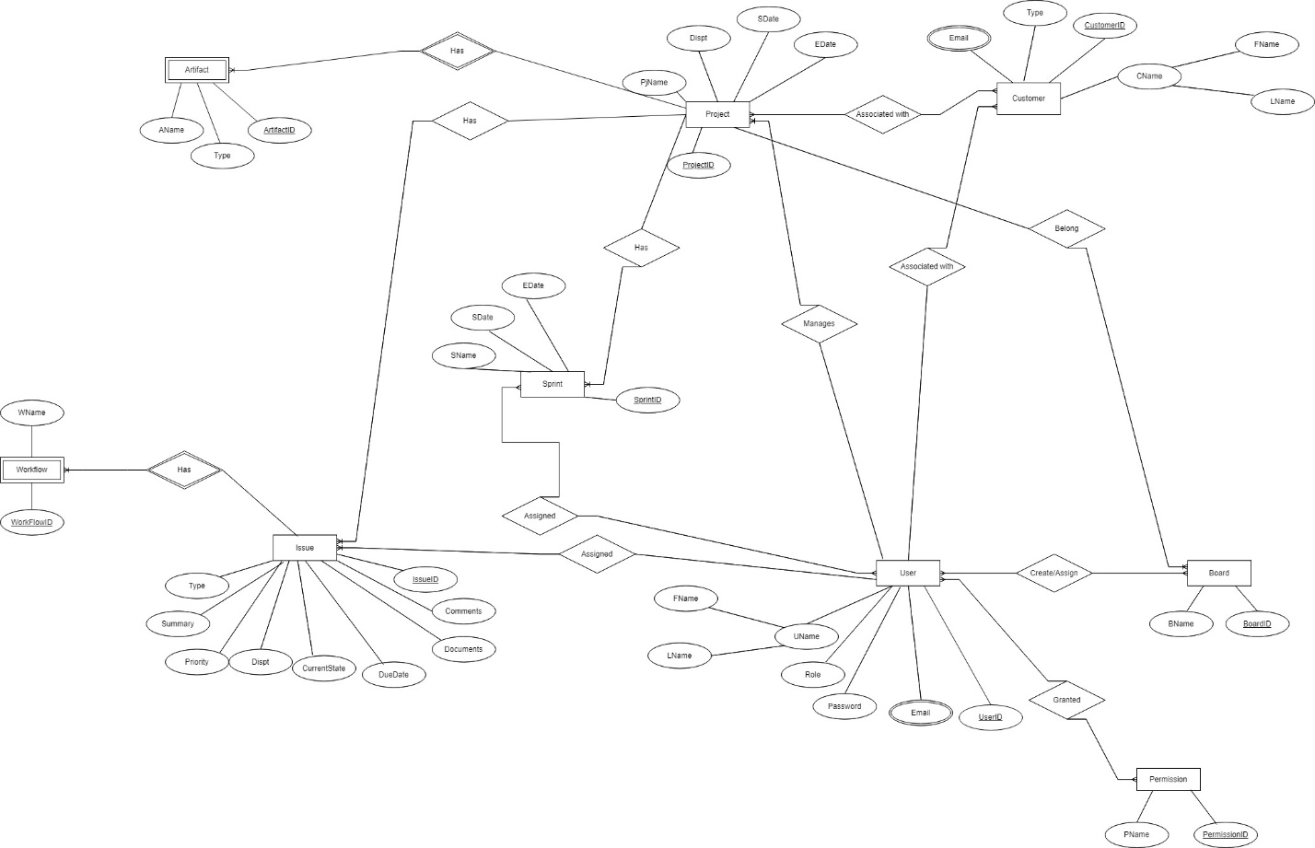

**ERD: -**

**Entities:**

User

Project

Issue

Board

Sprint

Workflow

Artifact

Customer

Permission

CustomerEmail

Uemail

Granted

Assignedb

Assigneds

Associated

**Attributes:**

**User:**

UserID (primary key)

Username

Password

Email

First Name

Last Name

RoleID (foreign key)

**Administrator:**

AdminID (primary key)

UserID (foreign key)

**Project:**

ProjectID (primary key)

Project Name

Description

Start Date

End Date

Team Lead/ Project ManagerID (foreign key)

**Issue:**

IssueID (primary key)

Type

Summary

Description

Assigned To (foreign key)

Current State

Priority

Due Date

Comments

Files/ Documents

**Board:**

BoardID (primary key)

Board Name

ProjectID (foreign key)

**Sprint:**

SprintID (primary key)

Sprint Name

ProjectID (foreign key)

Start Date

End Date

**Workflow:**

WorkflowID (primary key)

Workflow Name

IssueID (foreign key)

**Artifact:**

ArtifactID (primary key)

Artifact Name

ProjectID (foreign key)

**Customer:**

CustomerID (primary key)

Customer Name

Email

Type

UserID (foreign key)

**Role:**

RoleID (primary key)

Role Name

**Permission:**

PermissionID (primary key)

Permission Name

**Relationships:**

**User** has one role.

**Administrator** is a type of user and has one user.

**Project** has one team lead/ project manager and can have multiple issues, boards, sprints, workflows, and artifacts.

**Issue** can be part of multiple boards, sprints, and workflows, and can be assigned to one team member.

**Board** is part of one project and can have multiple issues.

**Sprint** is part of one project and can have multiple issues.

**Workflow** is part of one issue and can have multiple states.

**Artifact** is part of one project and can have multiple issues.

**Customer** can be a type of user and can have multiple issues.

**Role** can be assigned to multiple users.

**Permission** can be assigned to multiple roles.

Dataset:

**User**

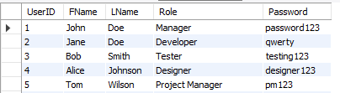

**UEmail**

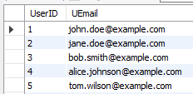

**Project**

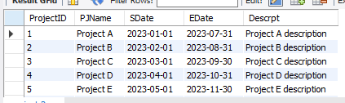

**Issue**

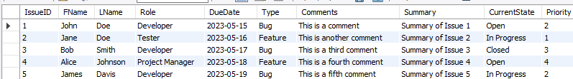

**Board**

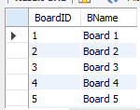

**Sprint**

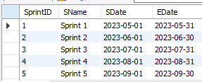

**Workflow**

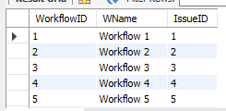

**Artifact**

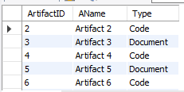

**Customer**

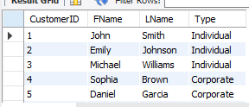

**CustomerEmail**

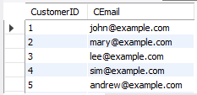

**Permission**

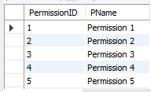

**Associated**

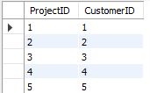

**AssignedB**

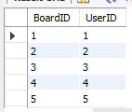

**AssignedS**

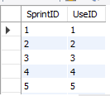

**Granted**

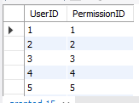

TABLE DESCRIPTION:

User

|  |  |  |  |  |
| --- | --- | --- | --- | --- |
| ATTRIBUTES | DESCRIPTION | CONSTRAINTS | TYPE | EXAMPLE |
| FName | Name of accoutn | Not null | Varchar() | manahil |
| LName | Name of accoutn | Not null | Varchar() | manahil |
| Userid | id | Index | Int() | 001, 02 |
| Role | Type of account | Not null | varchar | manager |
| Password | Password key of account | Not null | varchar | 011, 002 |

Project

|  |  |  |  |  |
| --- | --- | --- | --- | --- |
| ATTRIBUTES | DESCRIPTION | CONSTRAINTS | TYPE | EXAMPLE |
| PJName | Name of account | Not null | Varchar() | manahil |
| Sdate | Start date | Not null | datetime() | 07-10-2023 |
| Projectid | id | Index | Int() | 001, 02 |
| Edate | End date | Not null | datetime | 07-10-2023 |
| Description | Project description | Not null | varchar | 011, 002 |

Issue

|  |  |  |  |  |
| --- | --- | --- | --- | --- |
| ATTRIBUTES | DESCRIPTION | CONSTRAINTS | TYPE | EXAMPLE |
| FName | Name of account | Not null | Varchar() | manahil |
| LName | Name of accoutn | Not null | Varchar() | manahil |
| Issueid | id | Index | Int() | 001, 02 |
| Role | Role of issuer | Not null | varchar | manager |
| Due date | Time due | Not null | datetime | 09-09-2020 |
| Type | Type of account | Not null | varchar | Bug, feature |
| Comments | reviews | Not null | varchar | “very cute” |
| Summary | Short review | Nor null | varchar | “uwu” |
| Currentstae | Password key of account | Not null | varchar | 011, 002 |
| priority | rank | Not null | Int | 2 |

Board

|  |  |  |  |  |
| --- | --- | --- | --- | --- |
| ATTRIBUTES | DESCRIPTION | CONSTRAINTS | TYPE | EXAMPLE |
| BName | Name of account | Not null | Varchar() | manahil |
| Boardid | id | Index | Int() | 001, 02 |

Sprint

|  |  |  |  |  |
| --- | --- | --- | --- | --- |
| ATTRIBUTES | DESCRIPTION | CONSTRAINTS | TYPE | EXAMPLE |
| SName | Name of account | Not null | Varchar() | manahil |
| Sdate | Start date | Not null | datetime() | 07-10-2023 |
| sprintid | id | Index | Int() | 001, 02 |
| Edate | End date | Not null | datetime | 07-10-2023 |

Workflow

|  |  |  |  |  |
| --- | --- | --- | --- | --- |
| ATTRIBUTES | DESCRIPTION | CONSTRAINTS | TYPE | EXAMPLE |
| WName | Name of account | Not null | Varchar() | manahil |
| workflowid | id | Index | Int() | 001, 02 |
| issueid | Foreign id | Index | Int() | 001, 02 |

Artifact

|  |  |  |  |  |
| --- | --- | --- | --- | --- |
| ATTRIBUTES | DESCRIPTION | CONSTRAINTS | TYPE | EXAMPLE |
| AName | Name of accoutn | Not null | Varchar() | manahil |
| Artifactid | id | Index | Int() | 001, 02 |
| type | Type of artifact | Not null | varchar | Code, document |

Customer

|  |  |  |  |  |
| --- | --- | --- | --- | --- |
| ATTRIBUTES | DESCRIPTION | CONSTRAINTS | TYPE | EXAMPLE |
| FName | Name of accoutn | Not null | Varchar() | manahil |
| LName | Name of accoutn | Not null | Varchar() | manahil |
| customerid | id | Index | Int() | 001, 02 |
| type | Type of customer | Not null | varchar | premiuim |

Permission

|  |  |  |  |  |
| --- | --- | --- | --- | --- |
| ATTRIBUTES | DESCRIPTION | CONSTRAINTS | TYPE | EXAMPLE |
| PName | Name of permission | Not null | Varchar() | manahil |
| Permissionid | id | Index | Int() | 001, 02 |

CustomerEmail

|  |  |  |  |  |
| --- | --- | --- | --- | --- |
| ATTRIBUTES | DESCRIPTION | CONSTRAINTS | TYPE | EXAMPLE |
| CEmial | Email address | Not null | Varchar() | manahil@gmail.com |
| Customerid | id | Index | Int() | 001, 02 |

Uemail

|  |  |  |  |  |
| --- | --- | --- | --- | --- |
| ATTRIBUTES | DESCRIPTION | CONSTRAINTS | TYPE | EXAMPLE |
| UEmial | Email address | Not null | Varchar() | manahil@gmail.com |
| Urid | id | Index | Int() | 001, 02 |

Granted

|  |  |  |  |  |
| --- | --- | --- | --- | --- |
| ATTRIBUTES | DESCRIPTION | CONSTRAINTS | TYPE | EXAMPLE |
| userid | id | Index | Int() | 001, 02 |
| Permissionid | id | Index | Int() | 001, 02 |

Assignedb

|  |  |  |  |  |
| --- | --- | --- | --- | --- |
| ATTRIBUTES | DESCRIPTION | CONSTRAINTS | TYPE | EXAMPLE |
| userid | id | Index | Int() | 001, 02 |
| boardid | id | Index | Int() | 001, 02 |

Assigneds

|  |  |  |  |  |
| --- | --- | --- | --- | --- |
| ATTRIBUTES | DESCRIPTION | CONSTRAINTS | TYPE | EXAMPLE |
| userid | id | Index | Int() | 001, 02 |
| sprintid | id | Index | Int() | 001, 02 |

Associated

|  |  |  |  |  |
| --- | --- | --- | --- | --- |
| ATTRIBUTES | DESCRIPTION | CONSTRAINTS | TYPE | EXAMPLE |
| customerid | id | Index | Int() | 001, 02 |
| Projectid | id | Index | Int() | 001, 02 |

**Front End Development of Forms/ Reports using NodeJS & MYSQL**

Some code snippets:

**App.js**

Initial connection set up

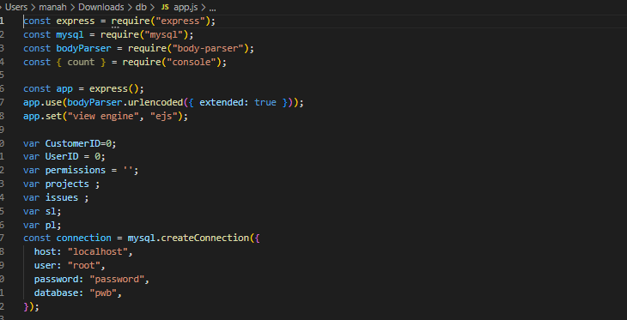

To take login info and verify using queries and tables like user and granted:

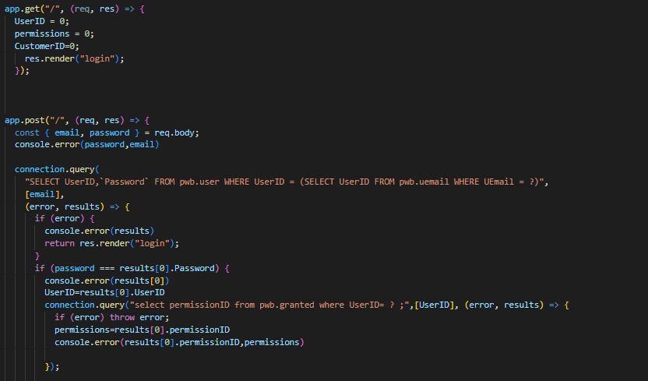

Checking the issue and projected as well.

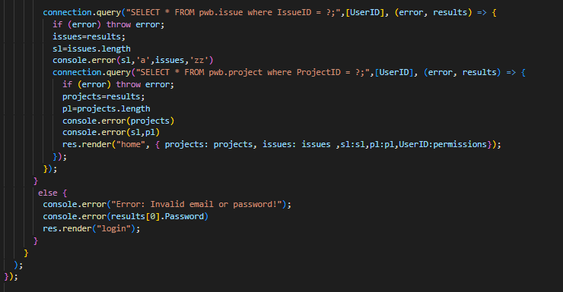

Some other queries with node.js

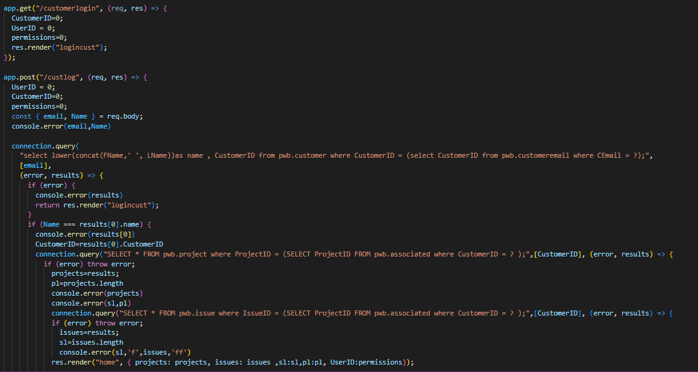

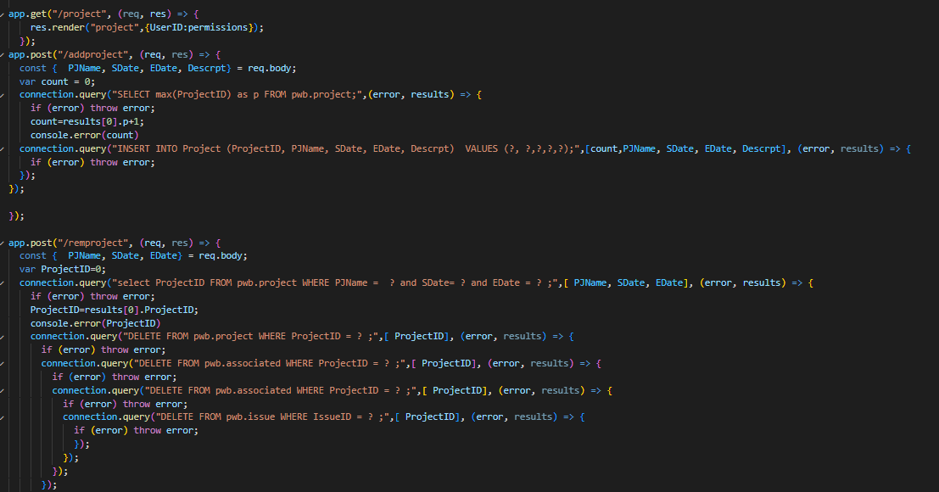

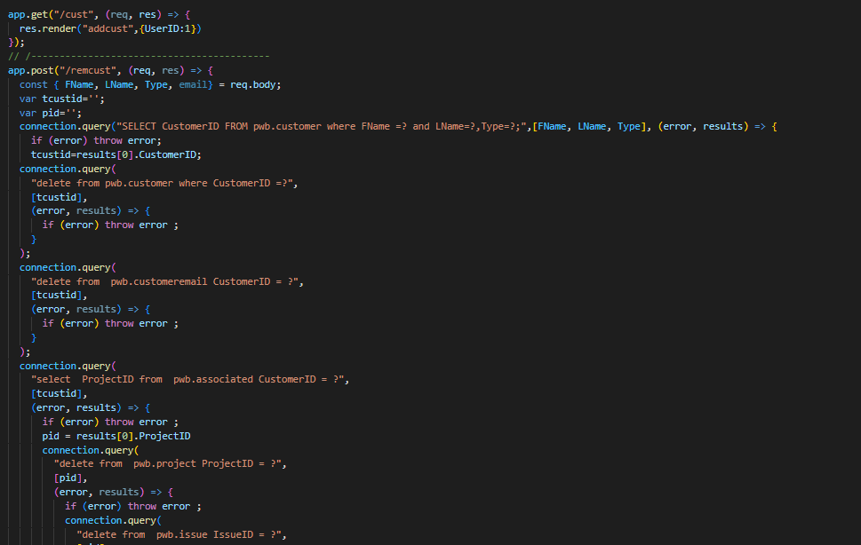

Some insertion queries:

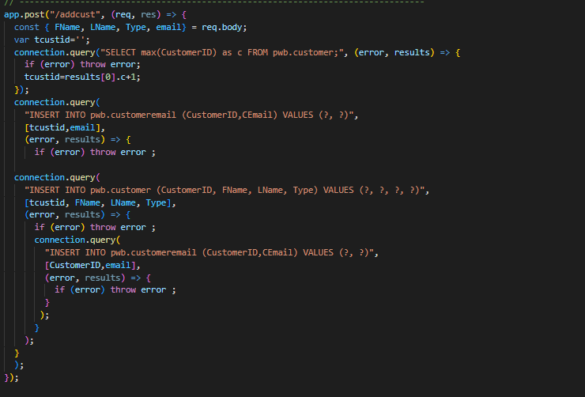

Setting up connection with port

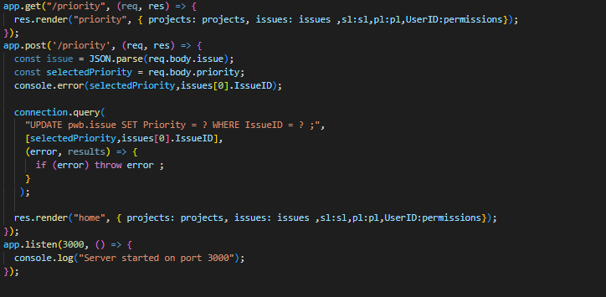

**Style.css:**

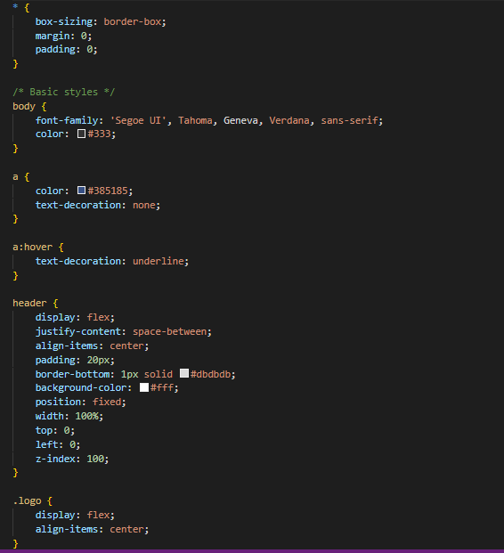

**Post-1.css:**

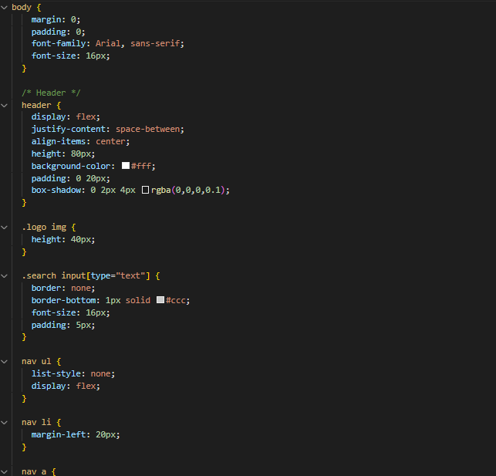

**WEB PAGE:**

LOGIN:

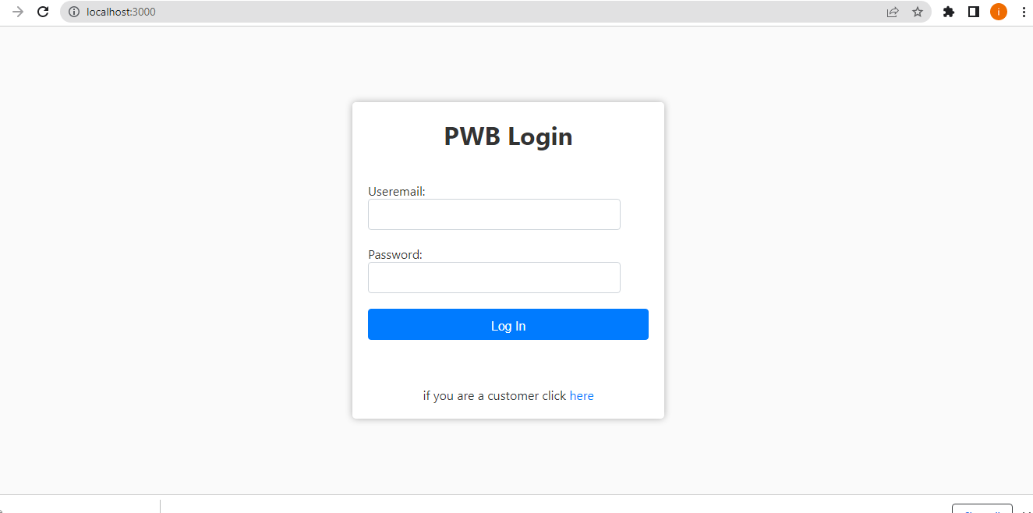

**HOME:**

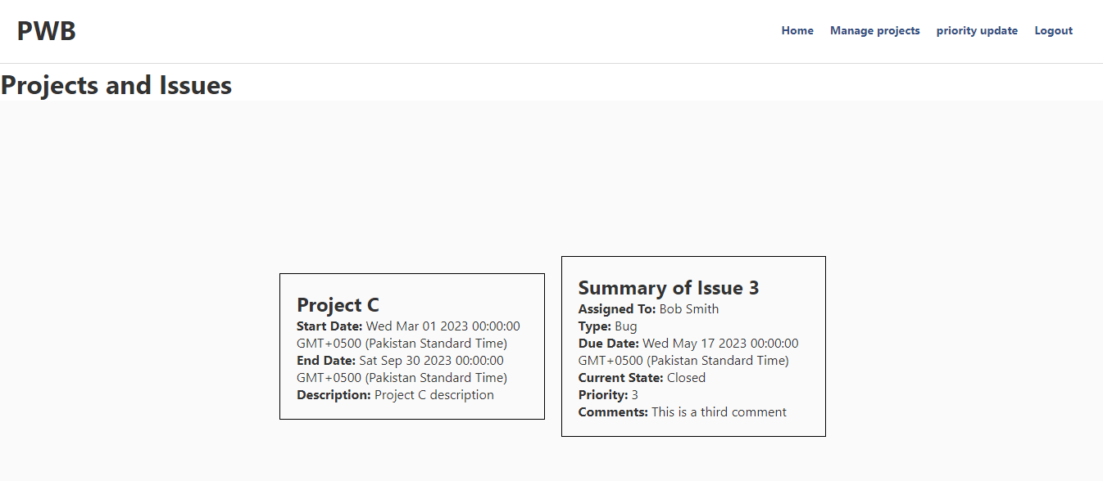

**MANAGING PROJECTS:**

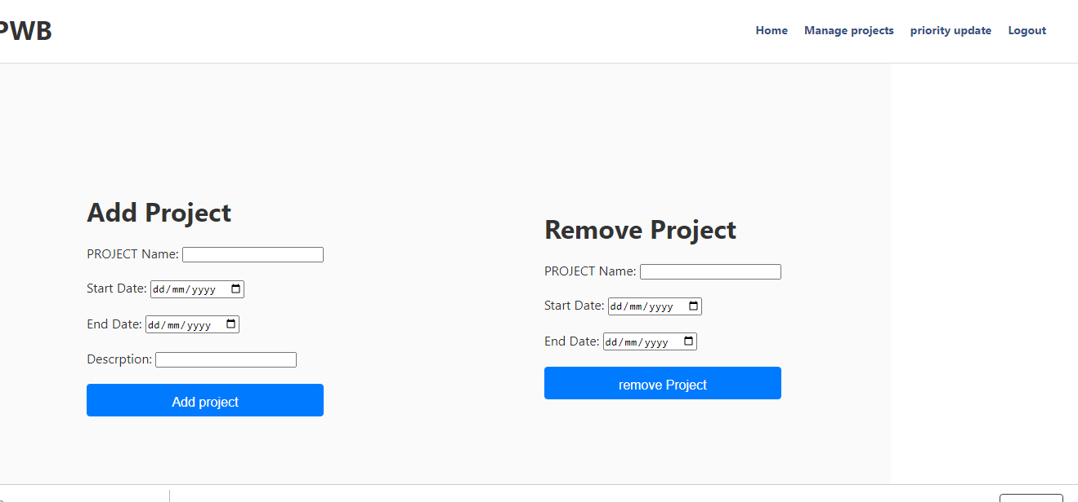

**PRIORITY UPDATE:**

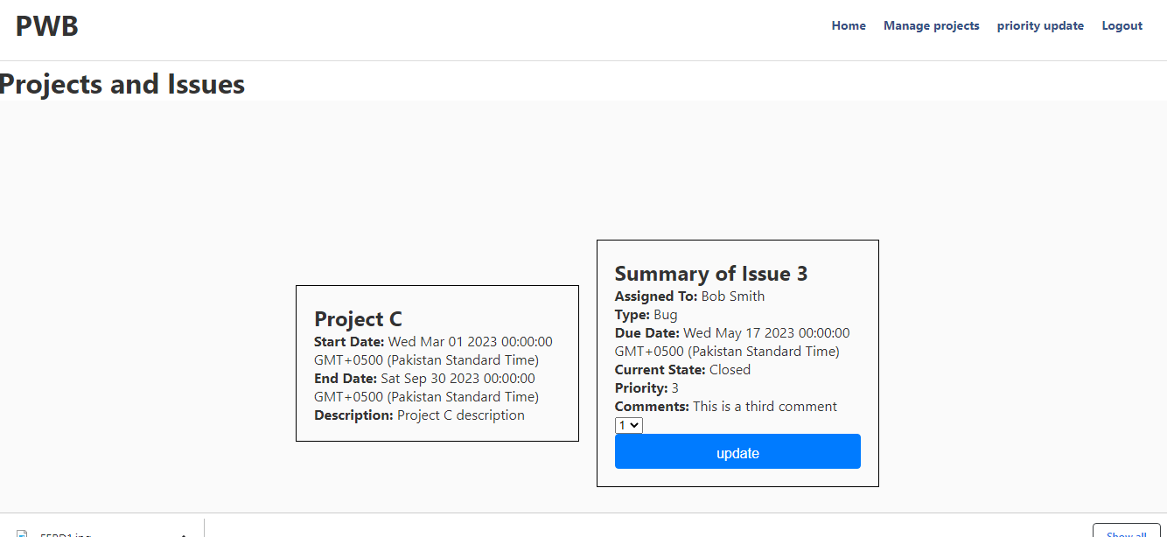

**User 10 (admin has more access options on navigation bar):**

**For example managing the customers and users.**

