Correlated Beam Misalignment in THz Sensing
PURE Program — research project

Objective
Extend the existing beam-misalignment simulation by replacing independent pointing-error samples with a simple temporally correlated model. The goal is to observe how slowly varying beam misalignment affects sensing performance over several consecutive radar frames. No new probability derivations are required.

Background
In the current model, the pointing error is generated independently for every sensing frame. In practice, platform motion, vibration and beam pointing errors change gradually. Therefore, the current pointing error should depend partly on the previous pointing error. The beam-misalignment power coefficient is
h_{k} = exp , (1)
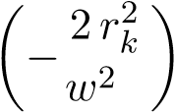
mo
where r_{k} is the pointing displacement during sensing frame k. Use h_{k} directly as a received-power coefficient. Do not use h²_{k}.

Task 1 — Review the existing simulation
Read the two provided papers and identify:
- how the pointing displacement r is generated;
Equation:
D2D Paper Eqn. 5
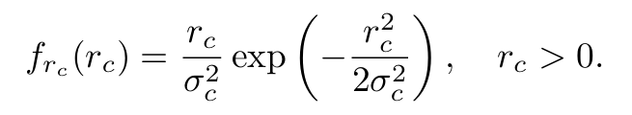
- how h is calculated;
Equation:
SIU Paper Eqn. 5
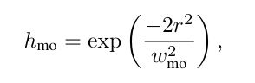
Code:
- where h is included in the radar equation or received signal;
%% Compute mean BM fading (normalized model)
if theta_bm == 0
h_mo_mean = 1;
gamma_bm = inf;
else
sigma_s = distance * tan(theta_bm);
gamma_bm = w_mo_sq / (4 * sigma_s^2);
h_mo_mean = gamma_bm / (gamma_bm + 1);
end
Equation:
SIU Paper Eqn.7
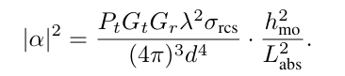
Code:
%% Radar equation amplitude
A_base = sqrt(P_radar) * L_atm_lin * ...
sqrt((G_total * lambda^2 * sigma_rcs) / ((4*pi)^3 * distance^4));
A_echo = A_base * h_mo_mean;
- the meanings of spot-filling and spot-limited sensing.
Equation:
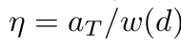
In the spot-filling (SF) regime (η > 1)
In the spot-limited (SL) regime (η < 1)
Code:
% - SF config: w_0 = 50 mm, a_T = 1.5 m (eta >> 1)
% - SL config: w_0 = 250 mm, a_T = 0.2 m (eta < 1)
% Fill factor
eta = apert_T / wz;
results.(regime).eta(d_idx) = eta;
is_SF = (eta > 1);
% Return path beam waist
if is_SF
w0_R = wz;
else
w0_R = apert_T * sqrt(2);
end

Check the simulation code and confirm that
Pr = P_{r,}aligned h. (2)
Equations:
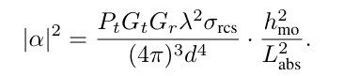
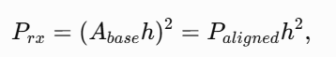
But since explicitly asked to use h instead of squared h so
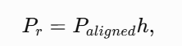
Code:

A_echo = A_base * h_mo_mean;

% SNR
P_rx_radar = A_echo^2;

Combined Code Task 2-4 (sensible because they share parameters)
Code:
%% ========================================================================
% CORRELATED BEAM MISALIGNMENT IN THz SENSING
% Everything runs top-to-bottom in ONE script and ONE workspace -- no
% .mat loading between tasks, so there is nothing to "run out of order."
% Just press Run.
% Equations used throughout (assignment sheet numbering):
% Eq.(1)/(7): h_k = exp(-2*r_k^2 / w_mo^2)
% Eq.(3)-(4): i.i.d. case, x_k~N(0,sigma^2), y_k~N(0,sigma^2), r_k=sqrt(x^2+y^2)
% Eq.(5)-(6): correlated case (AR(1)):
% x_k = rho*x_{k-1} + sqrt(1-rho^2)*sigma*ux,k
% y_k = rho*y_{k-1} + sqrt(1-rho^2)*sigma*uy,k
% Eq.(2)/(8): Pr,k = Pr,aligned * h_k (LINEAR in h, NOT h^2)
%
% =========================================================================
clear;
clc;
close all;
rng(1);
% Single global seed -- reproducible top-to-bottom
%% ========================================================================
% 0. FOLDER SETUP (absolute paths, robust to current-folder drift)
%% ========================================================================
scriptDir = fileparts(mfilename('fullpath'));
if isempty(scriptDir)
scriptDir = pwd;
end

figDir = fullfile(scriptDir, 'Figures');
resDir = fullfile(scriptDir, 'Results');
datDir = fullfile(scriptDir, 'Data');

folderList = {figDir, resDir, datDir};
for f = 1:numel(folderList)
if ~exist(folderList{f}, 'dir')
[ok, msg] = mkdir(folderList{f});
if ~ok
error('Could not create folder "%s": %s', folderList{f}, msg);
end
end
end

fprintf('Script folder = %s\n', scriptDir);
fprintf('Figures folder = %s\n', figDir);
fprintf('Results folder = %s\n', resDir);
fprintf('Data folder = %s\n\n', datDir);

%% ========================================================================
% 0. SYSTEM / BEAM PARAMETERS (shared across all tasks)
%% ========================================================================

N = 10000; % samples/frames for Tasks 2-4 statistics
distance = 15; % m
theta_bm = 30e-3; % 30 mrad
sigma_s = distance*tan(theta_bm); % pointing jitter std, m

w_mo_SF = 0.2158; % m, Spot-Filling regime (from main THz-ISAC sim)
w_mo_SL = 0.0721; % m, Spot-Limited regime (from main THz-ISAC sim)

rho_list = [0, 0.9, 0.99]; % correlation coefficients to test
h_th = 0.10; % detection/outage threshold (fixed for all comparisons)

fprintf('===============================================\n');
fprintf('Shared parameters\n');
fprintf('===============================================\n');
fprintf('Distance = %.1f m | Beam angle = %.0f mrad | sigma_s = %.4f m\n', ...
distance, theta_bm*1000, sigma_s);
fprintf('w_mo SF = %.4f m | w_mo SL = %.4f m\n', w_mo_SF, w_mo_SL);
fprintf('rho values = %s | h_th = %.2f | N = %d\n\n', mat2str(rho_list), h_th, N);

%% ========================================================================
% TASK 2 -- INDEPENDENT (i.i.d.) MISALIGNMENT SAMPLES
% Eq.(3): xk~N(0,sigma^2), yk~N(0,sigma^2); Eq.(4): rk; Eq.(1): hk
% =========================================================================

fprintf('=== TASK 2: i.i.d. reference case ===\n');

xk_iid = sigma_s * randn(N,1);
yk_iid = sigma_s * randn(N,1);
rk_iid = sqrt(xk_iid.^2 + yk_iid.^2);
hk_iid_SF = exp(-2*rk_iid.^2 / w_mo_SF^2);
hk_iid_SL = exp(-2*rk_iid.^2 / w_mo_SL^2);

r_theory = linspace(0, max(rk_iid), 500);
pdf_rayleigh = (r_theory./sigma_s.^2).*exp(-(r_theory.^2)./(2*sigma_s.^2));

% Figure T2-1: x_k
fig = figure('Color','w','Position',[100 100 900 550]);
plot(xk_iid,'b'); xlabel('Sample Number'); ylabel('x_k (m)');
title('Task 2: Independent Horizontal Pointing Error, x_k'); grid on;
save_figure(fig, fullfile(figDir,'T2_Fig1_xk'));

% Figure T2-2: r_k
fig = figure('Color','w','Position',[100 100 900 550]);
plot(rk_iid,'k'); xlabel('Sample Number'); ylabel('r_k (m)');
title('Task 2: Radial Pointing Displacement, r_k'); grid on;
save_figure(fig, fullfile(figDir,'T2_Fig2_rk'));

% Figure T2-3: histogram + Rayleigh theory
fig = figure('Color','w','Position',[100 100 900 550]);
histogram(rk_iid,50,'Normalization','pdf'); hold on;
plot(r_theory,pdf_rayleigh,'r','LineWidth',2);
xlabel('r_k (m)'); ylabel('Probability Density');
title('Task 2: Rayleigh Distribution of Pointing Error, r_k');
legend('Simulation','Theory','Location','best'); grid on;
save_figure(fig, fullfile(figDir,'T2_Fig3_RayleighPDF'));

% Figure T2-4: h_k, SF
fig = figure('Color','w','Position',[100 100 900 550]);
plot(hk_iid_SF,'m'); xlabel('Sample Number'); ylabel('h_k');
title(sprintf('Task 2: Beam Coefficient, SF Regime (w_{mo}=%.4f m)', w_mo_SF));
ylim([0 1]); grid on;
save_figure(fig, fullfile(figDir,'T2_Fig4_hk_SF'));

% Figure T2-5: h_k, SL
fig = figure('Color','w','Position',[100 100 900 550]);
plot(hk_iid_SL,'Color',[0.20 0.55 0.20]); xlabel('Sample Number'); ylabel('h_k');
title(sprintf('Task 2: Beam Coefficient, SL Regime (w_{mo}=%.4f m)', w_mo_SL));
ylim([0 1]); grid on;
save_figure(fig, fullfile(figDir,'T2_Fig5_hk_SL'));

fprintf('Mean(x_k)=%.5f Mean(r_k)=%.5f Mean(h_k)SF=%.5f Mean(h_k)SL=%.5f\n\n', ...
mean(xk_iid), mean(rk_iid), mean(hk_iid_SF), mean(hk_iid_SL));

%% ========================================================================
% TASK 3 -- CORRELATED (AR(1)) MISALIGNMENT SAMPLES
% Eq.(5)-(6): AR(1) recursion; Eq.(7): rk, hk
% =========================================================================

fprintf('=== TASK 3: Correlated (AR(1)) cases, rho = %s ===\n', mat2str(rho_list));

% Shared innovations across all rho -- isolates rho as the ONLY variable
ux = randn(N,1);
uy = randn(N,1);

nRho = numel(rho_list);
xk_all = zeros(N,nRho);
yk_all = zeros(N,nRho);
rk_all = zeros(N,nRho);
hkSF_all = zeros(N,nRho);
hkSL_all = zeros(N,nRho);

for ri = 1:nRho
rho = rho_list(ri);
[xk, yk, rk] = gen_correlated_xy(N, rho, sigma_s, ux, uy);
xk_all(:,ri) = xk; yk_all(:,ri) = yk; rk_all(:,ri) = rk;
hkSF_all(:,ri) = exp(-2*rk.^2/w_mo_SF^2);
hkSL_all(:,ri) = exp(-2*rk.^2/w_mo_SL^2);
end

colors = lines(nRho);

% Figure T3-1: r_k vs frame, all rho
fig = figure('Color','w','Position',[100 100 1000 550]); hold on;
for ri = 1:nRho
plot(rk_all(:,ri),'Color',colors(ri,:),'DisplayName',sprintf('\\rho=%.2f',rho_list(ri)));
end
xlabel('Frame Number, k'); ylabel('r_k (m)');
title('Task 3: r_k vs Frame Number, by \rho'); legend('Location','best'); grid on;
save_figure(fig, fullfile(figDir,'T3_Fig1_rk_vs_frame_allrho'));

% Figure T3-2: h_k SF vs frame, all rho
fig = figure('Color','w','Position',[100 100 1000 550]); hold on;
for ri = 1:nRho
plot(hkSF_all(:,ri),'Color',colors(ri,:),'DisplayName',sprintf('\\rho=%.2f',rho_list(ri)));
end
xlabel('Frame Number, k'); ylabel('h_k');
title(sprintf('Task 3: h_k vs Frame, SF Regime (w_{mo}=%.4f m)', w_mo_SF));
ylim([0 1]); legend('Location','best'); grid on;
save_figure(fig, fullfile(figDir,'T3_Fig2_hk_SF_vs_frame_allrho'));

% Figure T3-3: h_k SL vs frame, all rho
fig = figure('Color','w','Position',[100 100 1000 550]); hold on;
for ri = 1:nRho
plot(hkSL_all(:,ri),'Color',colors(ri,:),'DisplayName',sprintf('\\rho=%.2f',rho_list(ri)));
end
xlabel('Frame Number, k'); ylabel('h_k');
title(sprintf('Task 3: h_k vs Frame, SL Regime (w_{mo}=%.4f m)', w_mo_SL));
ylim([0 1]); legend('Location','best'); grid on;
save_figure(fig, fullfile(figDir,'T3_Fig3_hk_SL_vs_frame_allrho'));

% Figure T3-4: combined histogram comparison
fig = figure('Color','w','Position',[100 100 900 550]); hold on;
for ri = 1:nRho
histogram(rk_all(:,ri),50,'Normalization','pdf', ...
'DisplayName',sprintf('\\rho=%.2f',rho_list(ri)), ...
'FaceAlpha',0.35,'FaceColor',colors(ri,:));
end
plot(r_theory,pdf_rayleigh,'k--','LineWidth',2,'DisplayName','Rayleigh theory');
xlabel('r_k (m)'); ylabel('Probability Density');
title('Task 3: Histogram of r_k, all \rho (marginal shape unchanged)');
legend('Location','best'); grid on;
save_figure(fig, fullfile(figDir,'T3_Fig4_rk_histogram_compare'));

% Figures T3-5,6,7: individual histograms per rho
histNames = {'T3_Fig5_rk_histogram_rho0','T3_Fig6_rk_histogram_rho0p9','T3_Fig7_rk_histogram_rho0p99'};
for ri = 1:nRho
fig = figure('Color','w','Position',[100 100 900 550]);
histogram(rk_all(:,ri),50,'Normalization','pdf','FaceColor',colors(ri,:),'FaceAlpha',0.6);
hold on; plot(r_theory,pdf_rayleigh,'r','LineWidth',2);
xlabel('r_k (m)'); ylabel('Probability Density');
title(sprintf('Task 3: Histogram of r_k, \\rho=%.2f', rho_list(ri)));
legend('Simulation','Rayleigh theory','Location','best'); grid on;
save_figure(fig, fullfile(figDir, histNames{ri}));
end

for ri = 1:nRho
xk_ri = xk_all(:,ri);
ac = corrcoef(xk_ri(1:end-1), xk_ri(2:end));
fprintf('rho=%.2f: measured lag-1 autocorr=%.4f | Mean(h_k)SF=%.5f | Mean(h_k)SL=%.5f\n', ...
rho_list(ri), ac(1,2), mean(hkSF_all(:,ri)), mean(hkSL_all(:,ri)));
end
fprintf('\n');

%% ========================================================================
% TASK 4 -- STATISTICAL COMPARISON TABLE
% Uses the SAME in-memory variables from Task 2 & 3 -- no file I/O needed
% =========================================================================

fprintf('=== TASK 4: Statistical comparison table (h_th = %.2f) ===\n', h_th);

caseLabels = [{'i.i.d. (Task 2)'}, arrayfun(@(r) sprintf('AR(1), rho=%.2f',r), rho_list, 'UniformOutput', false)];
hkSF_cases = [hk_iid_SF, hkSF_all];
hkSL_cases = [hk_iid_SL, hkSL_all];
nCases = numel(caseLabels);

regimeNames = {'SF','SL'};
regimeData = {hkSF_cases, hkSL_cases};
w_mo_vals = [w_mo_SF, w_mo_SL];

T4 = table();
for regIdx = 1:2
hkMat = regimeData{regIdx};
for c = 1:nCases
hk = hkMat(:,c);
below = hk < h_th;
[avgRun, maxRun] = run_length_stats(below);
newRow = table({regimeNames{regIdx}}, {caseLabels{c}}, w_mo_vals(regIdx), ...
mean(hk), min(hk), 100*mean(below), avgRun, maxRun, ...
'VariableNames', {'Regime','Case','w_mo_m','AvgH','MinH', ...
'PctFramesBelowThresh','AvgConsecRunLen','MaxConsecRunLen'});
T4 = [T4; newRow]; %#ok<AGROW>
end
end

disp(T4);
writetable(T4, fullfile(resDir,'Task4_comparison_table.csv'));

fprintf('\n');

%% ========================================================================
% SAVE ALL DATA (Tasks 2-4)
%% ========================================================================

save(fullfile(datDir,'Combined_Task2to4_data.mat'), ...
'xk_iid','yk_iid','rk_iid', ...
'hk_iid_SF','hk_iid_SL', ...
'rho_list', ...
'xk_all','yk_all','rk_all', ...
'hkSF_all','hkSL_all', ...
'w_mo_SF','w_mo_SL', ...
'sigma_s','h_th','T4');

fprintf('\nAll figures saved to %s\n', figDir);
fprintf('All tables saved to %s\n', resDir);
fprintf('All data saved to %s\n', fullfile(datDir,'Combined_Task2to4_data.mat'));
fprintf('\n============ TASKS 2-4 COMPLETE ============\n');

%% ========================================================================
% LOCAL FUNCTIONS
%% ========================================================================

function [xk,yk,rk] = gen_correlated_xy(N, rho, sigma, ux, uy)
% AR(1) correlated pointing-error generator, Eq.(5)-(6)
xk = zeros(N,1); yk = zeros(N,1);
xk(1) = sigma*ux(1); yk(1) = sigma*uy(1);
for k = 2:N
xk(k) = rho*xk(k-1) + sqrt(1-rho^2)*sigma*ux(k);
yk(k) = rho*yk(k-1) + sqrt(1-rho^2)*sigma*uy(k);
end
rk = sqrt(xk.^2 + yk.^2);
end

function [avgRun, maxRun] = run_length_stats(boolVec)
% Average & max length of consecutive TRUE runs in boolVec
boolVec = boolVec(:);
d = diff([0; boolVec; 0]);
starts = find(d==1); ends = find(d==-1)-1;
if isempty(starts)
avgRun = 0; maxRun = 0;
else
lens = ends-starts+1;
avgRun = mean(lens); maxRun = max(lens);
end
end

function save_figure(figHandle, baseName)
% Saves a figure as FIG, PNG, and PDF at publication quality.
% baseName should already be an ABSOLUTE path with no extension.
% Uses exportgraphics (robust, R2020a+) rather than legacy print().
targetFolder = fileparts(baseName);
if ~exist(targetFolder, 'dir')
error('save_figure: target folder does not exist: %s', targetFolder);
end
savefig(figHandle, [baseName '.fig']);
if exist('exportgraphics', 'file')
exportgraphics(figHandle, [baseName '.png'], 'Resolution', 600);
exportgraphics(figHandle, [baseName '.pdf'], 'ContentType', 'vector');
else
print(figHandle, [baseName '.png'], '-dpng', '-r600');
print(figHandle, [baseName '.pdf'], '-dpdf', '-bestfit');
end
end

Common Output:
===============================================
Shared parameters
===============================================
Distance = 15.0 m | Beam angle = 30 mrad | sigma_s = 0.4501 m
w_mo SF = 0.2158 m | w_mo SL = 0.0721 m
rho values = [0 0.9 0.99] | h_th = 0.10 | N = 10000

Task 2 — Generate independent misalignment samples
Generate two independent Gaussian pointing components:
x_{k} ∼N(0, σ²), y_{k} ∼N(0, σ²),  and calculate | (3)
q rk = x2k + yk2. | (4)
Generate at least 10,000 samples. Plot:
Output:
=== TASK 2: i.i.d. reference case ===
Mean(x_k)=-0.00173 Mean(r_k)=0.56568 Mean(h_k)SF=0.05507 Mean(h_k)SL=0.00599

- x_{k} versus sample number;
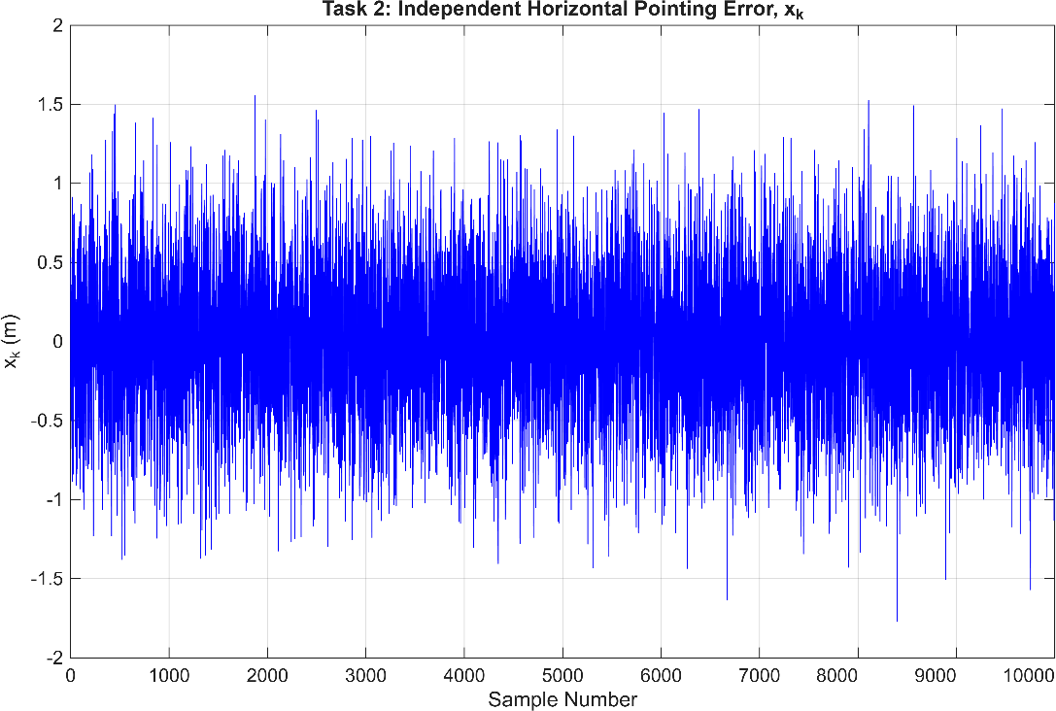

- r_{k} versus sample number;
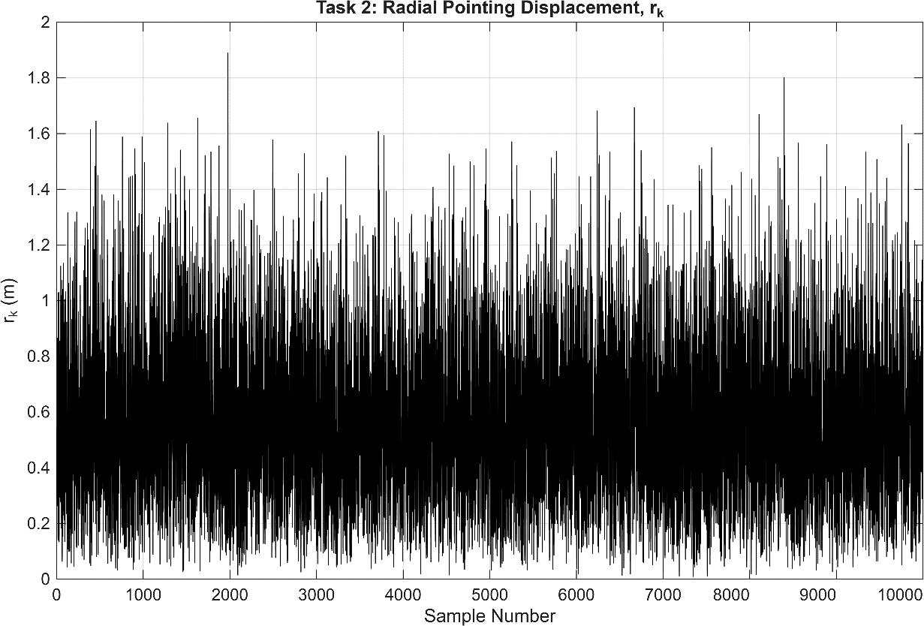

- a histogram of r_{k};
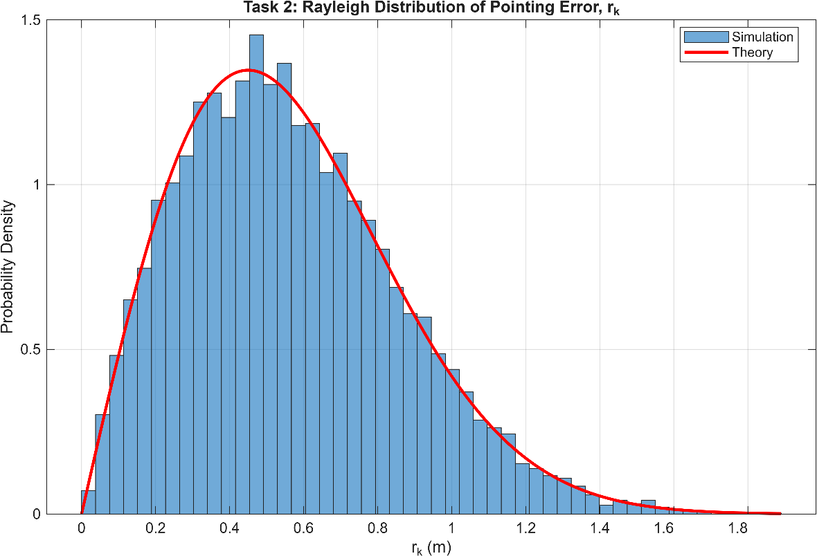

- the resulting beam coefficient h_{k}.
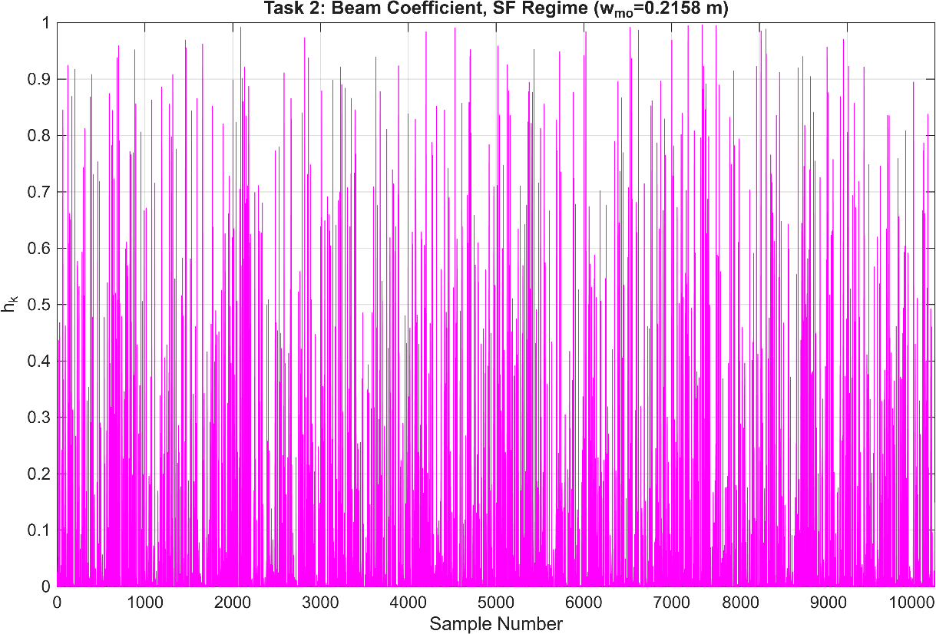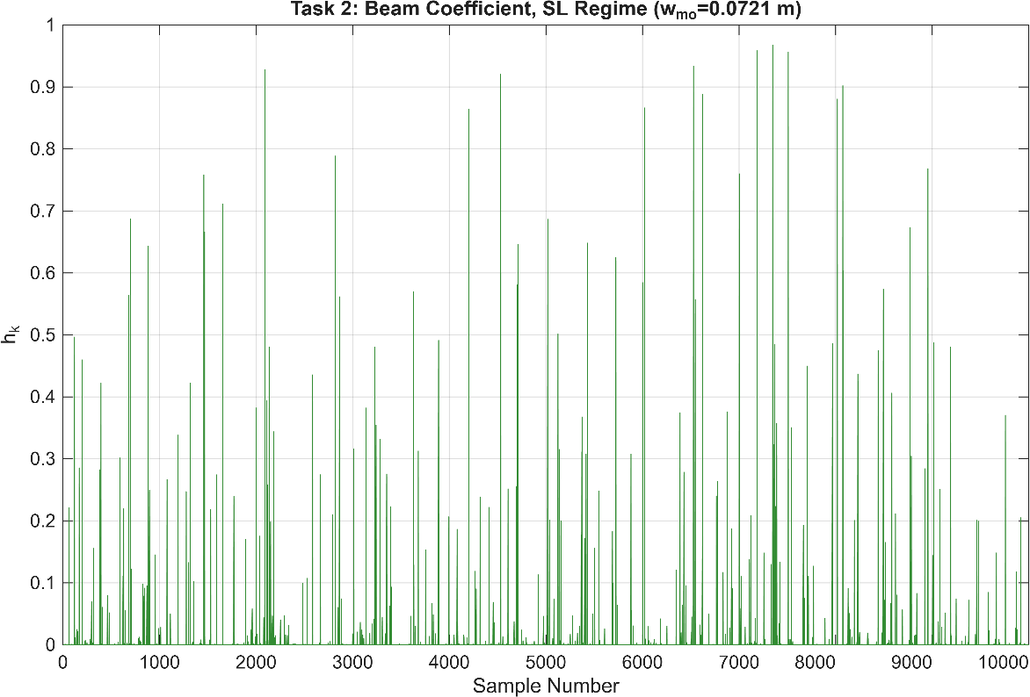

This is the independent (i.i.d.) reference case.

Task 3 — Generate correlated misalignment samples
Replace the independent Gaussian samples with
xk = ρxk−1 + p1 − ρ2 σ ux,k, (5) yk = ρyk−1 + p1 − ρ2 σ uy,k, (6)
where u_{x,k}, u_{y,k} ∼N(0,1).
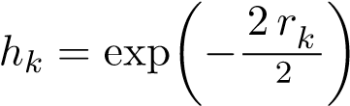
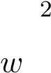
Test ρ ∈{0, 0.9, 0.99}. For each value of ρ, calculate
q
rk = x2k + yk2 and. (7)
mo
Plot r_{k} and h_{k} versus sensing-frame number, and compare the histograms of r_{k} obtained for the different values of ρ.

Output:
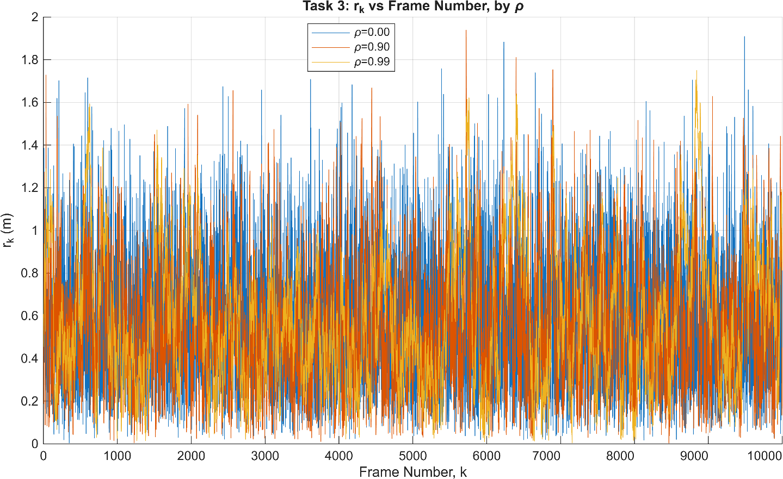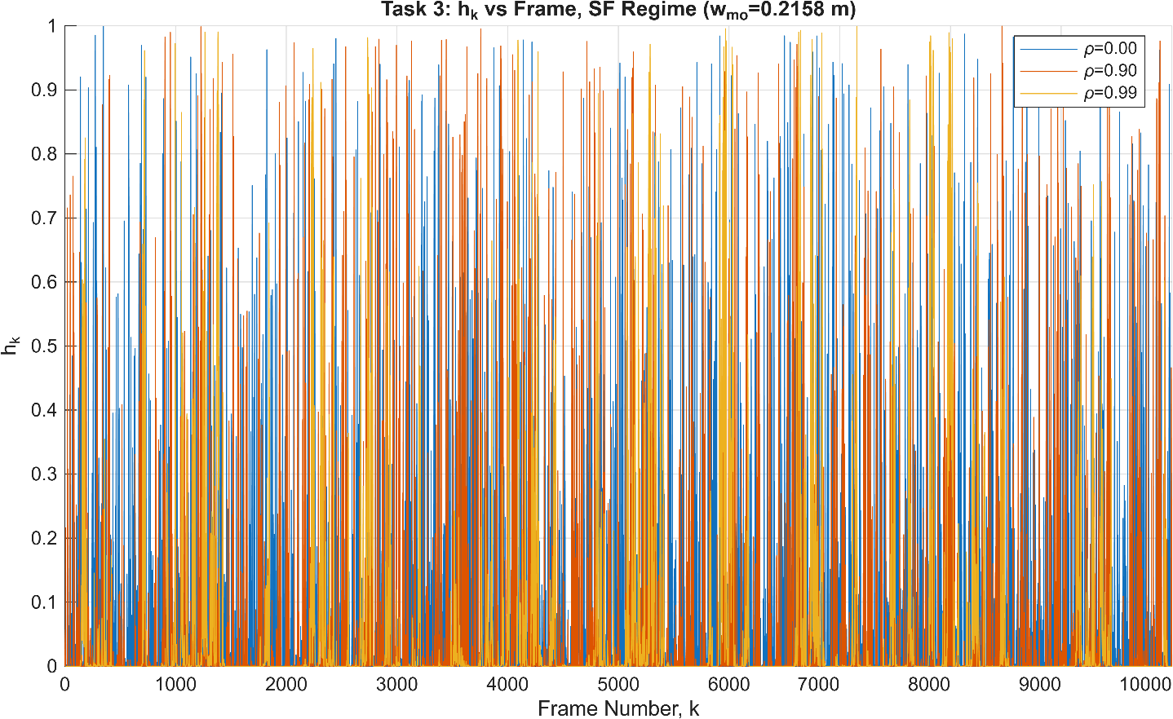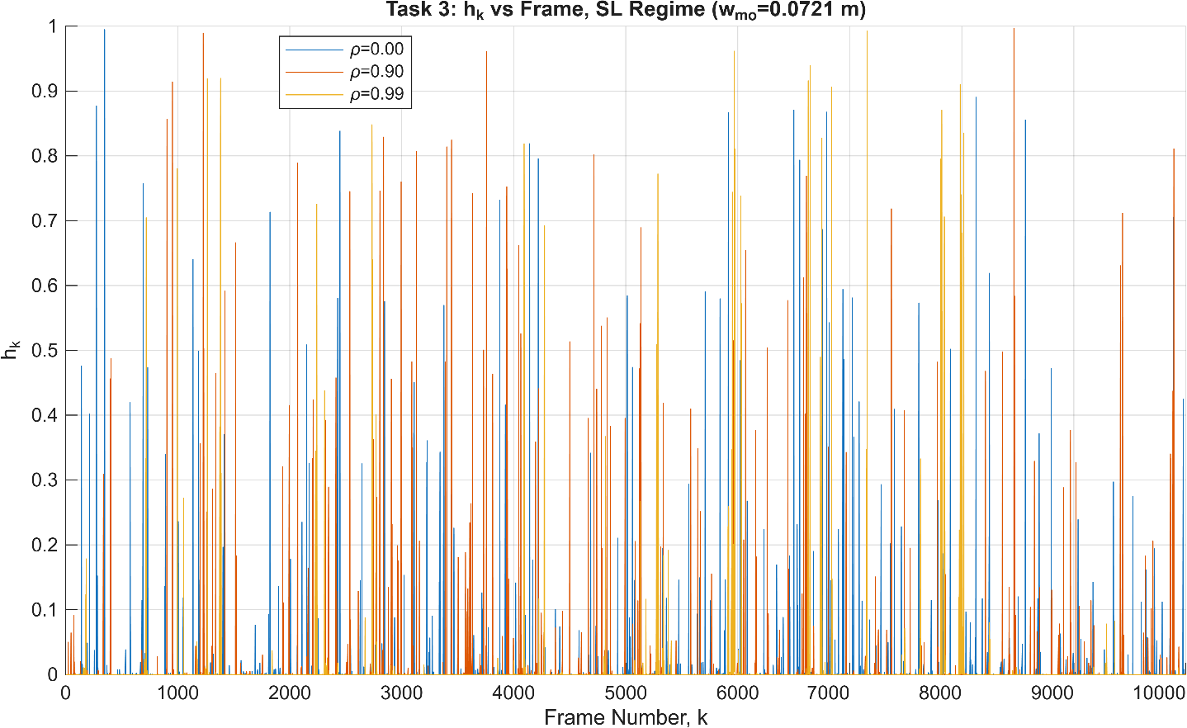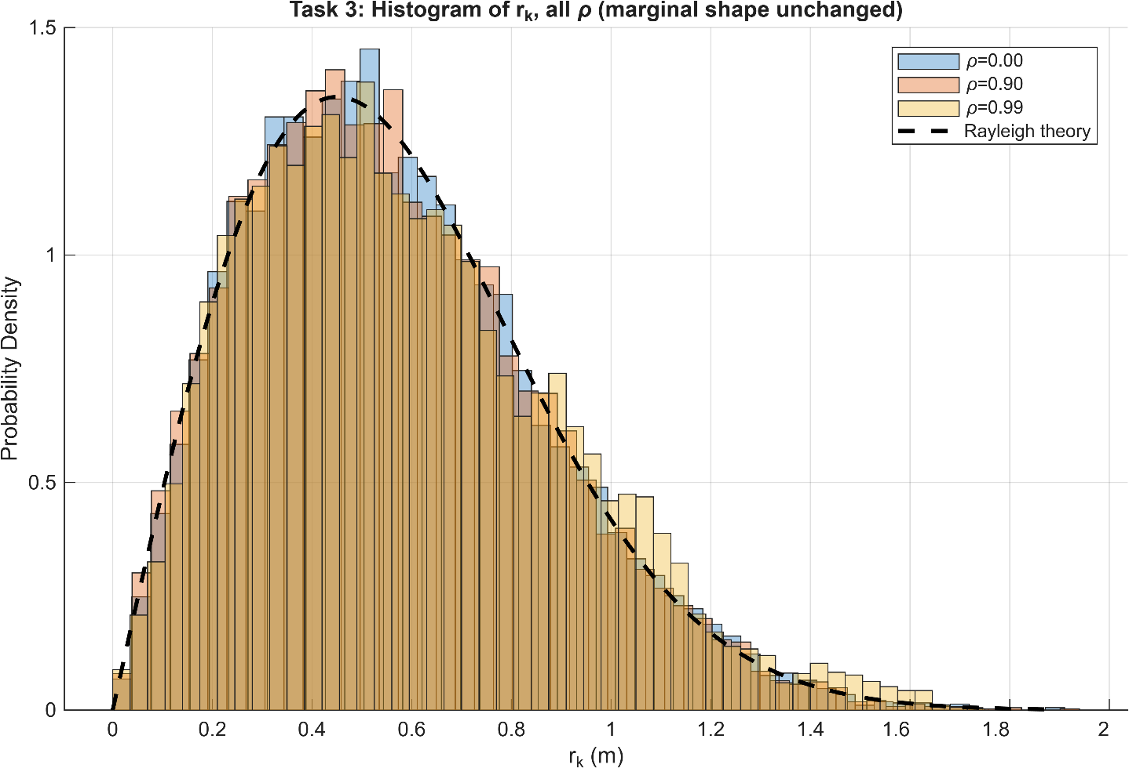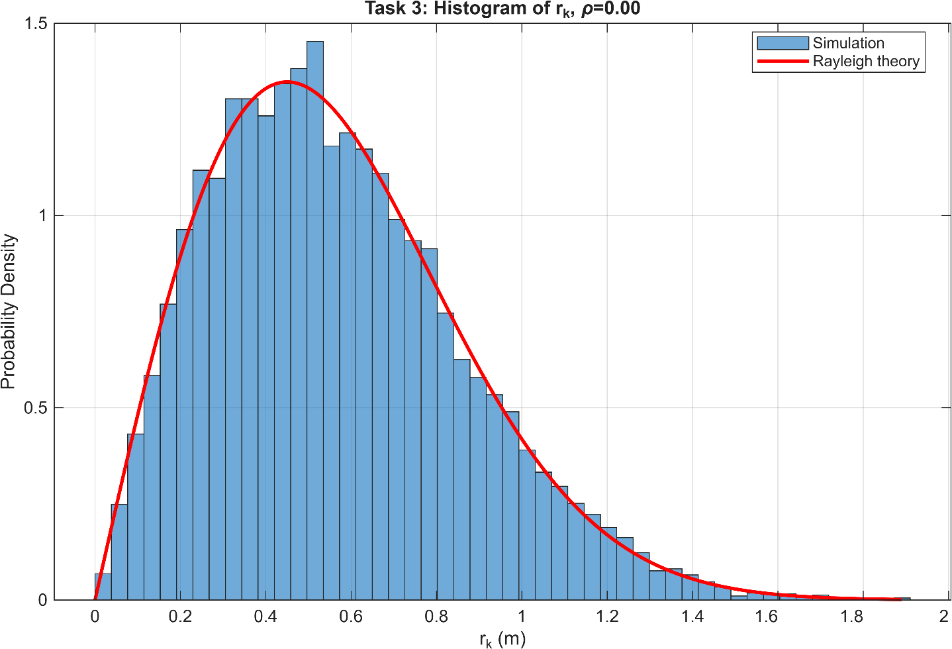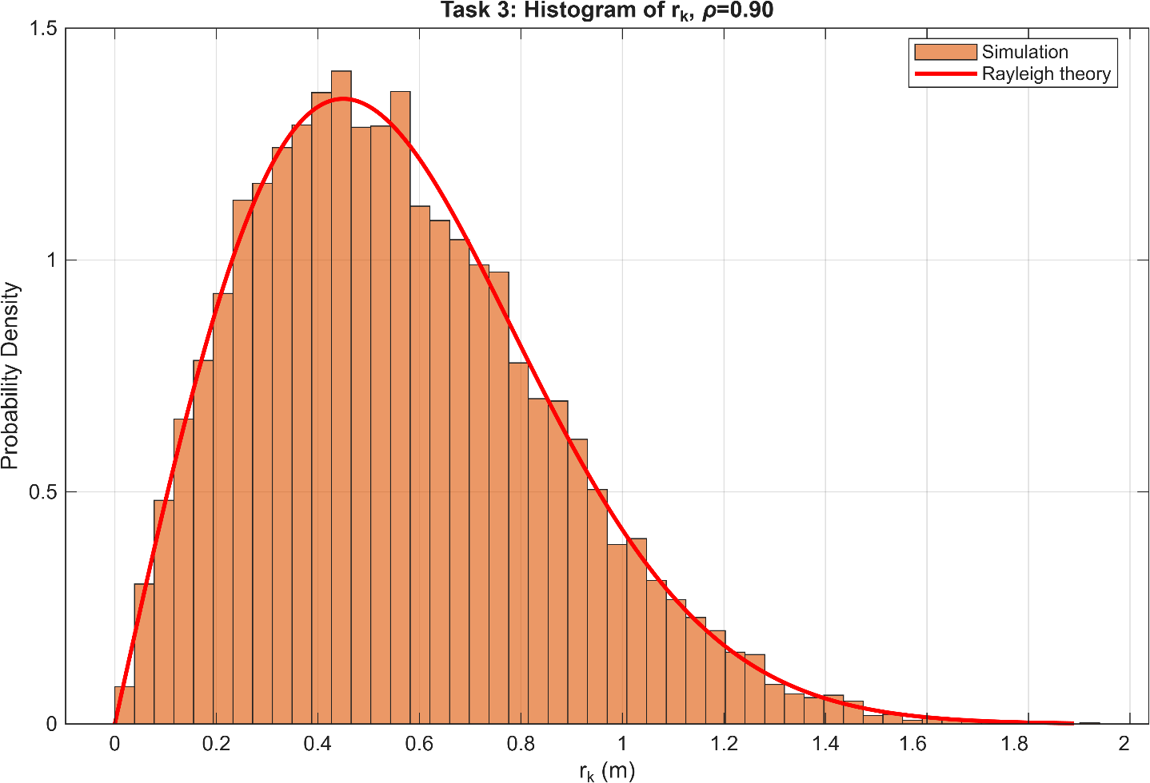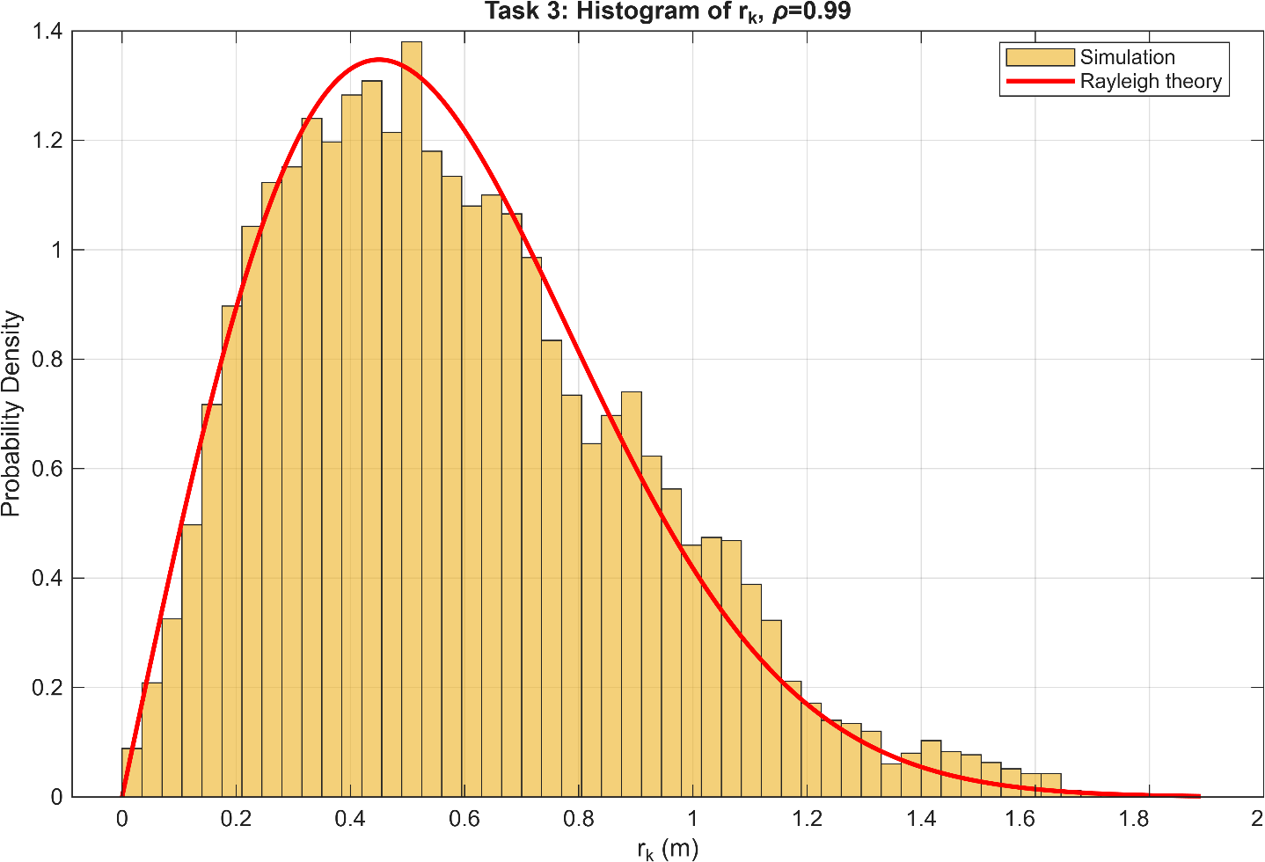
=== TASK 3: Correlated (AR(1)) cases, rho = [0 0.9 0.99] ===
rho=0.00: measured lag-1 autocorr=-0.0091 | Mean(h_k)SF=0.05061 | Mean(h_k)SL=0.00494
rho=0.90: measured lag-1 autocorr=0.8950 | Mean(h_k)SF=0.05511 | Mean(h_k)SL=0.00649
rho=0.99: measured lag-1 autocorr=0.9903 | Mean(h_k)SF=0.04918 | Mean(h_k)SL=0.00557

Task 4 — Compare the statistical behaviour
For the i.i.d. case and each correlated case, calculate:
average value of h_{k};
minimum value of h_{k};
percentage of frames for which h_{k} < h_{th};
average number of consecutive frames below the threshold; maximum number of consecutive frames below the threshold.
Select one reasonable value of h_{th}, such as 0.1 or 0.2, and use the same threshold in every comparison.
Deliverable.
One comparison table.
Output:
Used hth =0.1
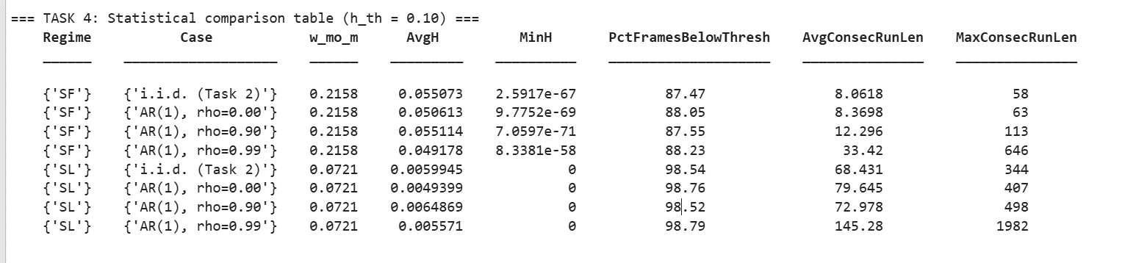

Conclusions from this data:
• Average beam gain (AvgH) changes very little with correlation, indicating that correlation does not significantly affect the long-term average received power.
• Percentage of frames below the threshold also remains almost unchanged across different values of ρ, meaning the probability of entering a poor-alignment state is similar.
• However, the average and maximum consecutive outage lengths increase dramatically as ρ increases, especially for ρ=0.99. This shows that temporal correlation causes beam misalignment to persist for much longer periods.
• The Spot-Limited (SL) regime is considerably more vulnerable than the Spot-Filling (SF) regime, exhibiting much lower average beam coefficients and significantly longer outage durations.
Combined Code:
%% ========================================================================
% TASK 5 & 6 -- CORRELATED BEAM MISALIGNMENT IN THE FULL SENSING SIM
% Plugs the Task 2-4 temporal misalignment model (Eq.5-6, Eq.7) into the
% main THz-ISAC OFDM vs SC-FDMA range-Doppler simulation, per Eq.(8):
% Pr,k = Pr,aligned * h_k (LINEAR in h, NOT h^2)
%
% Runs a sequence of sensing frames for 4 scenarios:
% 1. Aligned (h_k = 1 for all k)
% 2. i.i.d. misalignment
% 3. Correlated, rho = 0.9
% 4. Correlated, rho = 0.99
% for both regimes (SF, SL) and both waveforms (OFDM, SC-FDMA).
%
% *** IMPORTANT FIX vs the provided main SIU script ***
% The main script did: A_echo = A_base * h_mo_mean; P_rx = A_echo^2;
% -> that makes RECEIVED POWER scale as h_mo_mean^2, which contradicts
% Eq.(2)/(8) "Pr = Pr,aligned * h" (linear) and Task 1's explicit
% instruction "Do not use h_k^2".
% Fix used here: scale the ECHO AMPLITUDE by sqrt(h_k), so that
% P_rx = A_base^2 * h_k = P_aligned * h_k (linear, as required).
% This is flagged again at the point it is used below, and should be
% listed under "problems / unclear assumptions" in the write-up.
% =========================================================================

clear; clc; close all;
rng(1); % single global seed, reproducible

%% ------------------------------------------------------------------
% 0. FOLDERS
%% ------------------------------------------------------------------
scriptDir = fileparts(mfilename('fullpath'));
if isempty(scriptDir), scriptDir = pwd; end
figDir = fullfile(scriptDir,'Figures_T56');
resDir = fullfile(scriptDir,'Results_T56');
datDir = fullfile(scriptDir,'Data_T56');
for f = {figDir,resDir,datDir}
if ~exist(f{1},'dir'), mkdir(f{1}); end
end

%% ------------------------------------------------------------------
% 1. SYSTEM PARAMETERS (Table I, same as the main SIU script)
%% ------------------------------------------------------------------
c = physconst('LightSpeed');
kb = physconst('Boltzmann');

fc = 0.85e12; % 0.85 THz
lambda = c/fc;
k_wave = 2*pi/lambda;

Gt_dB = 20; Gr_dB = 20;
G_total = 10^((Gt_dB+Gr_dB)/10);

B = 20e9;
N_fft = 4096;
N_radar = 2048;
N_cp = 1024;
N_symbols = 1024;

delta_f = B/N_fft;
T_sym = (N_fft+N_cp)/B;
Fs = B;

% Regime configs -- SAME beam, target size sets SF/SL (matches main script)
w_0_SF = 0.20; apert_T_SF = 1.5;
w_0_SL = 0.20; apert_T_SL = 0.04;
apert_R = 0.075;
C_n_sq = 1e-11;

sigma_rcs_dBsm = 10;
sigma_rcs = 10^(sigma_rcs_dBsm/10);
velocity = 5; % m/s, target radial velocity

regimes = {'SF','SL'};
w_0_list = [w_0_SF, w_0_SL];
apert_T_list = [apert_T_SF, apert_T_SL];
waveforms = {'OFDM','SCFDMA'};

%% ------------------------------------------------------------------
% 2. SENSING / MISALIGNMENT SCENARIO SETUP (Task 5 requirements)
%% ------------------------------------------------------------------
distance = 15; % m (matches Task 2-4 sigma_s calc)
theta_bm = 30e-3; % 30 mrad (matches Task 2-4)
sigma_s = distance*tan(theta_bm); % pointing-jitter std, m

Ptx_dBm_fixed = 0; % ASSUMPTION: single fixed operating
Ptx_W = 10^((Ptx_dBm_fixed-30)/10); % point (mid of the sweep used in the
% main script), since T5 asks for a
% *sequence of frames*, not a power
% sweep. Change here if a different
% operating power is preferred.

N_frames = 500; % ASSUMPTION: 500 sensing frames per
% scenario (>=10,000 was for the
% static histograms in Task 2-4; a
% CPI-by-CPI tracking run of 500
% frames keeps runtime reasonable
% while still showing long
% correlated fade events at rho=0.99)

h_th = 0.10; % same threshold as Task 4

rho_list = [0, 0.9, 0.99]; % 0 stands in for "i.i.d." (rho=0
% collapses AR(1) exactly to i.i.d.)
scenarioNames = {'Aligned','i.i.d.','AR(1) rho=0.90','AR(1) rho=0.99'};
scenarioTagsSF = {'Aligned','iid','rho0p9','rho0p99'};
nScenario = 4;

fprintf('===============================================\n');
fprintf('Task 5-6 setup\n');
fprintf('===============================================\n');
fprintf('distance=%.1f m | theta_bm=%.0f mrad | sigma_s=%.4f m\n', distance, theta_bm*1000, sigma_s);
fprintf('Ptx = %.1f dBm | N_frames = %d | h_th = %.2f\n\n', Ptx_dBm_fixed, N_frames, h_th);

%% ------------------------------------------------------------------
% 3. ATMOSPHERIC MODEL (same as main script)
%% ------------------------------------------------------------------
height = 100;
[T_atm_K, p_hPa, wvden] = atmositu(height);
T_C = T_atm_K - 273.15;
P_Pa = p_hPa*100;

L_atm_dB = gaspl(distance, fc, T_C, P_Pa, wvden);
L_atm_lin = 10^(-L_atm_dB/10);

T_noise = (1-L_atm_lin)*T_atm_K;
P_n = kb*T_noise*B;
P_n_radar = P_n*(N_radar/N_fft);

%% ------------------------------------------------------------------
% 4. RADAR REFERENCE (Zadoff-Chu), built once, reused every frame
%% ------------------------------------------------------------------
n_zc = (0:N_radar-1)';
zc_root = 2;
radar_seq = exp(-1j*pi*zc_root*n_zc.*(n_zc+1)/N_radar);
radar_ref = repmat(radar_seq,1,N_symbols);

k_delay = round(2*distance/c*Fs);
f_D = 2*velocity/lambda;
t_vec_full = (0:(N_fft+N_cp)*N_symbols-1)'/Fs;
doppler_phase_full = exp(1j*2*pi*f_D*t_vec_full);

rangeRes = c/(2*N_radar*delta_f); % range bin size
velRes = lambda/(2*N_symbols*T_sym); % velocity bin size

%% ------------------------------------------------------------------
% 5. PARALLEL POOL
%% ------------------------------------------------------------------
pool = gcp('nocreate');
if isempty(pool), pool = parpool('local'); end
fprintf('Using parallel pool with %d workers\n\n', pool.NumWorkers);

%% ------------------------------------------------------------------
% 6. MAIN LOOP: regime x waveform x scenario x frame
%% ------------------------------------------------------------------
% Result containers, indexed results.(regime).(waveform).(scenarioTag)
results = struct();

for reg_idx = 1:numel(regimes)
regime = regimes{reg_idx};
w_0 = w_0_list(reg_idx);
apert_T = apert_T_list(reg_idx);

fprintf('========== %s CONFIG (w_0=%.0f mm, a_T=%.2f m) ==========\n', regime, w_0*1000, apert_T);

%% --- beam-waist / w_mo computation, IDENTICAL to main script ---
rho_0 = (0.55*C_n_sq*k_wave^2*distance)^(-3/5);
eps_turb = 1 + (2*w_0^2)/(rho_0^2);
wz = w_0*sqrt(1 + eps_turb*((lambda*distance)/(pi*w_0^2))^2);
eta = apert_T/wz;
is_SF = (eta > 1);

if is_SF
w0_R = wz;
else
w0_R = apert_T*sqrt(2);
end
eps_R = 1 + (2*w0_R^2)/(rho_0^2);
wz_R = w0_R*sqrt(1 + eps_R*((lambda*distance)/(pi*w0_R^2))^2);
v_R = (sqrt(pi)*apert_R)/(sqrt(2)*wz_R);
weq_R_sq = (wz_R^2*sqrt(pi)*erf(v_R))/(2*v_R*exp(-v_R^2));

if is_SF
w_mo_sq = weq_R_sq;
else
w_mo_sq = 1/(1/wz^2 + 1/weq_R_sq);
end
w_mo = sqrt(w_mo_sq); % <-- Eq.(1)/(7) beam-width parameter
fprintf(' eta=%.2f -> w_mo = %.4f m\n', eta, w_mo);

%% --- Task 2/3 generators: build h_k(k) for every scenario --------
ux = randn(N_frames,1); uy = randn(N_frames,1); % shared innovations
hk_scenario = zeros(N_frames, nScenario);
rk_scenario = zeros(N_frames, nScenario);

% 1: aligned
hk_scenario(:,1) = 1;
rk_scenario(:,1) = 0;
% 2: i.i.d. (rho=0 realization uses independent innovations, not the
% AR(1) recursion, to match Task 2 exactly)
xk_iid = sigma_s*randn(N_frames,1);
yk_iid = sigma_s*randn(N_frames,1);
rk_scenario(:,2) = sqrt(xk_iid.^2+yk_iid.^2);
hk_scenario(:,2) = exp(-2*rk_scenario(:,2).^2/w_mo^2);
% 3 & 4: correlated AR(1), rho = 0.9, 0.99
for si = 1:2
rho = rho_list(si+1);
[xk,yk,rk] = gen_correlated_xy(N_frames, rho, sigma_s, ux, uy);
rk_scenario(:,si+2) = rk;
hk_scenario(:,si+2) = exp(-2*rk.^2/w_mo^2);
end

%% --- radar equation amplitude (aligned reference) -----------------
P_radar = Ptx_W*(N_radar/N_fft);
A_base = sqrt(P_radar)*L_atm_lin* ...
sqrt((G_total*lambda^2*sigma_rcs)/((4*pi)^3*distance^4));

for wf_idx = 1:numel(waveforms)
waveform = waveforms{wf_idx};
is_SCFDMA = strcmp(waveform,'SCFDMA');

if is_SCFDMA
scfdma_input = ifft(radar_ref, N_radar, 1)*sqrt(N_radar);
tx_symbols = fft(scfdma_input, N_radar, 1)/sqrt(N_radar);
else
tx_symbols = radar_ref;
end
corr_ref = radar_ref;

tx_freq = zeros(N_fft, N_symbols);
tx_freq(1:N_radar,:) = tx_symbols;
tx_time = ifft(tx_freq, N_fft, 1)*sqrt(N_fft);
tx_cp = [tx_time(end-N_cp+1:end,:); tx_time];
tx_serial = tx_cp(:);
rx_delayed = [zeros(k_delay,1); tx_serial(1:end-k_delay)];
rx_delayed_doppler = rx_delayed .* doppler_phase_full;

for sc_idx = 1:nScenario
hk_vec = hk_scenario(:,sc_idx);

range_est = zeros(N_frames,1);
vel_est = zeros(N_frames,1);
correct_det = false(N_frames,1);
SNR_dB = zeros(N_frames,1);
Prx_lin = zeros(N_frames,1);

parfor kf = 1:N_frames
h_k = hk_vec(kf); %#ok<PFBNS>

% --- Eq.(8): Pr,k = Pr,aligned * h_k --> LINEAR in h ---
% Amplitude is scaled by sqrt(h_k) so that POWER scales
% by h_k (NOT h_k^2). See header note.
A_echo_k = A_base * sqrt(h_k);

rx_echo = A_echo_k * rx_delayed_doppler;
noise = sqrt(P_n_radar/2)*(randn(size(rx_echo))+1j*randn(size(rx_echo)));
rx_signal = rx_echo + noise;

rx_cp = reshape(rx_signal, N_fft+N_cp, N_symbols);
rx_time = rx_cp(N_cp+1:end,:);
rx_freq = fft(rx_time, N_fft, 1)/sqrt(N_fft);
rx_radar = rx_freq(1:N_radar,:);

corr_out = rx_radar .* conj(corr_ref);
range_profile = ifft(corr_out, N_radar, 1);
range_doppler = fft(range_profile, N_symbols, 2);

[~, max_idx] = max(abs(range_doppler(:)));
[r_idx, d_idx_peak] = ind2sub(size(range_doppler), max_idx);

r_est = (r_idx-1)*c/(2*N_radar*delta_f);
if d_idx_peak > N_symbols/2
d_shift = d_idx_peak - N_symbols - 1;
else
d_shift = d_idx_peak - 1;
end
v_est = d_shift*lambda/(2*N_symbols*T_sym);

range_est(kf) = r_est;
vel_est(kf) = v_est;
correct_det(kf) = (abs(r_est-distance) <= rangeRes/2) && ...
(abs(v_est-velocity) <= velRes/2);

Pr_k = A_echo_k^2; % = A_base^2*h_k
Prx_lin(kf) = Pr_k;
SNR_dB(kf) = 10*log10(Pr_k/P_n_radar);
end

failVec = ~correct_det;
[avgFail, maxFail] = run_length_stats(failVec);

tag = scenarioTagsSF{sc_idx};
results.(regime).(waveform).(tag).h_k = hk_vec;
results.(regime).(waveform).(tag).r_k = rk_scenario(:,sc_idx);
results.(regime).(waveform).(tag).range_est = range_est;
results.(regime).(waveform).(tag).vel_est = vel_est;
results.(regime).(waveform).(tag).correct_det = correct_det;
results.(regime).(waveform).(tag).SNR_dB = SNR_dB;
results.(regime).(waveform).(tag).Prx_lin = Prx_lin;
results.(regime).(waveform).(tag).avgRangeErr = mean(abs(range_est-distance));
results.(regime).(waveform).(tag).avgVelErr = mean(abs(vel_est-velocity));
results.(regime).(waveform).(tag).Pd = mean(correct_det);
results.(regime).(waveform).(tag).avgFailRun = avgFail;
results.(regime).(waveform).(tag).maxFailRun = maxFail;

fprintf(' [%s,%s,%-14s] Pd=%.3f avgRangeErr=%.4f m avgVelErr=%.4f m/s avgFailRun=%.2f maxFailRun=%d\n', ...
regime, waveform, scenarioNames{sc_idx}, mean(correct_det), ...
mean(abs(range_est-distance)), mean(abs(vel_est-velocity)), avgFail, maxFail);
end
end
fprintf('\n');
end

%% ------------------------------------------------------------------
% 7. TASK 6 -- RESULTS TABLE
%% ------------------------------------------------------------------
T6 = table();
for reg_idx = 1:numel(regimes)
regime = regimes{reg_idx};
for wf_idx = 1:numel(waveforms)
waveform = waveforms{wf_idx};
for sc_idx = 1:nScenario
tag = scenarioTagsSF{sc_idx};
R = results.(regime).(waveform).(tag);
newRow = table({regime}, {waveform}, {scenarioNames{sc_idx}}, ...
R.avgRangeErr, R.avgVelErr, R.Pd, R.avgFailRun, R.maxFailRun, ...
'VariableNames', {'Regime','Waveform','Scenario', ...
'AvgRangeErr_m','AvgVelErr_mps','Pd','AvgConsecFailRun','MaxConsecFailRun'});
T6 = [T6; newRow]; %#ok<AGROW>
end
end
end
disp(T6);
writetable(T6, fullfile(resDir,'Task6_results_table.csv'));

%% ------------------------------------------------------------------
% 8. TASK 6 -- FIGURES
% (produced for OFDM as the representative waveform in each regime;
% SC-FDMA data is identical in structure and saved in T6/results,
% comparing waveforms is explicitly out of scope per the brief)
%% ------------------------------------------------------------------
colorsSc = lines(nScenario);
wfShow = 'OFDM';

for reg_idx = 1:numel(regimes)
regime = regimes{reg_idx};

% --- Fig 1: h_k vs frame number, all rho ---
fig = figure('Color','w','Position',[100 100 1000 550]); hold on;
for sc_idx = 2:nScenario % skip 'Aligned' (h_k==1 trivial line)
tag = scenarioTagsSF{sc_idx};
plot(results.(regime).(wfShow).(tag).h_k, 'Color', colorsSc(sc_idx,:), ...
'DisplayName', scenarioNames{sc_idx});
end
xlabel('Frame Number, k'); ylabel('h_k');
title(sprintf('Task 6 Fig 1: h_k vs Frame, %s regime', regime));
ylim([0 1]); legend('Location','best'); grid on;
save_figure(fig, fullfile(figDir, sprintf('T6_Fig1_hk_vs_frame_%s', regime)));

% --- Fig 2: received SNR vs frame number ---
fig = figure('Color','w','Position',[100 100 1000 550]); hold on;
for sc_idx = 1:nScenario
tag = scenarioTagsSF{sc_idx};
plot(results.(regime).(wfShow).(tag).SNR_dB, 'Color', colorsSc(sc_idx,:), ...
'DisplayName', scenarioNames{sc_idx});
end
xlabel('Frame Number, k'); ylabel('Received SNR (dB)');
title(sprintf('Task 6 Fig 2: SNR vs Frame, %s regime, %s', regime, wfShow));
legend('Location','best'); grid on;
save_figure(fig, fullfile(figDir, sprintf('T6_Fig2_SNR_vs_frame_%s', regime)));

% --- Fig 3: correct/incorrect detections vs frame number ---
fig = figure('Color','w','Position',[100 100 1000 700]);
for sc_idx = 1:nScenario
tag = scenarioTagsSF{sc_idx};
subplot(nScenario,1,sc_idx);
stem(double(results.(regime).(wfShow).(tag).correct_det), ...
'Marker','none','Color', colorsSc(sc_idx,:));
ylim([-0.2 1.2]); ylabel(scenarioNames{sc_idx}, 'FontSize', 8);
if sc_idx == 1
title(sprintf('Task 6 Fig 3: Detection Correct(1)/Incorrect(0) vs Frame, %s, %s', regime, wfShow));
end
if sc_idx == nScenario, xlabel('Frame Number, k'); end
end
save_figure(fig, fullfile(figDir, sprintf('T6_Fig3_detections_vs_frame_%s', regime)));
end

% --- Fig 4: number of consecutive failed frames vs rho (both regimes) ---
fig = figure('Color','w','Position',[100 100 900 550]); hold on;
barWidth = 0.35;
xRho = 1:3; % iid, rho0.9, rho0.99 (aligned excluded: not a fading scenario)
avgFailSF = zeros(1,3); maxFailSF = zeros(1,3);
avgFailSL = zeros(1,3); maxFailSL = zeros(1,3);
for i = 1:3
tag = scenarioTagsSF{i+1};
avgFailSF(i) = results.SF.(wfShow).(tag).avgFailRun;
maxFailSF(i) = results.SF.(wfShow).(tag).maxFailRun;
avgFailSL(i) = results.SL.(wfShow).(tag).avgFailRun;
maxFailSL(i) = results.SL.(wfShow).(tag).maxFailRun;
end
bar(xRho-0.2, avgFailSF, 0.15, 'FaceColor',[0.2 0.4 0.8], 'DisplayName','SF avg');
bar(xRho-0.05, maxFailSF, 0.15, 'FaceColor',[0.1 0.2 0.5], 'DisplayName','SF max');
bar(xRho+0.1, avgFailSL, 0.15, 'FaceColor',[0.85 0.4 0.2], 'DisplayName','SL avg');
bar(xRho+0.25, maxFailSL, 0.15, 'FaceColor',[0.55 0.2 0.1], 'DisplayName','SL max');
set(gca,'XTick', xRho, 'XTickLabel', {'i.i.d.','\rho=0.90','\rho=0.99'});
ylabel('Consecutive failed frames'); xlabel('Misalignment scenario');
title(sprintf('Task 6 Fig 4: Consecutive Failed Frames vs \\rho (%s)', wfShow));
legend('Location','best'); grid on;
save_figure(fig, fullfile(figDir,'T6_Fig4_consec_fail_vs_rho'));

%% ------------------------------------------------------------------
% 9. SAVE DATA
%% ------------------------------------------------------------------
save(fullfile(datDir,'Task5_6_results.mat'), 'results', 'T6', ...
'distance','theta_bm','sigma_s','Ptx_dBm_fixed','N_frames','h_th', ...
'rangeRes','velRes','regimes','waveforms','scenarioNames','scenarioTagsSF');

fprintf('\nFigures -> %s\nTable -> %s\nData -> %s\n', figDir, resDir, datDir);
fprintf('============ TASKS 5-6 COMPLETE ============\n');

%% ========================================================================
% LOCAL FUNCTIONS (Task 2-4 generator + helpers, reused verbatim)
%% ========================================================================

function [xk,yk,rk] = gen_correlated_xy(N, rho, sigma, ux, uy)
% AR(1) correlated pointing-error generator, Eq.(5)-(6)
xk = zeros(N,1); yk = zeros(N,1);
xk(1) = sigma*ux(1); yk(1) = sigma*uy(1);
for k = 2:N
xk(k) = rho*xk(k-1) + sqrt(1-rho^2)*sigma*ux(k);
yk(k) = rho*yk(k-1) + sqrt(1-rho^2)*sigma*uy(k);
end
rk = sqrt(xk.^2 + yk.^2);
end

function [avgRun, maxRun] = run_length_stats(boolVec)
% Average & max length of consecutive TRUE runs in boolVec
boolVec = boolVec(:);
d = diff([0; boolVec; 0]);
starts = find(d==1); ends = find(d==-1)-1;
if isempty(starts)
avgRun = 0; maxRun = 0;
else
lens = ends-starts+1;
avgRun = mean(lens); maxRun = max(lens);
end
end

function save_figure(figHandle, baseName)
targetFolder = fileparts(baseName);
if ~exist(targetFolder, 'dir')
error('save_figure: target folder does not exist: %s', targetFolder);
end
savefig(figHandle, [baseName '.fig']);
if exist('exportgraphics', 'file')
exportgraphics(figHandle, [baseName '.png'], 'Resolution', 600);
exportgraphics(figHandle, [baseName '.pdf'], 'ContentType', 'vector');
else
print(figHandle, [baseName '.png'], '-dpng', '-r600');
print(figHandle, [baseName '.pdf'], '-dpdf', '-bestfit');
end
end

Task 5 — Add the model to the sensing simulation
Keep the beam coefficient constant during each sensing frame or CPI. For frame k, use
Pr,k = Pr,aligned hk. (8)
Run the existing range–velocity estimation for a sequence of frames using:
- aligned sensing;
- i.i.d. beam misalignment;
- correlated beam misalignment with ρ = 0.9;
- correlated beam misalignment with ρ = 0.99.
Use identical system parameters and noise settings. Record for each frame:
estimated range;
estimated velocity;
whether the correct range–Doppler peak was detected; received SNR or received power; current value of h_{k}.

Task 6 — Produce the main results
Prepare the following figures:
For Transmit Power: 0dBm
- beam coefficient h_{k} versus frame number for different ρ;
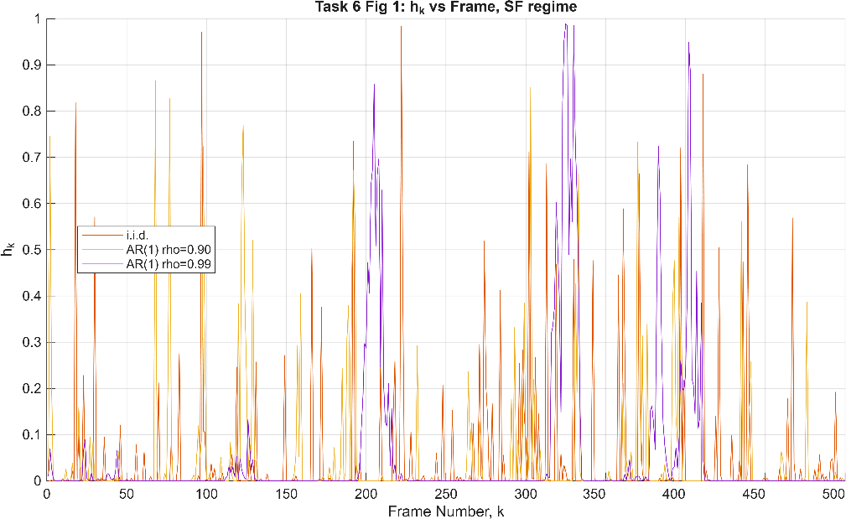
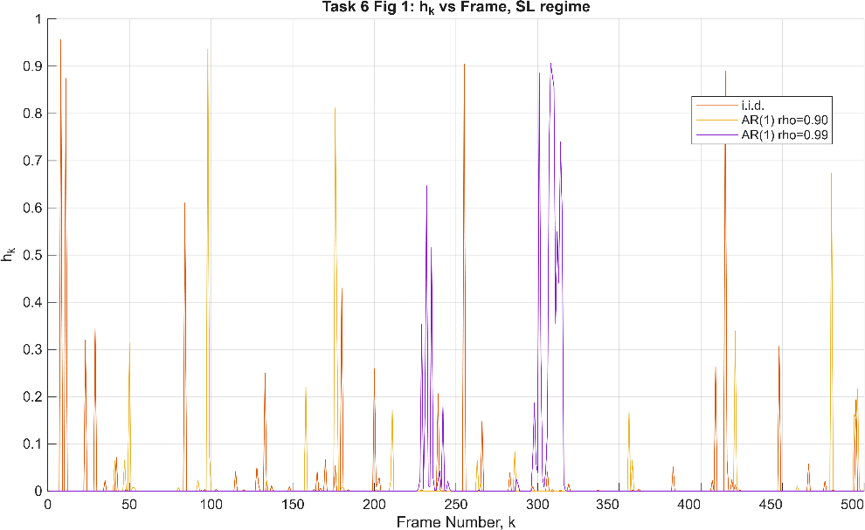
- received SNR versus frame number;
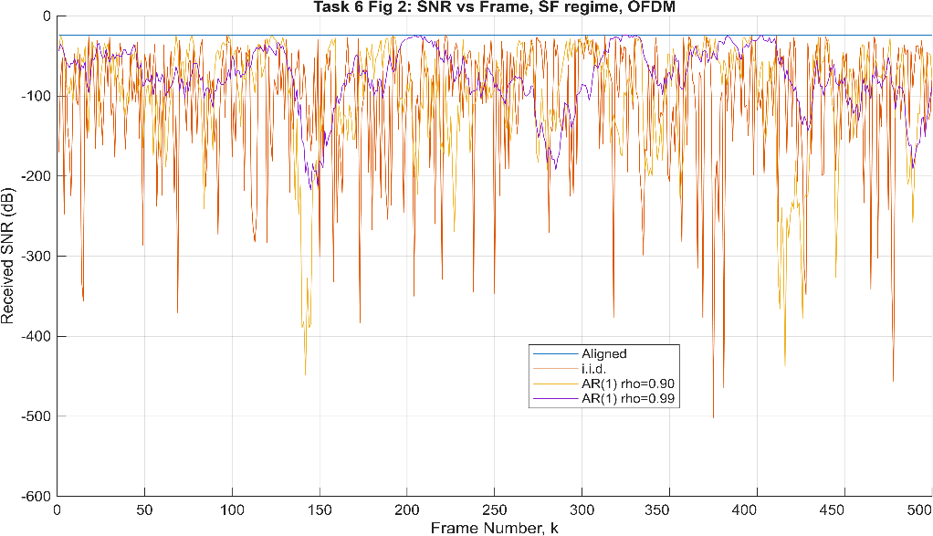
- correct and incorrect detections versus frame number;
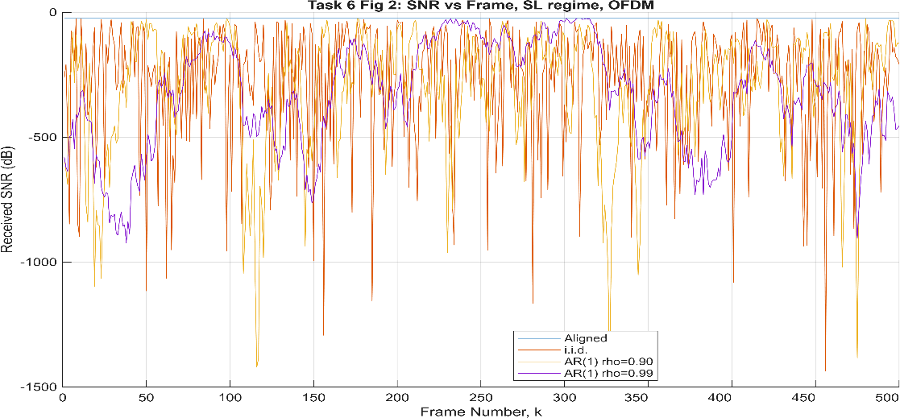
- number of consecutive failed sensing frames versus ρ.
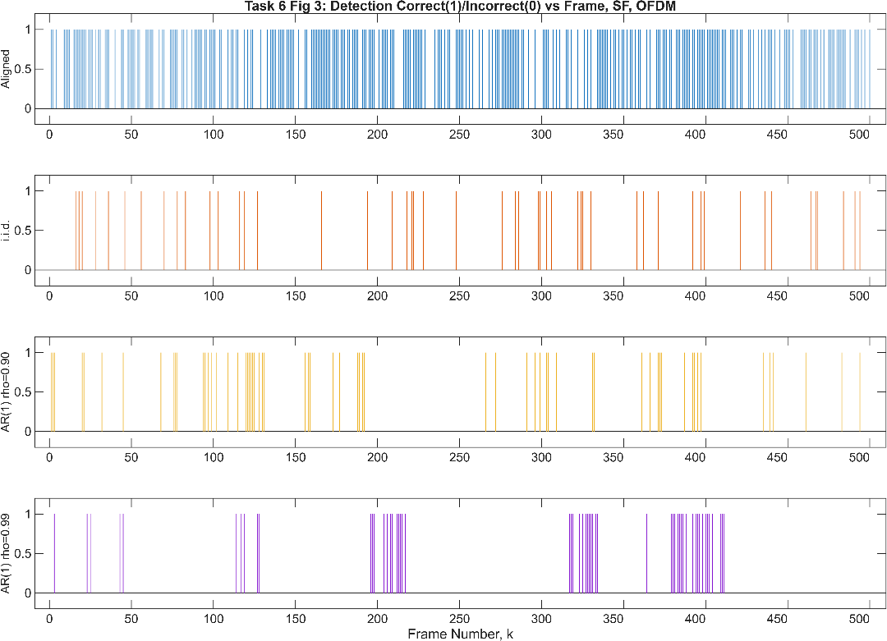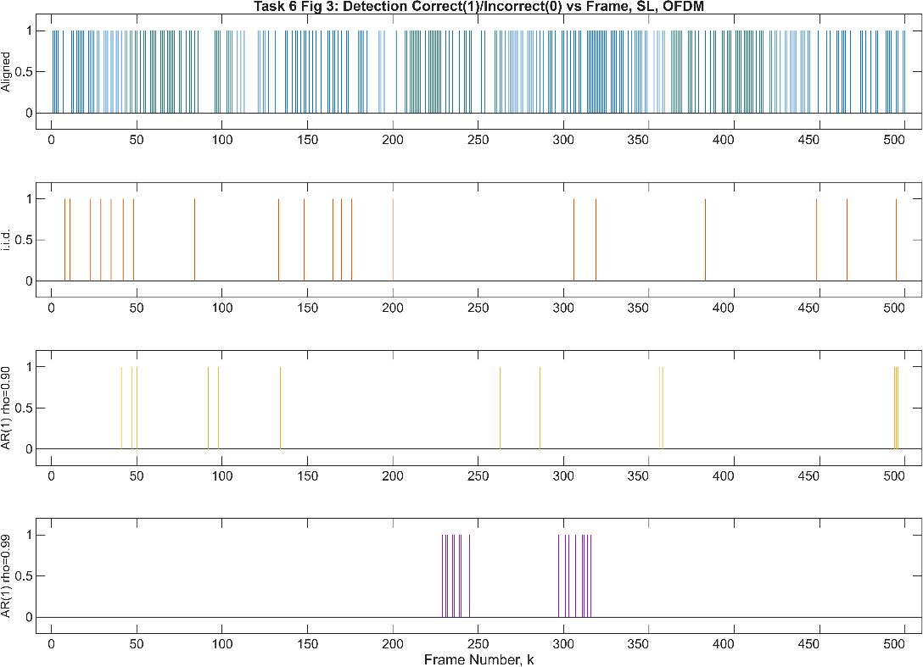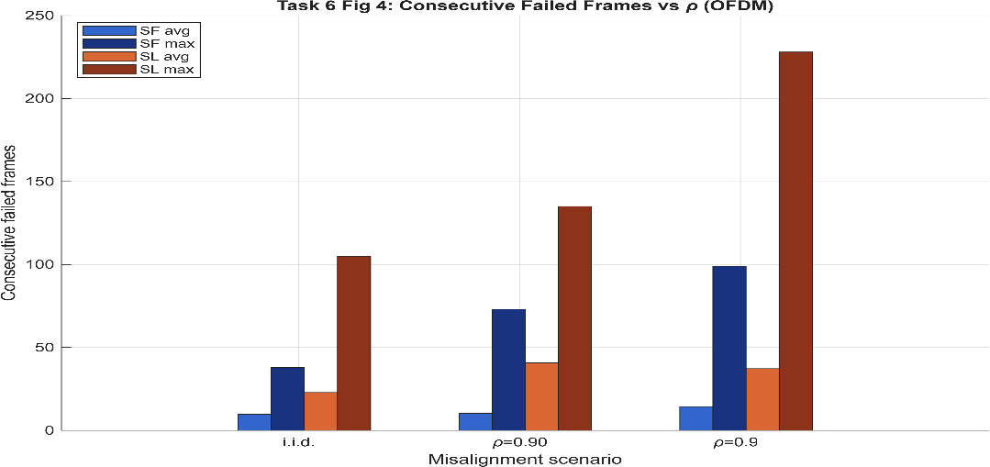

Also prepare one table containing: average range error; average velocity error; probability of correct detection; average consecutive failure duration; maximum consecutive failure duration.
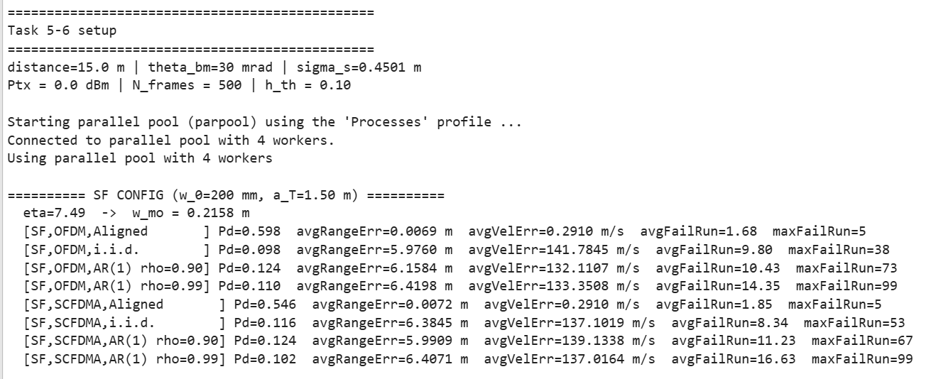
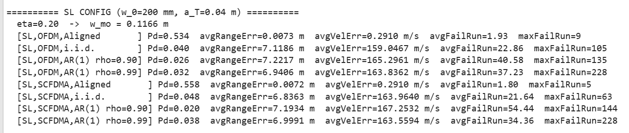
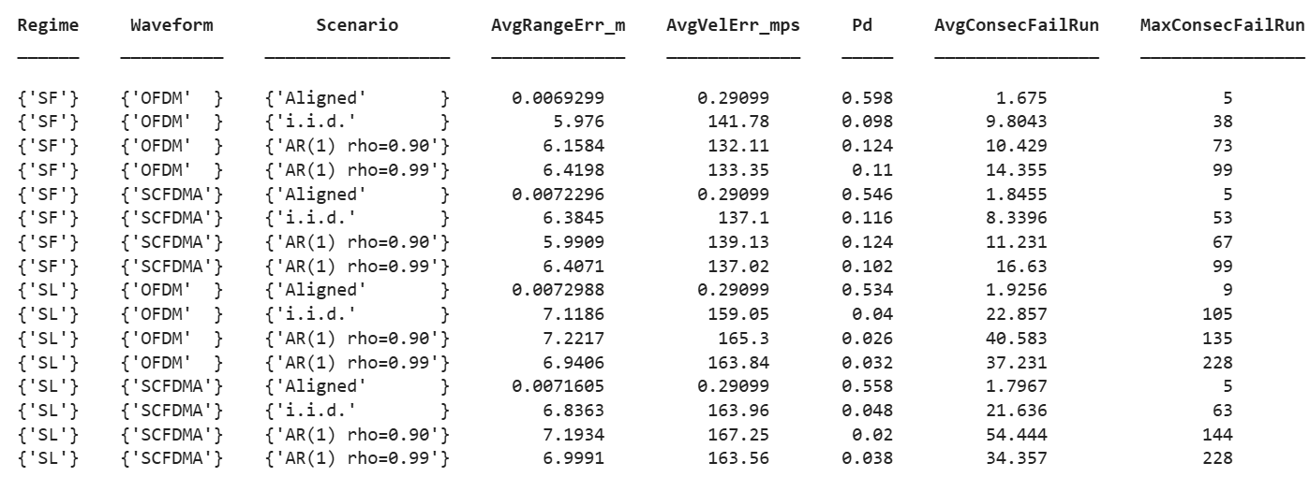

Task 7 — Write a short interpretation
Write a brief discussion answering:
- Does temporal correlation change the average beam loss?
Answer: No. Temporal correlation does not significantly change the average beam loss because the beam coefficient is generated from the same statistical distribution. It mainly changes the temporal behavior of the beam loss.

- Does it change how long poor alignment lasts?
Answer: Yes. Correlated beam misalignment produces much longer periods of poor alignment than the i.i.d. case, resulting in longer consecutive sensing failures.
- Can i.i.d. and correlated misalignment have similar average performance but different failure patterns?
Answer: Yes. Although the average detection performance is similar, correlated misalignment causes failures to occur in long bursts, whereas i.i.d. misalignment produces shorter and more random failures.

- Is range or velocity estimation more sensitive?
Answer: Based on the simulation results, velocity estimation is more sensitive to beam misalignment, showing a much larger increase in estimation error than range estimation.

- Why may correlated misalignment be more important for tracking than for a single sensing frame?
Answer: Tracking requires reliable measurements over many consecutive frames. Correlated misalignment creates long sensing outages, making it more likely to lose the target track than isolated failures in the i.i.d. case.

Scope limits
You are not required to:
derive the probability distribution of the correlated process; derive Marcum-Q expressions; implement Kalman filtering; model compensation delay; study beam squint; compare OFDM and SC-FDMA; perform hardware experiments.

Final submission
The organisation, format and pacing of the submission are left to you. The items below are the expected content; decide yourselves how to package and present them.
commented MATLAB or Python code; the main figures; the results table; the written interpretation; a list of any problems or unclear assumptions encountered.

Recommended references
- S. Sani, A. Saeed, O. Gurbuz and W. Gerstacker, “Beam Misalignment Fading in THz D2D ISAC: From Communication to Sensing,” IEEE PIMRC, 2025.
- “OFDM vs. SC-FDMA for Monostatic THz ISAC Sensing Under Beam Misalignment Fading,” SIU 2026 draft (provided).
- A.A. Farid and S. Hranilovic, “Outage Capacity Optimization for Free-Space Optical Links With Pointing Errors,” Journal of Lightwave Technology, 2007.
- M.S. Bashir and M.R. Bell, “Optical Beam Position Tracking in Free-Space Optical Communication Systems,” IEEE Transactions on Aerospace and Electronic Systems, 2018.

