DevOps

Lab project
MANAHIL KHAN
2025
Contents
Procedure 3
Creating a Simple Web Application (Flask + MySQL) 3
Pushing code to Github 4
Setting up Jenkins on AWS EC2 4
Working web 5
Installing basic dependencies 6
Jenkins 6
Docker 10
Kubernetes 10
Helm 11
Kubernetes 12
Creating DockerHub credentials in Jenkins 12
Create Jenkins pipeline job 13
GitHub Webhook Integration 15
Jenkins Pipeline Script 16
Kubernetes YAML Files 16
Pods 16
Inbound rules 17
Prometheus 18
Access Prometheus 19
Trigger Pipeline 19
Successful 19
Dashboard Grafana 20
Dashboard Prometheus 21
Executing different queries 22
Import Working Dashboard 23
Files 25
DockerFile 25
Jenkinsfile 26
Deployment.yaml 29
service.yaml 30
mysql-deployment.yaml 30
mysql-service.yaml 31
pvc.yaml 31

Procedure

Creating a Simple Web Application (Flask + MySQL)
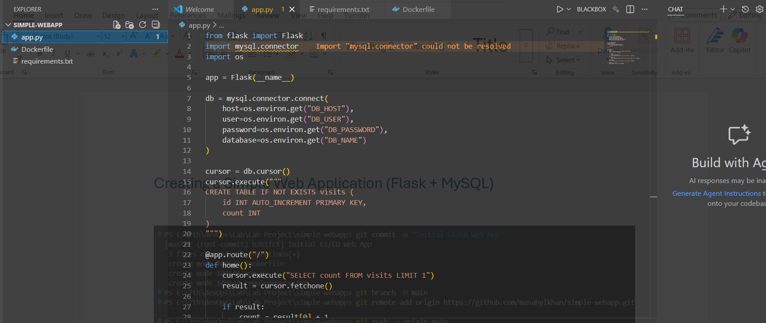
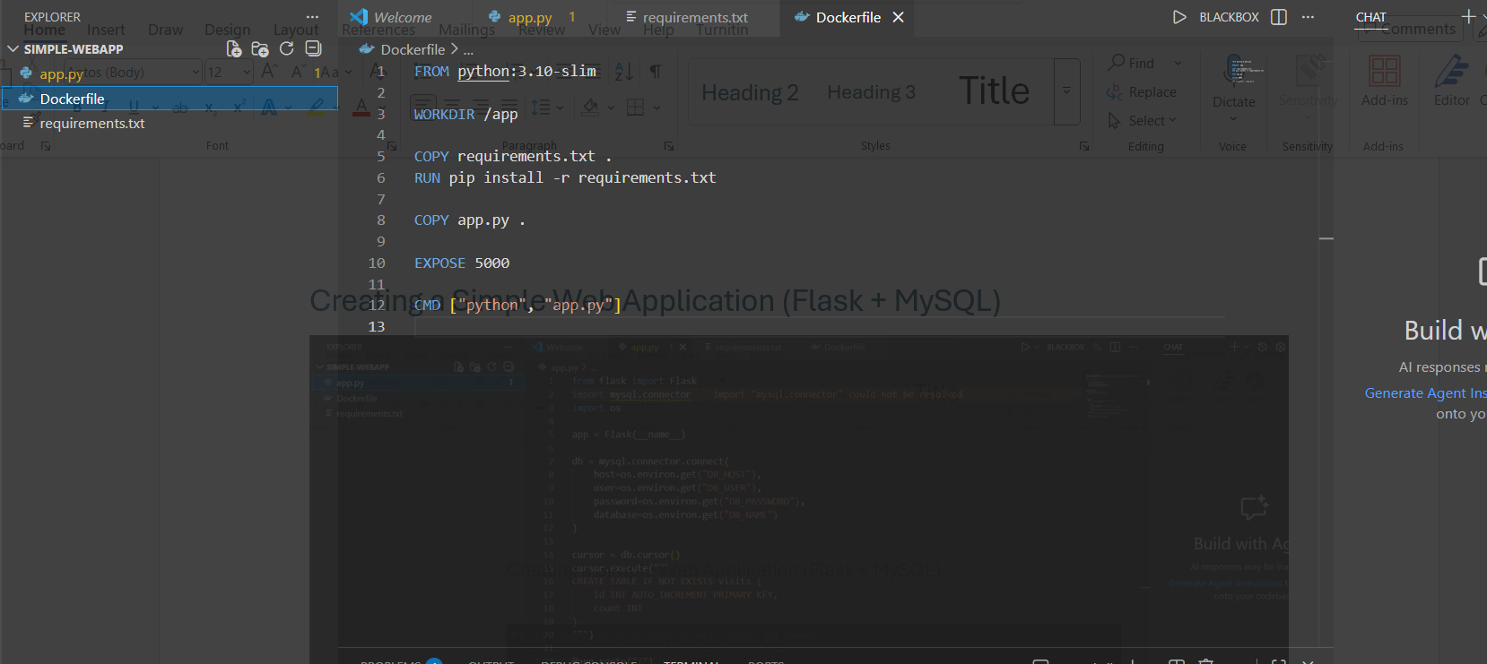
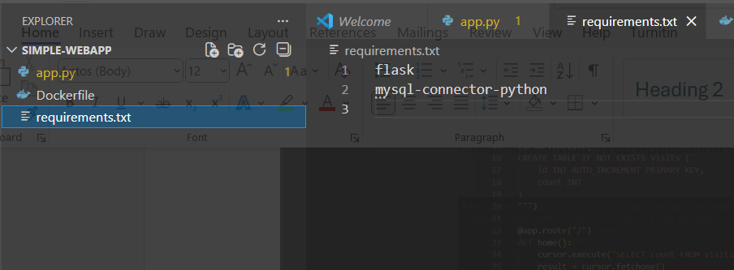

Pushing code to Github
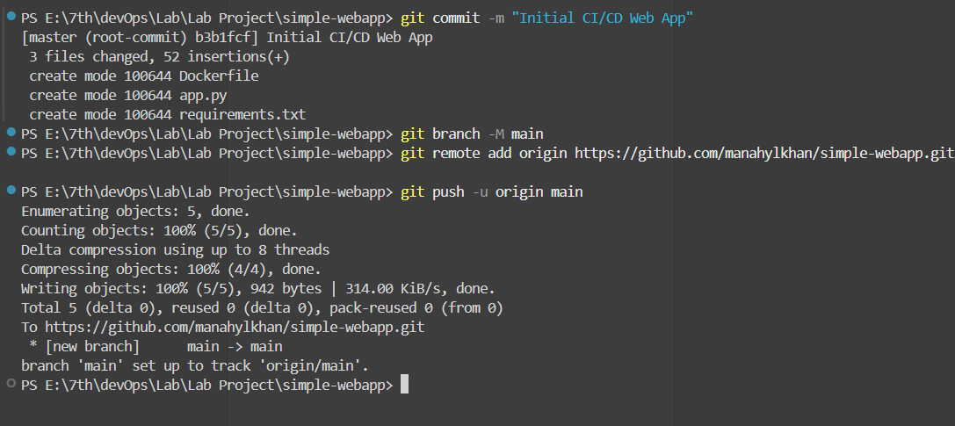

Setting up Jenkins on AWS EC2
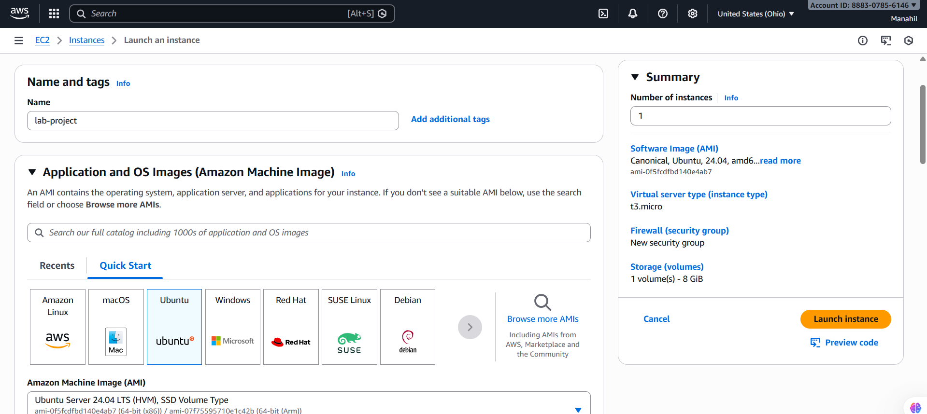
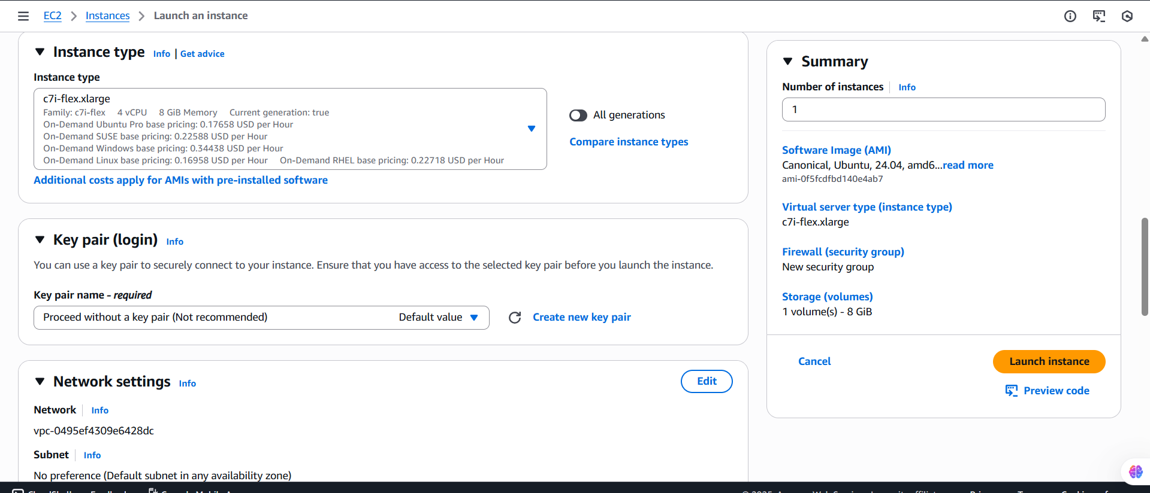
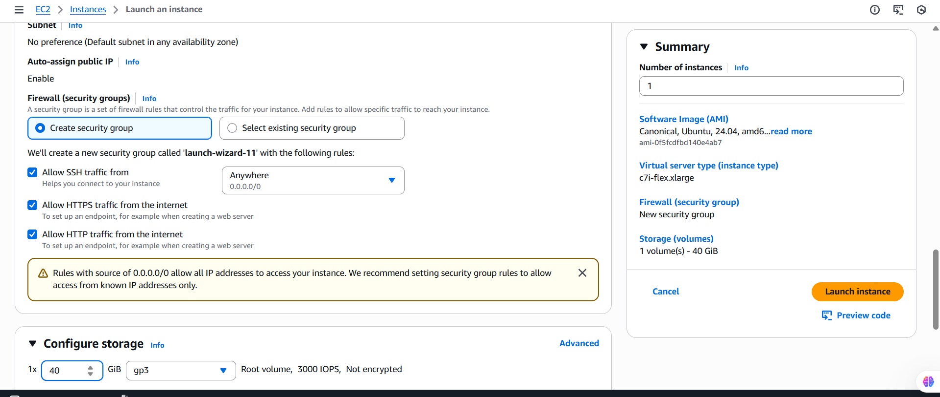

Working web
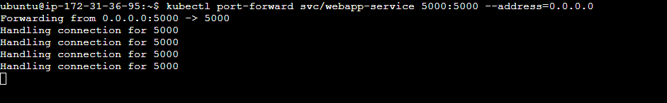
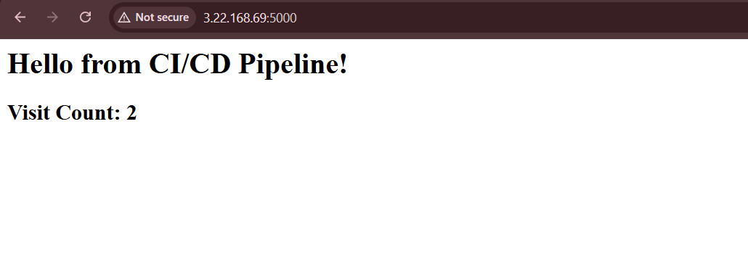

Installing basic dependencies
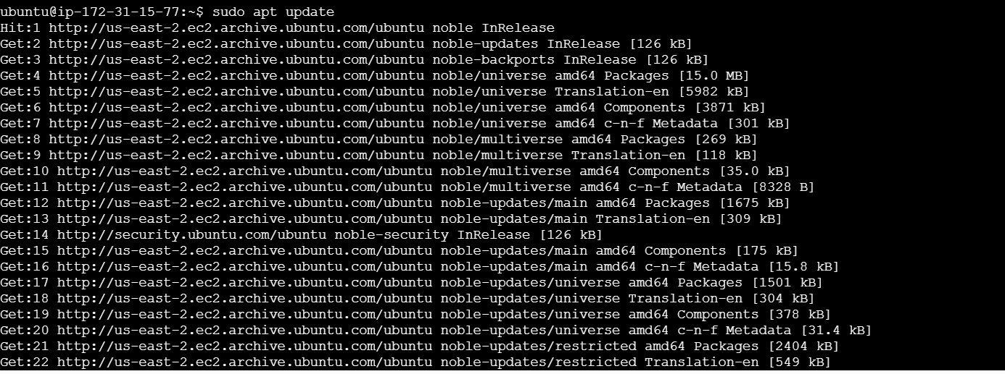

Jenkins
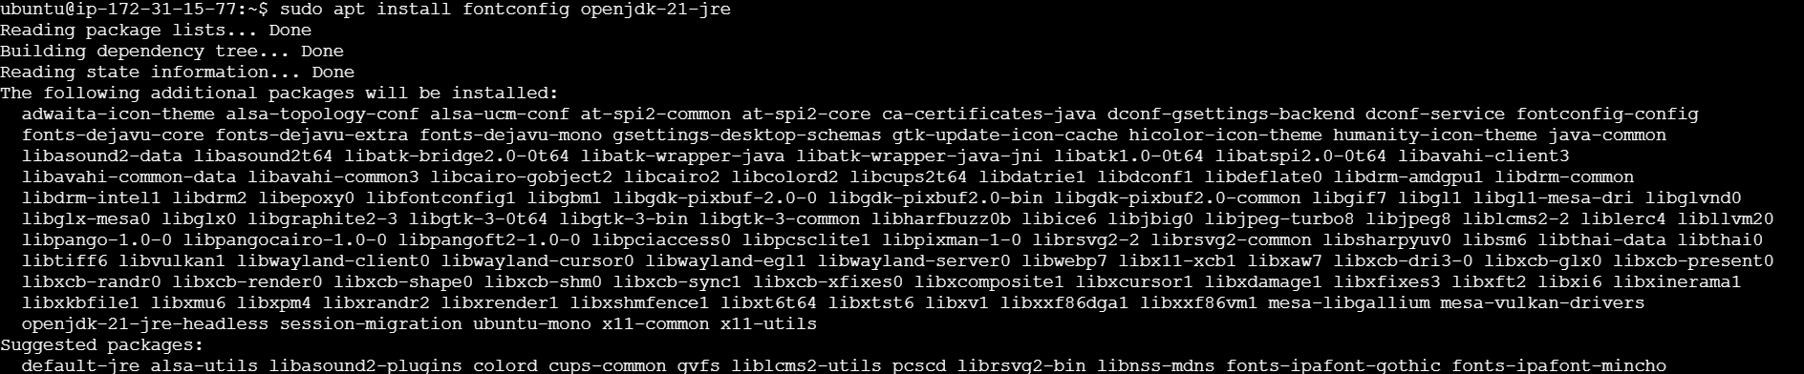
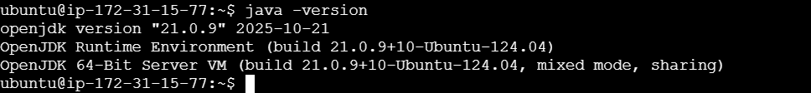
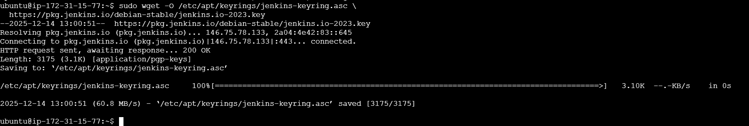
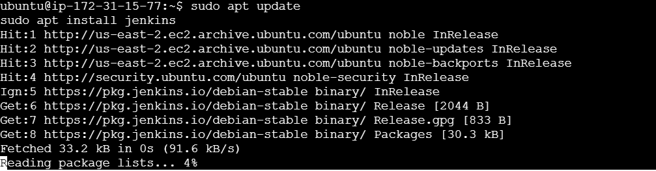

Jenkins Setup
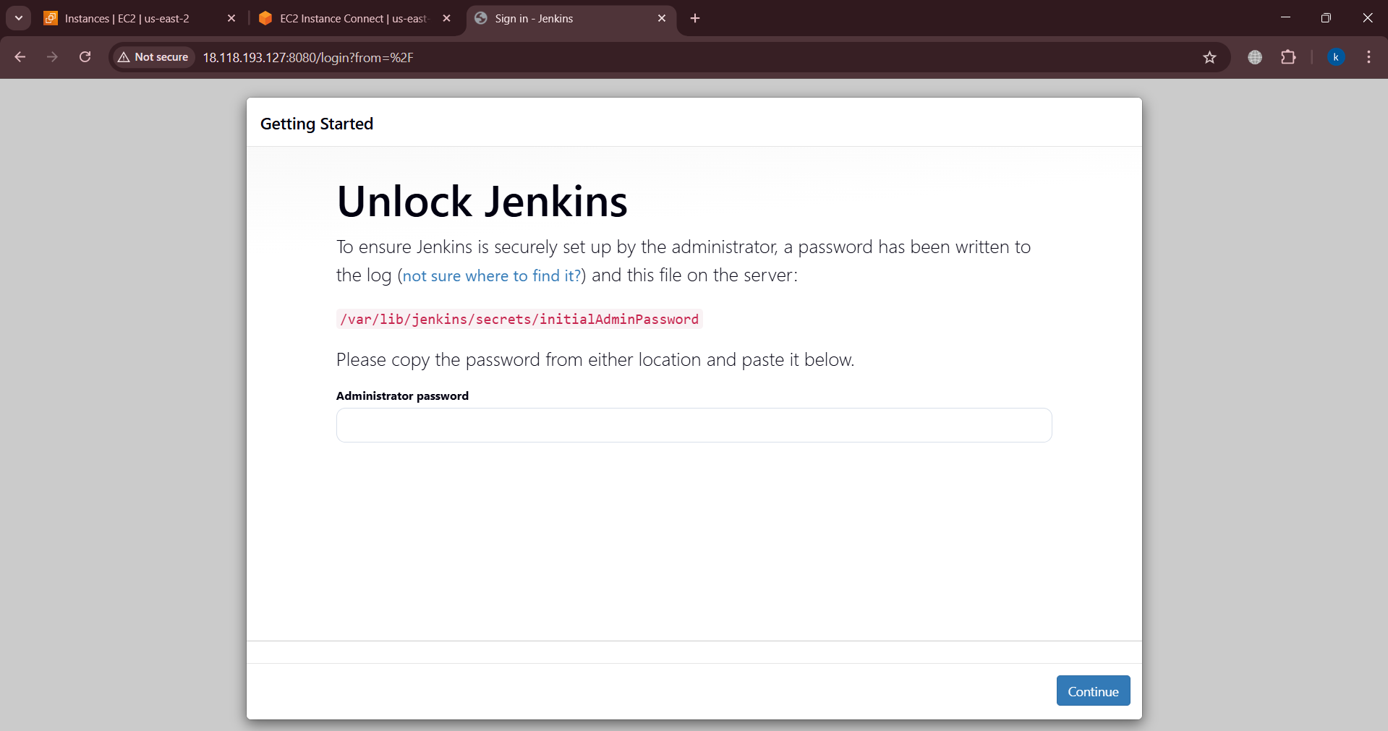
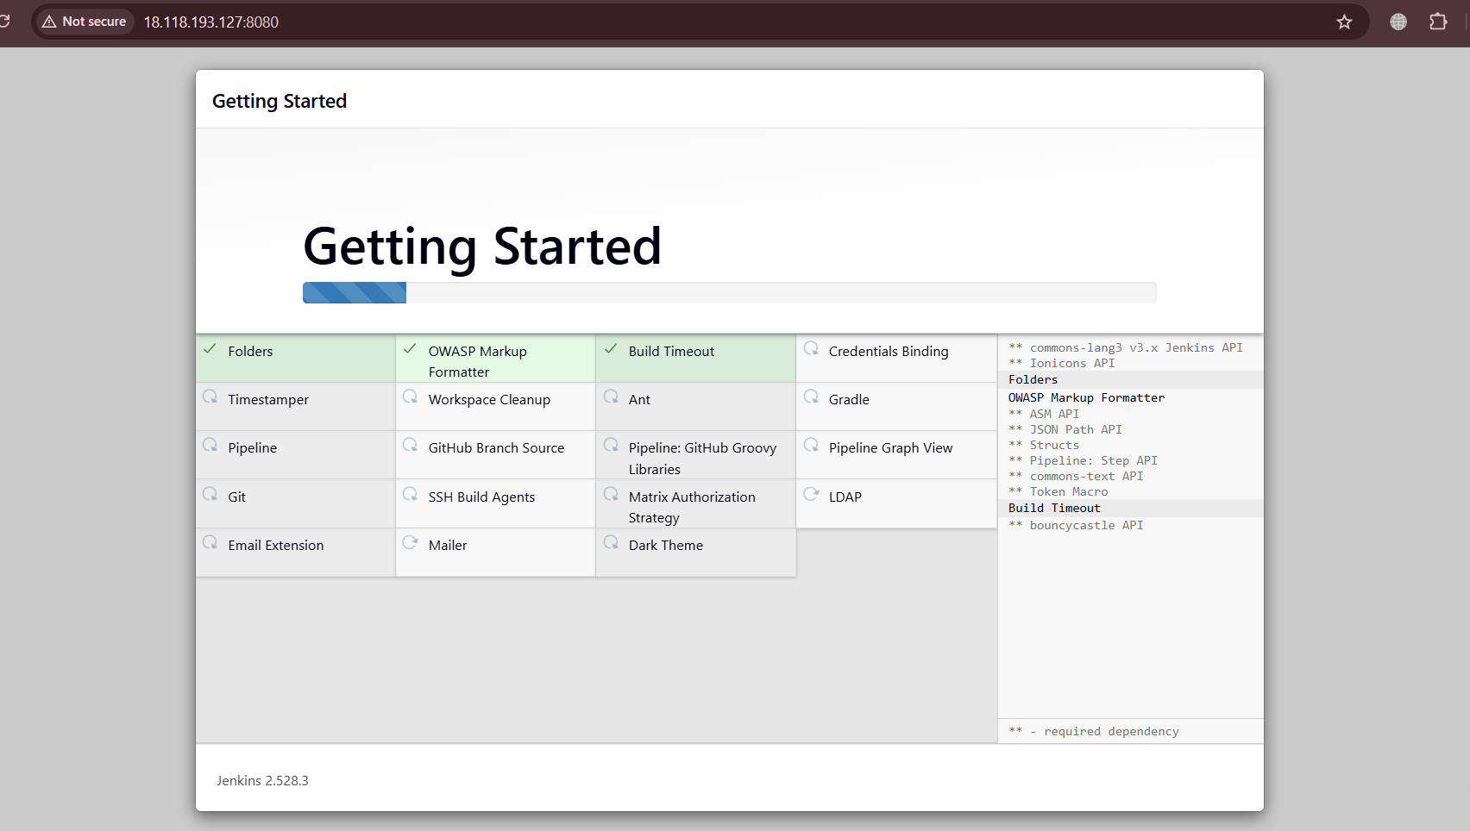
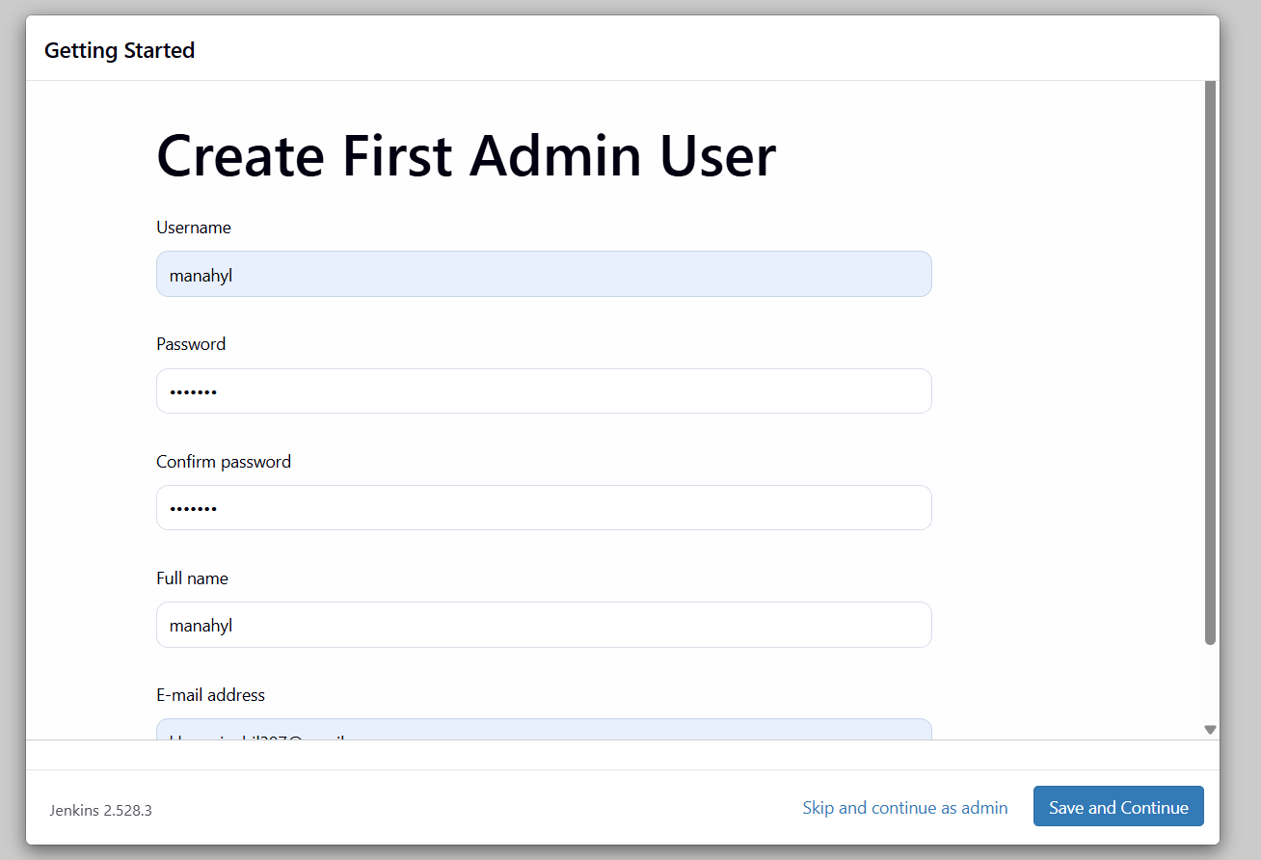
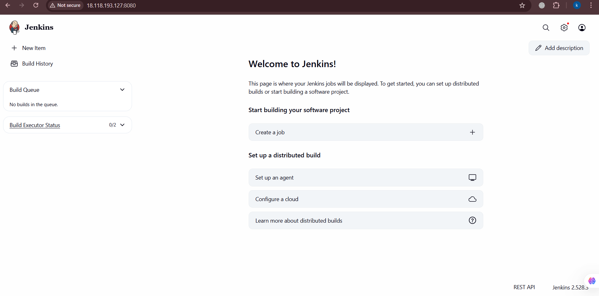

JENKINS PLUGINS
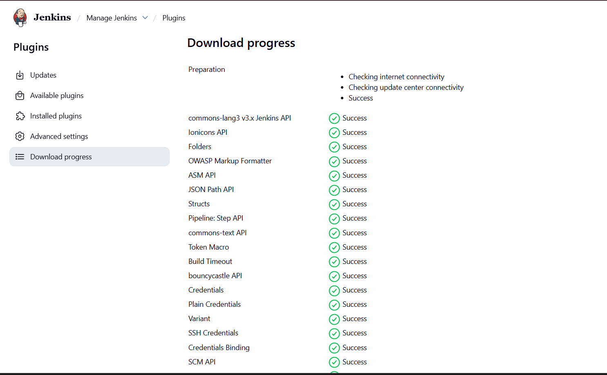

Docker
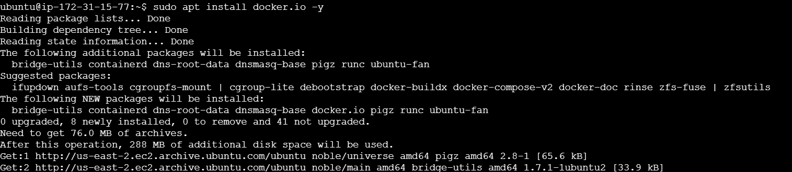
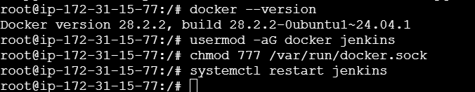

Kubernetes
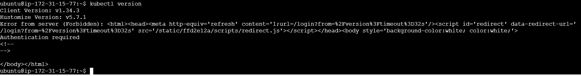
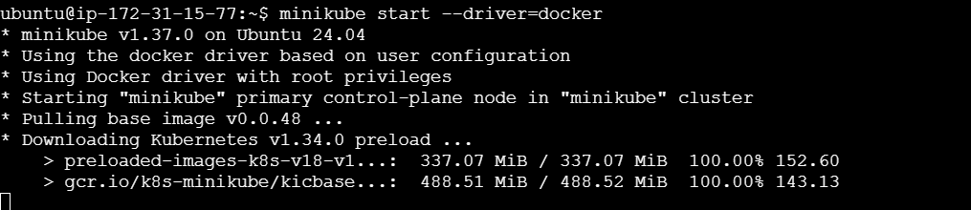
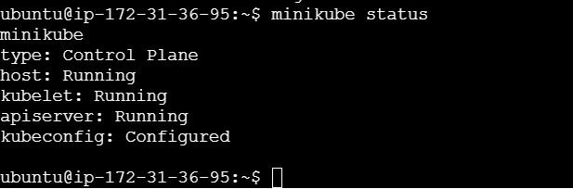
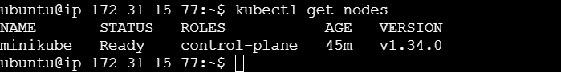

Helm
curl https://raw.githubusercontent.com/helm/helm/main/scripts/get-helm-3 | bash
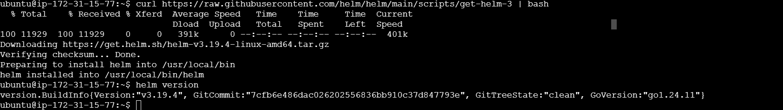
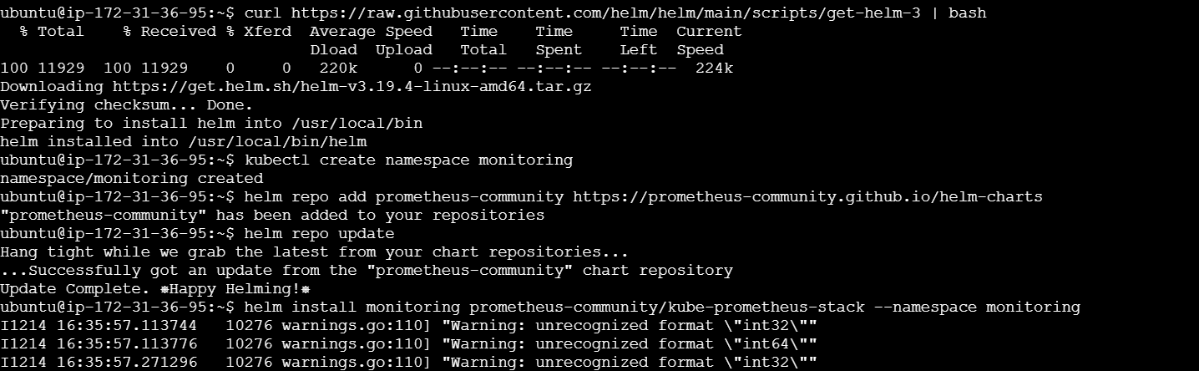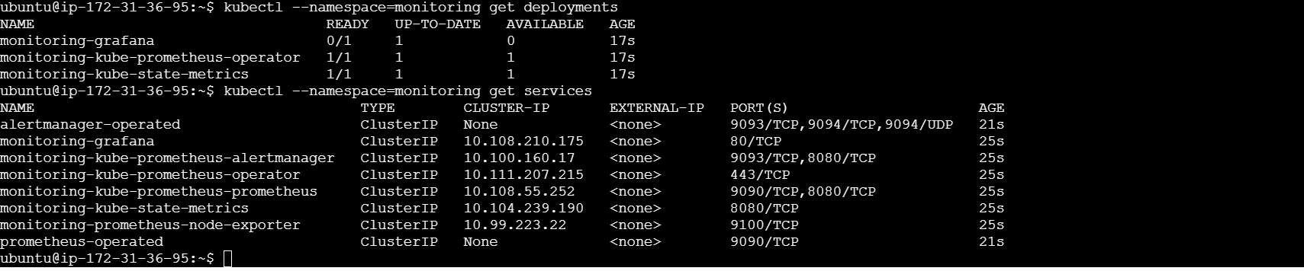

Kubernetes
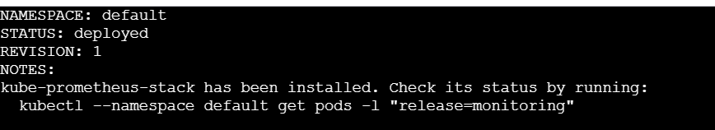

Creating DockerHub credentials in Jenkins
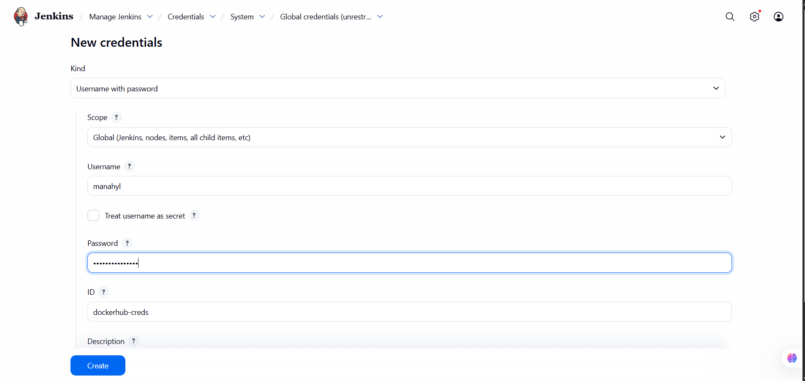

Create Jenkins pipeline job
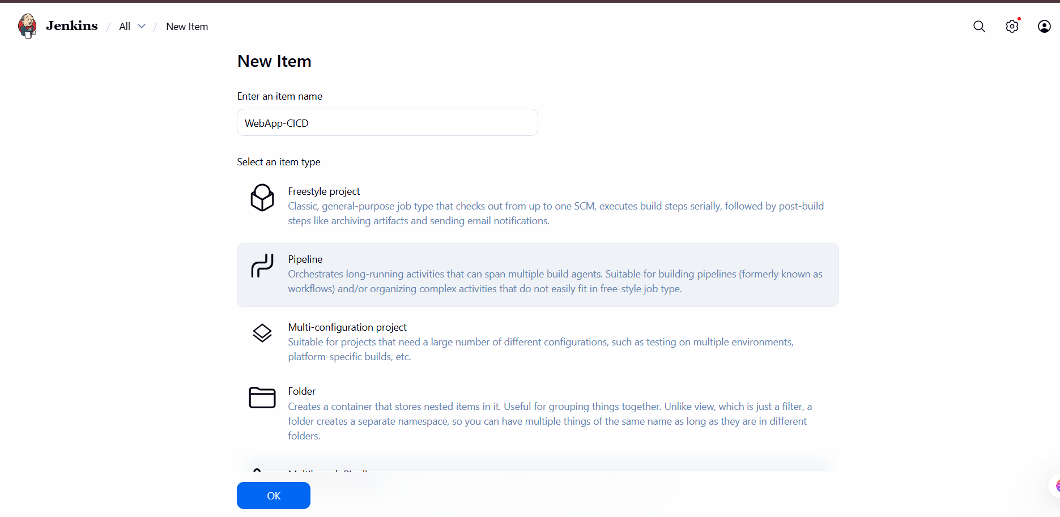
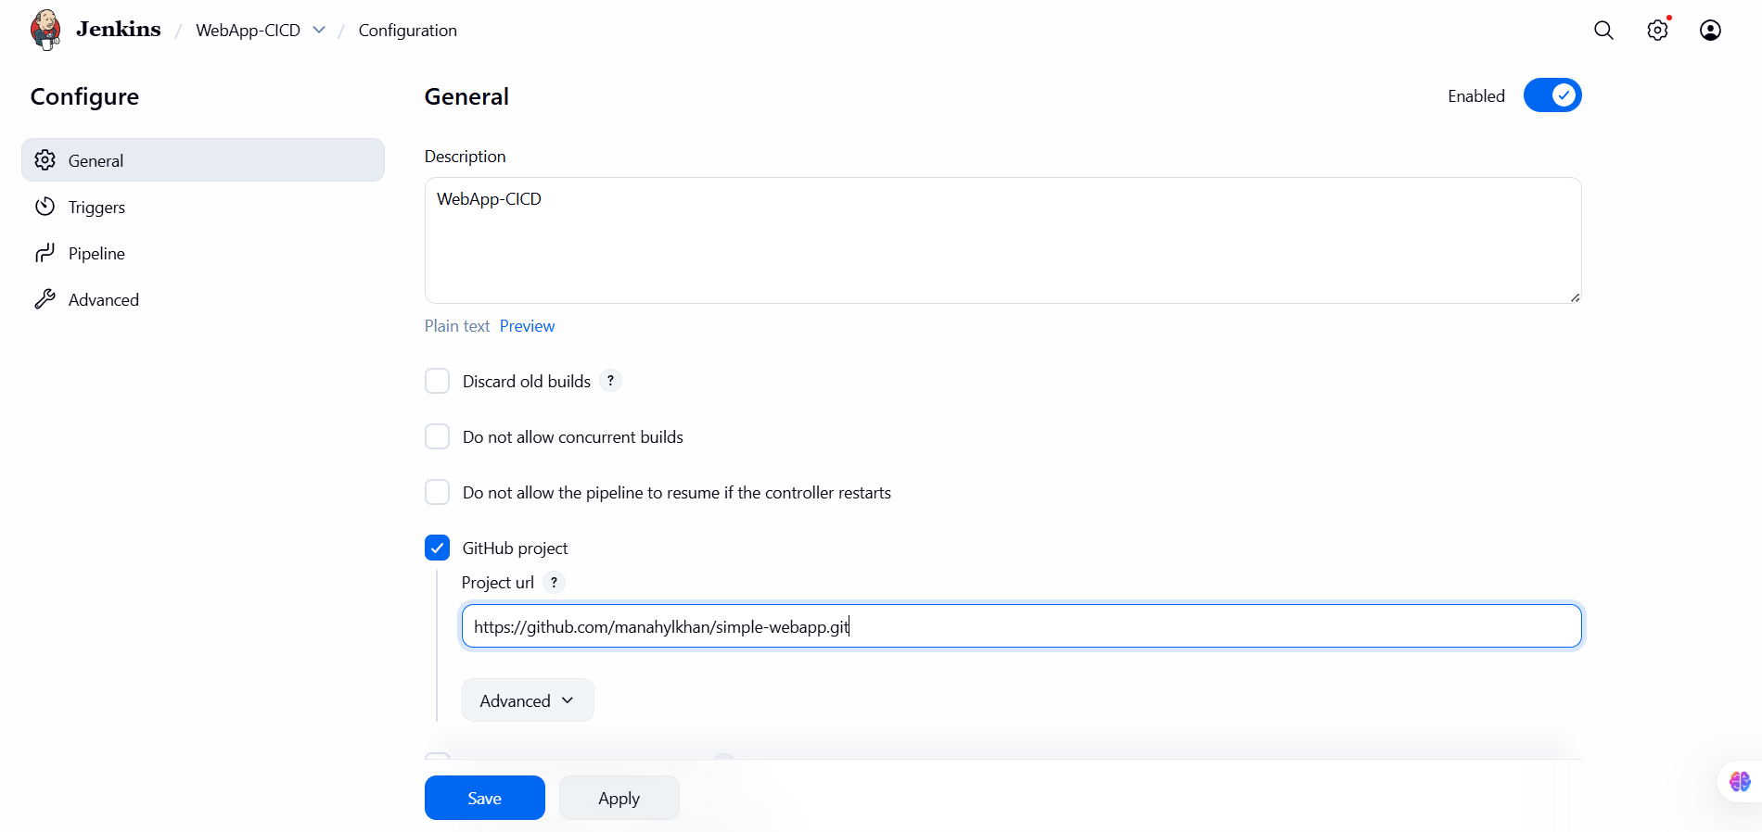
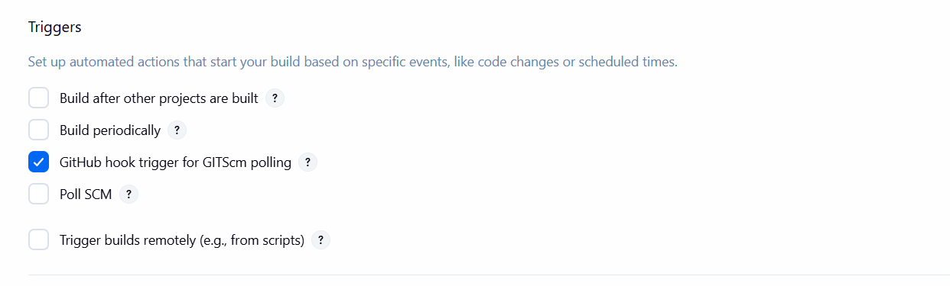
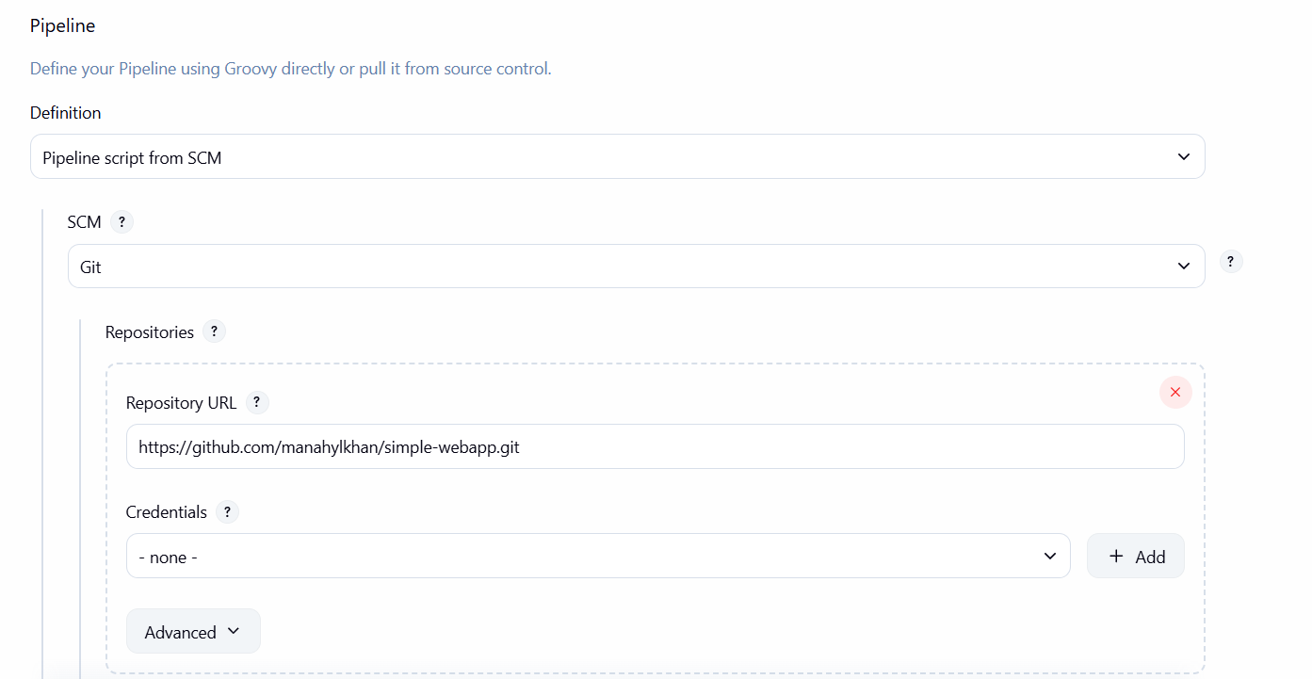
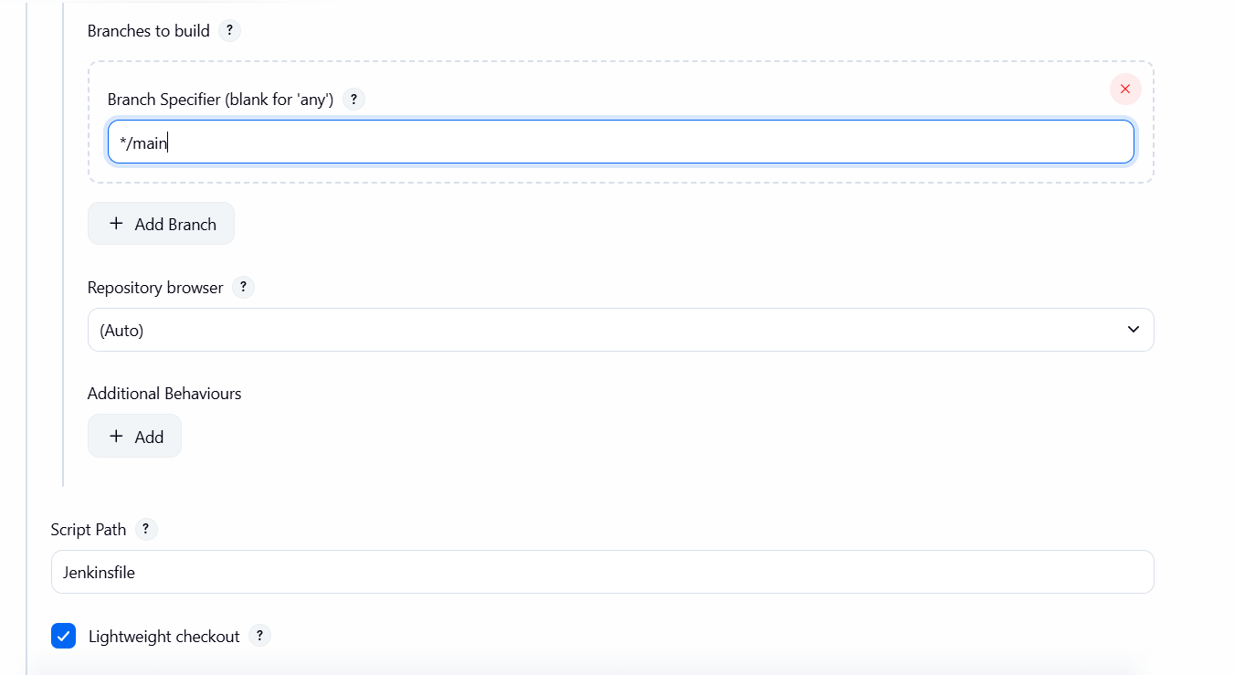
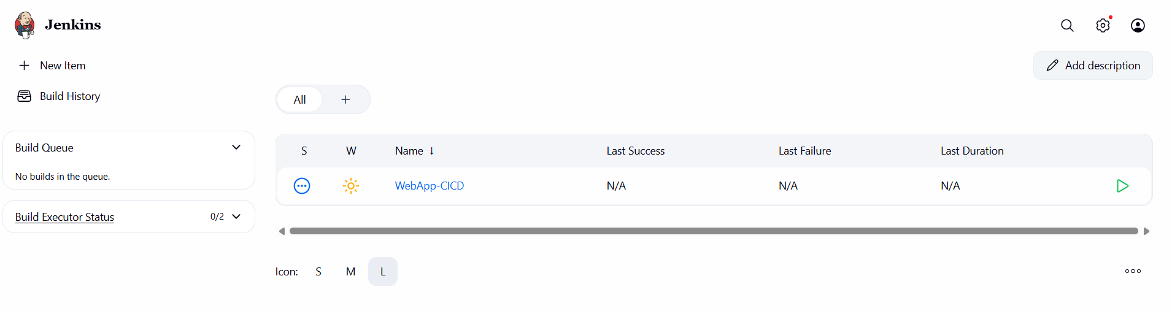

GitHub Webhook Integration
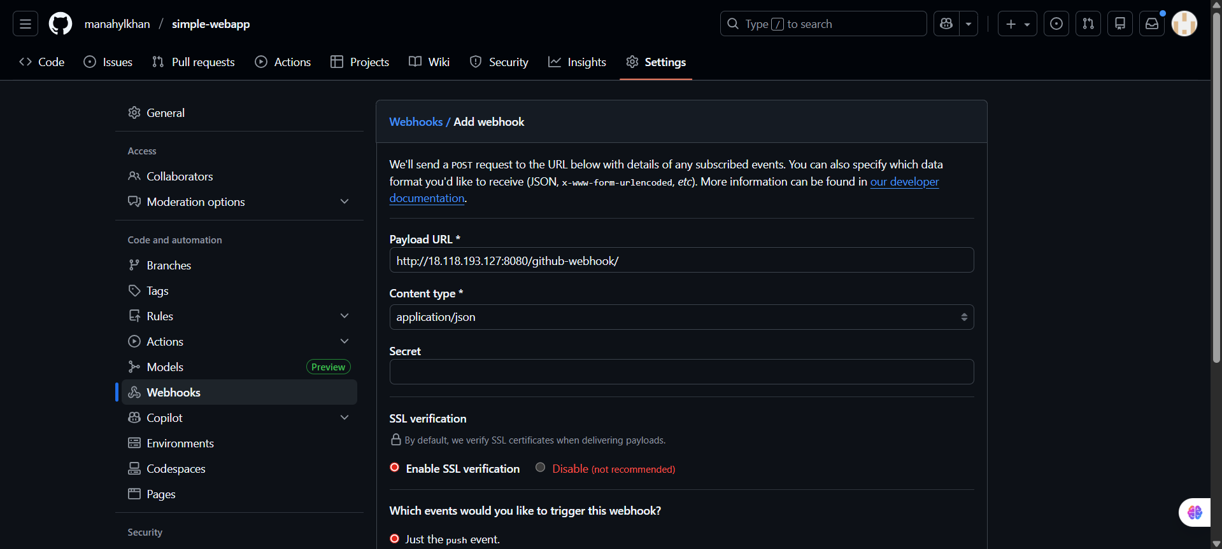
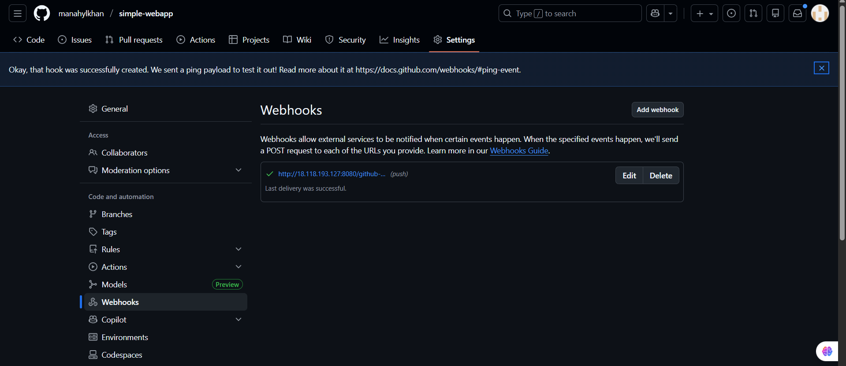

Jenkins Pipeline Script
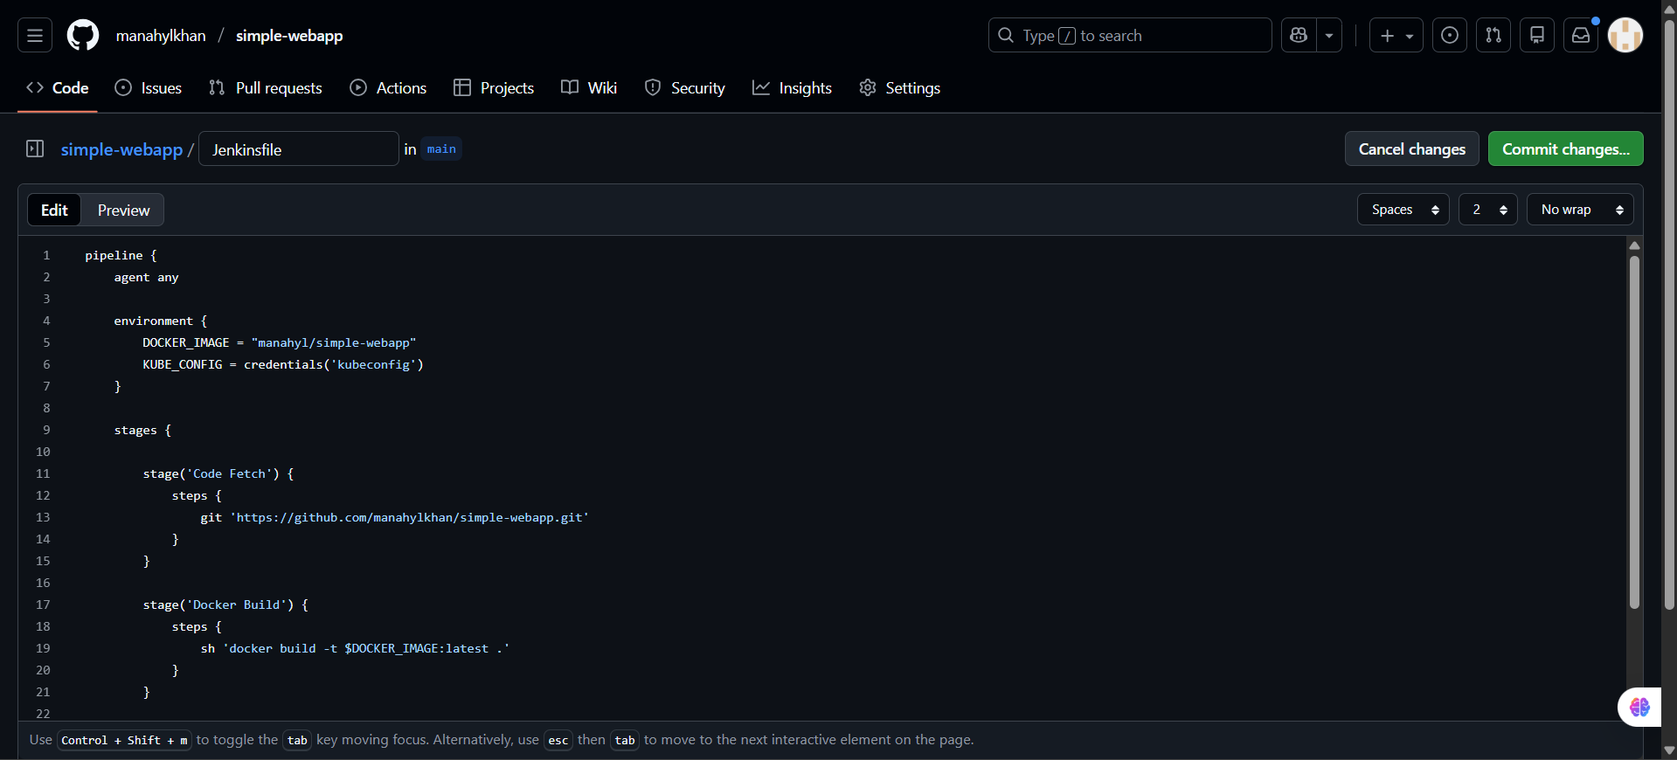

Kubernetes YAML Files
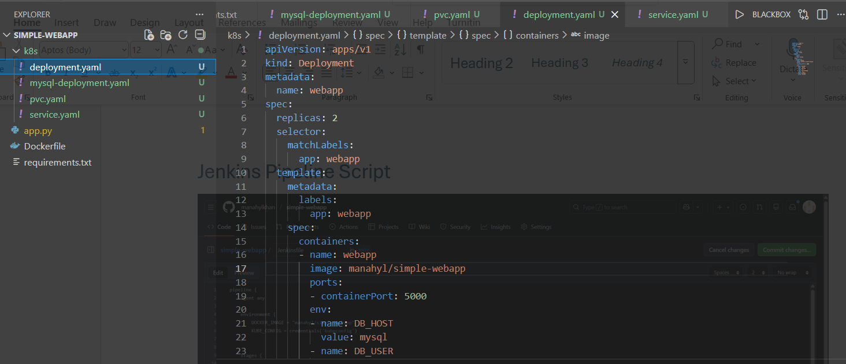

Pods
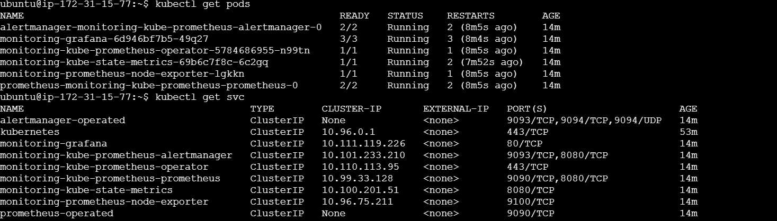

Inbound rules
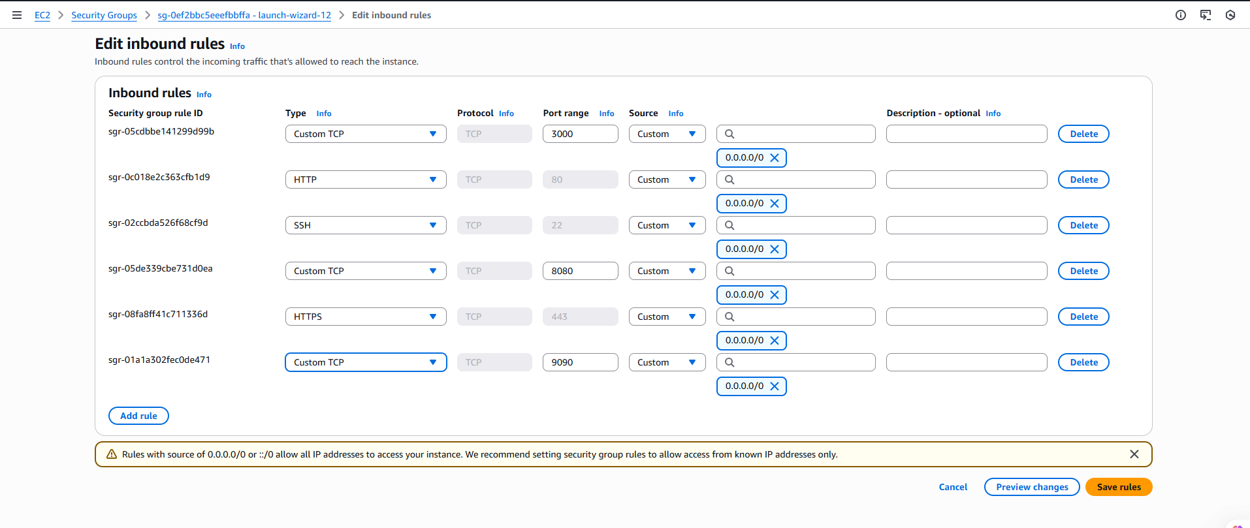
Access Grafana
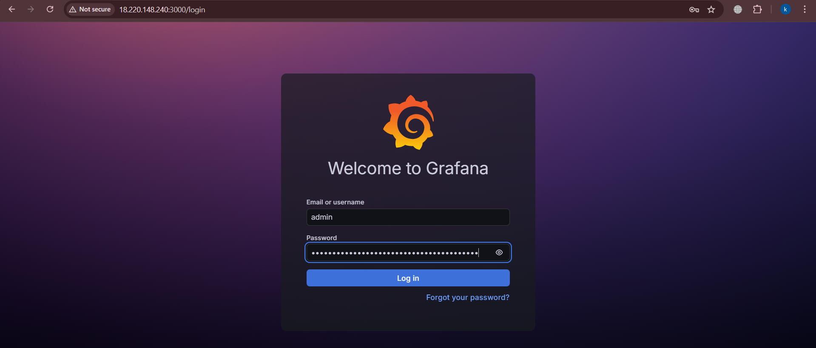
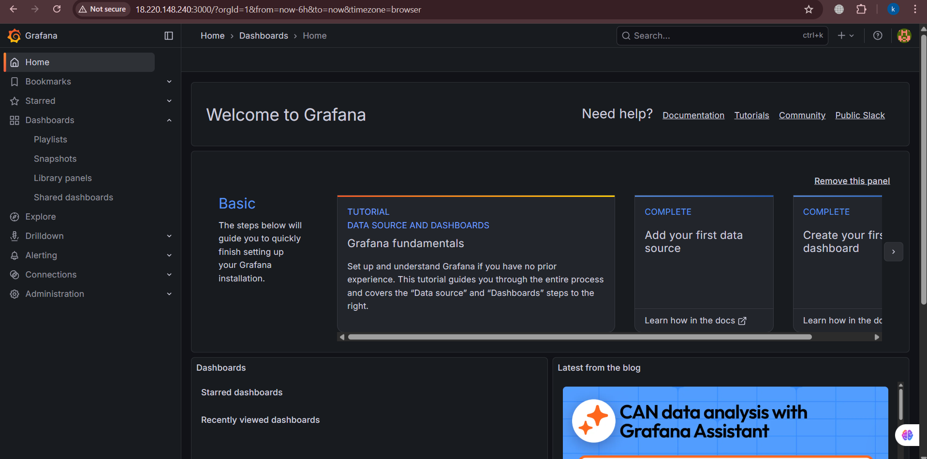
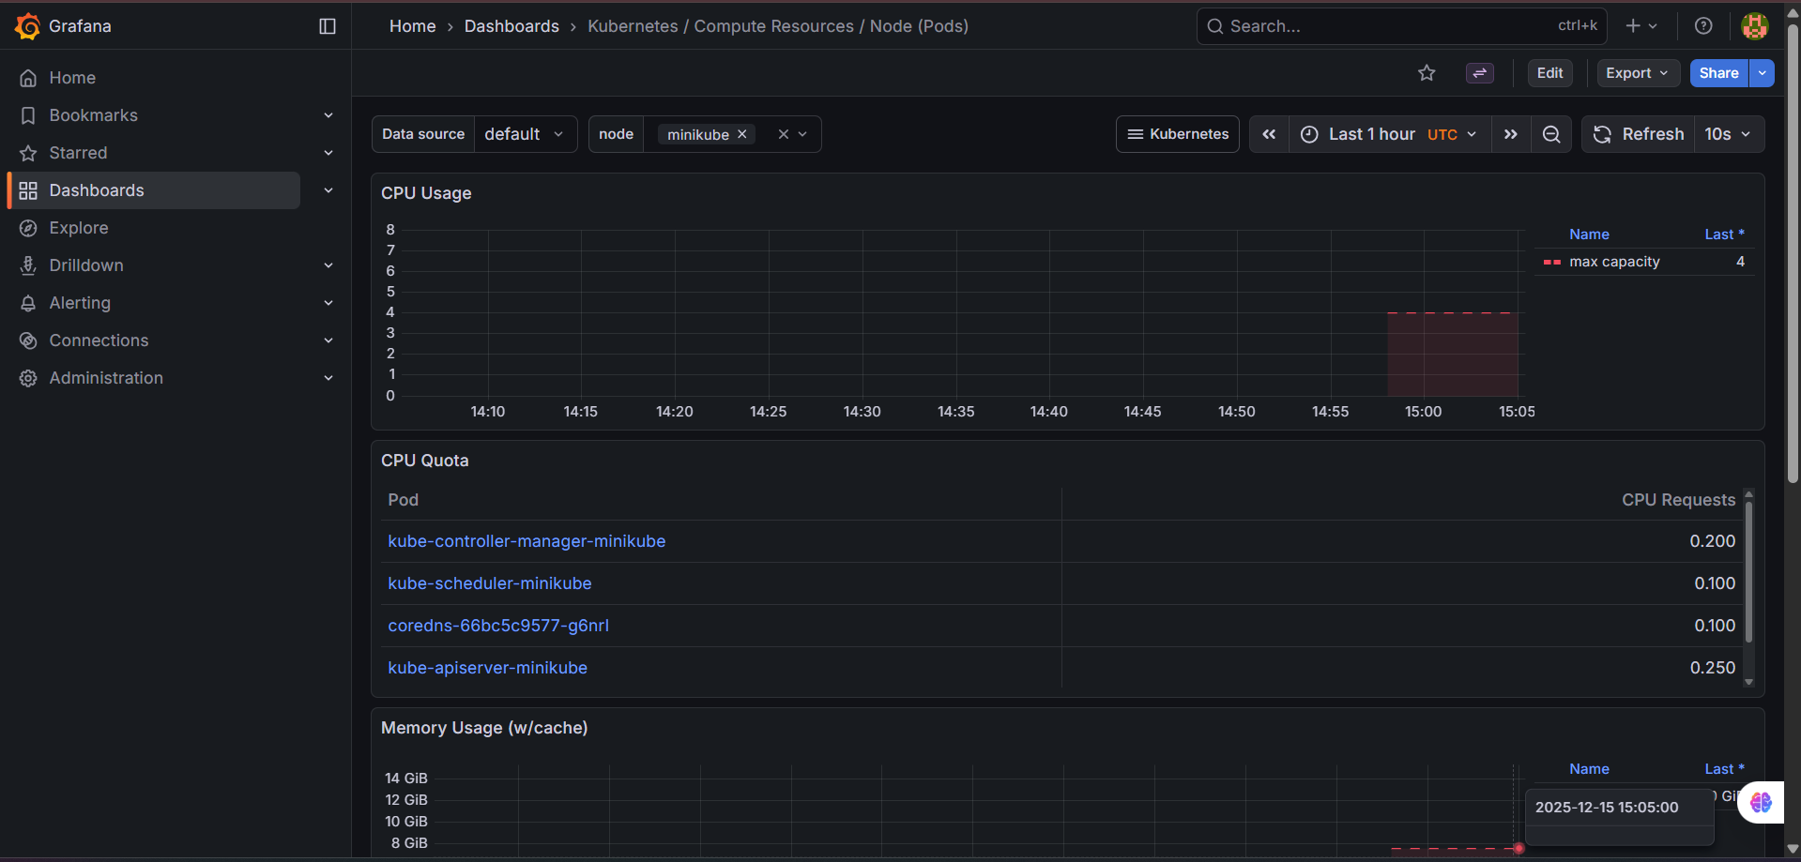

Prometheus

Access Prometheus
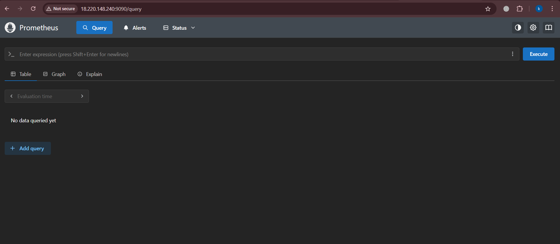

Trigger Pipeline
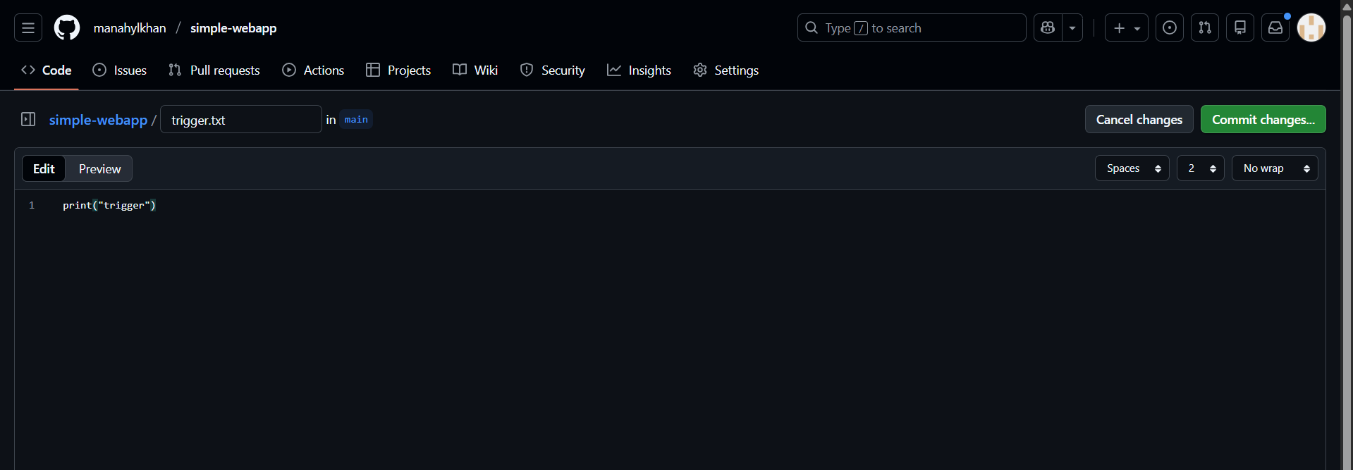

Successful
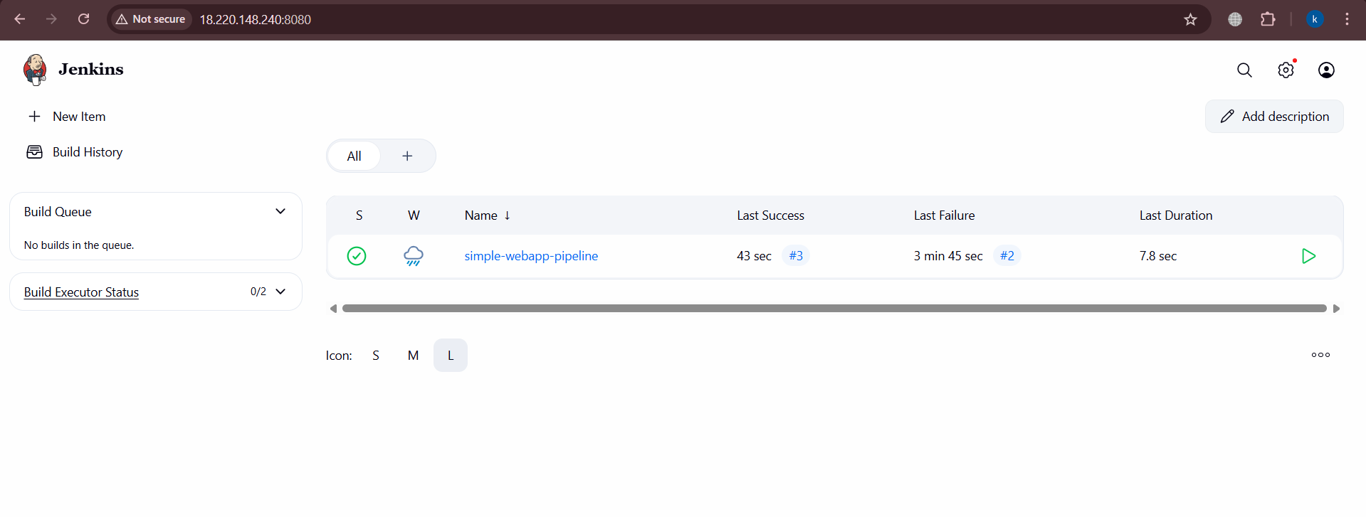
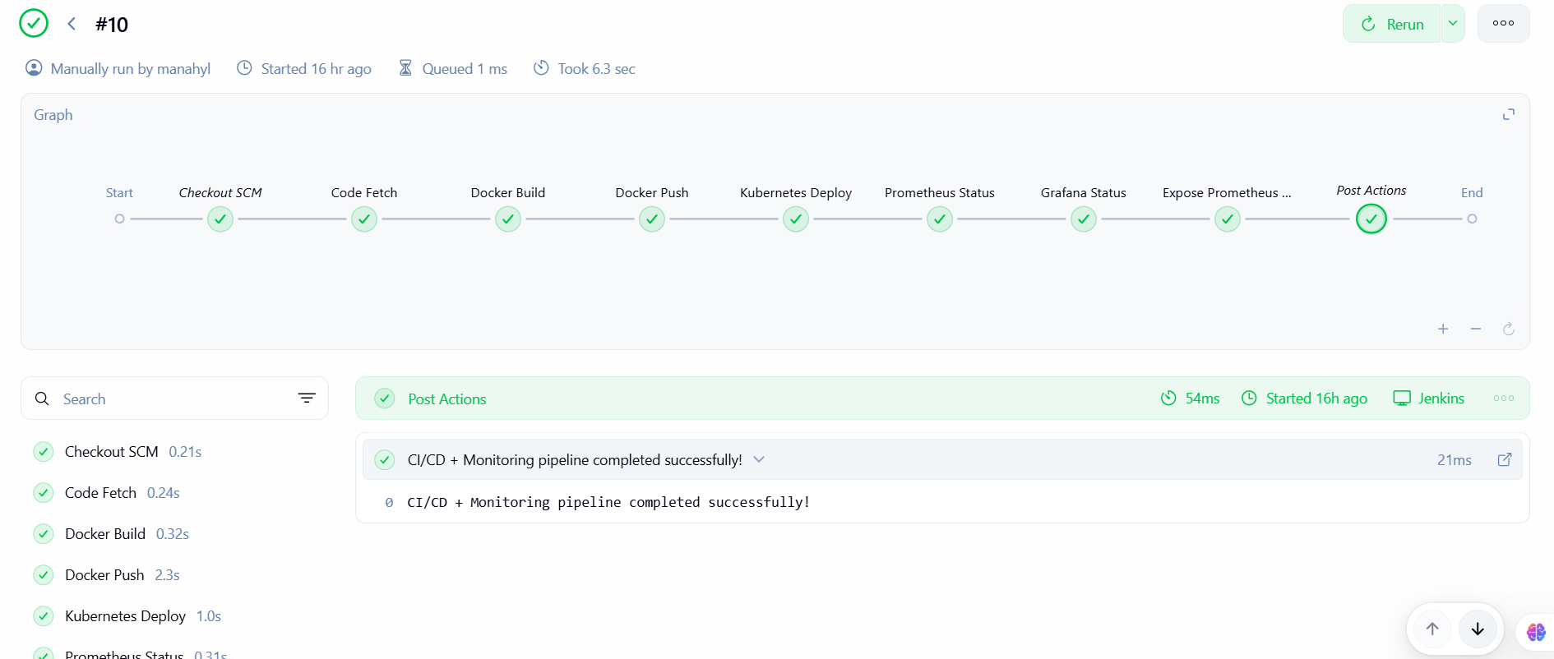

Dashboard Grafana
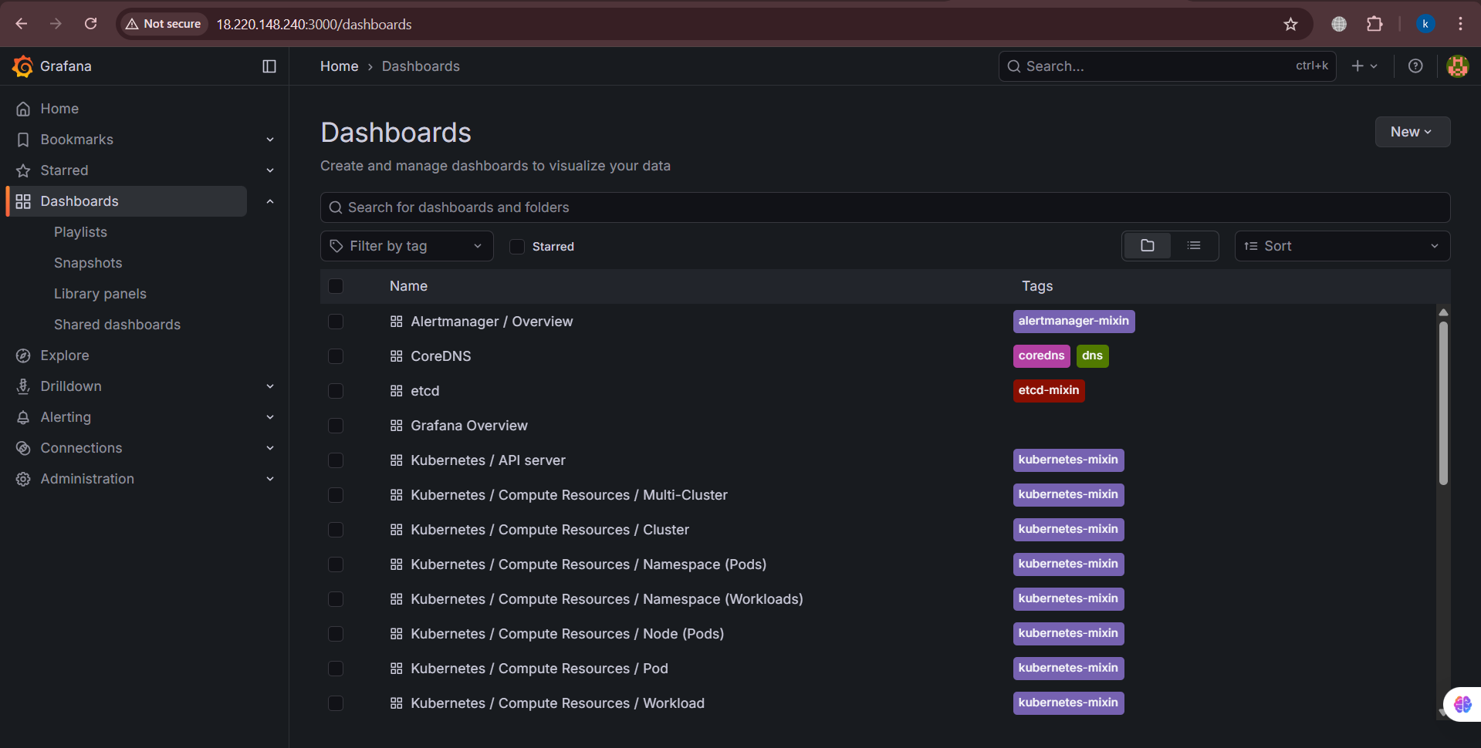
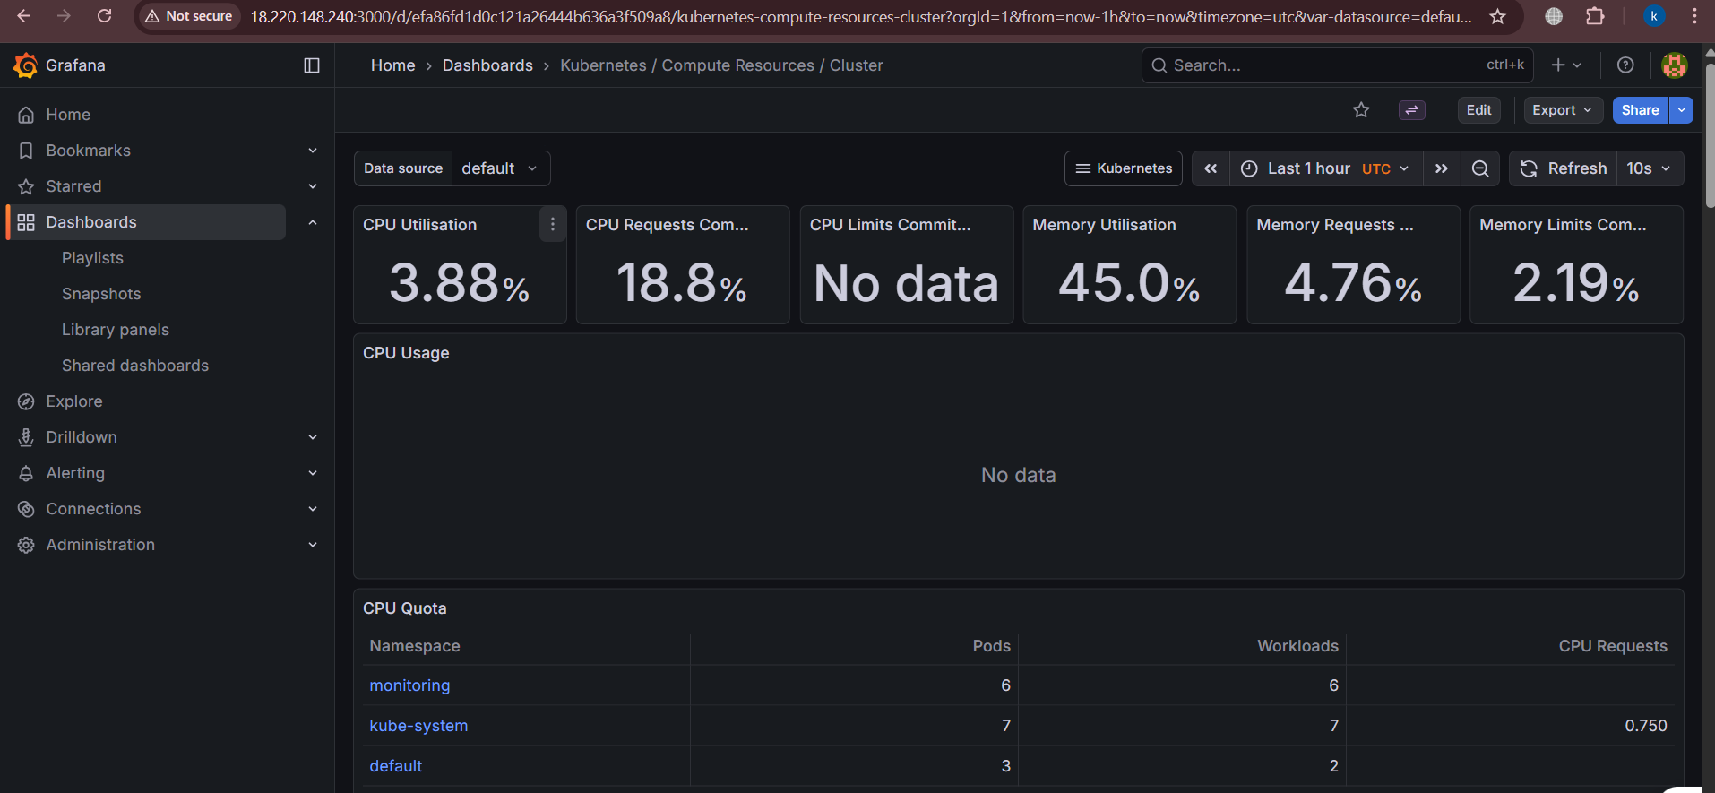

Dashboard Prometheus
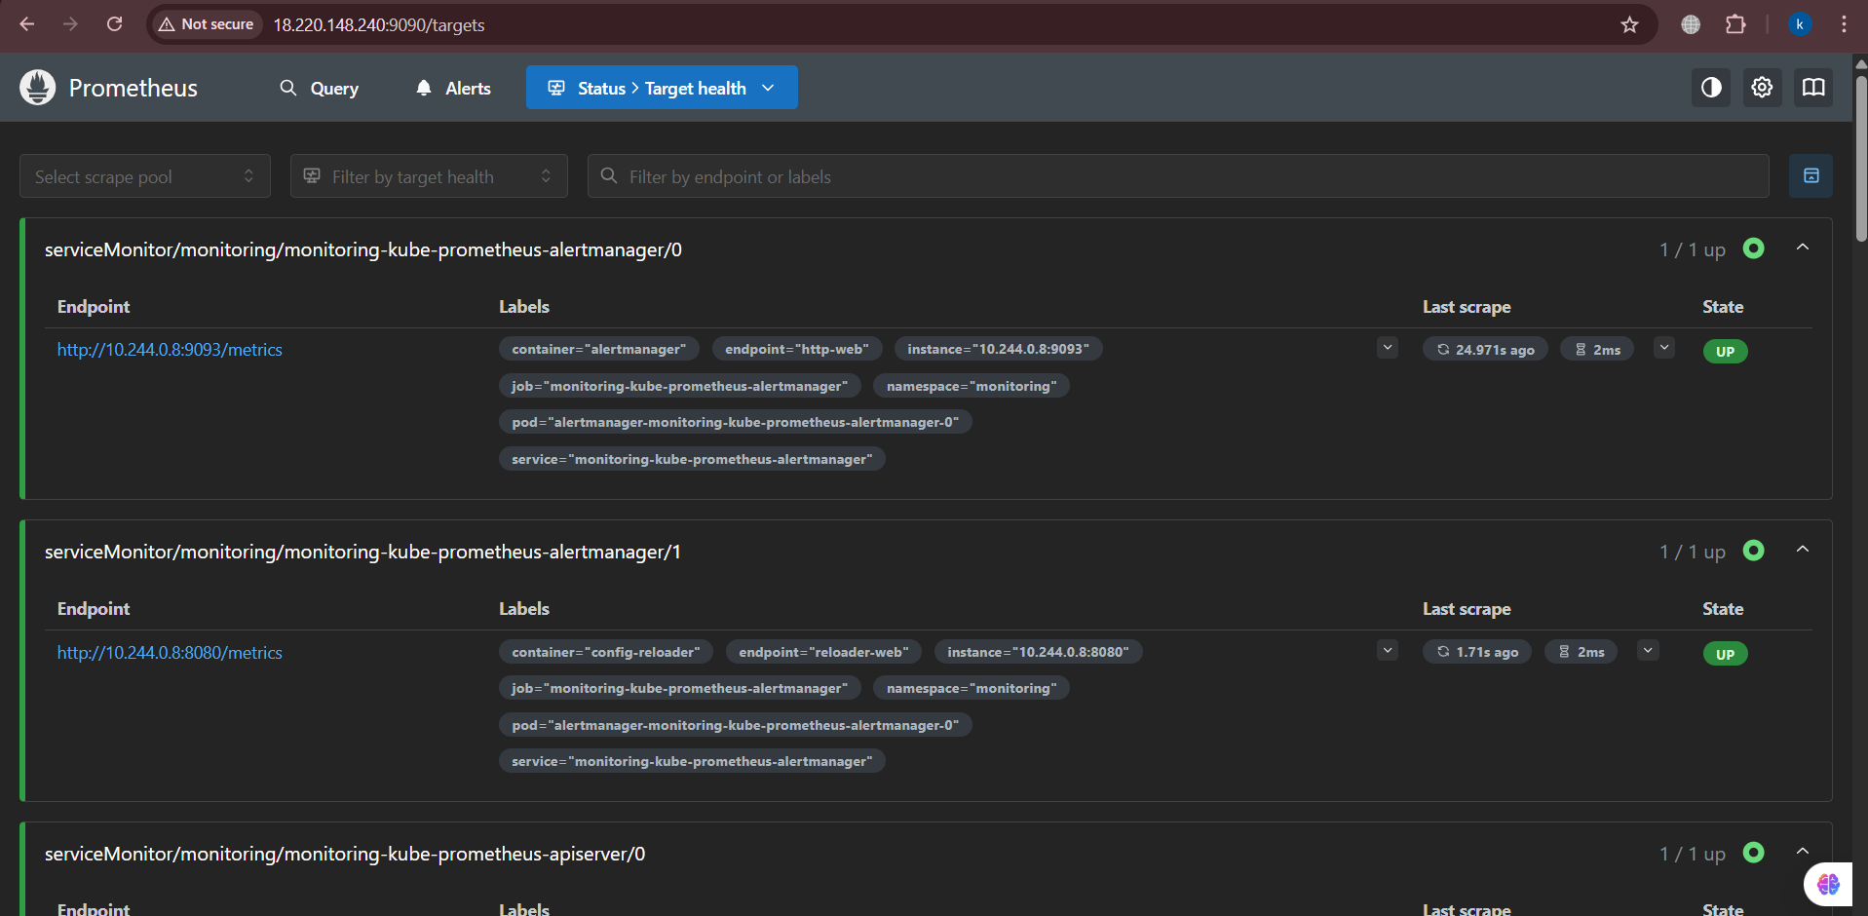
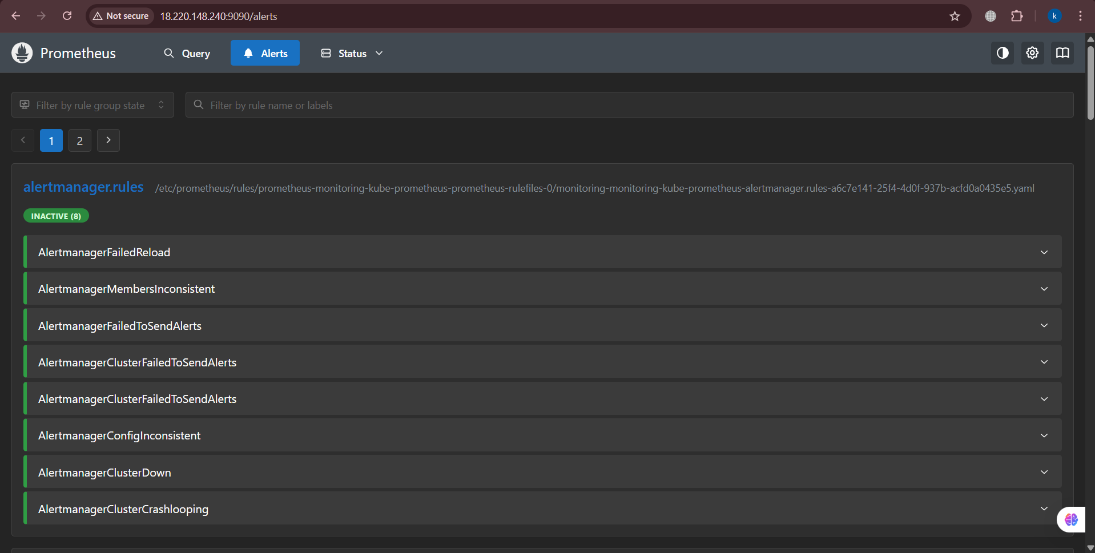

Executing different queries
Checking pods:
kube_pod_status_phase{namespace="default"}
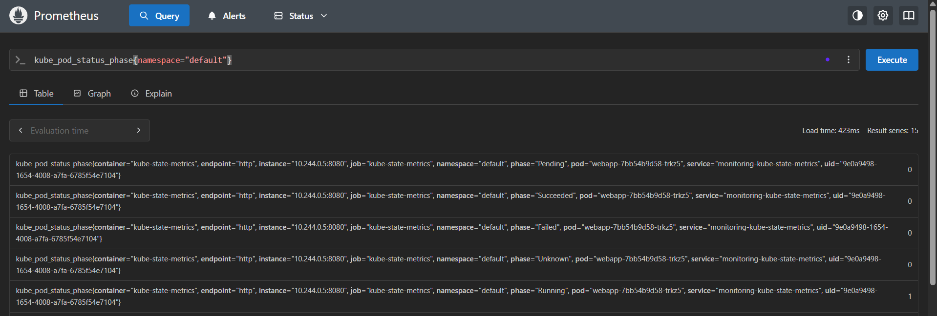
Memory usage:
container_memory_usage_bytes{namespace="default"}

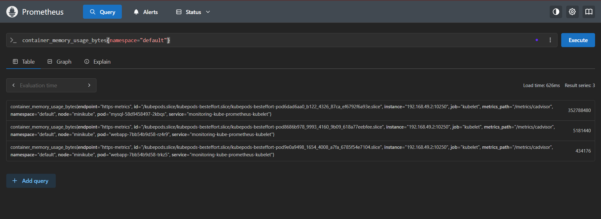

Import Working Dashboard
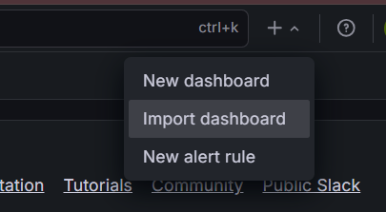
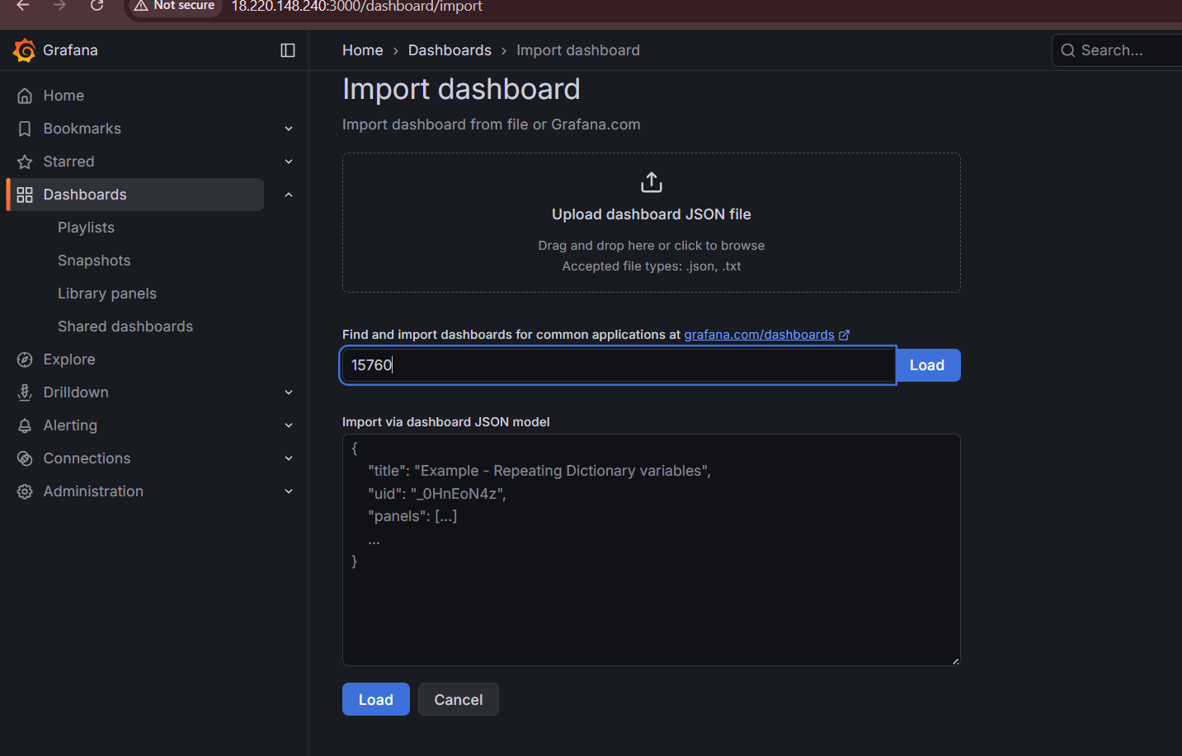
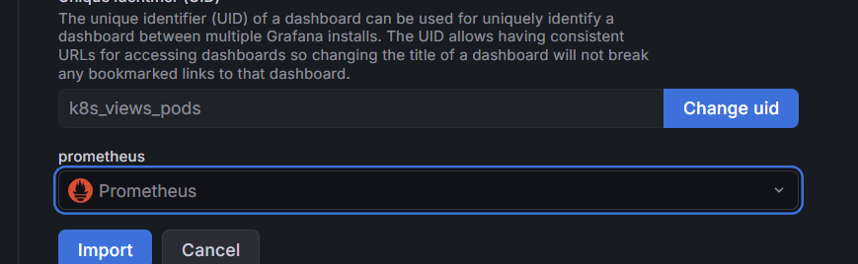
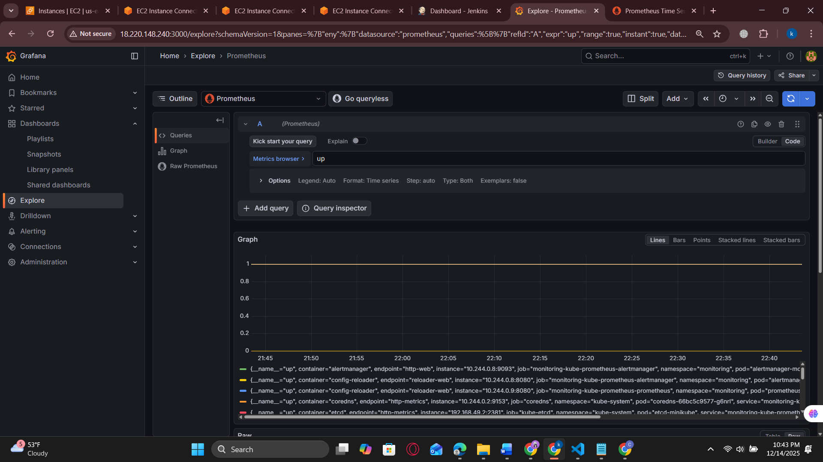
Query
kube_pod_info{namespace="default"}
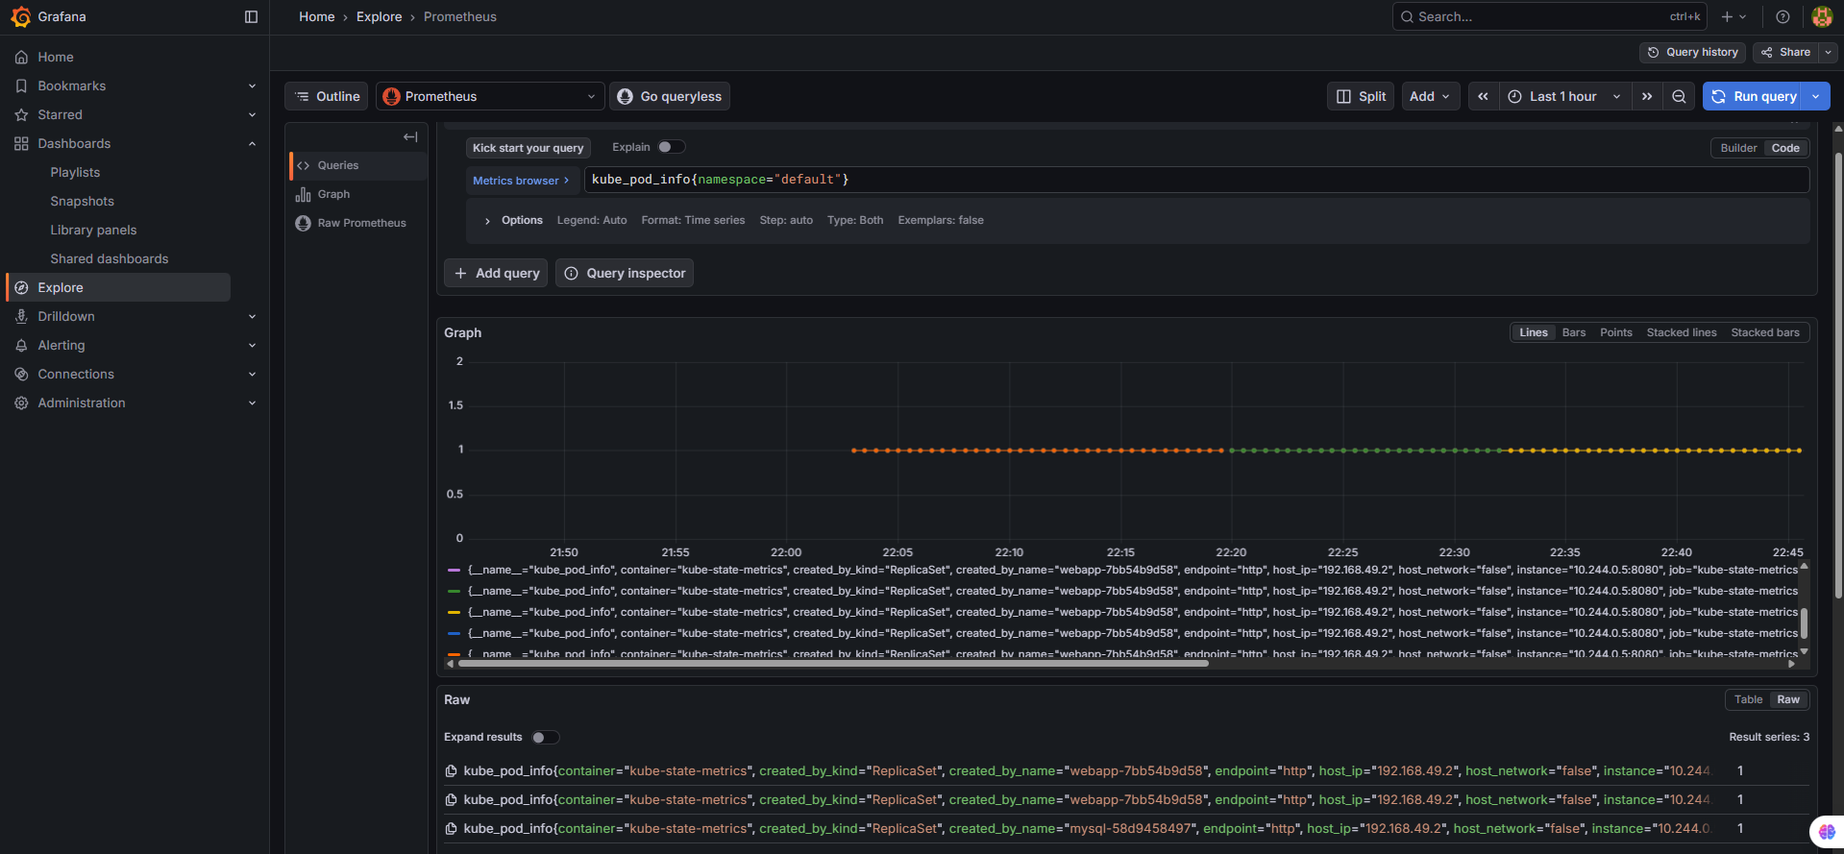

Files

DockerFile
FROM python:3.10-slim

WORKDIR /app

COPY requirements.txt .
RUN pip install -r requirements.txt

COPY app.py .

EXPOSE 5000

CMD ["python", "app.py"]

Jenkinsfile
pipeline {
agent any

environment {
DOCKER_IMAGE = "manahyl/simple-webapp"
MONITORING_NS = "monitoring"
}

stages {

stage('Code Fetch') {
steps {
echo "Fetching code from GitHub..."
git branch: 'main', url: 'https://github.com/manahylkhan/simple-webapp.git'
}
}

stage('Docker Build') {
steps {
echo "Building Docker Image..."
sh 'docker build -t $DOCKER_IMAGE:latest .'
}
}

stage('Docker Push') {
steps {
echo "Pushing Docker Image to DockerHub..."
withDockerRegistry([credentialsId: 'dockerhub-credentials', url: '']) {
sh 'docker push $DOCKER_IMAGE:latest'
}
}
}

stage('Kubernetes Deploy') {
steps {
echo "Deploying application to Kubernetes..."
sh '''
sudo -u ubuntu kubectl apply -f k8s/pvc.yaml
sudo -u ubuntu kubectl apply -f k8s/mysql-deployment.yaml
sudo -u ubuntu kubectl apply -f k8s/mysql-service.yaml
sudo -u ubuntu kubectl apply -f k8s/deployment.yaml
sudo -u ubuntu kubectl apply -f k8s/service.yaml
'''
}
}

/* ===================== MONITORING ===================== */

stage('Prometheus Status') {
steps {
echo "Checking Prometheus pods & service..."
sh '''
sudo -u ubuntu kubectl -n $MONITORING_NS get pods
sudo -u ubuntu kubectl -n $MONITORING_NS get svc
'''
}
}

stage('Grafana Status') {
steps {
echo "Checking Grafana pods & service..."
sh '''
sudo -u ubuntu kubectl -n $MONITORING_NS get pods | grep grafana
sudo -u ubuntu kubectl -n $MONITORING_NS get svc | grep grafana
'''
}
}

stage('Expose Prometheus & Grafana') {
steps {
echo "Access Prometheus & Grafana via Port Forwarding"
echo "Prometheus → http://<EC2-IP>:9090"
echo "Grafana → http://<EC2-IP>:3000 (admin/admin)"
sh '''
sudo -u ubuntu kubectl -n $MONITORING_NS port-forward svc/prometheus-kube-prometheus-prometheus 9090:9090 --address=0.0.0.0 &
sudo -u ubuntu kubectl -n $MONITORING_NS port-forward svc/prometheus-grafana 3000:80 --address=0.0.0.0 &
'''
}
}
}

post {
success {
echo "CI/CD + Monitoring pipeline completed successfully!"
}
failure {
echo "Pipeline failed. Please check logs."
}
}
}

Deployment.yaml
apiVersion: apps/v1
kind: Deployment
metadata:
name: webapp
spec:
replicas: 2
selector:
matchLabels:
app: webapp
template:
metadata:
labels:
app: webapp
spec:
containers:
- name: webapp
image: manahyl/simple-webapp:latest
ports:
- containerPort: 5000
env:
- name: DB_HOST
value: mysql
- name: DB_USER
value: root
- name: DB_PASSWORD
value: root
- name: DB_NAME
value: testdb

service.yaml
apiVersion: v1
kind: Service
metadata:
name: webapp-service
spec:
type: NodePort
selector:
app: webapp
ports:
- port: 5000
targetPort: 5000
nodePort: 30007

mysql-deployment.yaml
apiVersion: apps/v1
kind: Deployment
metadata:
name: mysql
spec:
replicas: 1
selector:
matchLabels:
app: mysql
template:
metadata:
labels:
app: mysql
spec:
containers:
- name: mysql
image: mysql:5.7
env:
- name: MYSQL_ROOT_PASSWORD
value: root
- name: MYSQL_DATABASE
value: testdb
ports:
- containerPort: 3306
volumeMounts:
- mountPath: /var/lib/mysql
name: mysql-storage
volumes:
- name: mysql-storage
persistentVolumeClaim:
claimName: mysql-pvc

mysql-service.yaml
apiVersion: v1
kind: Service
metadata:
name: mysql
spec:
selector:
app: mysql
ports:
- port: 3306
targetPort: 3306
type: ClusterIP

pvc.yaml
apiVersion: v1
kind: PersistentVolumeClaim
metadata:
name: mysql-pvc
spec:
accessModes:
- ReadWriteOnce
resources:
requests:
storage: 1Gi

