Artificial Intelligence Assignment 1
- Explain various types of agents in AI.
- What are the branches of AI? Explain in brief.
- Find a path between nodes A and G using BFS for the given tree.
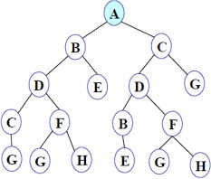
- Solve the given 8-puzzle problem.
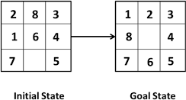
- What do you mean by Blind search? Explain different types of Blind search with an example.
- Describe the Knowledge Cycle in Artificial Intelligence. Explain various types of knowledge in AI.
- Explain the concept of Production Systems in AI in detail.
- What do you mean by heuristic and heuristic search techniques?
- Explain the concept of frames in knowledge representation.
- What do you mean by problem reduction? Explain with the help of an AND-OR graph.
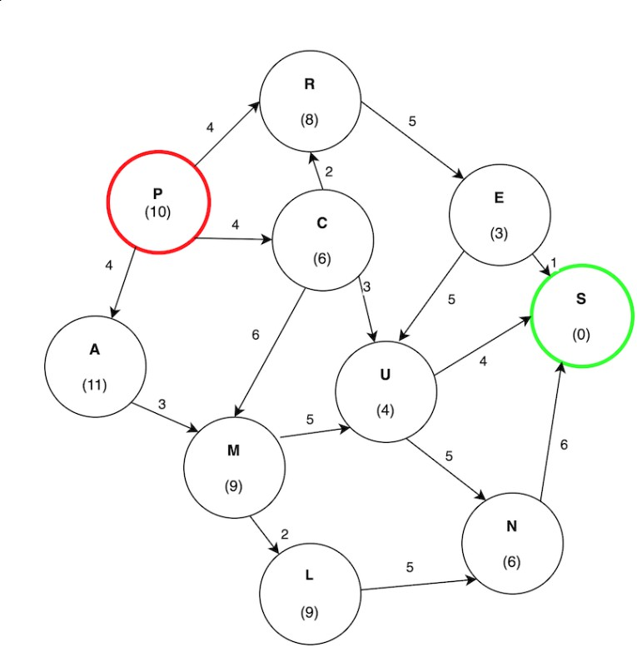
- Find the path from P to S from the following graph by using the best-first search algorithm.

- What is a state-space diagram for the Hill-climbing algorithm? Explain all the regions in the state-space diagram of the Hill-climbing algorithm.
- Consider the following graph. The numbers written on nodes represent the heuristic value.
Find the most cost-effective path to reach from start state A to final state J using A* algorithm.
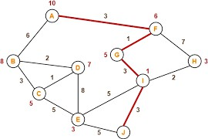

- Find the path to reach goal node G from A by using the Breadth First Search algorithm on the following graph.


- Find the final solution path by using the Best First Search on following graph.
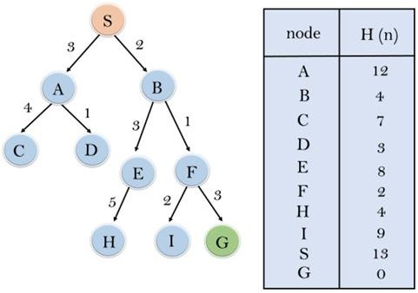

- Prove the following using resolution.

- All humans are mortal.
Socrates is a human.
Prove that Socrates is mortal.
- All birds can fly.
Penguins are birds.
Prove or disprove that Penguins can fly using resolution.

- Every person has at least one parent.
Alice is a person.
Prove that Alice has at least one parent using resolution.

- Every student studies.
Alice is a student.
Prove that Alice studies.

- Consider the argument,” All dogs bark. Some animals are dogs. Therefore, some animals bark”. Determine whether the conclusion is a valid consequence of the premises.
[ Hint: Step 1: Convert all statements to First-Order Logic (FOL).
Step 2: Convert to Clause Form (CNF).
Step 3: Negate the conclusion.
Step 4: Apply Resolution (Unification & Elimination).
Step 5: If we derive ⊥ (contradiction), the original conclusion is true.]
- Explain a knowledge-based system. Discuss the properties of Knowledge Representation Systems.
- Explain semantic nets. What are the interfaces of it.
- Differentiate between:
i) Informed and uninformed search
ii) Declarative, Procedural knowledge and control knowledge
iii) Monotonic and Non-Monotonic Reasoning
iv) Predicate logic and Propositional Logic
v) Forward and Backward Chaining
21. Solve the following And OR graph
