**Assignment 2: OpenSSL Commands and Screenshots**

**Name:** Syeda Manal Ammad **Roll Number:** 251606966

This document contains the OpenSSL commands used for the assignment and their corresponding screenshots as proof of execution.

**Step 1: Generate a Private Key**

**Command:**

$ openssl genrsa -out private.key 2048

**Screenshot:**



**Step 2: Generate a Public Key**

**Command:**

$ openssl rsa -in private.key -pubout -out public.key

**Screenshot:**



**Step 3: Generate a Certificate Signing Request (CSR)**

**Command:**

$ openssl req -new -key private.key -out request.csr

**Screenshot:**

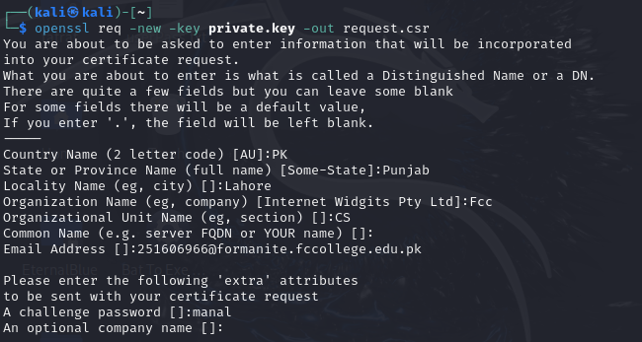

**Step 4: Create a Self-Signed Certificate**

**Command:**

$ openssl x509 -req -in request.csr -signkey private.key -out selfsigned.crt -days 365

**Screenshot:**

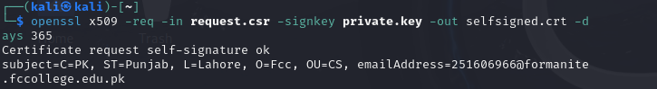

**Step 5: Generate a CA Private Key**

**Command:**

$ openssl genrsa -out ca.key 2048

**Screenshot:**



**Step 6: Create a CA Certificate**

**Command:**

$ openssl req -x509 -new -key ca.key -out ca.crt -days 365

**Screenshot:**

**Step 7: Issue a Certificate Using the CA**

**Command:**

$ openssl x509 -req -in request.csr -CA ca.crt -CAkey ca.key -CAcreateserial -out issued_cert.crt -days 365

**Screenshot:**

