MFM
To analyze and discover human-written and AI-generated texts

written by
Manal Daif Allah Almutiri | 4725075
Fatmah Abdullaziz Aldjran | 4725086
Manar Ghazi Hussain | 4725082

2025

Abstract
This research aims to address a growing problem in our time. With the development of artificial intelligence models, the ability to distinguish between human-generated Arabic text and text generated using AI models (Large Language Models) such as LLMs has become increasingly difficult. Therefore, the need for systems to detect machine-generated text has become critical due to its impact on academic integrity and content quality.
This research utilized a dataset of Arabic-generated abstracts available on the HuggingFace platform. This dataset includes thousands of human-generated texts and abstracts, along with their corresponding outputs generated by language models such as LLaMA, JAI, ALLAM, and OpenAI.
This research was conducted in several integrated phases, including data analysis, Arabic text cleaning, linguistic, statistical, and stylistic feature engineering, and training both classic Random Forest models and more advanced models such as BERT embeddings, which were applied to an independent test group. The results demonstrated the ability of the trained models to distinguish between texts based on the features they were trained on. The advanced model also showed remarkable success with an accuracy of 99.6%. Furthermore, the results revealed the importance of stylistic and semantic methods, which were used to develop AI-generated Arabic text detection systems.

Contents
Abstract 2
1 Introduction 4
3 Dataset Description 9
4 Methodology 10
4.1 Data Acquisition & Understanding 10
4.2 Data Preprocessing 10
4.4 Modeling Selection 16
5 Results & Analysis 17
6 Conclusion 23
References 24

1 Introduction
The recent period has witnessed rapid advancements in the capabilities of artificial intelligence and large language models (LLMs). This has led to the production of high-quality Arabic texts in terms of fluency, grammar, and style. The widespread use of these models in scientific research, social media, and education has created new challenges related to the inability to distinguish between human-generated texts and those generated using these models. Consequently, researchers have focused on detecting AI-generated texts, a topic that has become a central concern due to its implications for improving digital governance, academic integrity, and combating misinformation.
While numerous advanced tools exist for detecting texts generated by language models in English, Arabic remains limited in terms of both data and specialized detection tools. However, with the availability of the KFUPM-JACAI/arabic-generated-abstracts dataset, the first Arabic corpus specializing in this field, which was used in this project, we were able to utilize both human-written research abstracts and their counterparts generated using the previously mentioned linguistic models, which employed different methods for generation, editing, and content creation.
This research aimed to train an integrated data analysis model that studies the stylistic and statistical differences between human and synthetic texts.
2 Related work
With the significant advancements in artificial intelligence models capable of generating highly accurate text, the need for technologies that distinguish between human-generated and machine-generated text has become essential. Several methods have emerged that rely on analyzing the probabilistic properties of text and the behavior of linguistic models to detect these patterns.
- Ghostbuster technique: Detecting Text Ghostwritten by Large Language Models
Ghostbuster technology has introduced an approach based on text analysis using weaker language models, so that it aims to detect texts written by artificial intelligence models by analyzing the probability characteristics of words within the text. Ghostbuster depends on a very clever idea of passing text through several weak language models such as the Unigram model, the Trigram model, and early versions of GPT-3 (such as Ada'S, GPT-3 and Davinci's GPT-3 without setting directives). These models produce probabilities for each word, and since human texts differ in the way they choose words from machine-generated texts, these probabilities reveal a characteristic pattern. (Vivek Verma, 2024)
After obtaining the probabilities, Ghostbuster uses a set of statistical operations (such as addition, subtraction, multiplication, division, variance, highest and lowest probability) to create (Features) that reflect the behavior of the text. Then the “feature selection" algorithm is applied to select the best features that distinguish AI texts from human texts. Eventually a simple algorithm like Logistic Regression trains on these features to determine if the text is written by AI. What distinguishes Ghostbuster is that it does not need to know the model that wrote the text, as it depends on the assumption that machine – generated texts that possess a statistical “marks” different from human texts, show very high performance up to (F1 = 99%) and their ability to generalize to different areas (news – stories-student articles).
How Ghostbuster technology works:
- Calculation of word probabilities
- Passes the text on several small forms and collects the (probability) of each word.
- Building (Features)
- Apply operations such as addition, Division, difference, highest / lowest probability, variance.
- The goal is to discover the strange statistical patterns found in AI scripts.
- Simple workbook training
  - The best features are selected and then a linear workbook is trained to see whether the text is AI or not
- Ghostbuster features
- You do not need to know the model in which the text was written.
  - Very strong in generalization across different texts.
  - Its performance is very high (reached 99% F1 score).
AI texts are revealed because even if they are excellent, they contain statistical (marks) that differ from humans in the probability distribution of words.
- DetectGPT technique: Zero-Shot Machine-Generated Text Detection using Probability Curvature
The texts generated by AI are usually located at the top of the model's probability curve, which means that if the text changes slightly, the probability decreases strongly, but human texts, they are not at the top, simple changes do not significantly reduce the probability, this is what the DetectGPT technology does, it relies on a principle called probabilistic curvature of the linguistic model and also depends on an important mathematical hypothesis based on the texts generated by the AI model are often located at the “top” of the model's probability curve (i.e. at a point with a curvature negative). This means that the model chooses a certain wording because it is the most probable for it, so any small change in the text will significantly reduce the probability of the model. (Eric Mitchell, 2023)
DetectGPT exploits this idea by creating small Perturbations of the original text using another model such as T5 that slightly paraphrase some words or sentences. The probability of the original text and the probability of each altered version are then calculated using the same model that is suspected to have written the text. If the difference in probability between the original and the copied text is abnormally large, this indicates that the text is probably generated by AI and not by humans. The technique works in a Zero-Shot way, that is without the need for prior training or additional data and depends only on the characteristics of the model and the way it writes texts.
The texts generated by the AI model are usually close to the “top” of the probability function (Local Maximum), therefore when making very minor changes to the text (Perturbations), the probability of the model for these altered copies decreases more clearly compared to human texts.
Technology works via:
- Generate modified versions of the text using a model such as T5.
- Calculation of the probability of the original text and copying.
- Compare the difference: if the original text is much higher it is often
The method does not require prior training and is considered one of the best zero-Shot detection techniques.
How DetectGPT technology works:
- Generate small ( Perturbations) to the text
- Using a template such as T5 paraphrases small passages of text.
- Calculation of the probability of the original text and altered copies
- Using the same model that is responsible for writing.
- Comparison of the difference
- If the original text suddenly has a higher probability than all the modified versions, it is most likely AI.
- DetectGPT features
- Do not need training.
- Depend on the” behavior of the model " itself.
- Very accurate in news and anecdotal texts.
AI scripts are exposed because the AI model usually chooses a wording that is considered its “best”, while humans always write the best possible.
- GLTR technique: Giant Language Model Test Room
GLTR (Giant Language Model Test Room) technology is based on text examination by analyzing the predictability of words within the text using a language model such as GPT-2 or BERT. The basic hypothesis is that artificial intelligence models during text generation tend to choose words with higher probabilities to ensure the smoothness of the text, and this makes the distribution of words more “predictable” than human texts, this means that large models such as GPT tend to choose words with high probabilities (Top-k) and humans use words out of expectation a lot. (Sebastian Gehrmann, 2019)
GLTR analyzes each word and determines its probability rank among the possible words in that context. It then colors the words inside the text based on their ease of prediction: highly expected words (Top 10) appear in Green, those in the (Top 100) in Yellow, those outside the (Top 1000) in red, and very rare words appear in purple. When written texts are almost entirely in green and yellow colors, this gives a strong indication that they are written by AI, while human texts contain a greater mix of unexpected words (red/purple). The technique was also introduced in a human trial to increase people's ability to detect fake texts from 54% to 72%, making it useful as a visual analysis tool.
Models generate texts that tend to choose the words with the highest probability (Top-k), while humans use words that are more out of expectation.
The tool colors the words according to their probabilistic rank:
- Green: within the top 10 probabilities (indicates GPT pattern)
- Yellow: within the top 100
- Red: top 1000
- Purple: a rare word (mostly human)
The higher the percentages of green and yellow words in the text, the more likely it is that it was written by AI.
How GLTR technology works:
- Analyze each word in the text using a model such as GPT-2.
- Calculate the word ranking (Rank) is it in the top 10, 100 or more
- Visually display the result
- If the whole text is green / yellow, it is often AI text.
- If it has many unexpected words (red/purple), it is often a human text.
- GLTR features
- Clear to the user (Visualization).
- Based on statistics only.
- Do not need training.
AI texts are revealed because they tend to choose the most likely words to ensure eloquence, while humans write with greater and unexpected variety.

3 Dataset Description
This project relies on the arabic-generated-abstracts dataset available on the Hugging Face platform, which was designed to support AI-generated text discovery research. The dataset contains 8,388 samples, and details of the dataset are provided below:
Data Source | Hugging Face platform
Size | 1K – 10K
Class Distribution | Human | AI
Samples: subset based on generation methods.
by_polishing | A model that creates a human-generated summary and improves its language without rewriting it entirely.
from_title | Text generates only from title.
from_title_and_content | Text generates using both title and content
Each sample contains:
Original_abstract | Human-written abstract
{model}_generated_abstract | Machine-generated abstract
- allam_generated_abstract
- jais_generated_abstract
- llama_generated_abstract
- openai_generated_abstract

4 Methodology
The methodology section discusses the approach used in preparing the textual data and how Arabic data was handled, given its complexity due to its intricacies in morphology, spelling, diacritics, and the various forms of the hamza and alif (both short and long), among others.
The section will cover data preparation and cleaning, followed by the features used to prepare the model training file. It will then discuss the models used for training, provide information about the model used and its evaluation, and finally present a summary of the methodology.

Data Acquisition & Understanding
This stage is the methodological basis for building a reliable system for detecting machine-generated Arabic texts, a data set ( KFUPM-JRCAI/arabic-generated-abstracts) available on the HuggingFace platform was used, which is a specialized data set aimed at supporting research on detecting machine-generated Arabic texts by artificial intelligence models, where the data set was obtained and its structure, general statistical characteristics and inherent challenges were understood before moving on to processing or modeling.
The data was uploaded directly to the Python environment using the Huggingface datasets library, this approach provides a direct and reproducible upload mechanism (Reproducibility), while maintaining the integrity of the data and its original structure. This ensures a reliable and up-to-date copy of the data without having to upload it manually. The data set includes scientific abstracts written in Arabic, contains original texts written by humans, as well as machine-generated texts using several modern language models. This collection is one of the latest and most comprehensive resources available for machine-generated Arabic texts, as it was designed specifically to support research on detecting texts generated by large language models, in addition to linguistic style studies (Stylometry) and generalization across different generation models.
The data set consists of scientific abstracts written in Arabic, and includes two main types of texts:
- Original human texts (Human-written abstracts)
- Machine-generated texts using several advanced language models.
An initial exploration of the data was carried out with the aim of forming a deep understanding of its nature before applying any pre-processing, including:
- Examine the data structure, the number of columns and their types.
- Check the completeness of the records and the absence of missing values in the basic text fields.
- Viewing random samples of human and generated texts to understand the general differences in style, length, and linguistic structure.
- Preliminary analysis of the length of texts and the number of words, to anticipate possible challenges related to the variation of text lengths.
This step contributed to the formation of a comprehensive understanding of the nature of the data, identifying potential challenges associated with the Arabic language and the multiplicity of sources of Generation, which systematically paved the way for the transition to the data Preprocessing stage and the subsequent extraction of linguistic features.
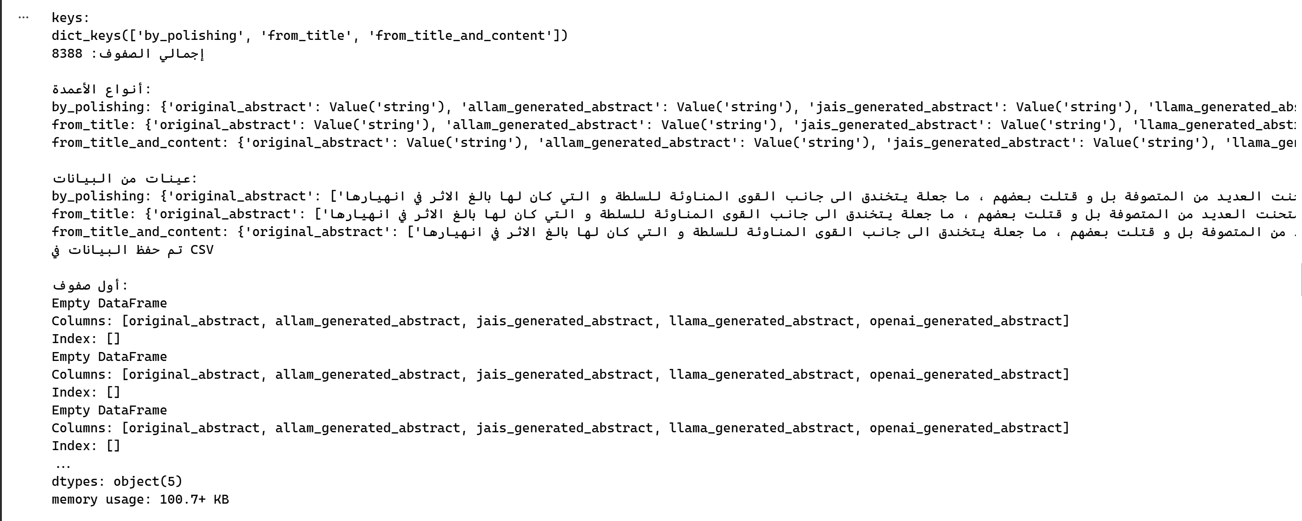
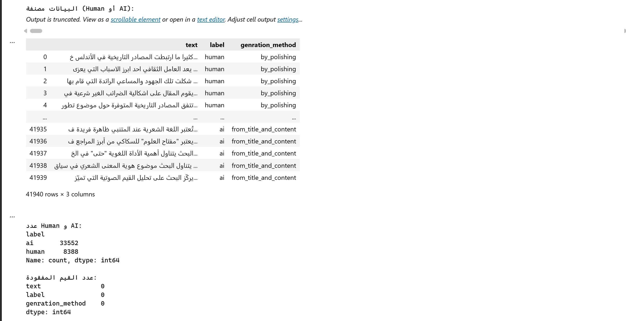
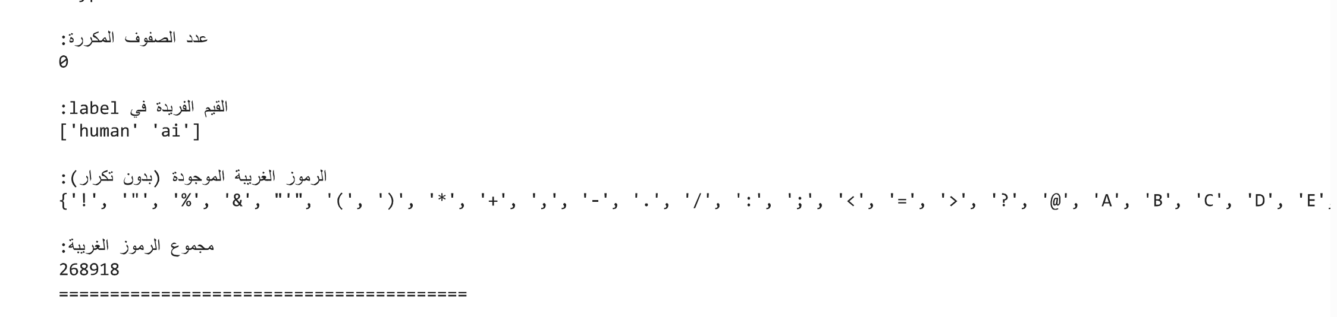

Data Preprocessing
- Normalized the letter Alef to a standard form
- Handling Missing Values
- Removed duplicate rows
- Removed common stopwords
- Removed punctuation and non-Arabic symbols, retaining only Arabic letters and digits.
- Stemmed words to their root
  - Feature Engineering
The table below explains the features used to prepare the model training data file, along with the reason for using each feature and its benefits.
Features:
Feature Number | Feature Name | Explanation | Reason For Using
14 | Hapax dislegomena Ratio: Ratio of words that appear exactly twice. | The feature measures the ratio of words that appear exactly twice within the text, reflecting how diverse and frequent the vocabulary is. | This feature helps in assessing the linguistic richness and writing style, and it can be useful in distinguishing between types of texts (AI or human)based on the repetition of words.
35 | Total number of paragraphs (P) | Counts the number of paragraphs inside the text before cleaning it and standardizing the commas. | The number of paragraphs gives an indication of the structural structure of the text and the way ideas are organized, which is useful for stylistic analysis or classification of texts.
56 | Adjective-to-Adverb Ratio: Ratio of adjectives to adverbs. | Measures the ratio of adjectives (ADJ) to adverbs (ADV) in the text using POS Tagging via the stanza library. | The link between adjectives and adverbs reflects the nature of the linguistic style and the semantic direction of sentences, and is considered an important linguistic property in the analysis of Arabic texts.
77 | Top 100 accumulative Zipf-like distribution | The ratio of repetitions of the top 100 words in the text compared to the total words is calculated according to distributions similar to the Zipf law. | This feature is useful for understanding the extent to which the text is based on repetitive and familiar words, which helps in distinguishing writing patterns and analyzing vocabulary repetition.
98 | BERT [CLS] Token Probability: Probability of the [CLS] token. | It measures the statistical value associated with the token representation [CLS], which represents the semantic summary of the text via the AraBERT model. | A powerful property because it exploits the capabilities of transformer models in capturing the general meaning and contextual representation of text. Excellent at classification or pattern detection tasks.
17 | Yule's K measure: Measures vocabulary richness. | This feature measures the variety of words in the text and whether the writer uses diverse words or repeats the same words. | The difference is illustrated by the fact that humans use a more varied and richer vocabulary, while AI-generated text contains a higher frequency of vocabulary.
38 | Average number of C/P | This feature measures the length of paragraphs, and based on this, the level of text complexity is assessed. | AI-generated text tends to use "formal" vocabulary and longer character counts, while humans mix long and short words irregularly. Therefore, the higher the value of this property, the more likely the text is AI-generated.
59 | Number of words found in the 500 positions within word  embedding (use corresponding word embedding aligned with the  used LLM model) | This property indicates the text density or length of content that the form can handle. | Human texts tend to be concise and brief, while artificial intelligence tends to be longer and more content-rich.
80 | Flesch–Kincaid Readability score | This property measures how easy the text is to read; the higher the property value, the easier the text is to read. In this project, the Flesch-Kincaid Grade Level (FKGL) was calculated, which represents the educational level required to read the text. | This feature was used because it shows that AI-generated text is organized and simple, and therefore gives a lower value, while human-generated text gives higher values ​​because human-generated text is more complex.
101 | Diacritic Presence Ratio: Ratio of diacritized characters to total characters. | This property is used to calculate the ratio of diacritics used in the text to the number of letters. | The purpose of using this feature is that AI-generated text uses a large number of diacritics, while humans, on the other hand, use diacritics only in rare cases and when necessary, such as to clarify the meaning of a particular word. The use of diacritics is almost nonexistent in everyday human texts.
18 | Simpson's Diversity Index | A score that calculates vocabulary diversity based on the probability of two random words being different. | To measure lexical richness; high scores mean varied vocabulary, while low scores indicate repetition.
39 | Average Words per Sentence | The average count of words found in a single sentence throughout the text. | To measure syntactic complexity; long sentences imply formal writing, while short ones suggest casual text.
60 | Unique Words (First 1000) | The number of distinct (unique) words found within the first 1,000 tokens of the text. | To allow a fair comparison of vocabulary richness across texts of different lengths.
81 | AraGPT2 LogRank | Uses the AraGPT2 model to calculate the text's "predictability" (average negative log-probability). | To detect AI-generated text; AI models find machine text predictable (low score), while human text is complex (high score).
102 | Detailed Diacritic Counts | Counts the frequency of specific Arabic marks (Fatha, Shadda, Tanwin, etc.) in the text. | To distinguish between formal Standard Arabic (heavy diacritics) and informal dialects (few diacritics).
Libraries:
Library Name | Where to Use | Why to Use
pandas | It is used to read, merge, clean, save CSV/XLSX data, and it was used to convert data to DataFrame and merge it, then storing the result | Because they are the most powerful in data processing (DataFrames)
pathlib | To organize and handle paths | To facilitate writing file paths in an organized way
IPython.display | Displaying a DataFrame inside a Notebook | To display data more clearly during analysis
collections.Counter | Used in the calculation of repetitions (words\ diacritics (tashkeel) \bigrams) | Because it is quick and easy to calculate repetitions
re (regex) | Extraction of strange symbols - demodulation - normalization, and also calculation of their proportions | Because regex gives high flexibility in text processing
nltk.stopwords | Removing Arabic stopwords | To reduce text noise
nltk.stem.isri | Used inside the text Preprocessing step to return the word to its original | Dedicated to dealing with Arabic morphology, suitable for processing on large volumes of texts.
nltk (general) | To download libraries stopwords – ngrams | Availability of important language tools
numpy | To calculate averages and support statistics | Because it is the basis of digital procesases
matplotlib.pyplot | Drawing statistics -WordCloud-n-grams | To create illustrations in the analysis
wordcloud | Creating a word cloud for texts | To visually display the most important words
os | Access folders and save results | Required when saving result files
openpyxl | Saving Excel files | To save your results inside various cheats
stanza | POS Tagging (extraction of adjectives-adverbs) | Because it is the best for Arabic in POS
math | Used in processing and managing batches | To calculate the number of batches
datasets | This library is used by the HuggingFace platform for handling big data. | It was used to load AI vs Human texts
tqdm | A library to display a progress bar during the execution of long loops. | It was used in properties that take a long time to determine where the code has reached in the download.
transformers | HuggingFace's core library for running Language Models (LLMs). | It used to be called BERT, AraBERT and other models.
torch (PyTorch) | It was used as a backend infrastructure to run transformer models, handle tensors, and use GPUs. | Because it is the Deep Learning library on which the BERT and GPT models rely for calculating gradients and training on the graphics card (GPU).
gc (Garbage Collector) | Used with very large embeddings and with loops and RAM-intensive transformer loads. | It was used inside loops
arabic-reshaper & python-bidi | Used with drawing libraries (Matplotlib/WordCloud). | To solve the problem of Arabic letters appearing disconnected or reversed in graphs and word clouds.
amiri_font.ttf | It was downloaded and used in Part 1 with the matplotlib and wordcloud drawing libraries. | This is not a software library but an Arabic font file (Amiri Font). It was used to solve the problem of empty boxes appearing when drawing Arabic text in diagrams and word clouds, as the default fonts do not support Arabic well.
matplotlib | It was used in both stages to draw the graphs. | Drawing Confusion Matrices and Training Loss Curves to visually illustrate model performance.
seaborn | It was used in conjunction with matplotlib to improve the appearance of the graphics. | To draw heatmaps of the confusion matrix and illustrate feature importance in an aesthetically pleasing and readable manner.
zipfile | Used at the end of each stage. | To compress files and folders (reports, forms, data) into a single .zip file ready for download and delivery.
warnings | It was used in Part 1, specifically before the start of the drawing and data analysis (EDA) processes. | To ignore unnecessary warning messages that appear while running code, making the report outputs and graphs cleaner and clearer.
sklearn | It was used extensively in the second part for data segmentation, training traditional ML models, and calculating performance metrics. | Because it has powerful classification algorithms (SVM, Random Forest, Logistic Regression), evaluation tools (Accuracy, F1-Score, Confusion Matrix), and transformation tools (StandardScaler).
wordcloud | Used at the end of Part One (EDA). | To create word clouds that show the most frequently used words in human texts versus artificial intelligence texts.
sys | It was used at the beginning of Part 2 when preparing the project structure. | To handle system variables and the Python Interpreter. It is often used in data science projects to add folder paths (such as the src folder) to the system path so that Python can recognize the software modules located within them.
joblib | Used at the end of Part 2. | To save the trained models (SVM, Random Forest) and Scaler on disk in .pkl format for later reuse without retraining.
time | It was used in Part 2 when training SVM and Random Forest models. | To calculate the time taken during the training process (Execution Time), the start and end times are recorded to calculate the duration in minutes or seconds and evaluate the model's efficiency.
accelerate | It was installed in the second part of the BERT training. | To speed up the training of Transformers models and improve memory management and the efficiency of computational operations on the GPU.

Modeling Selection
Model Name | Model Type
Stanza Arabic POS Pipeline | Linguistic Processing Model (POS Tagging)
AraBERT Base v02 | Deep Learning -Transformer-based Model
aragpt2-medium | Causal Language Model (GPT-2)
BERT (Used as Tokenizer) | Masked Language Model (Transformer)

Results & Analysis
- Experimental Overview
In this part, we aimed to evaluate the efficacy of four distinct machine learning algorithms in the task of distinguishing between human-authored Arabic text and content generated by Artificial Intelligence. The experiment utilized a substantial dataset comprising 41,937 samples, which underwent a rigorous stratified splitting process to ensure class balance; specifically, 70% of the data was allocated for training, 15% for validation, and the final 15% for independent testing .
The evaluated models included
- Logistic Regression (serving as a baseline)
- Support Vector Machine (SVM)
- Random Forest
- and finally, the deep learning model (AraBERTv02).
- Comparative Model Performance (Test Phase)
The final assessment on the held-out test set revealed significant disparities in predictive capabilities among the models. The BERT model demonstrated near-absolute dominance across all performance metrics, followed by the Random Forest classifier, which proved remarkably effective despite relying on traditional feature engineering.
Model | Accuracy | F1-Score (Target: AI) | Precision (AI) | Recall (AI) | ROC-AUC
BERT | 99.63% | 0.9977 | 0.9980 | 0.9974 | 0.9994
Random Forest | 98.59% | 0.9911 | 0.9936 | 0.9887 | 0.9954
SVM | 95.77% | 0.9738 | 0.9656 | 0.9821 | 0.9846
Logistic Regression | 94.45% | 0.9649 | 0.9780 | 0.9521 | 0.9796
The reason for the superiority of the BERT model is that the three classic models (LogReg, SVM, and RF) do not read the text itself, but rather its statistics. What distinguished RF from the others was its ability to capture complex non-linear relationships in properties, for example, the relationship between "intensity" and whether the text is human-generated.
Returning to the reason for the superiority of the BERT model, it is a model pre-trained on vast quantities of Arabic text. Therefore, it does not only concern itself with the number of vowel marks (fathas and dammas) but also understands the context of the words and their relationships to one another.
Observations: 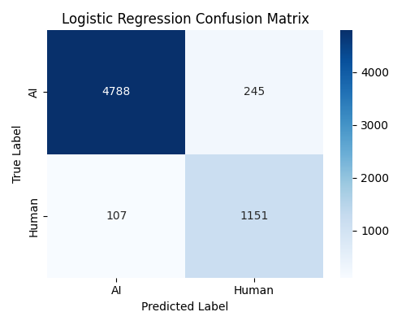
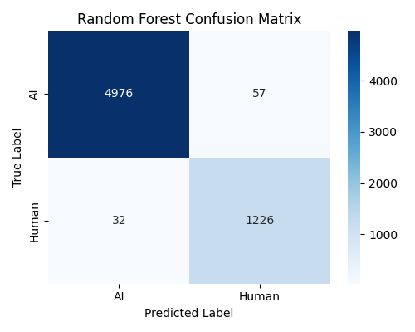

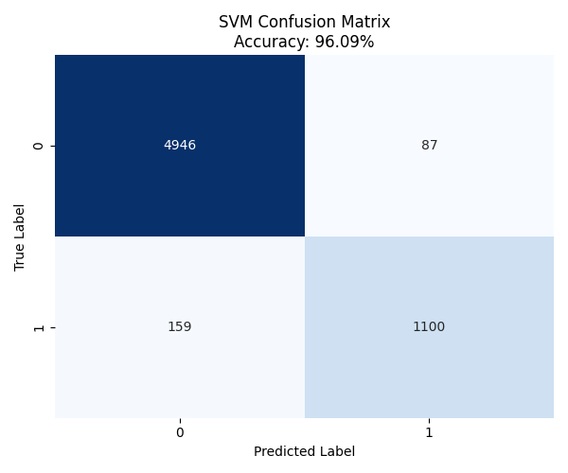
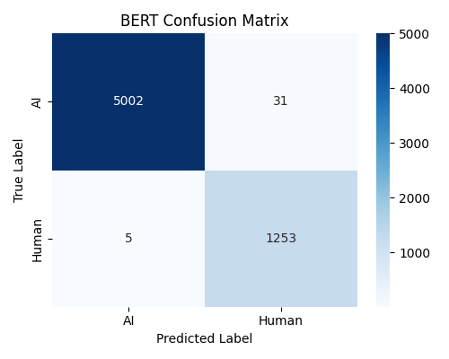

The preceding graphs confirm the observations made:
They demonstrate the superiority of deep learning: the BERT model achieved an exceptional accuracy of 99.63% and a near-perfect ROC-AUC value of 0.9994, reflecting its superior ability to capture subtle semantic and contextual differences often missed by traditional models.
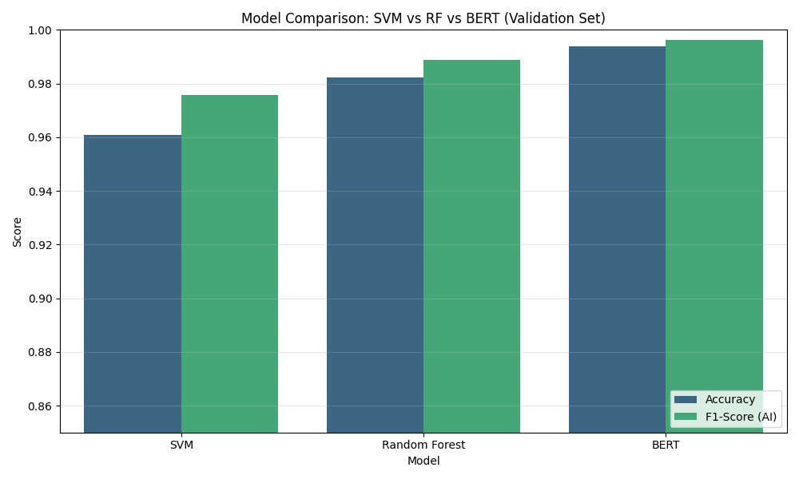
They also demonstrate the effectiveness of engineered features, which helped classical models achieve impressive results. Notably, the random forest model achieved a high accuracy of 98.59%, significantly outperforming both SVM and logistic regression. This indicates that manually extracted linguistic features (such as morphology and text statistical properties) possess high discriminatory power.
Analysis by interrogating the "feature importance" metrics within the Random Forest model, we were able to interpret the linguistic factors driving classification. The analysis highlighted that Arabic Diacritics (Tashkeel) played the most pivotal role in distinguishing the sources of the text
The top three most influential features were:
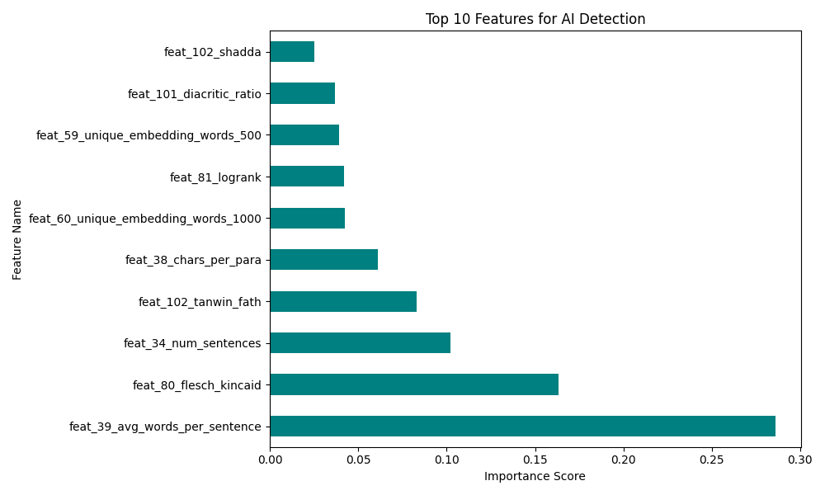
Therefore, we analyzed the key metrics that contributed to these impressive results in both classical models like RF and the BERT deep learning model.
By analyzing feature significance metrics within the random forest model, we were able to explain the linguistic factors driving the classification process.
The analysis highlighted that the average number of words per sentence (feat_39_avg_words_per_sentence) was a pivotal factor in distinguishing between AI-generated texts and those written by humans, followed by the Flesch_Kincaid metric (feat_80_flesch_kincaid), which measures the readability of the text.
- Training Dynamics (BERT)
Returning to the BERT model, which achieved the highest accuracy, the BERT training records showed high convergence stability across the three phases. Training and validation losses decreased steadily, with the final validation loss reaching approximately 0.029. Simultaneously, validation accuracy peaked at 99.46% during training, confirming that the model did not suffer from over-allocation, although it did experience a small error rate, which will be discussed in the following section.
- Error Analysis
As we mentioned previously and as the previous diagrams showed, the BERT model had a small error rate. In order to gain a deeper understanding of the model's limitations, we conducted a thorough examination of the cases where the BERT model failed, where the error rate was marginal and amounted to 0.54%, which represents only 34 misclassified samples out of 6292 samples in the validation set.
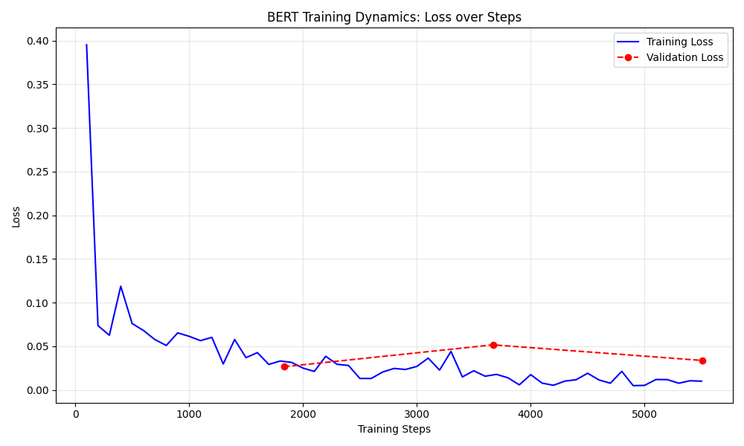
To discover the cause of the error, we printed a small sample of the error, which revealed interesting cases such as the text containing the phrase " مبدأ المسؤوليات المشتركة" " رصد واقع اللغة العربية" and " الدراسة الميدانية تمظهرات".
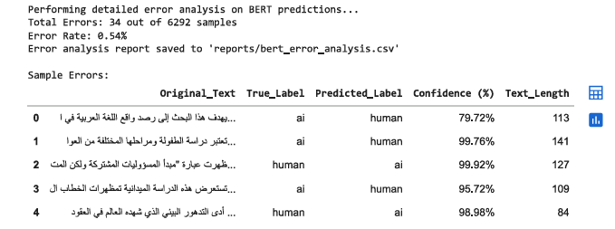
We observed that all the texts tended toward a rigid and emotionless style, a style humans use for academic writing. However, the model predicted this as AI-generated, as it is inclined toward this type of writing. Humans, on the other hand, tend to express some emotion, or their emotions are unconsciously reflected in their written text. This misled the model and caused it to make incorrect predictions.

6 Conclusion
In conclusion, the empirical evidence confirms that Deep Learning (BERT) provides the state-of-the-art solution for this specific detection task, maximizing both precision and recall. However, the Random Forest model serves as a robust, lightweight alternative that sacrifices less than 1.1% in accuracy while offering valuable interpretability regarding the linguistic features—specifically the critical role of average number of words per sentence —that distinguish AI-generated content.

References
Eric Mitchell, Y. L. (2023, July 23). DetectGPT: Zero-Shot Machine-Generated Text Detection using Probability Curvature. Retrieved from arxiv: https://arxiv.org/abs/2301.11305
Sebastian Gehrmann, H. S. (2019, July). GLTR: Statistical Detection and Visualization of Generated Text. Retrieved from aclanthology: https://aclanthology.org/P19-3019/?
Vivek Verma, E. F. (2024, April 5). Ghostbuster: Detecting Text Ghostwritten by Large Language Models. Retrieved from arxiv: https://arxiv.org/abs/2305.15047?

