|  |  |
| --- | --- |
|  | Lebanese American University  **Department of Computer Science and Math** |

***Name* :**Manal Diab

***Topic* :** Assignment 1

***Instructor* :**Mr. Elie Haddad

1. **Relative VS absolute position in CSS**

***What is relative position in CSS ?***

Position: relative means that the element is on its normal position

**What is absolute position in CSS ?**

Position: absolute means that the element is in the nearest position ancestor.

**Example:**

* When we apply relative position, the element remains in its normal position:

*Before applying it*



*After applying it*

 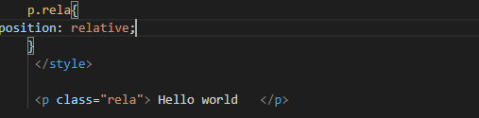

Same thing!

* When we apply absolute position

*Before applying*



*After applying*



We can recognize the second hello world moves near to the first one.

1. **CSS box sizing and more precisely margin vs padding**

**CSS box sizing**

Box sizing defines the size of the width and the height of the element , it includes padding and border as well.

When we set the box sizing to the border-box we guarantee that the element size includes border and paddings. With box sizing the element does not appear bigger than what it should be.

box-sizing: border-box;

is the most popular option for box sizing, because it guarantees that the **content box shrinks** to make space for the padding and borders.

We have 2 options :

**Content box**

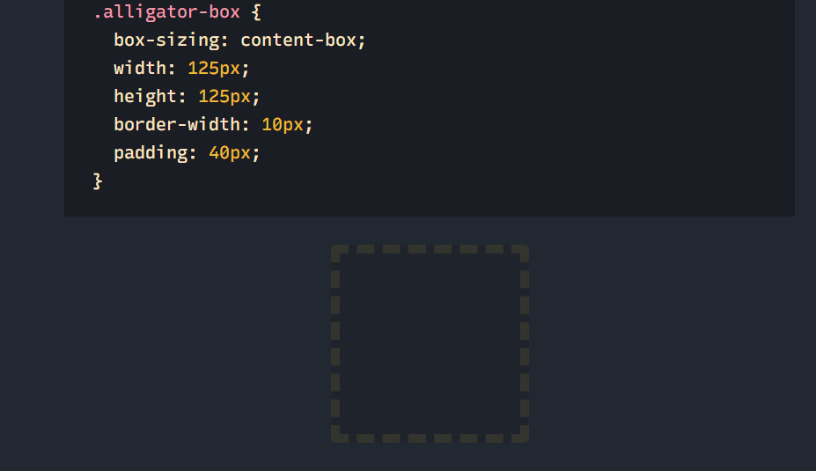

**Border box**

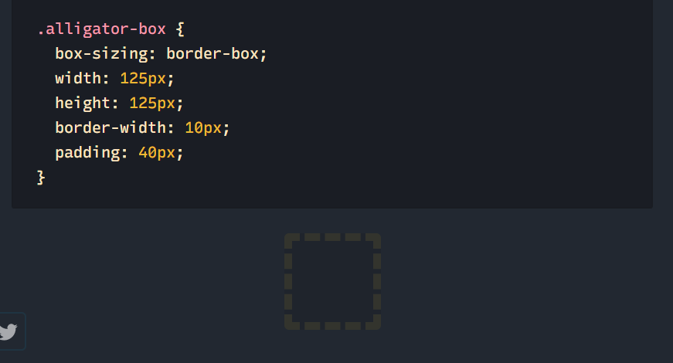

***What are the border ,padding ,height ,margin and width of the element?***

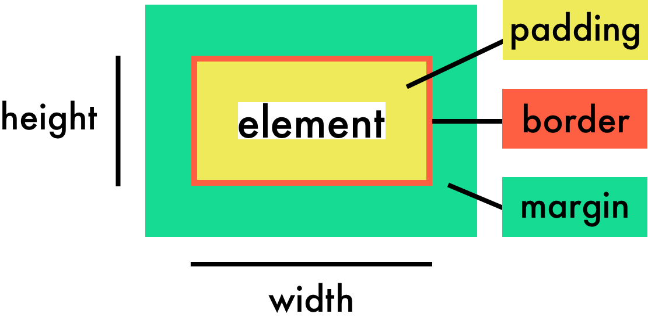

**Margin in CSS**

Margin in CSS is used to generate space **around the element** (as shown in the previous fig.)

We have different type of margins :

Margin top

Margin right

Margin left

Margin bottom

**Padding in CSS**

Padding in CSS is used to generate space **around the element’s content** (as shown in the previous fig.)

We have different type of padding :

Padding top

Padding right

Padding left

Padding bottom



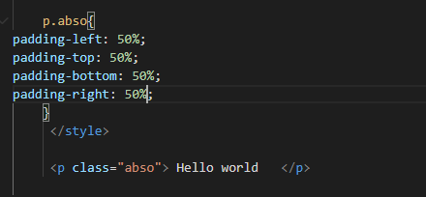

Because we want hello world appears in the center of the page, we set all paddings to 50 %.

* Margin is the outer space of the element(outside element’s border ), however padding is the inner space(inside element’s border).
* 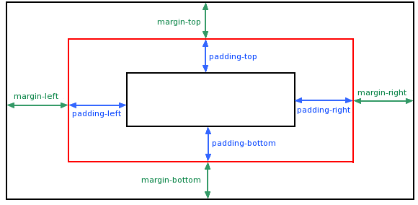

Border sizing include specific padding by default

**Sources :**

[*stackoverflow.com*](https://stackoverflow.com/questions/5958699/difference-between-margin-and-padding#:~:text=It%20is%20good%20to%20know%20about%20the%20differences%20between%20margin%20and%20padding%20.&text=Margin%20is%20the%20outer%20space,space%20inside%20of%20its%20border.)

*Alligator.io*

*w3schools.com*