1. **Creating and Renaming Files/Directories**

* Create a directory named test_dir using mkdir.

mkdir is used to create new directory.

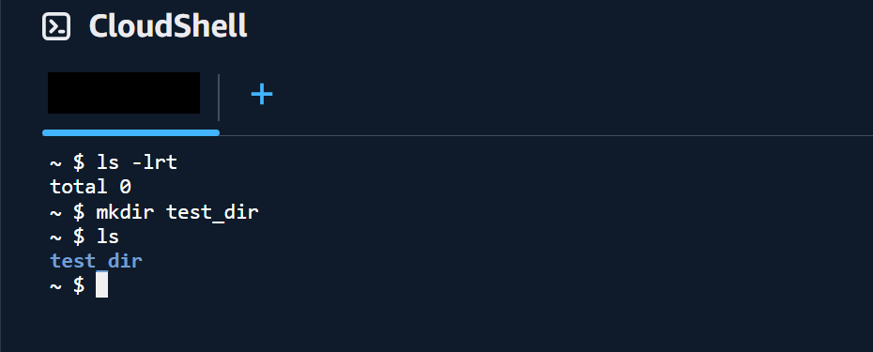

* Inside test_dir, create an empty file called example.txt.

touch is used to create any file, and cd is used to change the directory.

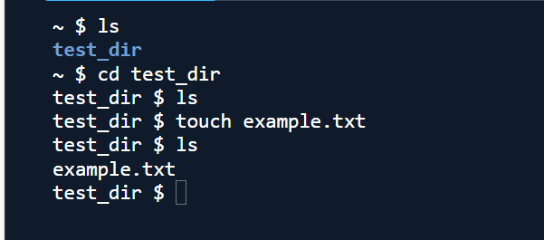

* Rename example.txt to renamed_example.txt using mv

mv command is used to rename any file name or move any file from one location to another.

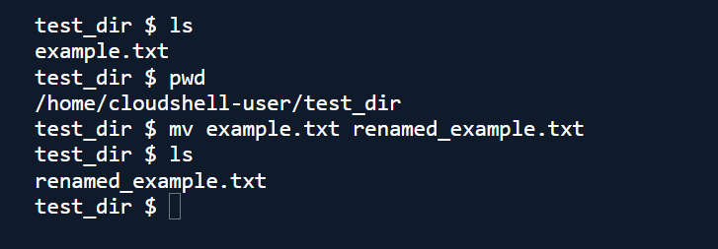

2. Viewing File Contents

* Use cat to display the contents of /etc/passwd.

cat is used to view file contents without opening the file.

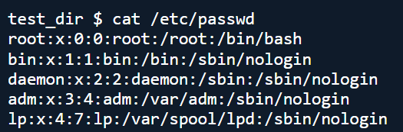

* Display only the first 5 lines of /etc/passwd using head.

head shows first lines and we can also parameterize how much lines to show

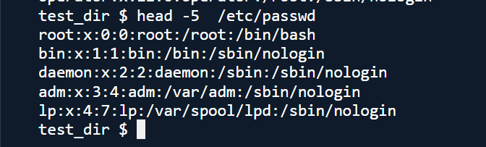

* Display only the last 5 lines of /etc/passwd using tail.

tail shows last lines and we can also parameterize how much lines to show

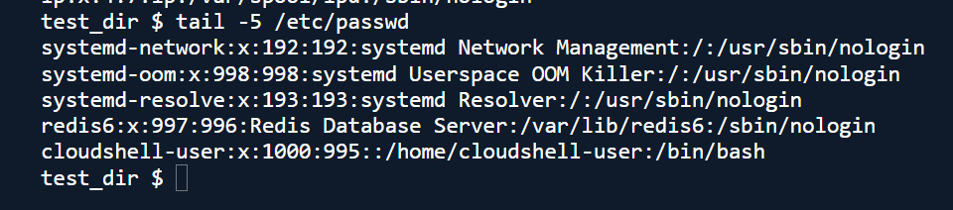

3.Searching for Patterns

* Use grep to find all lines containing the word "root" in /etc/passwd.

Grep helps to get patterns from files.

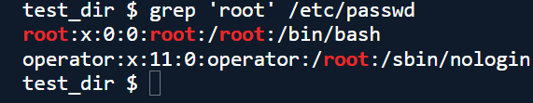

4. Zipping and Unzipping

* Compress the test_dir directory into a file named test_dir.zip using zip.

Zip to compress the file /folder

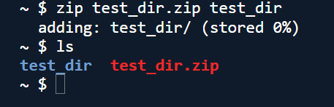

* Unzip test_dir.zip into a new directory named unzipped_dir.

Unzipping the zip file is done by unzip command

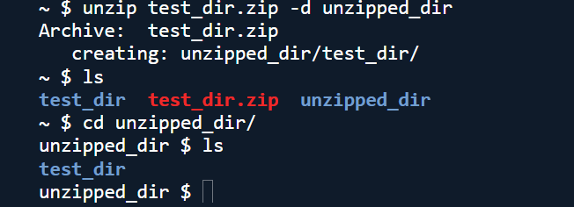

5. Downloading Files

* Use wget to download a file from a URL (e.g., <https://example.com/sample.txt>).

Performed the following command

wget https://getsamplefiles.com/download/txt/sample-1.txt

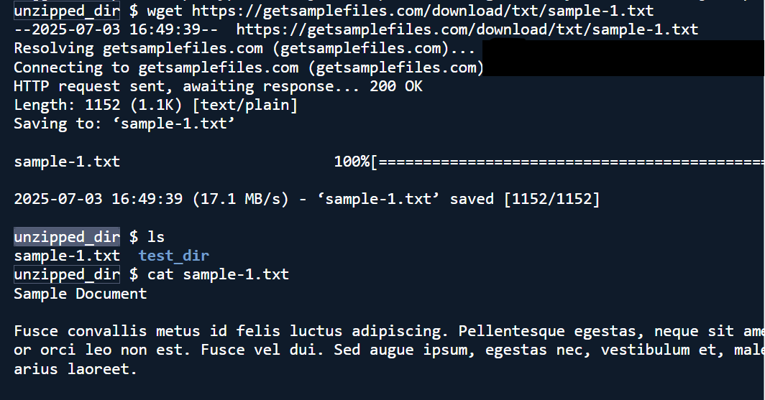

6. Changing Permissions

* Create a file named secure.txt and change its permissions to read-only for everyone using chmod.

Touch to create new file and chmod to change permissions

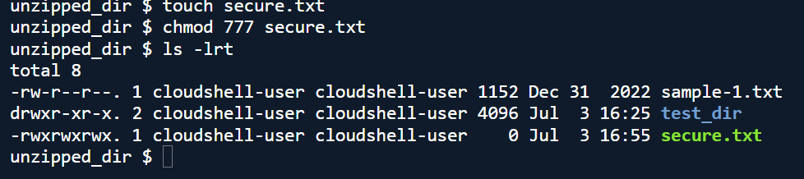

7. Working with Environment Variables

* Use export to set a new environment variable called MY_VAR with the value "Hello, Linux!".

