Name

**[Email address]**

**Forecast of Household Electricity Demand**

Contents

Introduction 2

Dataset 2

Models for electricity demand forecasting 2

LSTM 2

ARIMA 3

EDA 3

Model Outputs 6

Results 8

References 8

# Introduction

India is the 3rd biggest producer and consumer of electricity in the world. As of March 31, 2020, the electricity generation of India's national electric grid was 370.106 GW. Large hydropower facilities are included in the category of renewable power plants, which make up 35.86% of generation capacity in India. The gross power produced by utilities in India for the 2018–19 fiscal year was 1,372 TWh, and the nation as a whole (utilities and non–utilities) produced 1,547 TWh. 2018–19 had a gross power consumption of 1,181 kWh per person. Agriculture had the largest recorded global electric energy use (17.89 percent) in 2015–16. Despite India's low electricity rate, its per capita electricity usage is low compared to that of the majority of other nations. Every sector has seen the effects of the lockdown on economic activity as a result of the recent COVID-19 emergency, during which everyone was placed under lockdown for the months of April and May. We developed a plan to research the influence on energy consumption state and region-wise due to the importance of power consumption to the nation.

# Dataset

The dataset provides a comprehensive illustration of energy use at the state level. The 17-month time span between the 2nd of January 2019 and the 23rd of May 2020 is represented by content data in the form of a time series. Dates are used to index rows, and states are represented in columns. Together, the rows and columns of each datapoint represent the amount of electricity consumed in MU by the specified state on the mentioned date.

# Models for electricity demand forecasting

## LSTM

Recurrent neural networks have units or blocks called long short-term memory (LSTM). Certain artificial memory techniques are made to be used by recurrent neural networks, which can aid these artificial intelligence programs in more accurately mimicking human reasoning.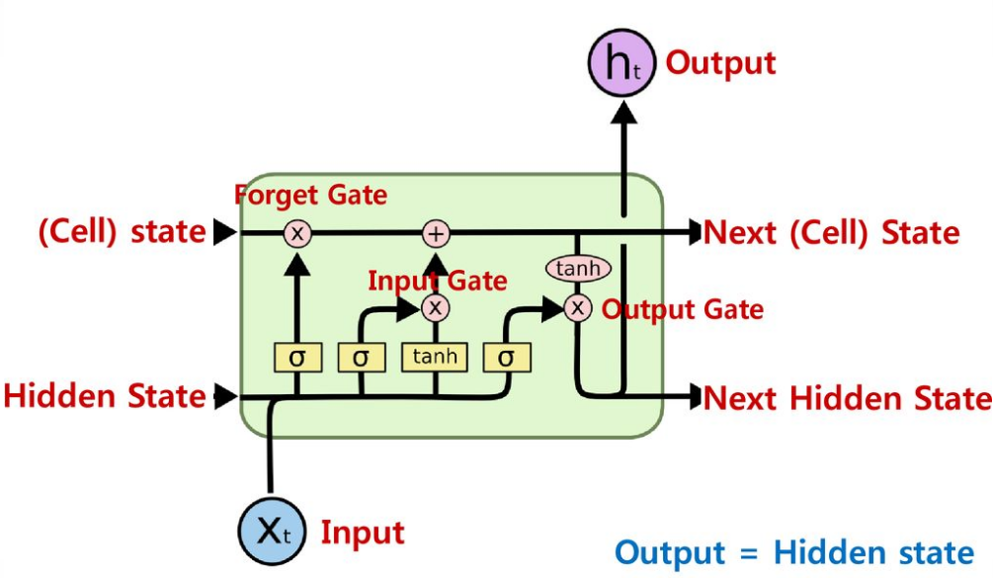 Long short-term memory blocks are used by the recurrent neural network to offer context for how the program receives inputs and produces outputs. A complicated structure, the long short-term memory block has several parts, including weighted inputs, activation functions, inputs from earlier blocks, and ultimate outcomes.

Since the program uses a structure built on short-term memory processes to build longer-term memory, the unit is known as a long short-term memory block. Examples of applications for these systems include natural language processing. In order to evaluate a word or phoneme in relation to other words in a string—where memory might be helpful in sorting and categorizing these types of inputs—the recurrent neural network uses lengthy short-term memory blocks. LSTM is a widely accepted and utilized idea in the development of the first recurrent neural networks.

## ARIMA

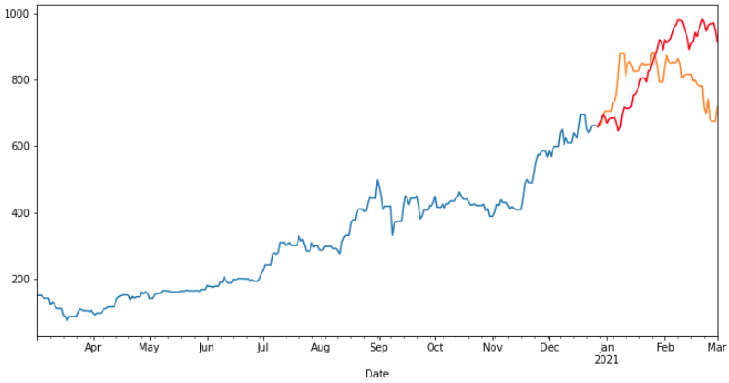

A statistical analysis model called an autoregressive integrated moving average, or ARIMA uses time series data to either better comprehend the data set or forecast future trends.

If a statistical model forecasts future values using data from the past, it is said to be autoregressive. For instance, an ARIMA model might try to anticipate a company's profitability based on previous periods or try to predict a stock's future pricing based on its historical results.

# EDA

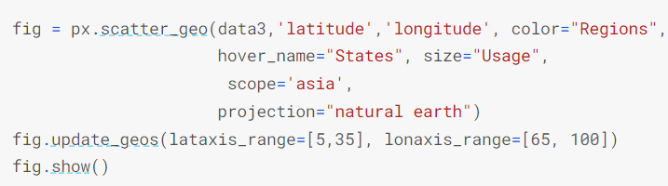

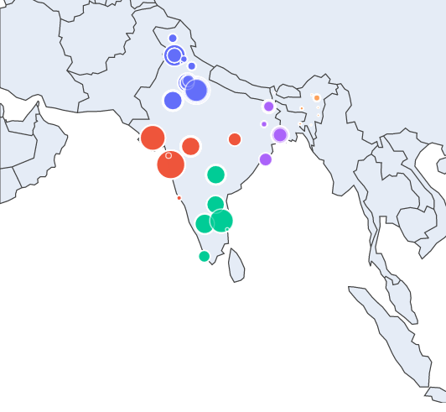

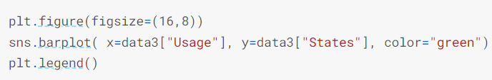

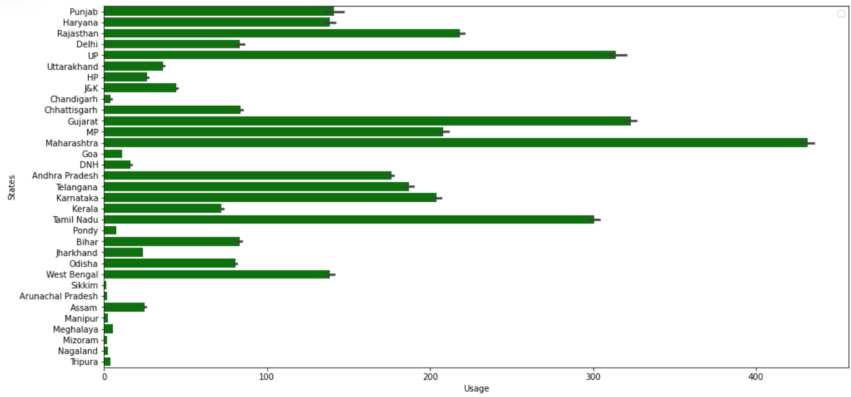

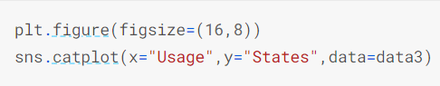

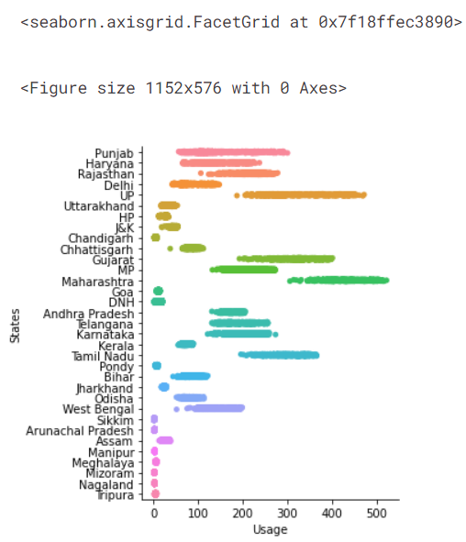

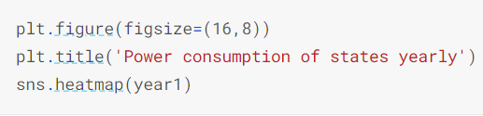

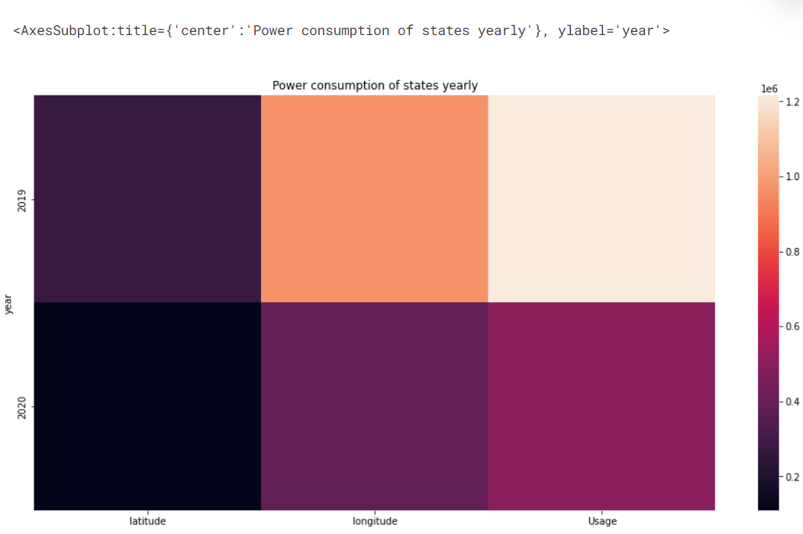

# Model Outputs

ARIMA

We will analyse the results for the state of Maharashtra

1. Checking the trend and seasonality

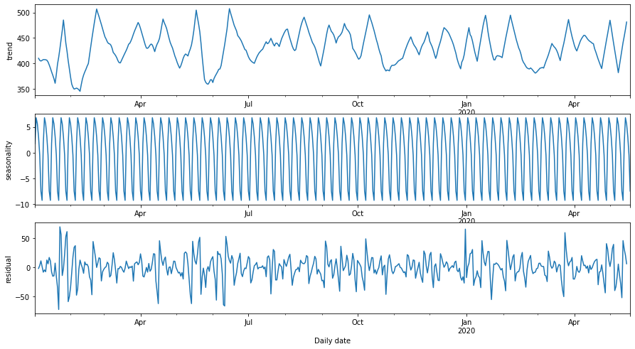

1. Checking the stationarity of the ts using Dickey-Fuller test

Test Statistic -6.567135e+00

p-value 8.105968e-09

#Lags Used 7.000000e+00

Number of Observations Used 4.950000e+02

Critical Value (1%) -3.443630e+00

Critical Value (5%) -2.867397e+00

Critical Value (10%) -2.569889e+00

dtype: float64

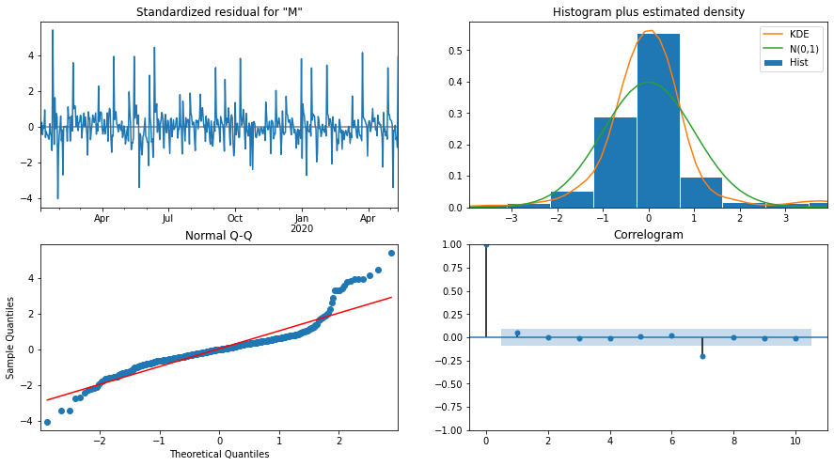

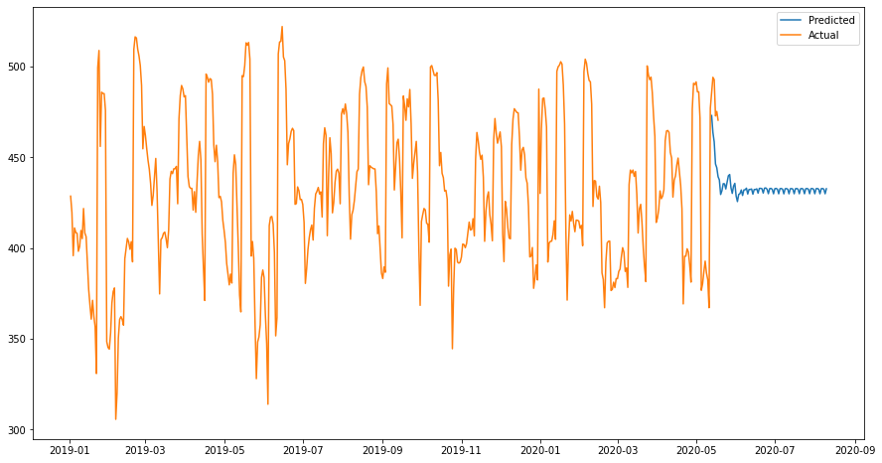

Plotting and comparing the results

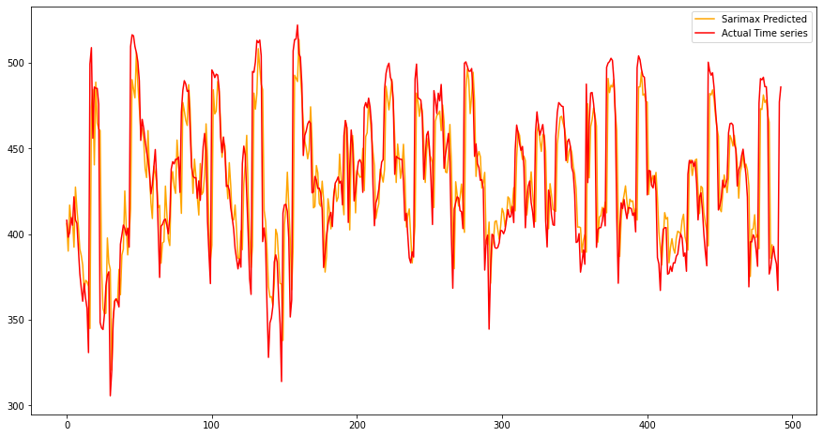

LSTM

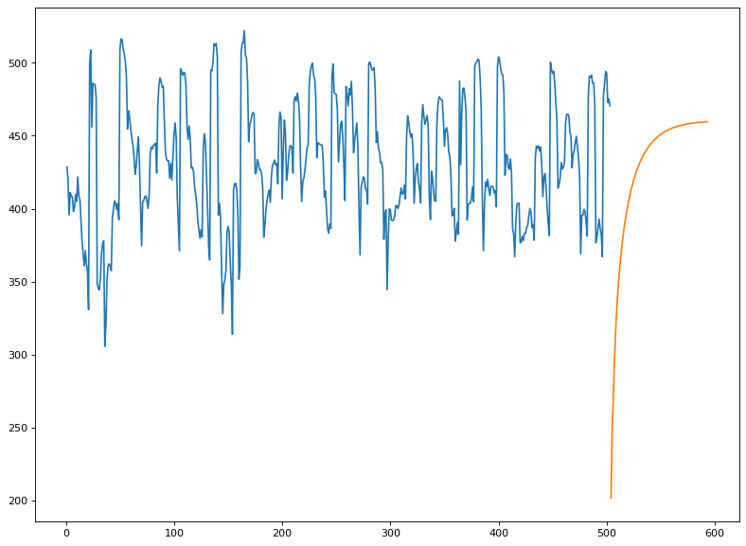

# Results

We have analyzed the top 3 and bottom 3 states as per usage. In other words, forecast usage for these in the next quarter.

Building models: There will essentially be two models. These are the processes for creating a model. In the case of ARIMA, the steps are as follows: first, determine the PQD order; second, perform correlation and partial autocorrelation; third, divide the train and test data; fourth, assess the efficacy of testing; and fifth, forecast the coming quarter. Scaling the data, dividing it into train and test runs, defining epoch loss, and specifying the output based on the input and prediction are all LSTM-related steps.

# References

* <https://www.techopedia.com/definition/33215/long-short-term-memory-lstm>
* <https://www.investopedia.com/terms/a/autoregressive-integrated-moving-average-arima.asp#:~:text=An%20autoregressive%20integrated%20moving%20average%2C%20or%20ARIMA%2C%20is%20a%20statistical,values%20based%20on%20past%20values>.