Issues
- the sticky notes tape cannot be seen in light mode

Fix
- the prayer posted in wall is connected to prayer list, it should also have an option to add this as a private or public but public by default.
- They can add the post of other people to their own prayer list
- add function where the color of the post can be customizable in selected light colors so it contrast good with the text
- on the profile, place the name on the right side of the image, also add a frontend for like Prayer Partners(friends), and Following(change it to whatever is applicable to bible terminologies)

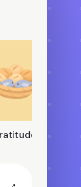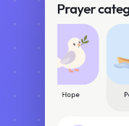fix the sides of this selector because it has like cut and does not extend to the sides, which supposed to extend

-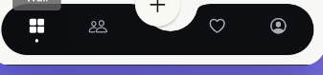Instead of bouncing motion when click use other like rotating, zoom in zoom out
-also on web view the + button conatiner is offset again
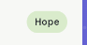 I don’t want the tags on the right

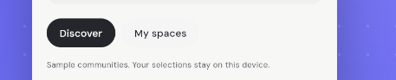instead of button selector make it like 2 tabs, the ui design is like the real bible tag where people can easily see the chapter of the bible, kindly look up for that idea and try to visualize the idea and apply it here

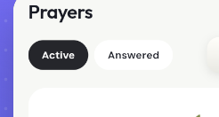 apply the same design idea above here

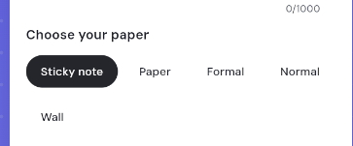
Put this selector on top of the preview
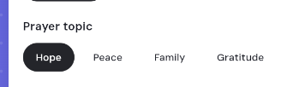
the prayer topic should be below the input boxes
Instead of save to wall, make it publish

Make the modal height from this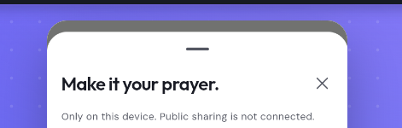to this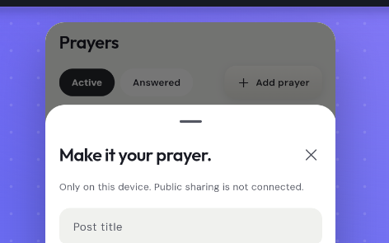
Because its too high, some device hides it to dynamic island
fix also redundancy, there is so many add prayer button.
also put a selector if the prayer will show 1 day, 1 week, 1 month, a specific date or infinite. But the owner can put it into his archive
show this as the output app, no wordings for instruction or sample sample text instrctuons.
the space means like their own community, just make a 3 place holder community for debugging, for Family, Young People, School Friends

