Amazon Website

Course - Web Application Programming (WEB120)

Instructor - Kadeem Best

Done By - Manal Solanki (N01397767)

Project GitHub Link -

<https://github.com/manalsolanki/Amazon-Assignment>

Project Heroku Link -

<https://amazon-website-assignment.herokuapp.com/>

DATABASE DESIGN –

* Create 1 separate module file to encapsulate static data
* This Java Script file represents model for my MVC

**Category DB**

|  |  |
| --- | --- |
| Column | Description |
| Unique ID | This gives a unique identifier to each category. |
| Name | Displays the name of the category. |
| Image | Displays the image title. |

**Product DB**

|  |  |
| --- | --- |
| Column | Description |
| ID | This gives a unique identifier to each product. |
| Name | Displays the name of the product. |
| Img | Displays the image title. |
| price | Displays the price of the product. |
| Featured | A Boolean attribute describing if it is a best seller product. |

Features:

Designed the dynamic webpages that listens to incoming HTTP Requests with the help of Express web server.

1. **HOME Page**

It has Header and the Navigation Bar and, a banner image depicting promotion of a trending product.

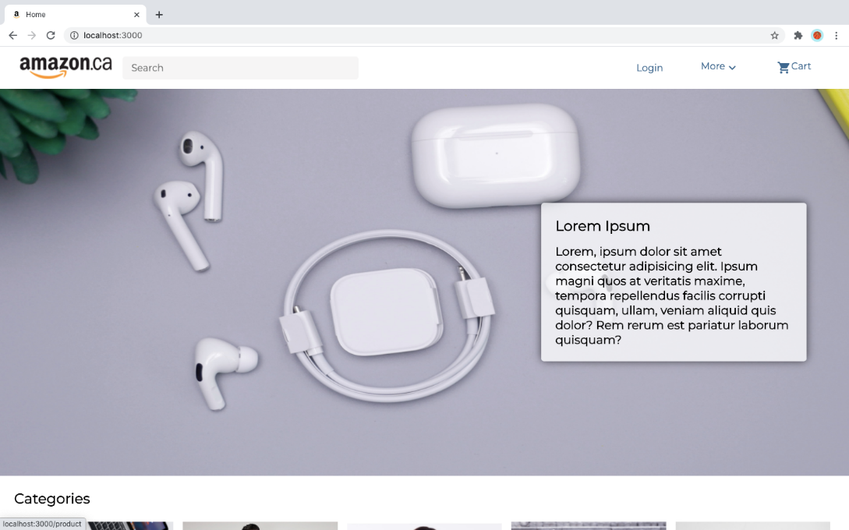

**Categories Section**

The Categories section exhibits different categories where the data of each section is fetched using static database (Category DB). The data fetched are name and image path.

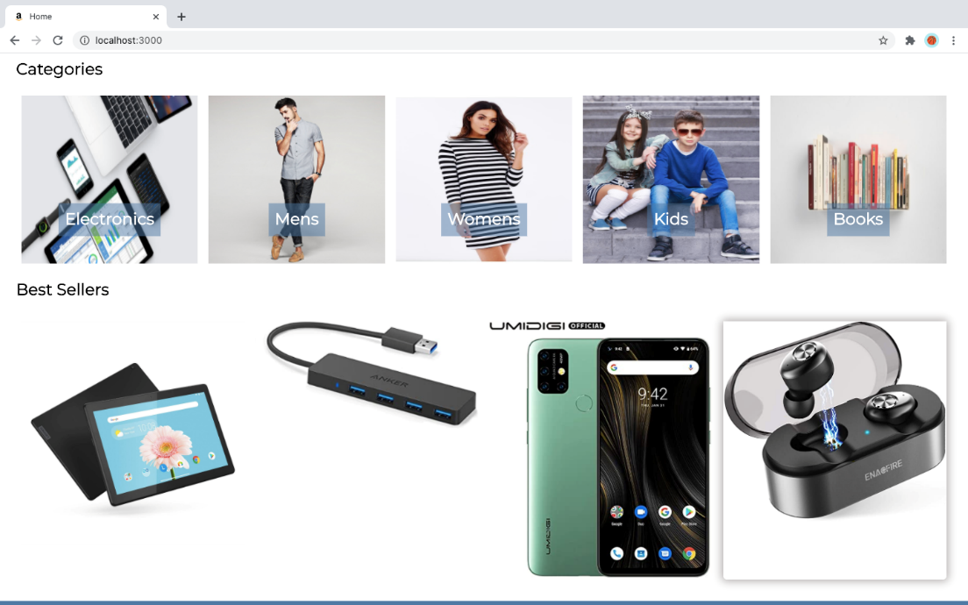

**Best Seller Section**

The Best Seller Section illustrates only the featured products from the Product DB.

**Footer Section**

This is the common footer section designed for all the pages across the website.

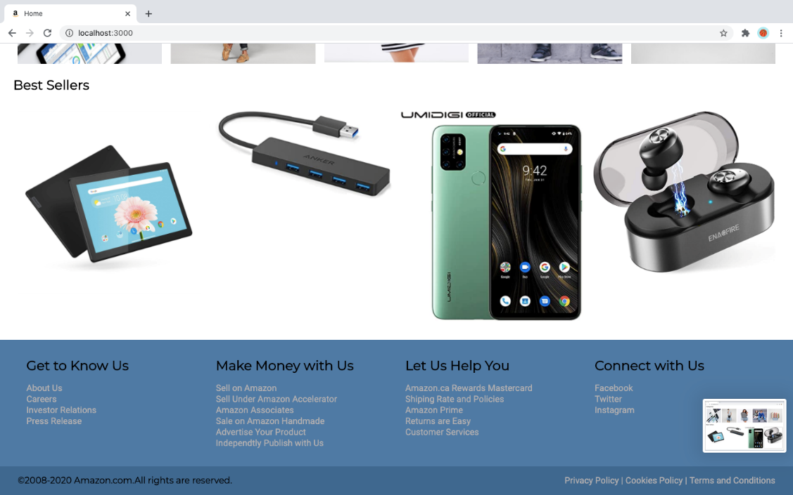

1. **Products Page**

The electronic category demonstrates the different products which are fetched from the database with attributes Name, image path, price and featured.

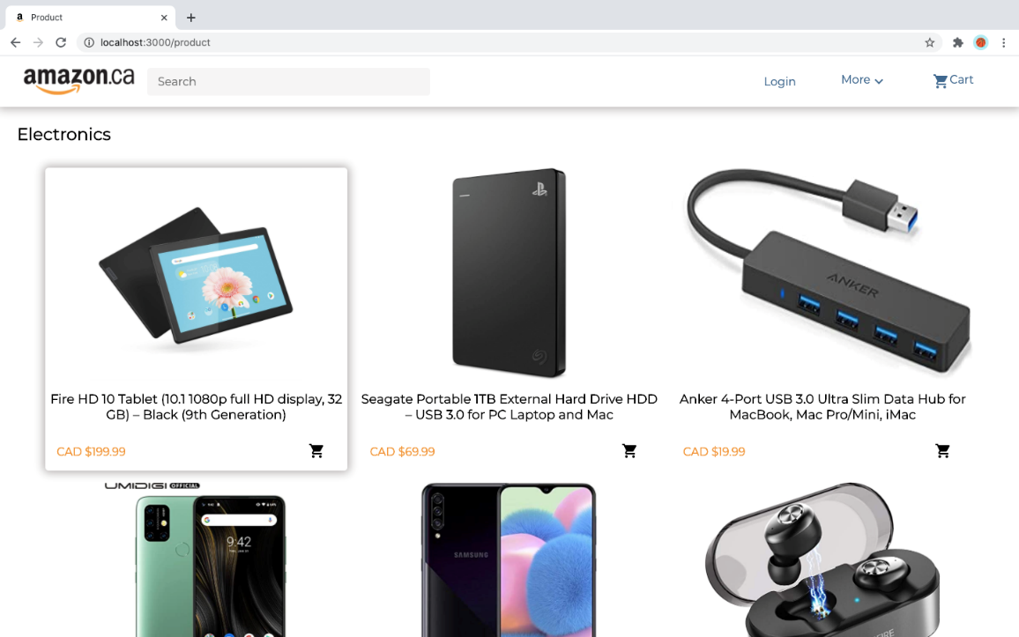

1. **Customer Registration**

This exemplifies the functionality of a new registration statically.

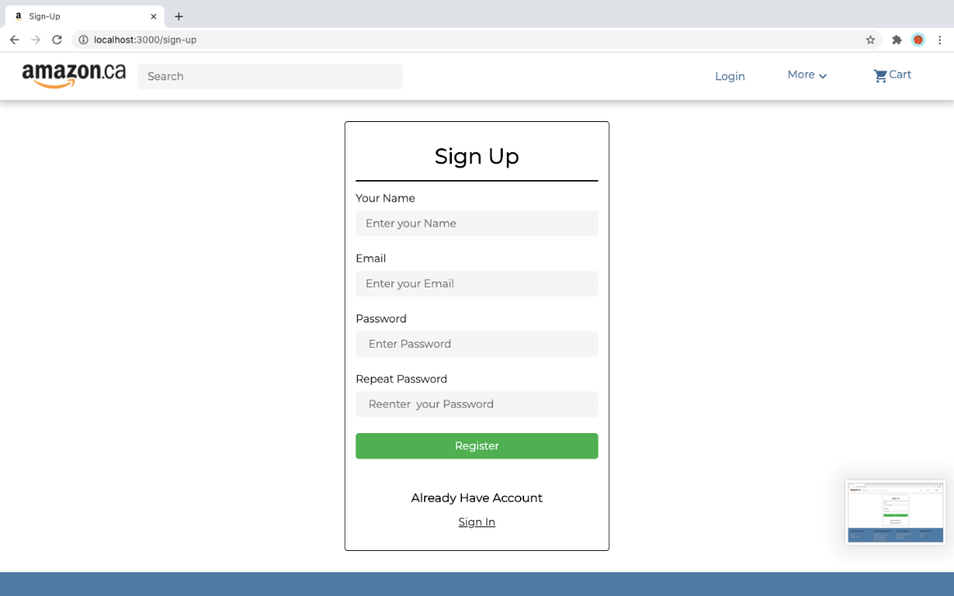

1. **Login Page**

This page is a standard login page designed statically.

