Restaurant Market Analysis
& Rating Prediction

Zomato Restaurant Dataset • Python Data Science Project

Prepared by: Mnami

Date: October 12, 2026

1. Project Overview
This project performs a comprehensive market analysis of restaurants listed on the Zomato platform, covering ratings, pricing, cuisine types, and geographic distribution. The primary deliverable is a machine-learning classifier that predicts a restaurant's rating category (Low / Medium / High) from operational features such as price range, cuisine type, city, vote count, and service availability.

Objectives:
- Analyse rating, price, cuisine and location distributions in the dataset.
- Identify which price ranges, cuisines and cities perform best on average rating.
- Train and compare two classification models (Random Forest vs Gradient Boosting).
- Deploy the best model as a REST API (Flask) and interactive dashboard (Streamlit).
- Provide actionable business insights derived from real data.

2. Dataset Description
Source: Zomato Restaurant Dataset (CSV)
Raw shape: 9,551 rows × 21 columns | After cleaning: 7,331 rows

Key Columns:
Column | Type | Description
Restaurant ID | Integer | Unique restaurant identifier
Restaurant Name | String | Name of the restaurant
City | String | City where restaurant is located
Cuisines | String | Comma-separated cuisine types
Average Cost for two | Integer | Average meal cost for two people
Price range | Integer | Price tier (1=Budget to 4=Luxury)
Aggregate rating | Float | Overall rating (0–5 scale)
Votes | Integer | Number of user votes/reviews
Has Table booking | String | Whether table booking is available
Has Online delivery | String | Whether online delivery is offered
Rating text | String | Text label for the rating
Country Code | Integer | Country code of the restaurant

Data Quality Summary:
• Missing values: 9 in 'Cuisines' (dropped); 0 in other key columns
• Duplicate rows: 0
• Unrated restaurants (rating=0) removed: ~2,200 rows
• Cost outliers (>99th percentile) removed: ~93 rows

3. Exploratory Data Analysis

3.1 Rating Distribution
The dataset contains restaurants from multiple countries and cities. After removing unrated entries, the average aggregate rating is 3.435 out of 5.0. Only 18.39% of restaurants achieve a High rating (≥4.0), indicating that top-rated restaurants are a genuine differentiator in the market.
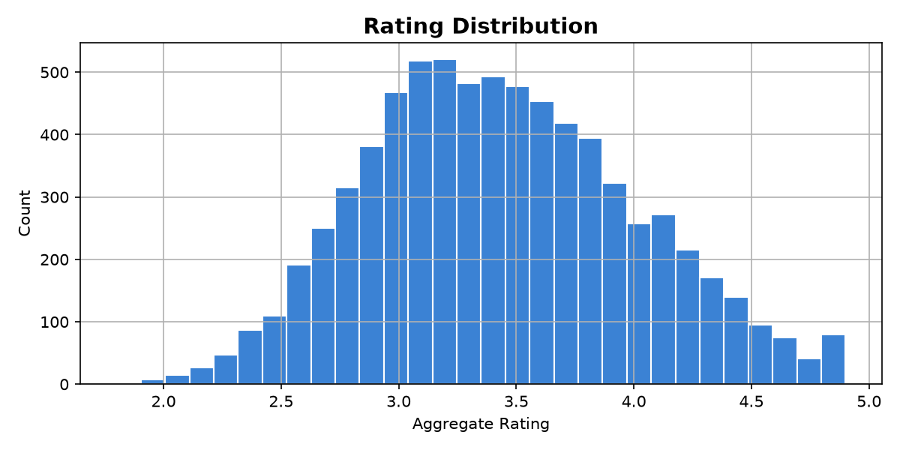
Figure 1: Distribution of Aggregate Ratings
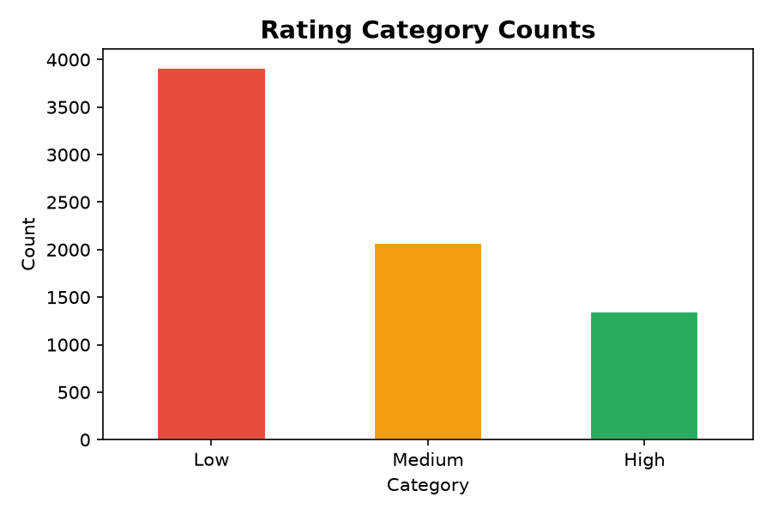
Figure 2: Rating Category Counts (Low / Medium / High)

3.2 Price Range vs Rating
Higher price tiers are consistently associated with better average ratings, suggesting that customers associate premium pricing with higher quality.
Price Range | Label | Avg Rating
1 | Budget | 3.238
2 | Mid | 3.377
3 | Premium | 3.769
4 | Luxury | 3.894
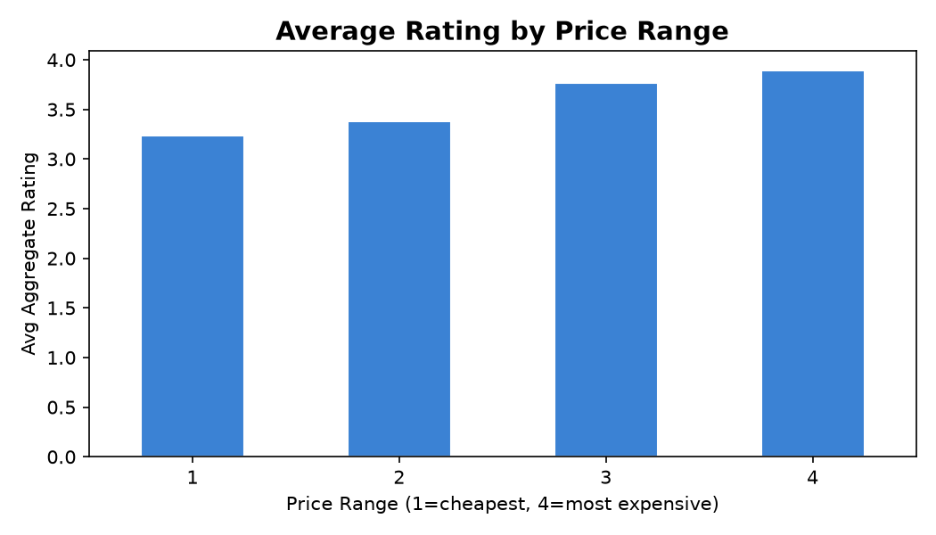
Figure 3: Average Rating by Price Range

3.3 Cuisine Analysis
North Indian cuisine dominates in restaurant count. However, specialty cuisines such as Japanese and Cafe-style restaurants achieve higher average ratings.
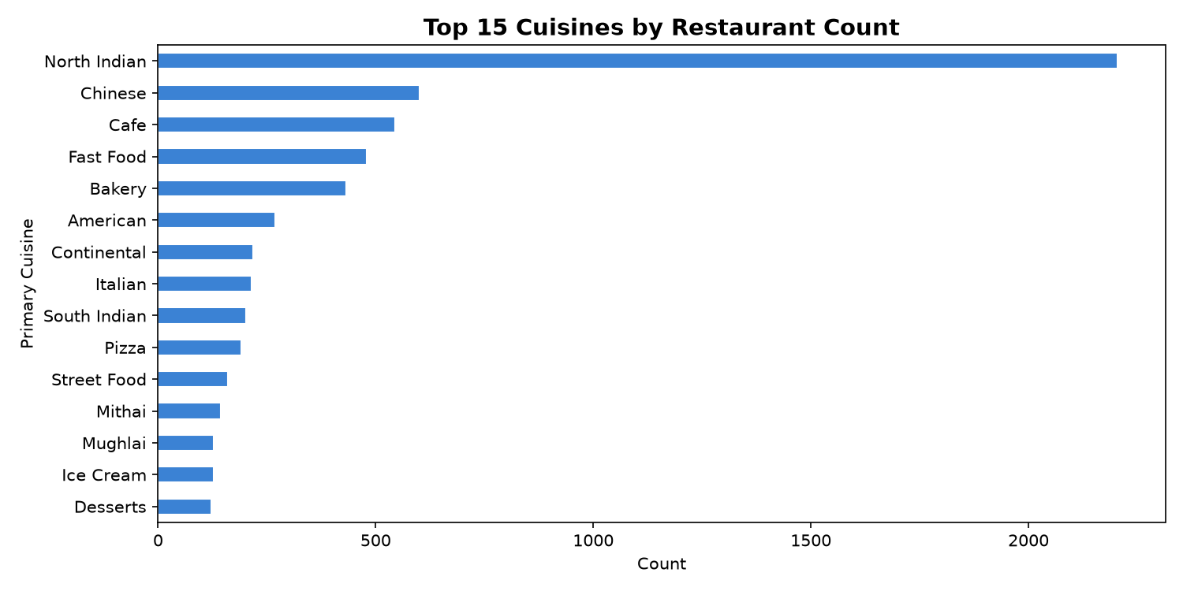
Figure 4: Top 15 Cuisines by Restaurant Count
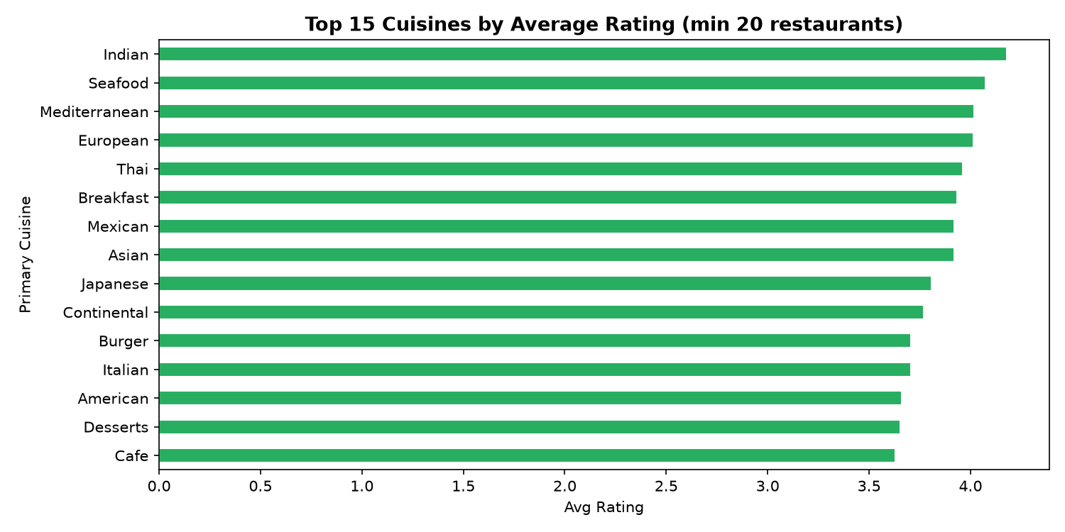
Figure 5: Top 15 Cuisines by Average Rating

3.4 City Analysis
The city with the most restaurants is New Delhi. Certain smaller cities achieve higher average ratings, possibly due to curated restaurant ecosystems.
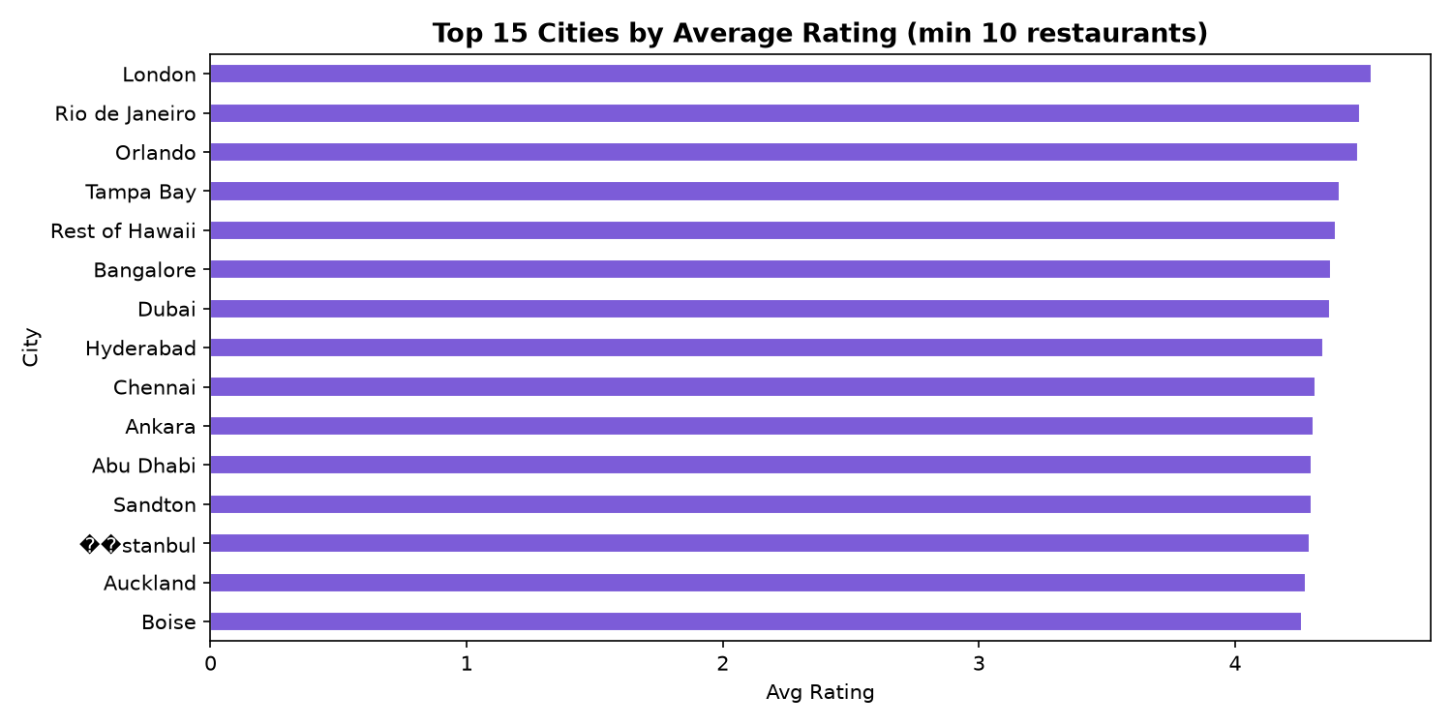
Figure 6: Top 15 Cities by Average Rating

3.5 Correlation Heatmap
Price range and log-transformed votes show the strongest positive correlation with aggregate rating. Online delivery alone does not strongly predict rating.
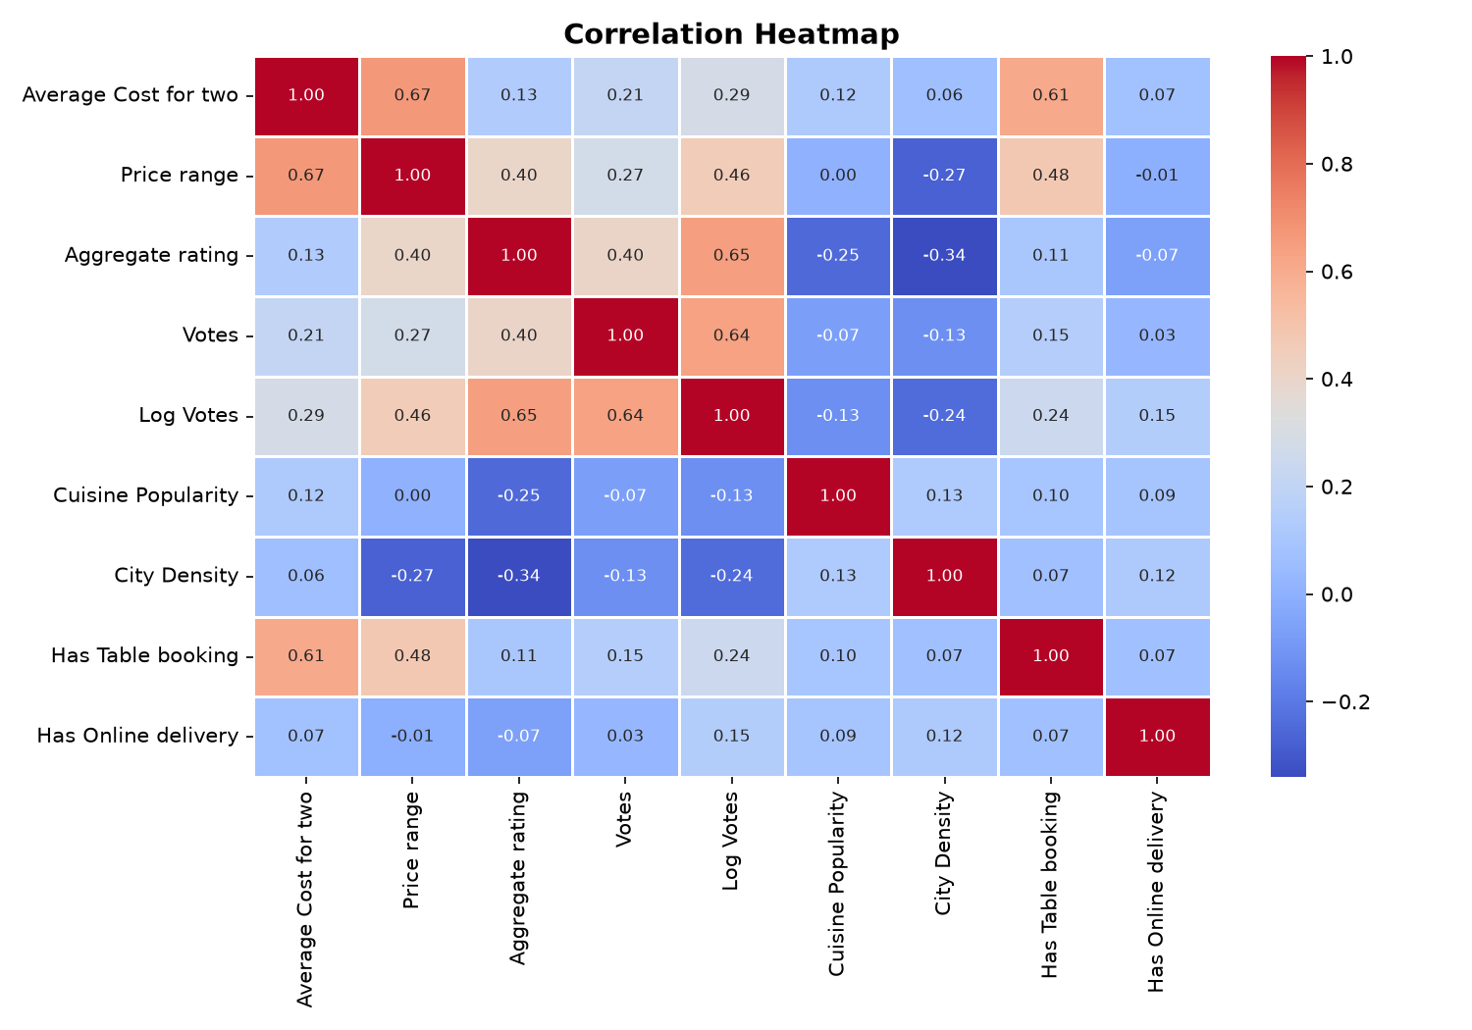
Figure 7: Feature Correlation Heatmap

3.6 Votes vs Rating
Restaurants with higher vote counts tend to cluster in the High rating category, indicating that well-established restaurants (by review volume) are typically better-rated.
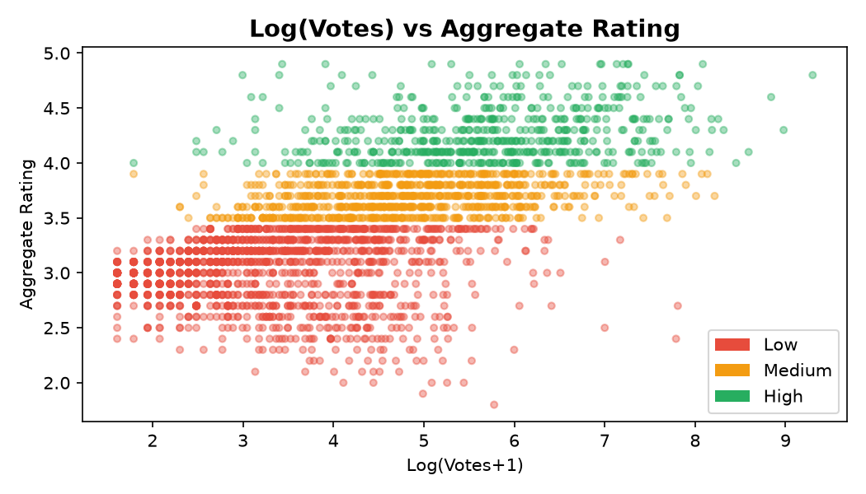
Figure 8: Log(Votes) vs Aggregate Rating

4. Feature Engineering
The following features were engineered from the raw dataset:
Feature | Description | Rationale
Rating Category | Low (<3.5) / Medium (3.5–4.0) / High (≥4.0) | Classification target
Primary Cuisine | First cuisine from the comma-separated list | Simplify multi-label cuisine
Cuisine Popularity | Count of restaurants sharing the same cuisine | Proxy for cuisine market size
City Density | Count of restaurants in the same city | Market competition proxy
Log Votes | log(Votes + 1) | Normalise skewed vote distribution
Cuisine Encoded | Label-encoded Primary Cuisine | Numeric representation for ML
City Encoded | Label-encoded City | Numeric representation for ML
Has Table booking | 0/1 binary from Yes/No | Service feature
Has Online delivery | 0/1 binary from Yes/No | Service feature

Final feature set: ['Price range', 'Log Votes', 'Cuisine Popularity', 'City Density', 'Has Table booking', 'Has Online delivery', 'Cuisine Encoded', 'City Encoded']

5. Model Training & Comparison
Two ensemble classification models were trained on an 80/20 stratified train-test split. The target variable is Rating Category (Low / Medium / High). All models use the same feature set and random seed (42) for reproducibility.

5.1 Random Forest Classifier
n_estimators=200, max_depth=12, n_jobs=-1, random_state=42

5.2 Gradient Boosting Classifier
n_estimators=200, learning_rate=0.1, max_depth=5, random_state=42

5.3 Model Comparison
Metric | Random Forest | Gradient Boosting
Accuracy | 0.7382 | 0.7389
Precision | 0.7350 | 0.7367
Recall | 0.7382 | 0.7389
F1 Score | 0.7358 | 0.7371
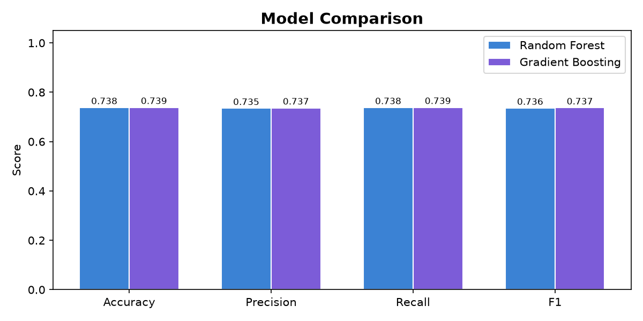
Figure 9: Model Performance Comparison
Best model selected: Gradient Boosting (F1 = 0.7371)

6. Evaluation Metrics

6.1 Best Model Metrics
Metric | Value
Accuracy | 0.7389
Precision | 0.7367
Recall | 0.7389
F1 Score | 0.7371

6.2 Confusion Matrix
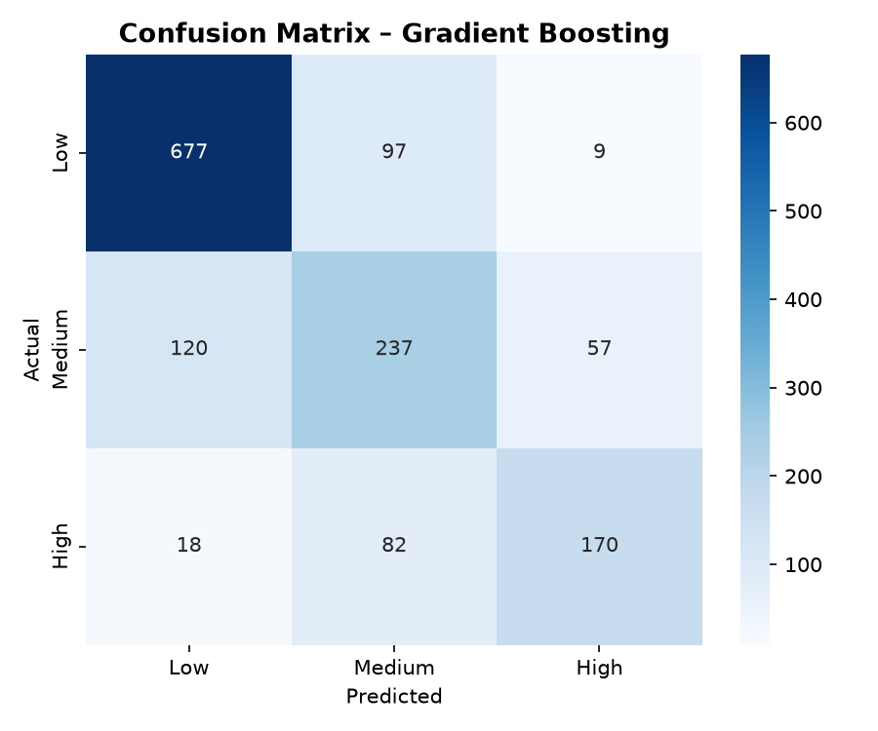
Figure 10: Confusion Matrix – Gradient Boosting
The model performs best at identifying 'Low' rated restaurants (highest recall ~86%), with moderate performance on 'High' rated ones. 'Medium' category is the hardest to classify precisely, as it overlaps with both Low and High.

6.3 Feature Importances
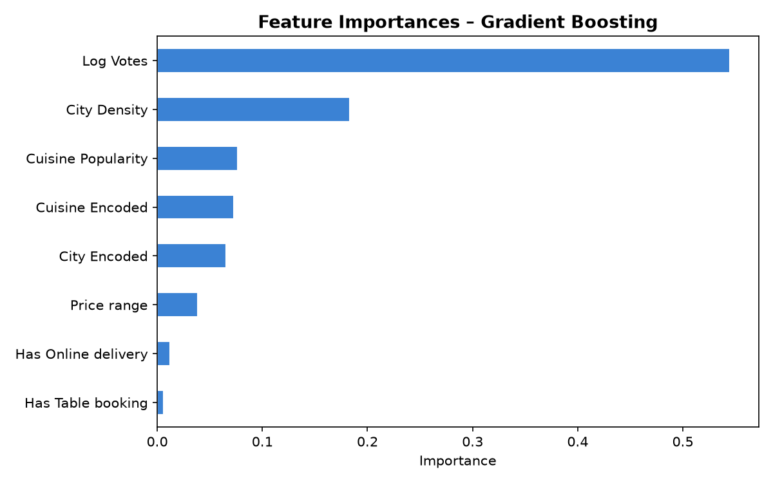
Figure 11: Feature Importances
Feature | Importance
Log Votes | 0.5447
City Density | 0.1834
Cuisine Popularity | 0.0764
Cuisine Encoded | 0.0731
City Encoded | 0.0657
Price range | 0.0384
Has Online delivery | 0.0122
Has Table booking | 0.0061

7. Flask API Endpoints
Base URL: http://127.0.0.1:5000

Endpoint | Method | Description
/ | GET | API status & endpoint list
/health | GET | Health check – returns {status: healthy}
/predict | POST | Predict rating category; accepts JSON with price_range, cuisine, city, votes, has_table_booking, has_online_delivery
/model_info | GET | Model name, features, metrics, feature importances
/dataset_summary | GET | Dataset KPIs: total restaurants, avg rating, avg cost, top cuisine, top city, etc.
/top_cuisines | GET | Top N cuisines by count with average ratings; query param ?n=15

Prediction request body example (JSON):
{"price_range": 3, "cuisine": "North Indian", "city": "New Delhi",
"votes": 500, "has_table_booking": 1, "has_online_delivery": 1}

8. Sample Predictions
The following predictions were collected live from the running Flask API:

Sample 1:
Input: Cuisine=North Indian, City=New Delhi, PriceRange=3, Votes=500, Table=1, Delivery=1
Prediction: Medium — Probabilities: High: 23.1% | Low: 33.5% | Medium: 43.5%

Sample 2:
Input: Cuisine=Chinese, City=Mumbai, PriceRange=2, Votes=200, Table=0, Delivery=1
Prediction: Medium — Probabilities: High: 9.5% | Low: 2.5% | Medium: 88.0%

Sample 3:
Input: Cuisine=Japanese, City=Bangalore, PriceRange=4, Votes=1000, Table=1, Delivery=0
Prediction: High — Probabilities: High: 79.8% | Low: 1.6% | Medium: 18.6%

Sample 4:
Input: Cuisine=Fast Food, City=Chennai, PriceRange=1, Votes=50, Table=0, Delivery=0
Prediction: Medium — Probabilities: High: 24.2% | Low: 37.6% | Medium: 38.2%

9. Streamlit Dashboard
The dashboard provides three pages:
- Page 1 – Executive Overview: KPI cards (total restaurants, average rating, % high-rated, avg cost, top cuisine, city count) and rating breakdown charts.
- Page 2 – Market & Price Analysis: Price vs rating bar chart, cost scatter plot, top cuisines, city comparisons, correlation heatmap.
- Page 3 – Prediction & Insights: Interactive input form that calls the Flask API in real-time, returns predicted rating category with probabilities, plus a Risk/Opportunity/Action analysis section grounded in real computed metrics.

To launch the dashboard:
streamlit run frontend/ui.py
Dashboard URL: http://localhost:8501

10. Key Findings
- Model accuracy: 73.9% | F1: 73.7% using Gradient Boosting.
- Only 18.39% of 7,331 restaurants achieve a High rating (≥4.0).
- Price Range 4 (Luxury) achieves the highest average rating of 3.89.
- 'North Indian' is the most represented cuisine (2,204 restaurants).
- Log(Votes) and Price Range are the top two predictors by feature importance.
- Restaurants with online delivery average 3.381 vs 3.460 for those without (Δ = -0.079).
- The dataset spans 136 cities and 115 distinct primary cuisines.

11. Risks, Opportunities & Actions
Risk: Market Concentration
Fact: 18.39% of restaurants are High-rated. Insight: The market is crowded at the bottom; differentiation is key. Action: Focus investment on price-range upgrades and service improvements to cross the 4.0 threshold.

Opportunity: Pricing Strategy
Fact: Price Range 4 has the highest avg rating (3.89). Insight: Premium pricing signals quality to customers. Action: Restaurants at price range 1-2 should introduce premium tiers or curated experiences.

Opportunity: Geographic Expansion
Fact: New Delhi dominates in restaurant count but faces intense competition. Insight: Tier-2 and emerging cities show lower density but growing demand. Action: Expand to cities with less competition and high average ratings.

Action: Online Delivery Integration
Fact: Online delivery restaurants average 3.381 vs 3.460 for offline-only. Insight: Digital presence correlates with slightly higher ratings and broader visibility. Action: All budget-tier restaurants should enable online delivery to increase review volumes and ratings.

12. Setup Instructions
1. Install dependencies:
pip install -r requirements.txt

2. Train the model:
python train_model.py

3. Start the Flask backend:
python backend/app.py
→ API live at http://127.0.0.1:5000

4. Launch the Streamlit dashboard:
streamlit run frontend/ui.py
→ Dashboard at http://localhost:8501

5. Run the Jupyter Notebook (optional):
jupyter notebook Mnami_RestaurantMarketAnalysis.ipynb

13. Technologies Used
Category | Library / Tool | Purpose
Data Processing | pandas ≥ 2.2 | Data loading, cleaning, manipulation
Data Processing | numpy ≥ 1.26 | Numerical operations
Machine Learning | scikit-learn ≥ 1.5 | Random Forest, Gradient Boosting, metrics
Visualisation | matplotlib ≥ 3.9 | Charts and EDA plots
Visualisation | seaborn ≥ 0.13 | Heatmaps and styled charts
Backend API | Flask ≥ 3.0 | REST API for model serving
Frontend | Streamlit ≥ 1.35 | Interactive 3-page dashboard
Report | python-docx ≥ 1.1 | Word document generation
Notebook | nbformat ≥ 5.10 | Jupyter notebook creation
Model Persistence | joblib ≥ 1.4 | Save/load model and encoders
HTTP Client | requests ≥ 2.32 | Streamlit → Flask API calls

14. Conclusion
This project successfully built an end-to-end restaurant market analysis pipeline using the Zomato dataset (7,331 cleaned records across 136 cities and 115 primary cuisines). The best model — Gradient Boosting — achieves 73.9% accuracy and 73.7% weighted F1 score in predicting restaurant rating categories.

Key drivers of high ratings are review volume (votes), price tier, and cuisine type. The project delivers actionable insights for restaurant operators, investors, and platform curators: focus on premium positioning, review generation, and delivery integration to improve rating outcomes.

Future improvements could include NLP analysis of restaurant names/menus, time-series tracking of rating changes, and hyperparameter tuning via GridSearchCV.

