

**UNIVERSITY OF TEHRAN**

**Digital Systems 2**

**Computer Assignment 1**

**Amirhesam Jafari Rad 810100247**

**Mana Mohammadi 810100207**

**DataPath:**

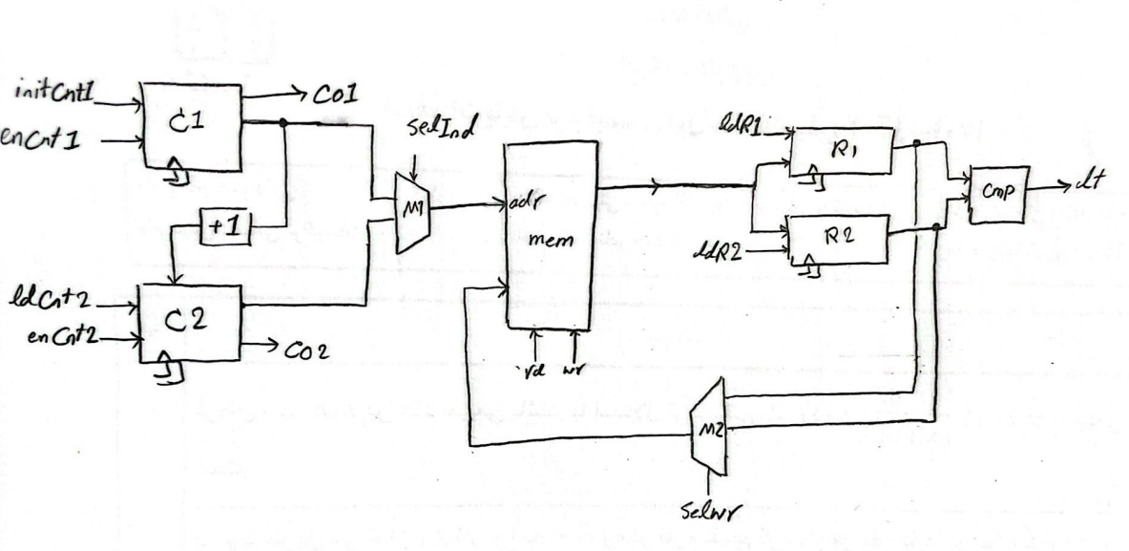

**Controller:**

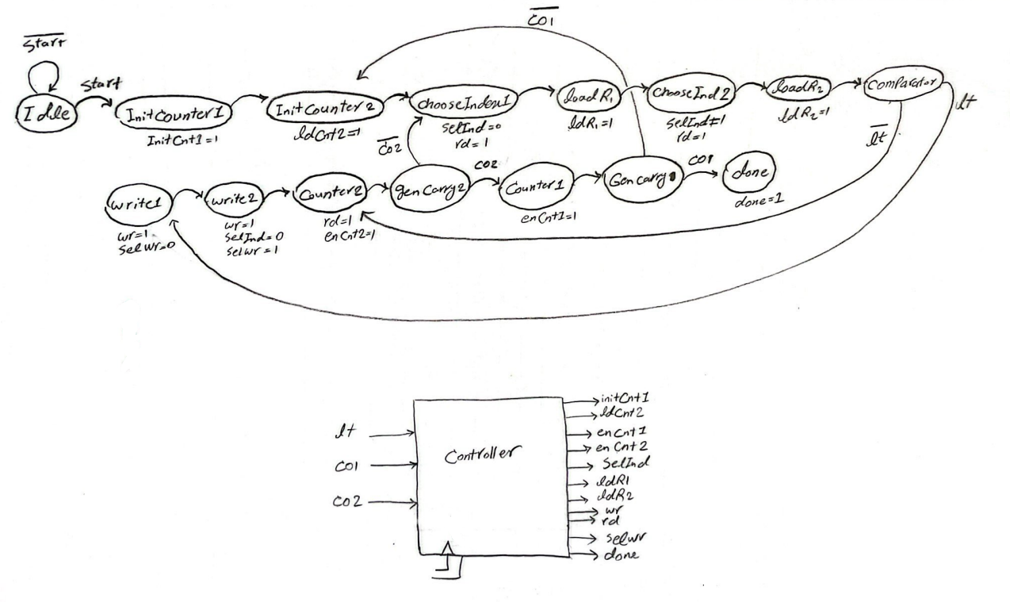

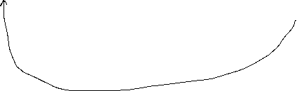

**WaveForm:**

