Task 01

<html>
<head>
<title>My Profile</title>
</head>
<body>
<h1>Hello, Web Engineering</h1>
<p>My name is <b>Abdul Manan</b> and this is my first page.</p>
<p>I enjoy learning web development and building interactive websites.</p>
<p>
<ul>
<li>HTML</li>
<li>CSS</li>
<li>JavaScript</li>
</ul>
</p>
<img src = "eye.jpg" alt = "EYE Image" width = "300" height = "200"/>
</body>
</html>
Output
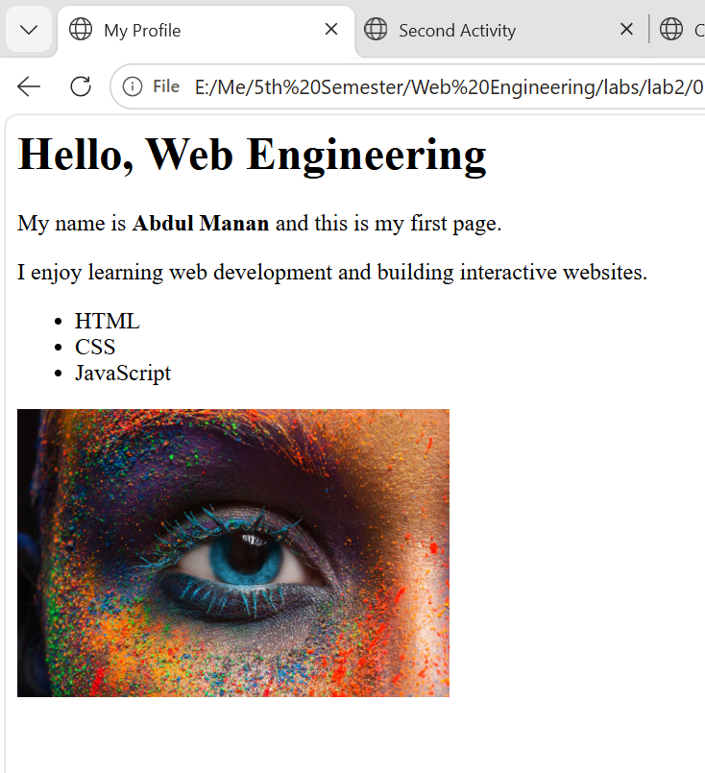
Task 2
<html>
<head>
<title>Second Activity</title>
</head>
<body>
<header>
<h1>Abdul Manan</h1>
<nav>
<ul>
<li><a href = "01-Profile.html" target = "_blank">Profile</a></li>
<li><a href="02-SecondActivity.html">Second Activity</a></li>
</ul>
</nav>
</header>

<main>
<article>
<h3>
This is the second activity page. Here, you can add more content related to your second activity or project. You can include text, images, links, and other HTML elements to showcase your work or provide information about the activity.
</h3>
</article>
<section>
<ul>
<li>Html</li>
<li>Css</li>
<li>JavaScript</li>
<li>Bootstrap </li>
</ul>
</section>
<aside>
<p>
currently, I am learning web development and building interactive websites. I enjoy exploring new technologies and frameworks to enhance my skills in front-end and back-end development.
</p>
</aside>
<footer>
<p>&copy; 2024 Abdul Manan. All rights reserved.</p>
<a href="mailto:abdulmananbohio012@gmail.com">Contact Me</a>
</footer>
</main>
</body>
</html>

Output
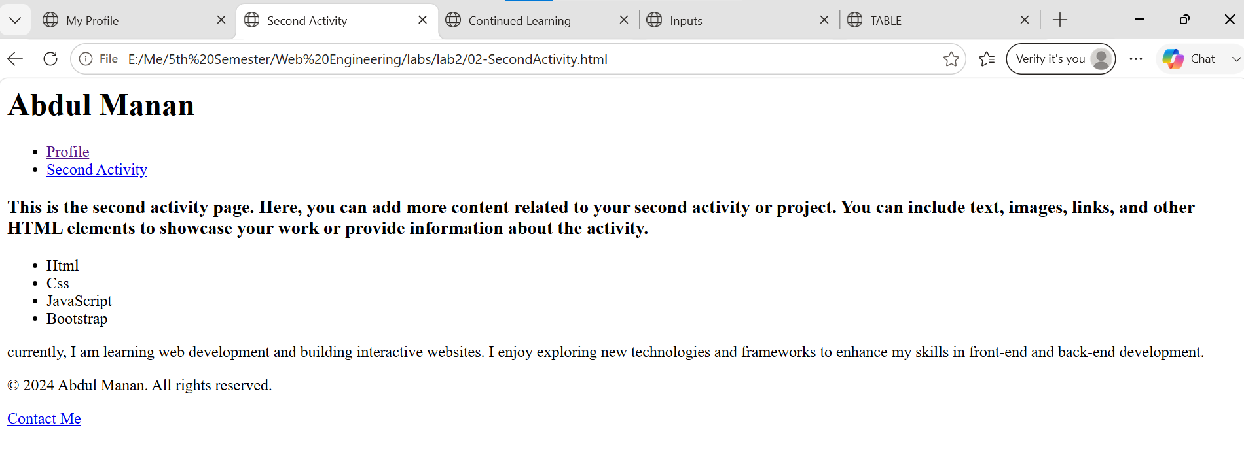

Task 3
<html>
<head>
<title>Continued Learning</title>
</head>
<body>
<nav>
<a href="#skills"> SKILLS </a>
</nav>
<figure>
<figcaption>Learning is a continuous journey that never ends.</figcaption>
<img src="eye.jpg" alt="Eye Image" width="400" height=" 300"/>
</figure>

<section id = "skills">
<h2>My SKILLS</h2>
<ul>
<li>Web Development</li>
<li>Programming</li>
<li>Problem Solving</li>
<li>Teamwork</li>
<li>Adaptability</li>
</ul>
</section>
<footer>
<a href="https://github.com/manan-404/" target = "_blank" rel = "noopener noreferrer">My Github</a>
<a href="https://linkedin.com/in/abudl-manan-760a90356/" target = "_blank" rel = "noopener noreferrer">My LinkedIn </a>
<a href="https://tik-tok.com/@_manan_404" target = "_blank" rel = "noopener noreferrer">My TikTok</a>
</footer>
</body>
Output
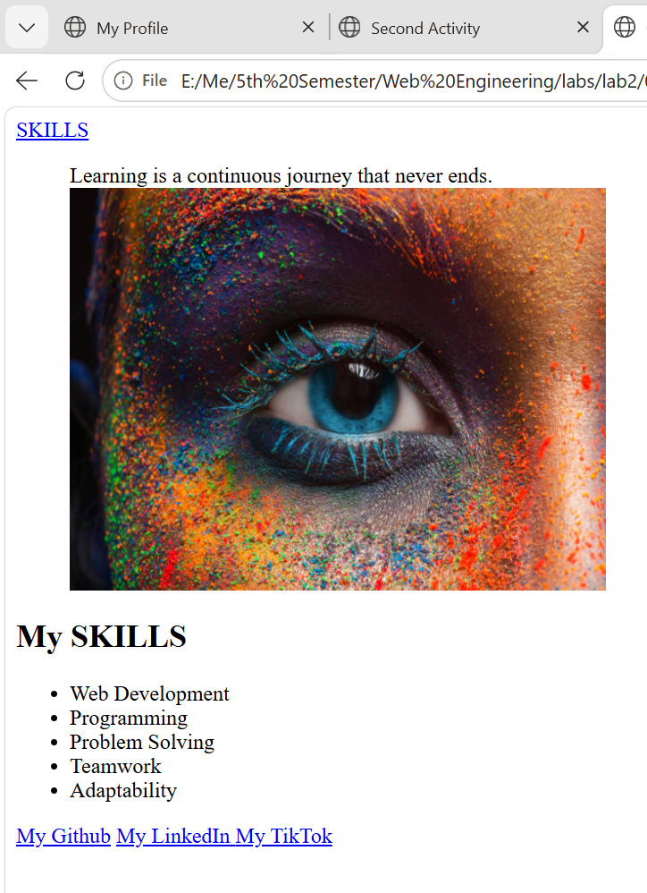

Task 4
<html>
<head>
<title>Inputs</title>
</head>
<body>
<section id="contact">
<h2>Contact</h2>
<form>

<div>
<label>Name</label>
<input type="text" id="name" name"name" required>
</div>
<div>
<label for="email">Email</label>
<input type = "email" id="email" name="email" required>
</div>
<div>
<label for="phone">Phone</label>
<input type="tel" id="phone" name="phone" required>
</div>
<div>
<label for="subject">Subject</label>
<select id="subject" name = "subject" required>
<option value="">Select a subject</option>
<option value="general">General Inquiry</option>
<option value="collaboration">Collaboration</option>
<option value="job">Job Application</option>
</select>
</div>
<div>
<label for="message">Message</label>
<textarea id="message" name="message" rows="5" required></textarea>
</div>
<div>
<input type = "checkbox" id="subscribe" name="subscribe">
<label for="subscribe">Subscribe to updates</label>
</div>
<div>
<button type="submit">Send Message</button>
</div>

</form>
</section>
</body>
</html>
Output
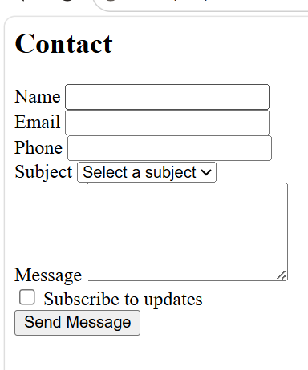

Task 5

<html>
<head>
<title>TABLE</title>
</head>
<body>

<table border="1">

<caption>Tools & Courses - Comfort Level</caption>
</thead>
<tr>
<th scope="col">Tool / Course</th>
<th scope="col">Comfort Level</th>
</tr>
</thead>
<tbody>
<tr>
<th scope = "row">HTML/CSS</th>
<td>Comfortable</td>
</tr>

<tr>
<th scope = "row">JavaScript</th>
<td>Learning</td>
</tr>

<tr>
<th scope="row">Git</th>
<td>Comfortable</td>
</tr>
</tbody>

</table>
</body>
</html>
Output
