Task 1
Flexbox Froggy
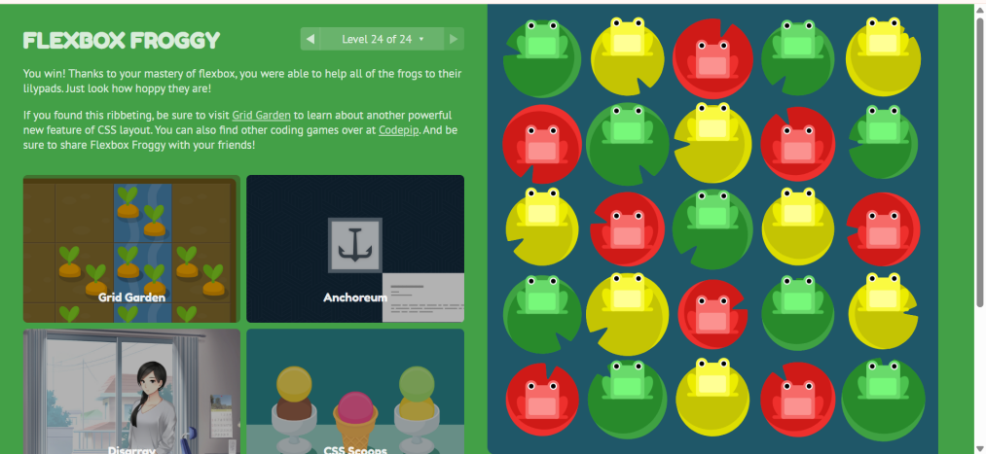

Grid Garden

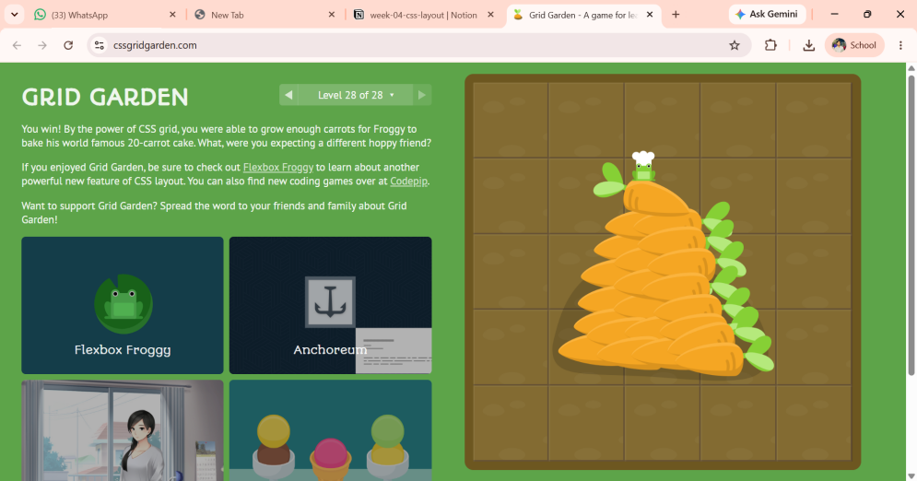

Task 2:
Index

<!DOCTYPE html>
<html lang="en">
<head>
<meta charset="UTF-8">
<meta name="viewport" content="width=device-width, initial-scale=1.0">
<title>Grey Box Homepage Clone - Abdul Manan Bohio</title>
<link rel="stylesheet" href="style.css">
</head>
<body>
<!-- Page Shell -->
<div class="page">
<!-- Header -->
<header class="header">
<div class="header-left">
<div class="logo-box">LOGO</div>
<nav class="nav">
<div class="nav-box">Home</div>
<div class="nav-box">Explore</div>
<div class="nav-box">Articles</div>
</nav>
</div>
<div class="header-right">
<div class="search-box">Search</div>
<div class="button-box">Login</div>
</div>
</header>

<!-- Main Content -->
<main class="main">
<!-- Hero Section -->
<section class="hero">
<div class="hero-image">
IMAGE
</div>
<div class="hero-content">
<div class="title-box"></div>
<div class="text-box"></div>
<div class="small-box"></div>
</div>
</section>

<!-- Content Grid -->
<section class="content-grid">
<!-- Card 1 -->
<article class="card">
<div class="card-image">IMAGE</div>
<div class="card-content">
<div class="card-title"></div>
<div class="card-line"></div>
<div class="card-line short"></div>
</div>
</article>

<!-- Card 2 -->
<article class="card">
<div class="card-image">IMAGE</div>
<div class="card-content">
<div class="card-title"></div>
<div class="card-line"></div>
<div class="card-line short"></div>
</div>
</article>

<!-- Card 3 -->
<article class="card">
<div class="card-image">IMAGE</div>
<div class="card-content">
<div class="card-title"></div>
<div class="card-line"></div>
<div class="card-line short"></div>
</div>
</article>

<!-- Card 4 -->
<article class="card">
<div class="card-image">IMAGE</div>
<div class="card-content">
<div class="card-title"></div>
<div class="card-line"></div>
<div class="card-line short"></div>
</div>
</article>
</section>

<!-- Lower Section -->
<section class="lower-section">
<div class="lower-main">
<div class="section-heading"></div>
<div class="article-row">
<div class="article-box"></div>
<div class="article-box"></div>
<div class="article-box"></div>
</div>
</div>
<aside class="sidebar">
<div class="sidebar-heading"></div>
<div class="sidebar-item"></div>
<div class="sidebar-item"></div>
<div class="sidebar-item"></div>
</aside>
</section>
</main>

<!-- Footer -->
<footer class="footer">
<div class="footer-logo">LOGO</div>
<div class="footer-links">
<div class="footer-box"></div>
<div class="footer-box"></div>
<div class="footer-box"></div>
<div class="footer-box"></div>
</div>
</footer>
</div>
</body>
</html>

Style

/* ------------------------------
Basic Setup
------------------------------ */
* {
box-sizing: border-box;
margin: 0;
padding: 0;
}

body {
font-family: Arial, sans-serif;
background: #ffffff;
color: #333;
}

/* ------------------------------
Page Shell
CSS GRID is used here
------------------------------ */
.page {
min-height: 100vh;
display: grid;
grid-template-rows: auto 1fr auto;
}

/* ------------------------------
Header
FLEXBOX is used here
------------------------------ */
.header {
min-height: 80px;
padding: 15px 5%;
background: #eeeeee;
border-bottom: 2px solid #cccccc;
display: flex;
align-items: center;
justify-content: space-between;
}

.header-left,
.header-right {
display: flex;
align-items: center;
gap: 15px;
}

/* Logo */
.logo-box {
width: 80px;
height: 45px;
background: #bdbdbd;
display: flex;
align-items: center;
justify-content: center;
font-weight: bold;
}

/* Navigation */
.nav {
display: flex;
gap: 10px;
}

.nav-box {
width: 75px;
height: 35px;
background: #d0d0d0;
display: flex;
align-items: center;
justify-content: center;
font-size: 13px;
}

/* Search and Login */
.search-box {
width: 180px;
height: 38px;
background: #d0d0d0;
display: flex;
align-items: center;
padding-left: 15px;
color: #666;
}

.button-box {
width: 70px;
height: 38px;
background: #bdbdbd;
display: flex;
align-items: center;
justify-content: center;
}

/* ------------------------------
Main
------------------------------ */
.main {
width: 90%;
max-width: 1200px;
margin: 30px auto;
}

/* ------------------------------
Hero Section
GRID is used here
------------------------------ */
.hero {
display: grid;
grid-template-columns: 2fr 1fr;
gap: 25px;
margin-bottom: 30px;
}

.hero-image {
min-height: 300px;
background: #c7c7c7;
display: flex;
align-items: center;
justify-content: center;
color: #777;
font-weight: bold;
}

.hero-content {
background: #eeeeee;
padding: 30px;
display: flex;
flex-direction: column;
justify-content: center;
gap: 18px;
}

/* Hero text placeholders */
.title-box {
width: 80%;
height: 35px;
background: #b5b5b5;
}

.text-box {
width: 100%;
height: 80px;
background: #d0d0d0;
}

.small-box {
width: 40%;
height: 35px;
background: #b5b5b5;
}

/* ------------------------------
Cards
GRID for card layout
------------------------------ */
.content-grid {
display: grid;
grid-template-columns: repeat(4, 1fr);
gap: 20px;
margin-bottom: 35px;
}

.card {
background: #eeeeee;
border: 1px solid #cccccc;
}

/* Card image */
.card-image {
height: 150px;
background: #c5c5c5;
display: flex;
align-items: center;
justify-content: center;
color: #777;
font-weight: bold;
}

/* Card content */
.card-content {
padding: 15px;
display: flex;
flex-direction: column;
gap: 10px;
}

.card-title {
width: 80%;
height: 25px;
background: #b5b5b5;
}

.card-line {
width: 100%;
height: 12px;
background: #d0d0d0;
}

.card-line.short {
width: 65%;
}

/* ------------------------------
Lower Section
------------------------------ */
.lower-section {
display: grid;
grid-template-columns: 2fr 1fr;
gap: 25px;
}

/* Main lower area */
.lower-main {
background: #eeeeee;
padding: 20px;
}

.section-heading {
width: 200px;
height: 30px;
background: #b5b5b5;
margin-bottom: 20px;
}

/* Article row */
.article-row {
display: flex;
gap: 15px;
}

.article-box {
flex: 1;
height: 100px;
background: #cccccc;
}

/* ------------------------------
Sidebar
------------------------------ */
.sidebar {
background: #eeeeee;
padding: 20px;
display: flex;
flex-direction: column;
gap: 15px;
}

.sidebar-heading {
width: 70%;
height: 30px;
background: #b5b5b5;
}

.sidebar-item {
width: 100%;
height: 45px;
background: #cccccc;
}

/* ------------------------------
Footer
FLEXBOX
------------------------------ */
.footer {
min-height: 100px;
background: #eeeeee;
border-top: 2px solid #cccccc;
padding: 25px 5%;
display: flex;
align-items: center;
justify-content: space-between;
}

.footer-logo {
width: 80px;
height: 40px;
background: #bdbdbd;
display: flex;
align-items: center;
justify-content: center;
font-weight: bold;
}

.footer-links {
display: flex;
gap: 12px;
}

.footer-box {
width: 70px;
height: 30px;
background: #cccccc;
}

/* ------------------------------
Responsive Design
------------------------------ */
@media (max-width: 900px) {
.content-grid {
grid-template-columns: repeat(2, 1fr);
}
.hero {
grid-template-columns: 1fr;
}
.lower-section {
grid-template-columns: 1fr;
}
}

@media (max-width: 600px) {
.header {
flex-direction: column;
gap: 15px;
}
.nav {
display: none;
}
.header-right {
width: 100%;
justify-content: center;
}
.content-grid {
grid-template-columns: 1fr;
}
.article-row {
flex-direction: column;
}
.footer {
flex-direction: column;
gap: 20px;
}
}

Grey Output:
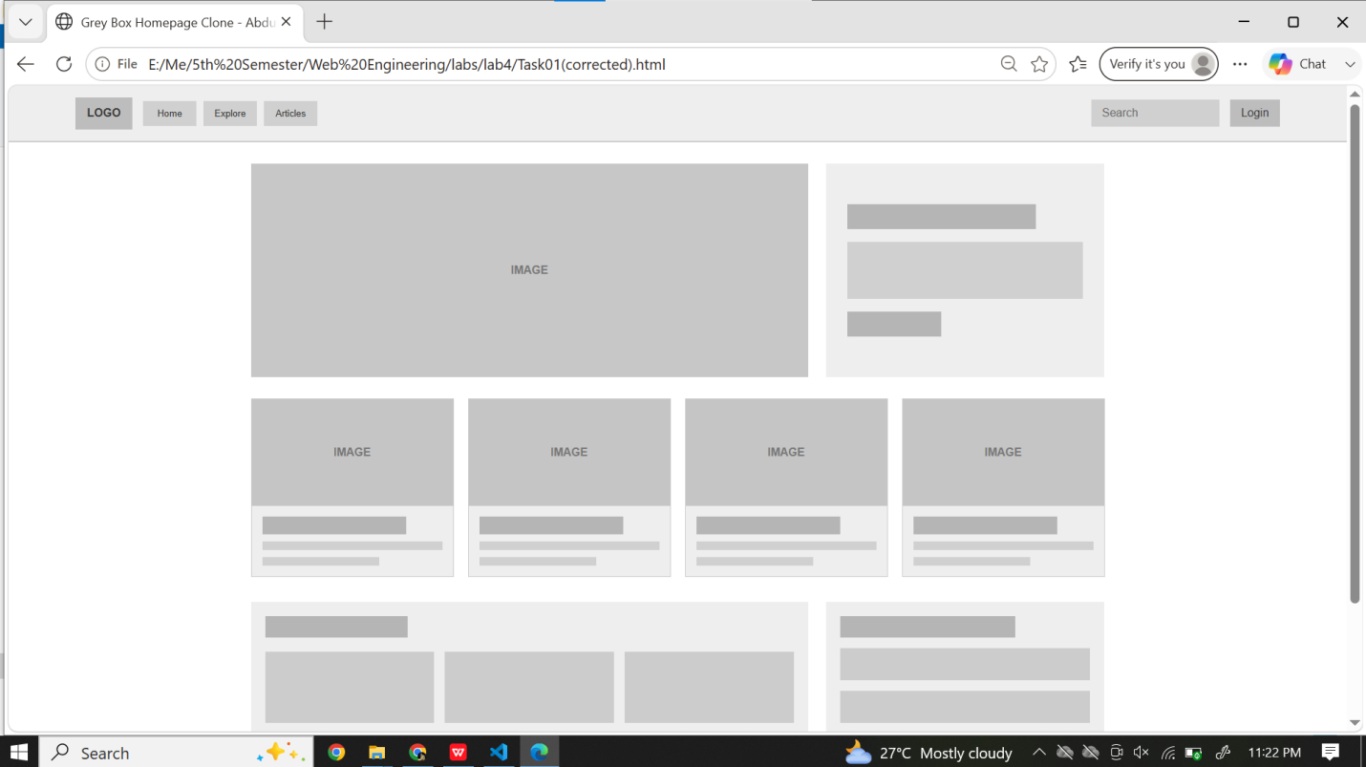

Task 3:
<!DOCTYPE html>
<html lang="en">
<head>
<meta charset="UTF-8">
<meta name="viewport" content="width=device-width, initial-scale=1.0">
<title>Profile - Abdul Manan</title>
<link rel="stylesheet" href="profile.css">
</head>
<body>
<div class="profile-container">
<!-- Top Green Section -->
<header class="profile-header">
<h1>Abdul Manan</h1>
<p class="subtitle">Web Development Student &mdash; Section E</p>
<nav class="profile-nav">
<a href="#about" class="active">About</a>
<a href="#skills">Skills</a>
<a href="#contact">Contact</a>
</nav>
</header>

<!-- Main Card Section -->
<main class="profile-main">
<!-- About Section -->
<section id="about" class="about-card">
<div class="avatar">AM</div>
<h2>About Me</h2>
<p class="bio">
Hi, I'm Abdul Manan &mdash; I build small web projects while learning HTML, CSS, and JavaScript. This page is my class profile, rebuilt to work cleanly on any screen starting from 320px wide.
</p>
<div class="tags">
<span class="tag">HTML5</span>
<span class="tag">CSS3</span>
<span class="tag">Flexbox</span>
<span class="tag">Grid</span>
<span class="tag">Responsive Design</span>
</div>
</section>

<!-- Skills Section -->
<section id="skills" class="skills-section">
<h2>Skills</h2>

<div class="skill-card">
<span class="skill-name">HTML</span>
<div class="progress-bar">
<div class="progress-fill" style="width: 80%;"></div>
</div>
</div>

<div class="skill-card">
<span class="skill-name">CSS</span>
<div class="progress-bar">
<div class="progress-fill" style="width: 70%;"></div>
</div>
</div>

<div class="skill-card">
<span class="skill-name">Flexbox / Grid</span>
<div class="progress-bar">
<div class="progress-fill" style="width: 65%;"></div>
</div>
</div>

<div class="skill-card">
<span class="skill-name">JavaScript</span>
<div class="progress-bar">
<div class="progress-fill" style="width: 45%;"></div>
</div>
</div>
</section>

<!-- Lab Hours Callout -->
<section class="callout-card">
<h3>Lab Hours</h3>
<p>Web Lab meets Mon &amp; Wed, 10:00 AM &ndash; 12:00 PM in Room 214. Drop by if you have questions about this project.</p>
</section>
</main>

<!-- Footer -->
<footer class="profile-footer">
<p>&copy; 2026 Abdul Manan. All rights reserved.</p>
<a href="#contact" class="contact-link">Get in touch &rarr;</a>
</footer>
</div>
</body>
</html>

profile.css (style)

* {
box-sizing: border-box;
margin: 0;
padding: 0;
}

body {
font-family: Georgia, 'Times New Roman', serif;
background-color: #f7f5f0;
color: #2b3a2f;
display: flex;
justify-content: center;
}

.profile-container {
width: 100%;
max-width: 420px;
background: #ffffff;
min-height: 100vh;
display: flex;
flex-direction: column;
}

/* Header Area */
.profile-header {
background-color: #1a3c2b;
padding: 24px 20px;
color: #ffffff;
}

.profile-header h1 {
font-size: 1.5rem;
font-weight: 700;
margin-bottom: 4px;
}

.profile-header .subtitle {
font-size: 0.85rem;
color: #a4c4b0;
font-family: Arial, sans-serif;
margin-bottom: 18px;
}

.profile-nav {
display: flex;
flex-direction: column;
gap: 12px;
}

.profile-nav a {
color: #c7decb;
text-decoration: none;
font-size: 0.9rem;
font-family: Arial, sans-serif;
font-weight: bold;
}

.profile-nav a.active {
color: #72d693;
}

/* Main Content */
.profile-main {
padding: 20px;
display: flex;
flex-direction: column;
gap: 20px;
}

/* About Card */
.about-card {
border: 1px solid #eae6dc;
border-radius: 12px;
padding: 20px;
background: #ffffff;
}

.avatar {
width: 48px;
height: 48px;
background-color: #2b4534;
color: #ffffff;
border-radius: 50%;
display: flex;
align-items: center;
justify-content: center;
font-family: Arial, sans-serif;
font-weight: bold;
font-size: 1rem;
margin-bottom: 14px;
}

.about-card h2,
.skills-section h2 {
font-size: 1.25rem;
margin-bottom: 10px;
}

.bio {
font-size: 0.88rem;
line-height: 1.45;
color: #444;
margin-bottom: 14px;
font-family: Arial, sans-serif;
}

.tags {
display: flex;
flex-wrap: wrap;
gap: 6px;
}

.tag {
background-color: #e9f0ea;
color: #2d5538;
padding: 4px 10px;
border-radius: 20px;
font-size: 0.75rem;
font-family: Arial, sans-serif;
}

/* Skills Section */
.skills-section {
display: flex;
flex-direction: column;
gap: 12px;
}

.skill-card {
background: #faf8f5;
border: 1px solid #ece7dc;
border-radius: 8px;
padding: 12px 14px;
}

.skill-name {
display: block;
font-family: Arial, sans-serif;
font-weight: bold;
font-size: 0.85rem;
margin-bottom: 8px;
}

.progress-bar {
width: 100%;
height: 6px;
background-color: #e8e2d5;
border-radius: 3px;
overflow: hidden;
}

.progress-fill {
height: 100%;
background-color: #2d5538;
border-radius: 3px;
}

/* Callout Box */
.callout-card {
background-color: #f3efe6;
border-radius: 8px;
padding: 14px;
font-family: Arial, sans-serif;
}

.callout-card h3 {
font-size: 0.9rem;
font-family: Georgia, serif;
margin-bottom: 6px;
color: #1a3c2b;
}

.callout-card p {
font-size: 0.8rem;
line-height: 1.4;
color: #555;
}

/* Footer */
.profile-footer {
padding: 20px;
margin-top: auto;
border-top: 1px solid #f0eee8;
font-family: Arial, sans-serif;
font-size: 0.75rem;
color: #777;
}

.contact-link {
display: inline-block;
margin-top: 8px;
color: #1a3c2b;
text-decoration: none;
font-weight: bold;
}

Output:
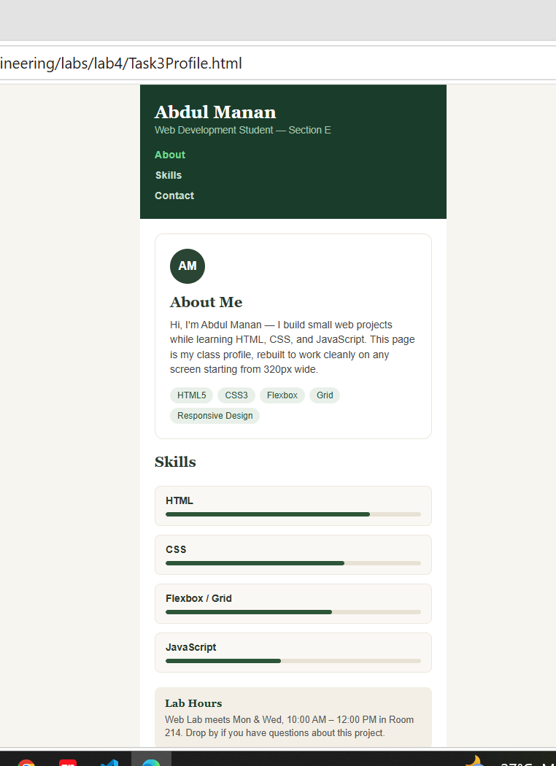

Task 4: Submit: the debug page with comments showing broken → fixed.
<!DOCTYPE html>
<html lang="en">
<head>
<meta charset="UTF-8">
<meta name="viewport" content="width=device-width, initial-scale=1.0">
<title>Layout Debugger (Broken to Fixed) - Abdul Manan</title>
<style>
* {
box-sizing: border-box;
margin: 0;
padding: 0;
font-family: Arial, sans-serif;
}

body {
background-color: #f7f9fb;
padding: 24px;
}

h1 {
font-size: 1.5rem;
margin-bottom: 24px;
}

.section-panel {
background: #ffffff;
border: 1px solid #e2e8f0;
border-radius: 8px;
padding: 20px;
margin-bottom: 24px;
}

.section-title {
font-size: 1rem;
font-weight: bold;
margin-bottom: 16px;
}

.comparison-grid {
display: grid;
grid-template-columns: 1fr 1fr;
gap: 20px;
}

.sub-heading {
font-size: 0.75rem;
font-weight: bold;
margin-bottom: 10px;
letter-spacing: 0.5px;
}

.broken-heading {
color: #dc2626;
}

.fixed-heading {
color: #16a34a;
}

.tag-btn {
background-color: #2563eb;
color: #ffffff;
padding: 6px 12px;
border-radius: 4px;
font-size: 0.8rem;
display: inline-block;
}

/* 1. Flex Wrap Debugging */
.container-box {
border: 1.5px dashed #94a3b8;
padding: 10px;
width: 250px;
}

/* Broken: No flex-wrap */
.flex-broken {
display: flex;
gap: 6px;
}

/* Fixed: flex-wrap added */
.flex-fixed {
display: flex;
flex-wrap: wrap;
gap: 6px;
}

/* 2. Absolute Positioning Debugging */
.card-container {
border: 1px solid #cbd5e1;
border-radius: 6px;
padding: 14px;
height: 120px;
font-size: 0.8rem;
color: #64748b;
}

.badge {
background-color: #dc2626;
color: white;
padding: 2px 8px;
border-radius: 4px;
font-size: 0.7rem;
font-weight: bold;
}

/* Broken: parent lacks relative position */
.relative-parent-broken {
position: static;
}

/* Fixed: parent includes position relative */
.relative-parent-fixed {
position: relative;
}

.relative-parent-fixed .badge {
position: absolute;
top: -10px;
right: 12px;
}
</style>
</head>
<body>

<h1>Layout Debugger (Broken &rarr; Fixed)</h1>

<!-- 1. Flex items overflowing -->
<div class="section-panel">
<div class="section-title">1. Flex items overflowing (Missing flex-wrap)</div>
<div class="comparison-grid">
<div>
<div class="sub-heading broken-heading">BROKEN (NO FLEX-WRAP)</div>
<div class="container-box flex-broken">
<span class="tag-btn">HTML5</span>
<span class="tag-btn">CSS Grid</span>
<span class="tag-btn">Flexbox</span>
<span class="tag-btn">Responsive</span>
</div>
</div>
<div>
<div class="sub-heading fixed-heading">FIXED (FLEX-WRAP: WRAP)</div>
<div class="container-box flex-fixed">
<span class="tag-btn">HTML5</span>
<span class="tag-btn">CSS Grid</span>
<span class="tag-btn">Flexbox</span>
<span class="tag-btn">Responsive</span>
</div>
</div>
</div>
</div>

<!-- 2. Absolute badge alignment -->
<div class="section-panel">
<div class="section-title">2. Absolute badge alignment (Missing position: relative)</div>
<div class="comparison-grid">
<div>
<div class="sub-heading broken-heading">BROKEN (PARENT LACKS POSITION: RELATIVE)</div>
<div class="card-container relative-parent-broken">
The badge escapes this card and flies out to the top corner of the window.
</div>
</div>
<div>
<div class="sub-heading fixed-heading">FIXED (POSITION: RELATIVE ADDED)</div>
<div class="card-container relative-parent-fixed">
<span class="badge">Fixed</span>
The badge is properly locked to the top-right corner of this card.
</div>
</div>
</div>
</div>

</body>
</html>

<!DOCTYPE html>
<html lang="en">
<head>
<meta charset="UTF-8">
<meta name="viewport" content="width=device-width, initial-scale=1.0">
<title>Layout Debugger (Broken to Fixed) - Abdul Manan</title>
<style>
* {
box-sizing: border-box;
margin: 0;
padding: 0;
font-family: Arial, sans-serif;
}

body {
background-color: #f7f9fb;
padding: 24px;
}

h1 {
font-size: 1.5rem;
margin-bottom: 24px;
}

.section-panel {
background: #ffffff;
border: 1px solid #e2e8f0;
border-radius: 8px;
padding: 20px;
margin-bottom: 24px;
}

.section-title {
font-size: 1rem;
font-weight: bold;
margin-bottom: 16px;
}

.comparison-grid {
display: grid;
grid-template-columns: 1fr 1fr;
gap: 20px;
}

.sub-heading {
font-size: 0.75rem;
font-weight: bold;
margin-bottom: 10px;
letter-spacing: 0.5px;
}

.broken-heading {
color: #dc2626;
}

.fixed-heading {
color: #16a34a;
}

.tag-btn {
background-color: #2563eb;
color: #ffffff;
padding: 6px 12px;
border-radius: 4px;
font-size: 0.8rem;
display: inline-block;
}

/* 1. Flex Wrap Debugging */
.container-box {
border: 1.5px dashed #94a3b8;
padding: 10px;
width: 250px;
}

/* Broken: No flex-wrap */
.flex-broken {
display: flex;
gap: 6px;
}

/* Fixed: flex-wrap added */
.flex-fixed {
display: flex;
flex-wrap: wrap;
gap: 6px;
}

/* 2. Absolute Positioning Debugging */
.card-container {
border: 1px solid #cbd5e1;
border-radius: 6px;
padding: 14px;
height: 120px;
font-size: 0.8rem;
color: #64748b;
}

.badge {
background-color: #dc2626;
color: white;
padding: 2px 8px;
border-radius: 4px;
font-size: 0.7rem;
font-weight: bold;
}

/* Broken: parent lacks relative position */
.relative-parent-broken {
position: static;
}

/* Fixed: parent includes position relative */
.relative-parent-fixed {
position: relative;
}

.relative-parent-fixed .badge {
position: absolute;
top: -10px;
right: 12px;
}
</style>
</head>
<body>

<h1>Layout Debugger (Broken &rarr; Fixed)</h1>

<!-- 1. Flex items overflowing -->
<div class="section-panel">
<div class="section-title">1. Flex items overflowing (Missing flex-wrap)</div>
<div class="comparison-grid">
<div>
<div class="sub-heading broken-heading">BROKEN (NO FLEX-WRAP)</div>
<div class="container-box flex-broken">
<span class="tag-btn">HTML5</span>
<span class="tag-btn">CSS Grid</span>
<span class="tag-btn">Flexbox</span>
<span class="tag-btn">Responsive</span>
</div>
</div>
<div>
<div class="sub-heading fixed-heading">FIXED (FLEX-WRAP: WRAP)</div>
<div class="container-box flex-fixed">
<span class="tag-btn">HTML5</span>
<span class="tag-btn">CSS Grid</span>
<span class="tag-btn">Flexbox</span>
<span class="tag-btn">Responsive</span>
</div>
</div>
</div>
</div>

<!-- 2. Absolute badge alignment -->
<div class="section-panel">
<div class="section-title">2. Absolute badge alignment (Missing position: relative)</div>
<div class="comparison-grid">
<div>
<div class="sub-heading broken-heading">BROKEN (PARENT LACKS POSITION: RELATIVE)</div>
<div class="card-container relative-parent-broken">
The badge escapes this card and flies out to the top corner of the window.
</div>
</div>
<div>
<div class="sub-heading fixed-heading">FIXED (POSITION: RELATIVE ADDED)</div>
<div class="card-container relative-parent-fixed">
<span class="badge">Fixed</span>
The badge is properly locked to the top-right corner of this card.
</div>
</div>
</div>
</div>

</body>
</html>



