1. Lab Summary & What We Covered
In this first lab, we learned the basics of how the web works, how browsers communicate with servers, how URLs are structured, and how to use Chrome DevTools. We also installed and set up Node.js, npm, Git, and VS Code extensions (Live Server and Prettier), and created our first HTML page.
2. Warm-up & Client vs Server (Activity A)
Warm-up: I opened YouTube/Google in Chrome, pressed F12 to open DevTools, and checked the Network tab. I saw around 40 requests loading, with status 200 OK for HTML and scripts.
Client vs Server: The web works as a conversation between two sides:
• Client (Frontend): Runs in the browser (HTML, CSS, JavaScript). It displays the page to the user and sends requests.
• Server (Backend): Runs on another computer (Node.js, Express, Database). It handles requests, logic, and sends back data.
3. Anatomy of a URL (Activity B)
Example URL: https://api.example.com:443/products/42?sort=price#reviews
Part | Value | What it means
Protocol | https:// | Secure HTTP protocol with TLS encryption.
Host / Domain | api.example.com | The server address (resolved to IP via DNS).
Port | :443 | Port number (443 for HTTPS, 80 for HTTP, 5500 for Live Server).
Path | /products/42 | Path to the specific resource on the server.
Query | ?sort=price | Extra parameters sent to server for filtering or search.
Fragment | #reviews | Jump link to an anchor on the page (client-side only).

4. HTTP Status Codes (Activity C)
Family | Codes | Meaning | What to do
2xx | 200 OK, 201 | Request succeeded. | Page/data loaded normally.
3xx | 301, 304 | Redirect / Loaded from cache. | Browser uses cached file or follows new link.
4xx | 400, 404 | Client error (wrong URL / bad request). | Fix the URL or client request.
5xx | 500, 502 | Server error (backend crashed). | Fix the server code / database.

5. Environment Setup Output (Activity D & Homework 1)
[Terminal Verification]
$ node -v
v20.18.0
$ npm -v
10.8.2
$ git --version
git version 2.43.0
$ git config --global user.name "Abdul Manan"
$ git config --global user.email "XYZ@example.com"

Task 01:
<!DOCTYPE html>
<html lang="en">

<head>
<meta charset="UTF-8">
<meta name="viewport" content="width=device-width, initial-scale=1.0">
<title>My First</title>
</head>
<body>
<h1>My First Web Page</h1>
<p>This is my first web page created using HTML.</p>
</body>
</html>

Output:
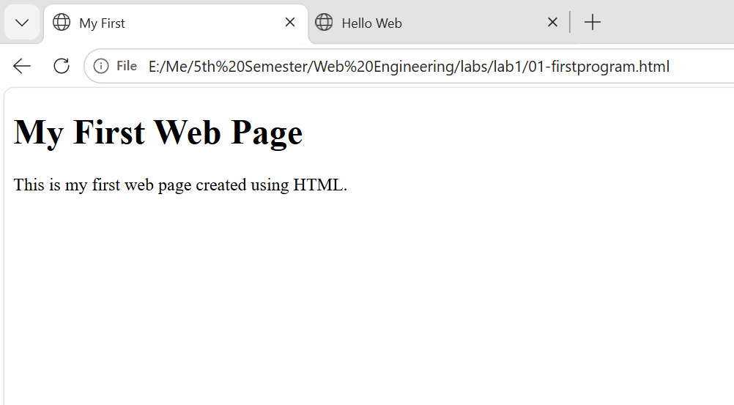

Task 02:
<!DOCTYPE html>
<html lang="en">
<head>
<meta charset="UTF-8"/>
<meta name="viewport" content="width=device-width, initial-scale=1.0"/>
<title>Hello Web</title>
</head>
<body>
<h1>Hello, Web Engineering</h1>
<p>My name is <strong>Abdul Manan</strong> and this is my first page.</p>
<button id="greet">Click me</button>

<script>
document.getElementById("greet").addEventListener("click", () => {
alert("The button works.");
});
</script>
</body>
</html>

Output:

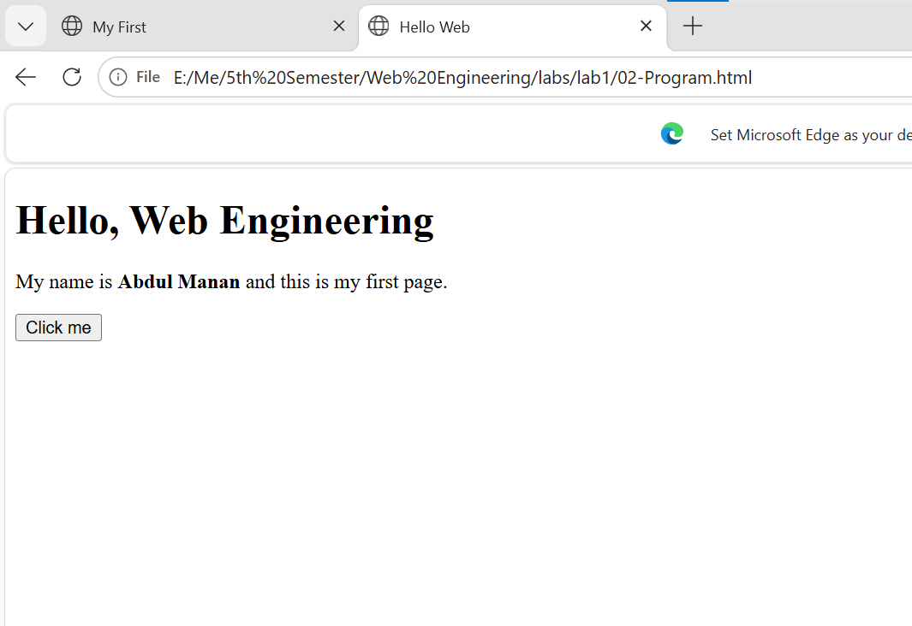

7. DevTools Drills & Error Explanation (Activity F)
- Network Tab: Reloaded the Live Server page (http://127.0.0.1:5500/hello-web/index.html) and verified that index.html loaded with status 200 OK.
- Console Tab: Typed document.title in console and it returned 'Hello Web – Shakir Ali'.
- Elements Tab: Double clicked the <h1> tag in Elements and changed the text. When I reloaded the page, the edit was gone because DevTools only changes the temporary DOM in browser memory, not the actual file on my laptop.
- Deliberate Error Test: Typed console.log(testVariable) in console.
Error: Uncaught ReferenceError: testVariable is not defined
Explanation: The error happened because the variable 'testVariable' was never created or declared before trying to use it.

Both codes are uploaded in github

