Imran Lateef Unar

BSCS-V-E

Task Warm-up: Flexbox is 1D, Grid is 2D
Question:
Six identical boxes A–F. Only the parent display property changes between the two sections (.flex and .grid).
Step 1: Add a seventh box G to both sections.
Step 2: On .flex, add flex-direction: column.
Done when you can say: "Flexbox is 1D, Grid is 2D."
Solution / Code:
<!DOCTYPE html>
<html lang="en">
<head>
<meta charset="UTF-8" />
<title>Warm-up: Flex vs Grid</title>
<style>
.box { background: #4a90d9; color: #fff; padding: 20px; text-align:center; font-family: sans-serif; }

.flex { display: flex; }
.flex.column { flex-direction: column; }

.grid { display: grid; grid-template-columns: repeat(3, 1fr); gap: 10px; margin-top: 20px; }
</style>
</head>
<body>

<h3>Flexbox (one direction)</h3>
<div class="flex">
<div class="box">A</div><div class="box">B</div><div class="box">C</div>
<div class="box">D</div><div class="box">E</div><div class="box">F</div>
<div class="box">G</div>
</div>

<h3>Grid (two directions)</h3>
<div class="grid">
<div class="box">A</div><div class="box">B</div><div class="box">C</div>
<div class="box">D</div><div class="box">E</div><div class="box">F</div>
<div class="box">G</div>
</div>

</body>
</html>
Predicted Output:
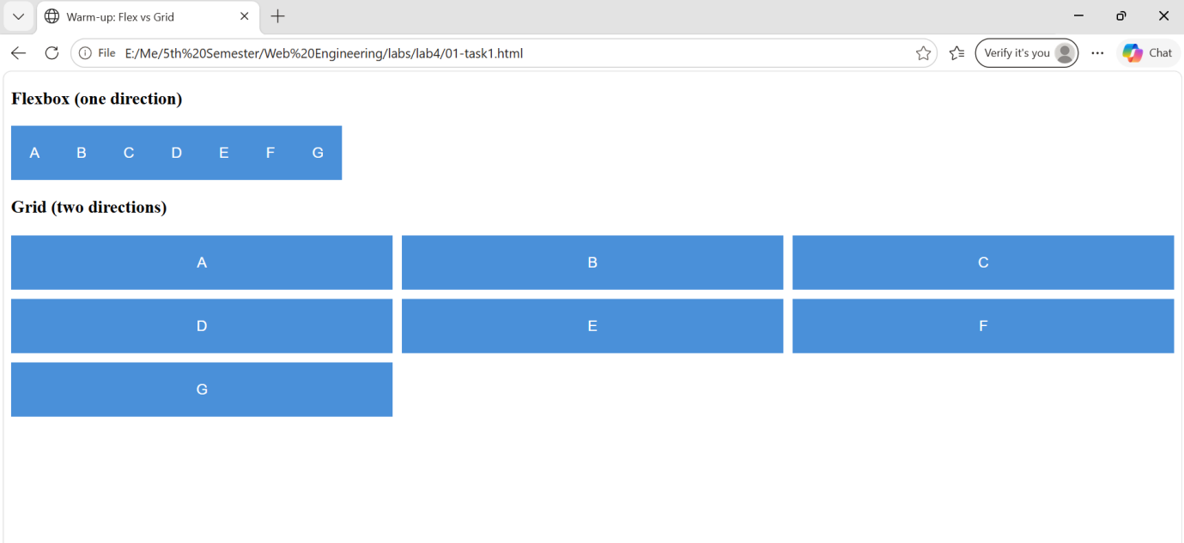
Task A: Flexbox gallery
Question:
Six boxes in normal flow. Add Flexbox so they sit in a wrapping row:
- display: flex and flex-wrap: wrap on .gallery
- gap on .gallery (not margins on .photo)
- flex: 1 1 160px on .photo so items prefer 160px, then wrap
Done when shrinking the window goes 4 → 2 → 1 across, with no horizontal scrollbar.
Solution / Code:
<!-- gallery.html -->
<div class="gallery">
<div class="photo">1</div>
<div class="photo">2</div>
<div class="photo">3</div>
<div class="photo">4</div>
<div class="photo">5</div>
<div class="photo">6</div>
</div>

/* styles.css */
.gallery {
display: flex;
flex-wrap: wrap;
gap: 12px;
}

.photo {
flex: 1 1 160px;
background: #4a90d9;
color: #fff;
height: 100px;
display: flex;
align-items: center;
justify-content: center;
}
Predicted Output:
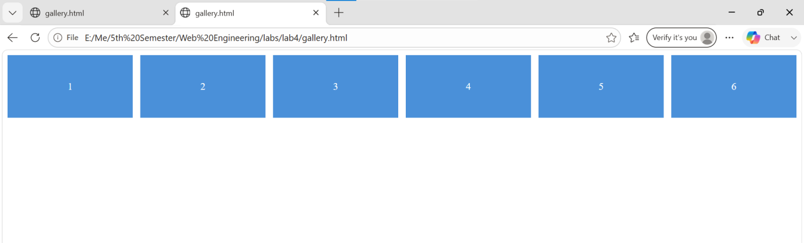

Task B: justify-content on the gallery
Question:
Stay in the same gallery.html. First set flex-basis fixed so items do not grow:
flex: 0 0 120px on .photo (so justify-content actually has leftover space to distribute).
Then on .gallery try one value at a time: flex-start | flex-end | center | space-between | space-around | space-evenly.
Done when you can point at the screen and name which value is showing.
Solution / Code:
/* fixed size so there is leftover space on the main axis */
.photo {
flex: 0 0 120px;
background: #4a90d9;
color: #fff;
height: 100px;
}

/* try one at a time */
.gallery { display: flex; justify-content: flex-start; }
/* .gallery { display: flex; justify-content: flex-end; } */
/* .gallery { display: flex; justify-content: center; } */
/* .gallery { display: flex; justify-content: space-between; } */
/* .gallery { display: flex; justify-content: space-around; } */
/* .gallery { display: flex; justify-content: space-evenly; } */
Predicted Output:
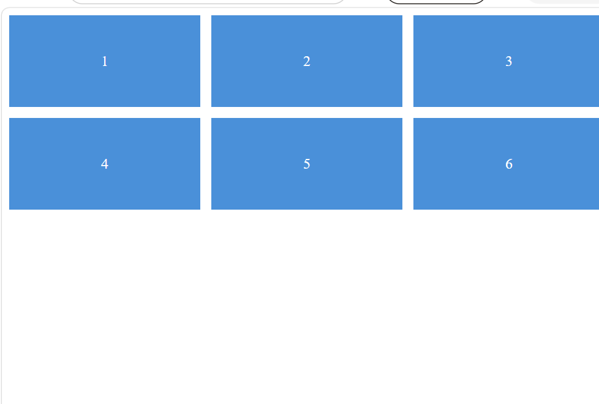
Task C: Grid gallery
Question:
New file: week-04/grid-gallery.html. Six image boxes. Use CSS Grid with auto-fit + minmax so it reflows automatically — no media query needed.
Done when widening/narrowing the window changes how many columns you see, with no horizontal scrollbar at 320px.
Solution / Code:
```html
<!DOCTYPE html>
<html lang="en">
<head>
<meta charset="UTF-8">
<meta name="viewport" content="width=device-width, initial-scale=1.0">
<title>Document</title>

<style>
/* styles.css */
.gallery {
display: grid;
grid-template-columns: repeat(auto-fit, minmax(160px, 1fr));
gap: 12px;
}

.photo {
background: #4a90d9;
color: #fff;
height: 100px;
display: flex;
align-items: center;
justify-content: center;
}
</style>
</head>

<body>

<!-- grid-gallery.html -->
<div class="gallery">
<div class="photo">1</div>
<div class="photo">2</div>
<div class="photo">3</div>
<div class="photo">4</div>
<div class="photo">5</div>
<div class="photo">6</div>
</div>

</body>
</html>
```

Predicted Output:
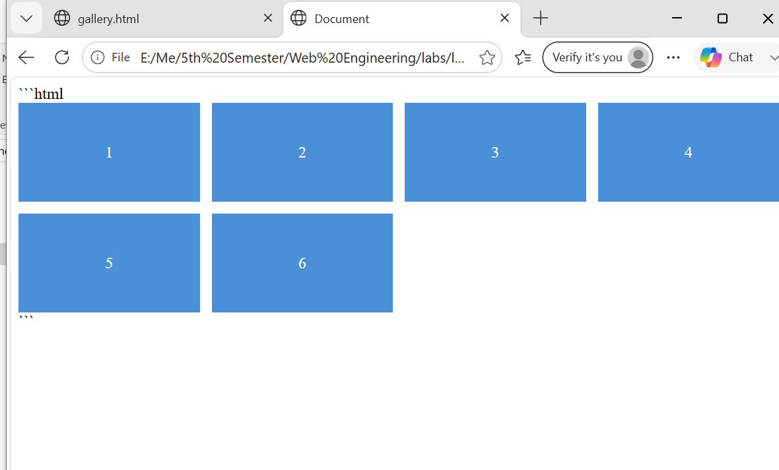

Task D: Mobile-first breakpoints (10 min)
Question:
Use the Grid gallery from Activity C but remove auto-fit / minmax — write the media queries manually this time.
Start small (base = 1 column, no media query). Then add all four min-width breakpoints, each changing the column count:
640px -> 2 columns | 768px -> 3 columns | 1024px -> 4 columns | 1280px -> 4 columns + larger gap.
Done when every breakpoint in the table changes the layout, and 320px has no horizontal scrollbar.
Solution / Code:
<!DOCTYPE html>
<html lang="en">

<head>
<meta charset="UTF-8">
<meta name="viewport" content="width=device-width, initial-scale=1.0">

<title>Responsive Grid Gallery</title>

<style>
/* Base
(mobile-first, no media query) */

.gallery {
display: grid;
grid-template-columns: 1fr;
gap: 10px;
}

.photo {
background: #4a90d9;
color: white;
height: 100px;

display: flex;
align-items: center;
justify-content: center;

font-size: 24px;
}

/* Small: 640px */

@media (min-width: 640px) {

.gallery {
grid-template-columns: repeat(2, 1fr);
}

}

/* Medium: 768px */

@media (min-width: 768px) {

.gallery {
grid-template-columns: repeat(3, 1fr);
}

}

/* Large: 1024px */

@media (min-width: 1024px) {

.gallery {
grid-template-columns: repeat(4, 1fr);
}

}

/* Extra large: 1280px */

@media (min-width: 1280px) {

.gallery {
grid-template-columns: repeat(4, 1fr);
gap: 20px;
}

}
</style>

</head>

<body>

<div class="gallery">

<div class="photo">1</div>
<div class="photo">2</div>
<div class="photo">3</div>
<div class="photo">4</div>
<div class="photo">5</div>
<div class="photo">6</div>

</div>

</body>

</html>

Predicted Output:
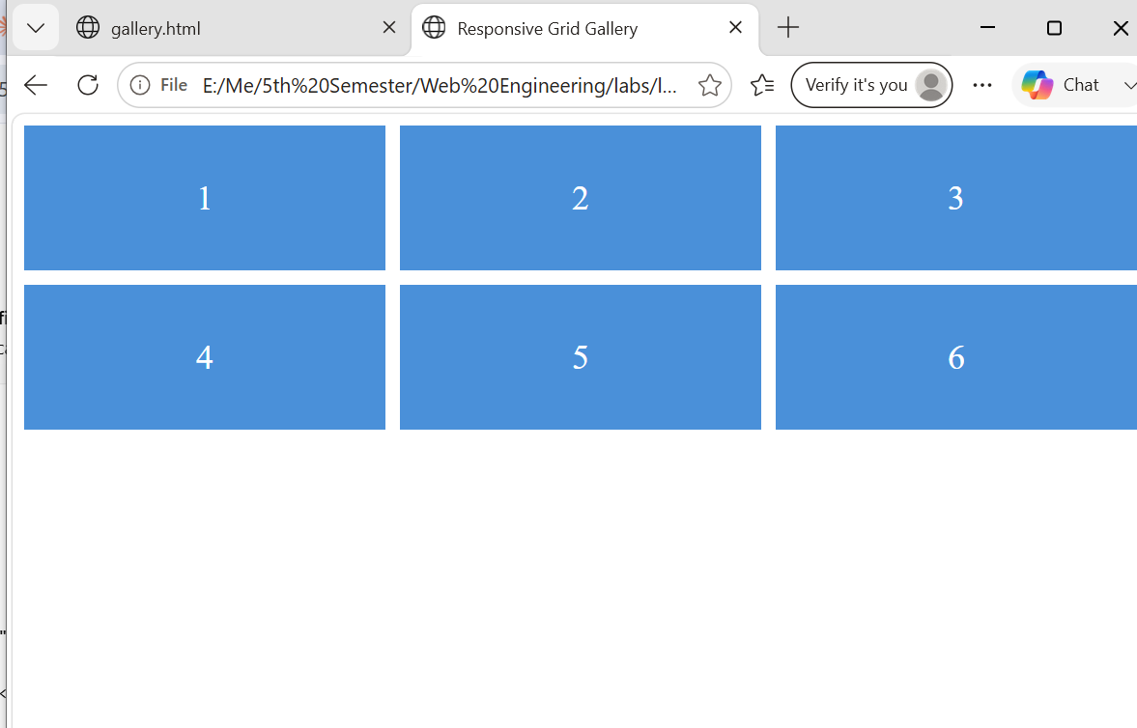
Task E: Position comparisons (8 min)
Question:
Open position.html. Compare static / relative / absolute / fixed / sticky. Finish these three sentences:
1. Static is …
2. Relative keeps a gap; absolute …
3. Fixed follows the window; sticky follows …
Solution / Code:
<!-- position.html -->
<div class="row">
<div class="box static">Static</div>
<div class="box relative">Relative</div>
<div class="box">Neighbour</div>
</div>

<div class="parent" style="position: relative;">
<div class="box">In flow</div>
<div class="box absolute">Absolute</div>
<div class="box">In flow 2</div>
</div>

<div class="box fixed">Fixed</div>

<div class="parent pink">
<div class="box sticky">Sticky</div>
<p>...tall scrollable content inside pink parent...</p>
</div>

<style>
.box { background:#4a90d9; color:#fff; padding:10px; margin:5px; display:inline-block; font-family:sans-serif; }
.relative { position: relative; top: 20px; left: 20px; }
.absolute { position: absolute; top: 0; right: 0; background:#5dcaa5; }
.fixed { position: fixed; bottom: 10px; right: 10px; }
.sticky { position: sticky; top: 0; background:#5dcaa5; }
.pink { background:#fbeaf0; height: 600px; padding:10px; }
</style>
Predicted Output:

Homework Tasks (due before Week 05)

Task 2: Grey-box layout clone
Question:
Recreate a real homepage structure only (grey boxes, no real images/brand copy). Use Grid for the page shell and Flexbox inside the header / cards.
Submit: HTML + CSS + a screenshot next to the original (or a link to the original).
Solution / Code:
<!-- index.html : grey-box clone of a typical news homepage shell -->
<body>
<div class="shell">
<header class="header">
<div class="box logo">LOGO</div>
<nav class="box nav">
<span>Home</span><span>News</span><span>Sports</span><span>Contact</span>
</nav>
</header>
<aside class="box sidebar">Sidebar</aside>
<main class="box main">Main content</main>
<div class="cards">
<div class="box card">Card 1</div>
<div class="box card">Card 2</div>
<div class="box card">Card 3</div>
</div>
<footer class="box footer">Footer</footer>
</div>
</body>

<style>
.box { background:#ccc; border:1px solid #999; padding:20px; text-align:center; font-family:sans-serif; }

.shell {
display: grid;
grid-template-columns: 1fr 3fr;
grid-template-areas:
"header header"
"sidebar main"
"cards cards"
"footer footer";
gap: 10px;
}

.header { grid-area: header; display: flex; justify-content: space-between; align-items: center; }
.nav { display: flex; gap: 16px; background: transparent; border: none; padding: 0; }
.sidebar { grid-area: sidebar; }
.main { grid-area: main; }

.cards { grid-area: cards; display: flex; gap: 10px; }
.card { flex: 1; }

.footer { grid-area: footer; }
</style>
Predicted Output
Task 3: Make the profile responsive
Question:
Take the Week 02-03 profile page and make it fully usable at 320px: nav, card, form, no horizontal scroll. Use mobile-first min-width queries where needed.
Submit: updated profile files + a 320px screenshot.
Solution / Code:
<!-- profile.html -->
<nav class="navbar">
<span class="brand">Abdul Manan</span>
<div class="nav-links"><a href="#">Home</a><a href="#">About</a><a href="#">Contact</a></div>
</nav>

<div class="profile-card">
<h1>Abdul Manan</h1>
<p>BSCS-V-E &mdash; Web Engineering</p>
</div>

<form class="contact-form">
<label>Name<input type="text" /></label>
<label>Email<input type="email" /></label>
<label>Message<textarea></textarea></label>
<button type="submit">Send</button>
</form>

<style>
* { box-sizing: border-box; }
body { margin: 0; font-family: sans-serif; }

/* Mobile-first base: everything stacked, full width */
.navbar { display: flex; flex-direction: column; padding: 10px; background: #333; color: #fff; }
.nav-links { display: flex; flex-direction: column; gap: 8px; margin-top: 8px; }
.nav-links a { color: #fff; text-decoration: none; }

.profile-card { padding: 16px; text-align: center; }

.contact-form { display: flex; flex-direction: column; gap: 10px; padding: 16px; max-width: 100%; }
.contact-form input, .contact-form textarea { width: 100%; padding: 8px; }

/* Small screens and up: nav becomes a row */
@media (min-width: 640px) {
.navbar { flex-direction: row; justify-content: space-between; align-items: center; }
.nav-links { flex-direction: row; gap: 16px; margin-top: 0; }
.contact-form { max-width: 500px; margin: 0 auto; }
}
</style>
Predicted Output:

Task 4: Break and fix (annotate)
Question:
In layout-debug.html, deliberately cause then fix TWO of the following four bugs, commenting each fix in the CSS:
1. Flex items overflowing because flex-wrap is missing
2. Absolute badge without position: relative on the parent
3. Image causing horizontal scroll
4. Desktop-only layout with no mobile base
(This solution fixes bugs 1 and 2.)
Solution / Code:
<!-- layout-debug.html -->
<div class="row">
<div class="item">1</div><div class="item">2</div><div class="item">3</div>
<div class="item">4</div><div class="item">5</div><div class="item">6</div>
</div>

<div class="card">
<span class="badge">New</span>
<p>Product card content</p>
</div>

<style>
/* BUG 1 (before): .row { display: flex; } -> items overflow the container, no wrap */
/* FIX 1: */
.row {
display: flex;
flex-wrap: wrap; /* fix: items now wrap onto new lines instead of overflowing */
gap: 8px;
}
.item { flex: 1 1 120px; background: #4a90d9; color:#fff; padding: 20px; text-align:center; }

/* BUG 2 (before): .card had no position set -> .badge pinned to the whole PAGE, not the card */
/* FIX 2: */
.card {
position: relative; /* fix: now the nearest positioned ancestor for the badge */
border: 1px solid #999;
padding: 20px;
margin: 20px;
}
.badge {
position: absolute;
top: 8px;
right: 8px;
background: #d85a30;
color: #fff;
padding: 4px 8px;
border-radius: 4px;
}
</style>
Predicted Output:

