Task 1: Create styles.css and link it
index.html:

<!DOCTYPE html>
<html lang="en">
<head>
<meta charset="UTF-8"/>
<title>Hello Web</title>
<link rel="stylesheet" href="styles.css"/>
</head>
<body>
<h1>Hello, Web Engineering</h1>
<p>My name is Abdul Manan and this is my first page.</p>
</body>
</html>

styles.css:

body {
font-family: Arial, sans-serif;
margin: 20px;
}

h1 {
color: navy;
}

p {
font-size: 16px;
color: #333;
}

Output
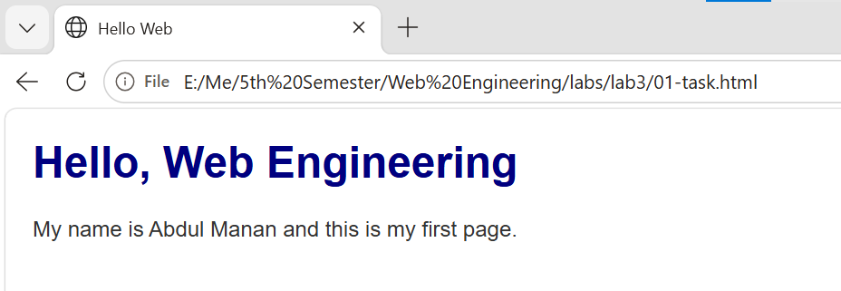

Task 8: Box model — padding, border, margin
.box {
background: lightblue;
padding: 40px;
border: 8px solid navy;
margin: 40px;
width: 200px;
}

Output
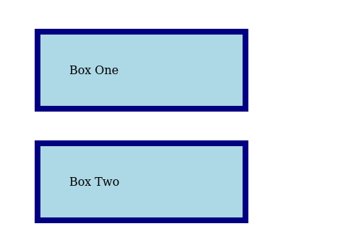
padding: 40px -> text sits further from the navy edge (blue space grows).
border: 8px solid navy -> the navy edge itself gets thicker.
margin: 40px -> the grey gap between Box One and Box Two grows.

Class Activity C: Selectors
h1 { color: navy; font-size: 32px; }
.note { color: teal; font-weight: bold; }
#alert { background: yellow; }
input[type="email"] { border: 2px solid teal; }
a:hover { color: crimson; }
li:nth-child(odd) { background: lightblue; }
li:nth-child(even) { background: orange; }

1. Tag (h1),
2. Class (.note),
3. ID (#alert),
4. Attribute (input[type="email"]),
6. Odd (li:nth-child(odd)),
7. Even (li:nth-child(even))
Output
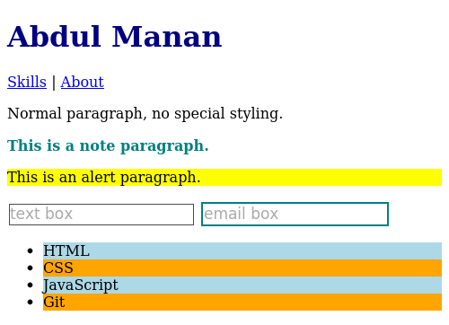

Output
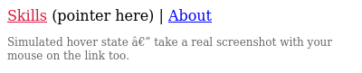

Class Activity D: Who wins and why (specificity duel)
Part 1 - HTML structure
<main id="main">
<p class="intro">I am the intro paragraph.</p>
</main>

Part 1 - styles.css (four rules, in this order)
/* 1) Element selector: 0,0,1 */
p {
color: green;
}

/* 2) Class selector: 0,1,0 */
.intro {
color: blue;
}

/* 3) Element + class: 0,1,1 */
p.intro {
color: purple;
}

/* 4) ID + element: 1,0,1 */
#main p {
color: navy;
}

Screenshot 1 - all 4 rules active (winner: #main p, navy, specificity 1,0,1)
Output


Screenshot 2 - #main p commented out (winner: p.intro, purple, specificity 0,1,1)
/* #main p { color: navy; } */
Output


Screenshot 3 - p.intro also commented out (winner: .intro, blue, specificity 0,1,0)
/* p.intro { color: purple; } */
Output


Screenshot 4 - same specificity, source order test (winner: crimson, last rule wins)
p { color: green; }
p { color: crimson; }
Output


Screenshot 5 - inline style added (winner: hotpink, inline always beats CSS rules)
<p class="intro" style="color: hotpink;">I am the intro paragraph.</p>
Output


