**Assignment-4**

Q1. Define a class employee having the following description:

|  |  |
| --- | --- |
| **Data Members** | **Description** |
| Pan | To store personal account number |
| Name | To store name |
| Taxincome | To store annual taxable income |
| Tax | To store tax that is calculated |

|  |  |
| --- | --- |
| **Member Functions** | **Description** |
| InputInfo() | Store the pan number,name,taxableincome |
| TaxCalc() | Calculate tax for an employee |
| DisplayInfo() | Output details of an employee |

**Write a C++ program to compute the tax according to the given conditions and display  
 the output.**

|  |  |
| --- | --- |
| **Total Annual Taxable Income** | **Tax Rate** |
| Upto 2,50,000 | No tax |
| From 2,50,000 to 3,00,000 | 10 % of the income exceeding 2,50,000 |
| From 3,00,000 to 4,00,000 | Rs. 5000+20 % of the income exceeding 3,00,000 |
| Above 4,00,000 | Rs 25000 + 30 % of the income exceeding 4,00,000 |

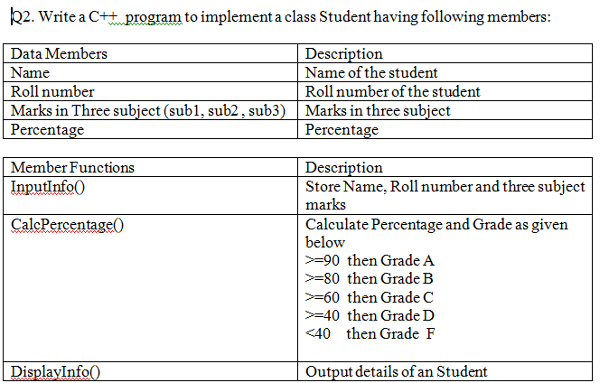

**Q3.Write a C++ program to create a class named 'Bank ' with the following data members:**

**Name of depositor**

**Address of depositor**

**Account Number**

**Balance in account**

**Class 'Bank' has a method for each of the following:**

**1 - Generate a unique account number for each depositor**

**For first depositor, account number will be 1001, for second depositor it will be 1002 and so on**

**2 - Display information and balance of depositor**

**3 - Deposit more amount in balance of any depositor**

**4 - Withdraw some amount from balance deposited**

**5 - Change address of depositor**

**After creating the class, do the following operations**

**1 - Enter the information (name, address, account number, balance) of the depositors. Number of depositors is to be entered by user.**

**2 - Print the information of any depositor.**

**3 - Add some amount to the account of any depositor and then display final information of that depositor**

**4 - Remove some amount from the account of any depositor and then display final information of that depositor**

**5 - Change the address of any depositor and then display the final information of that depositor**

**6 - Randomly repeat these processes for some other bank accounts.**