**Applied Distributed System**

**Assessment 1 – Java Client Server Application**

Prepared by:

Manan Amitkumar Patel

* Client 1:

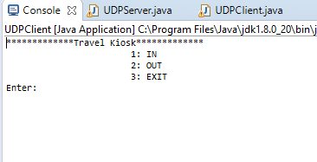

Here this is the screen where the customer will enter operation number which they want to perform.

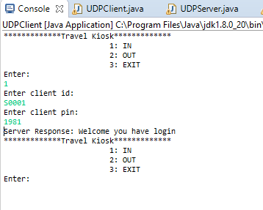

Customer wants to log in and enter the required details that is client id and password. Once the id and password are correct, the welcome message will display.

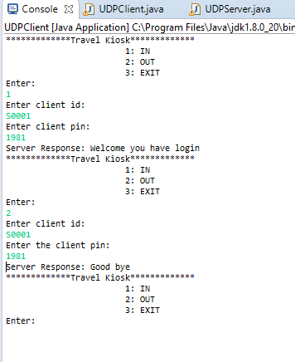

Customer has log out successfully. However, customer needs to select proper operation to perform and must write valid client id and password.

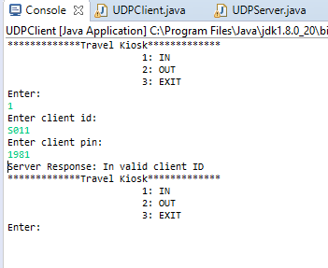

Here the customer writes invalid client ID, and the serer returns message of invalid client id message.

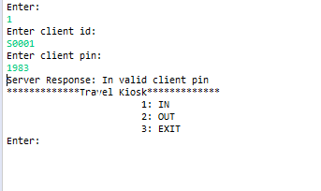

Here the customer writes invalid password, and the server returns invalid password message.

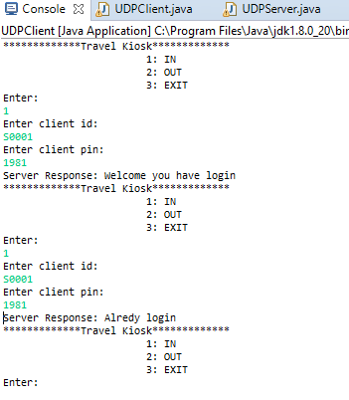

Here this screenshot indicates that if the customer is already login and tries to login another time then, the server returns the message that client already login.

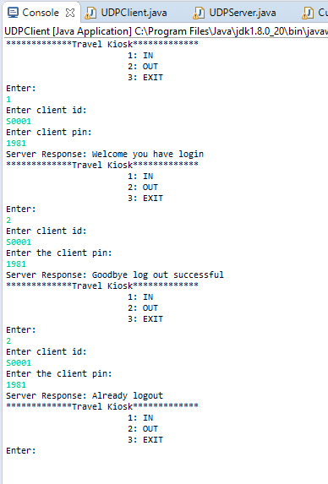

This image indicates that, if the customer is already logout and then tried again to logout then the server will send already logout message.

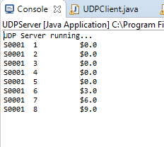

Here this image is from the server side where the server makes the records of total trip of the customer and total cost of trip. Once five free trips are done, every time three dollars will be increase per trip.

* Member.dat file:

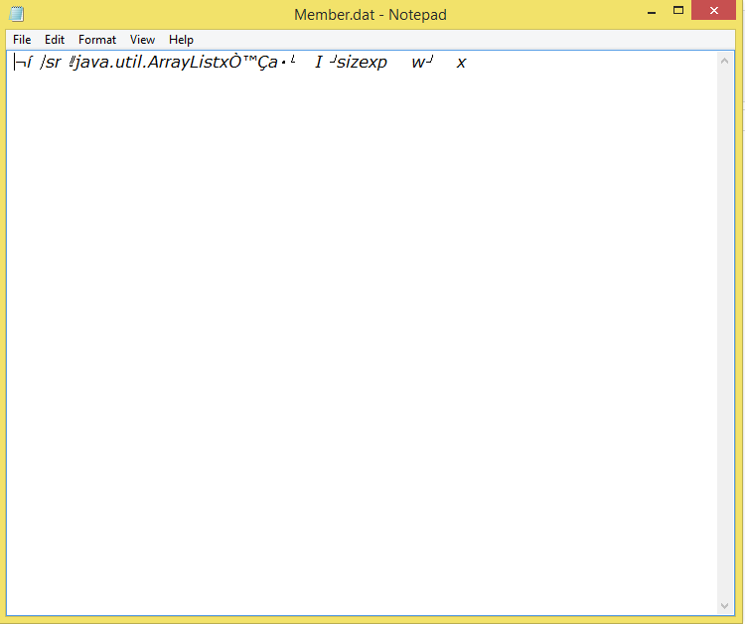

Here is the member.dat file which flush the contents of data structure by serializing each customer data during certain period of time.