 | Course Name: Design Patterns/Thinking LAB | EXPERIMENT NO. 1
 | Course Code: 20CP210P  Faculty: Dr. Ketan Sabale | Branch: CSE | Semester: IV
Submitted by: Manan Kapkar
Roll no: 23BCP336

Objective: To familiarize students with standard Creational design patterns.

Experiment: Explain the abstract factory design pattern and write a program using any object-oriented programming language to demonstrate the working of abstract factory design pattern.

Abstract Factory Pattern: The Abstract Factory Pattern provides an interface to create families of related or dependent objects without specifying their concrete classes.

Key Points:
- Purpose: To create a group of related objects (a "family") without exposing their implementation details.
- Structure:
  - Abstract Factory: Declares creation methods for related objects.
  - Concrete Factory: Implements creation methods for specific products.
  - Abstract Product: Common interface for objects in the family.
  - Concrete Product: Implements the abstract product interface.
- Example: Creating UI components for multiple platforms (e.g., Windows and MacOS).

Advantages:
- Encapsulation: Hides the details of object creation from the client.
- Consistency: Ensures related objects are compatible.
- Scalability: Adding new families of objects is easy; just add a new factory and related products.
- Flexibility: Allows the system to switch between different families of objects dynamically.

Disadvantages:
- Complexity: Increases the number of classes and interfaces in the codebase.
- Hard to Extend: Adding new types of products (not families) requires changes to the abstract factory and all its implementations.
- Tight Coupling: Concrete factories are tightly coupled to product families.

Problem Statement:
Design an abstract factory pattern that allows the user to choose from different companies of laptop components such as CPU, GPU and hardware using different factories for each component, and the final assembly should be done by a main factory class. The code should ask the brand from user and create the particular component object based on the user input. The solution should have modularity and scalability.

DIAGRAM:
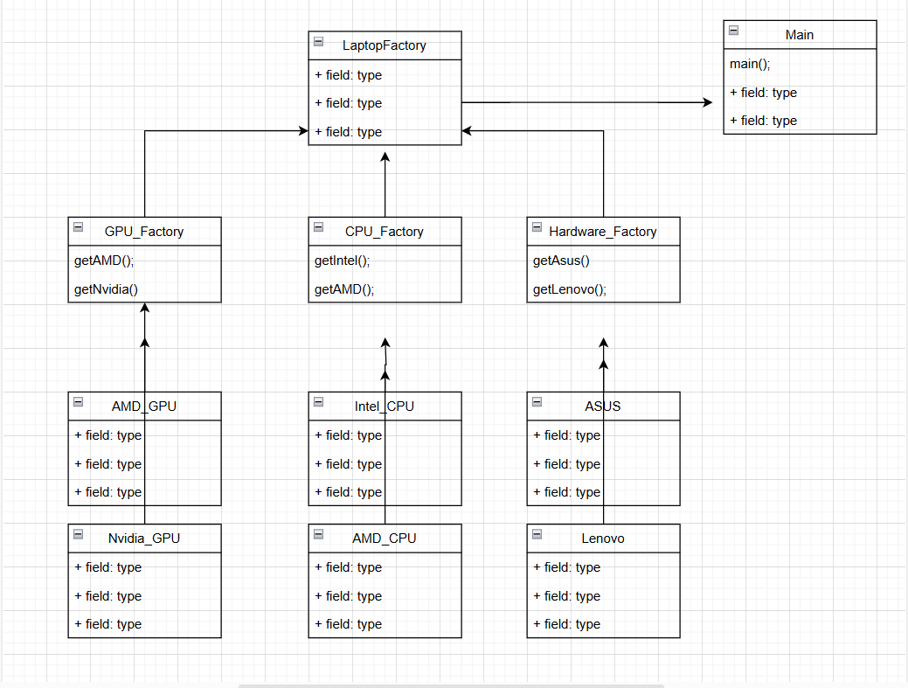

CODE:

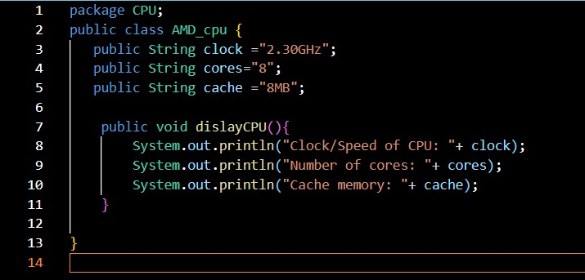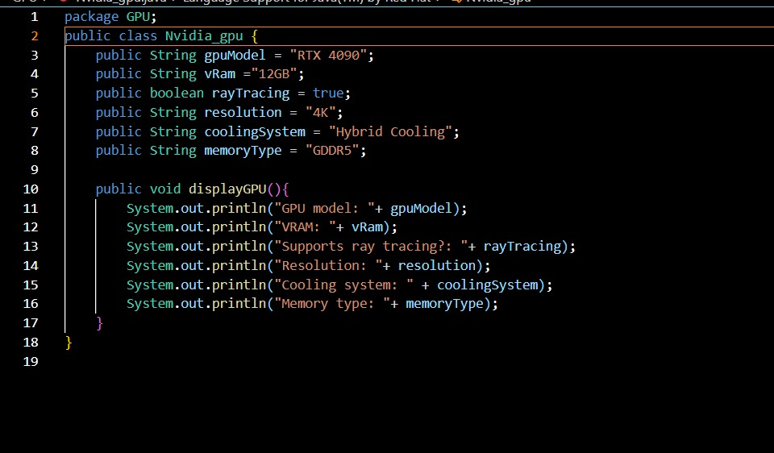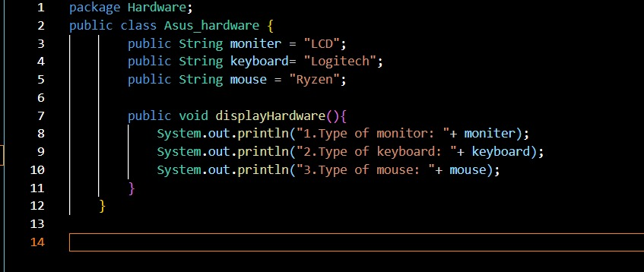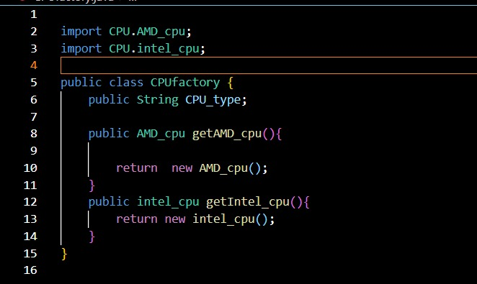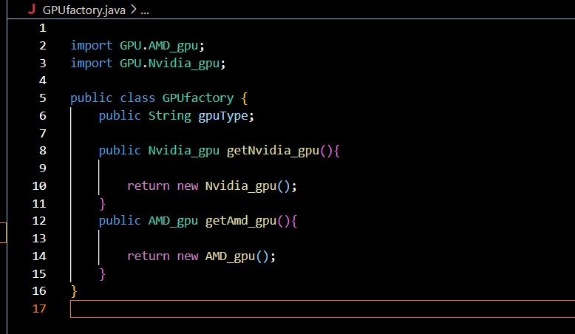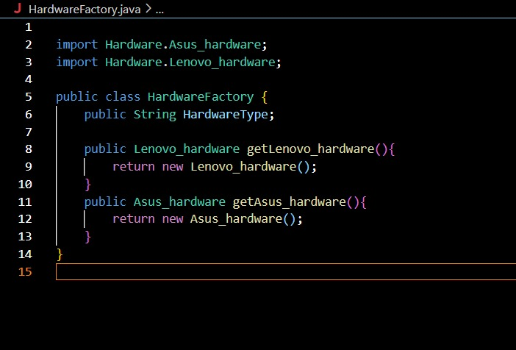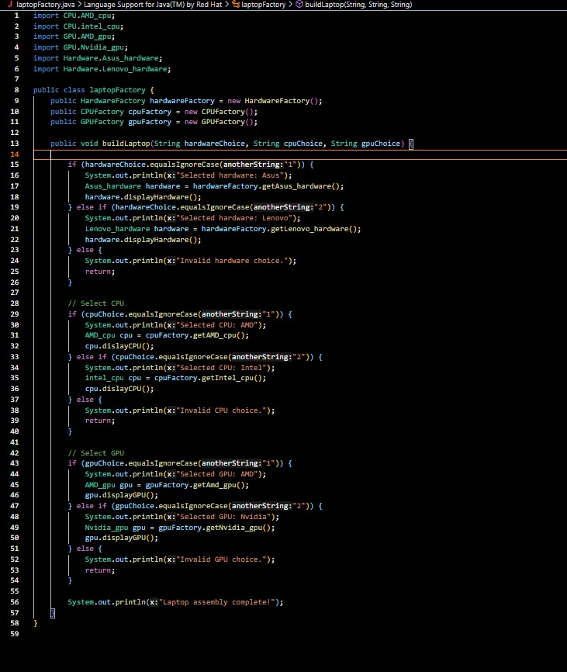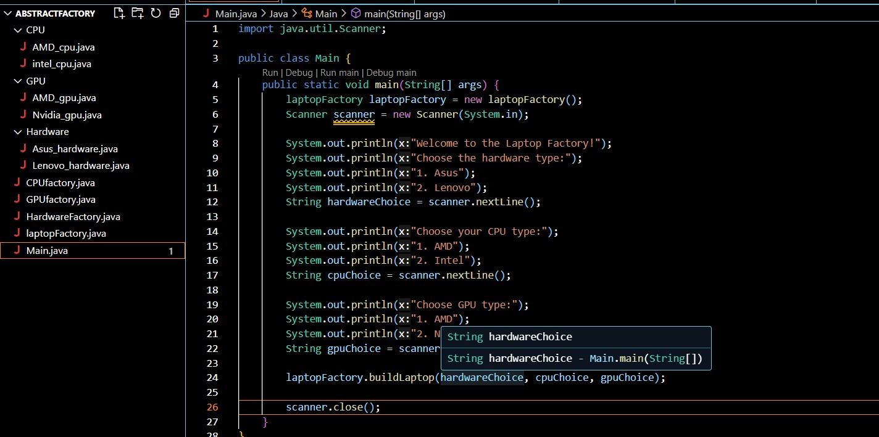

OUTPUT:

