 | Course Name: Design Patterns/Thinking LAB | EXPERIMENT NO. 1
 | Course Code: 20CP210P  Faculty: Dr. Ketan Sabale | Branch: CSE | Semester: IV
Submitted by: Manan Kapkar
Roll no: 23BCP336

Objective: To familiarize students with standard Creational design patterns.
Experiment: Explain the builder design pattern and write a program using any object-oriented programming language to demonstrate the working of builder design pattern.
Builder Design Pattern: The Builder design pattern is a creational design pattern used in Java to construct complex objects by separating the construction process from the actual representation. It allows you to create an object step-by-step, providing a flexible approach to constructing objects with different configurations.

Key Features:
1. Separation of Concerns: The construction process is separated from the representation of the object, making the code cleaner and more maintainable.
2. Fluent Interface: It often uses a fluent interface style, allowing method chaining for easier object construction.
3. Complex Objects: It’s used to construct objects with multiple components or optional parameters.

Advantages of Builder Design Pattern:
1. Flexibility: Builder pattern allows different representations of an object to be created with the same construction process.
2. Maintainability: It provides clear separation between object construction and its representation, making the code more maintainable.
3. Readability: By using a fluent interface and method chaining, it improves readability and makes object creation more intuitive.
Disadvantages of Builder Design Pattern:
1. Increased Number of Classes: The Builder pattern adds additional classes (e.g., Builder and Director), which can increase the complexity of the codebase.
2. Verbose Code: For simpler objects, using the Builder pattern may be overkill, leading to unnecessarily verbose code.
3. Learning Curve: It may require extra effort for beginners to understand how to implement and use the pattern effectively.

Type 1: Builder Design Pattern - Type 1 (Avoiding Constructor Overloading) in Java (Without Nested Class)
This version of the Builder Pattern does not use a nested class, making it more explicit but still effective in avoiding constructor overloading.

Why Avoid Constructor Overloading?
- Too many parameters make the code hard to read & maintain.
- Some parameters may be optional, leading to many overloaded constructors.

Problem Statement:
Design a builder pattern that allows the user to choose different items in a shopping mall in which the bill is made by a builder class which stores all the item bought by user and calculates the price. The solution should have modularity and scalability.
DIAGRAM:
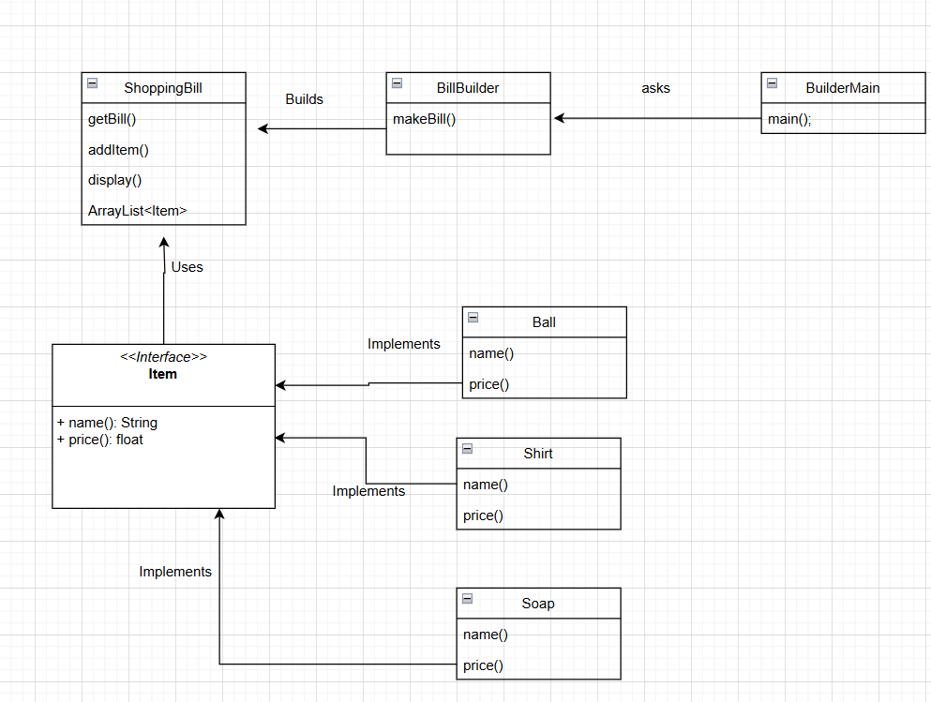
CODE:
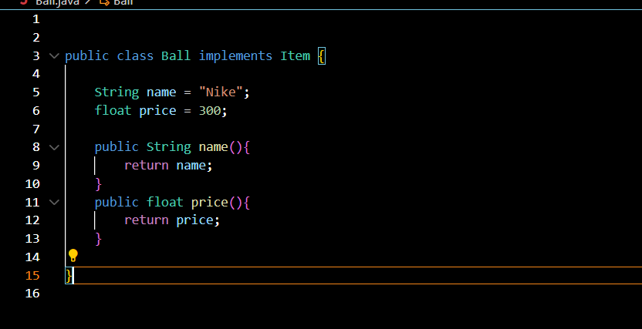

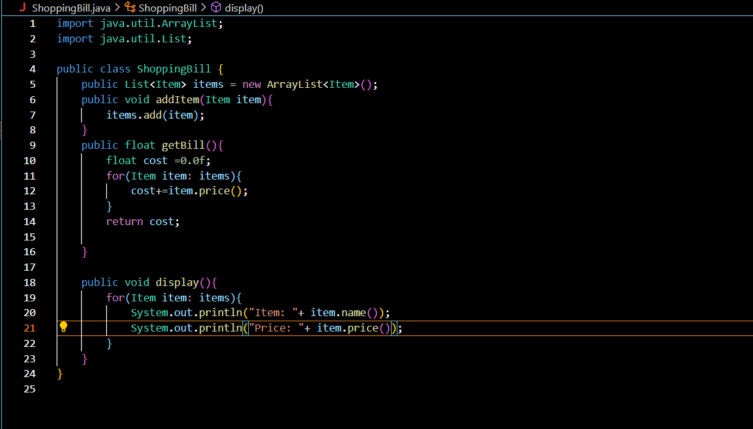

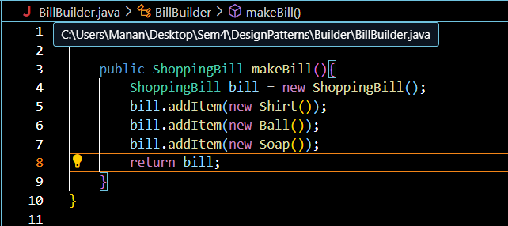

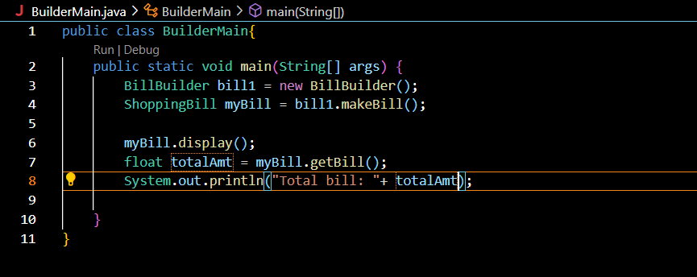

OUTPUT:
