 | Course Name: Design Patterns/Thinking LAB | EXPERIMENT NO. 1
 | Course Code: 20CP210P  Faculty: Dr. Ketan Sabale | Branch: CSE | Semester: IV
Submitted by: Manan Kapkar
Roll no: 23BCP336

Objective: To familiarize students with standard Creational design patterns.
Experiment: Explain the prototype design pattern and write a program using any object-oriented programming language to demonstrate the working of prototype design pattern.
Prototype Design Pattern: The Prototype Design Pattern is a creational design pattern that enables the cloning of objects to create new instances, rather than instantiating them from scratch. It provides a way to copy existing objects without making the code dependent on their classes.

Key Features:
• Object Cloning:
- A prototype object is created, which serves as a template for creating new objects.
- Instead of instantiating a new object, the existing object is cloned.
• Improves Performance:
- Creating an object by copying is faster and more efficient than creating it from scratch, especially when object creation is resource-intensive.
• Customization:
- The cloned objects can be customized without altering the original prototype.

Advantages
- Reduces Object Creation Time: Cloning is faster than creating a new object.
- Avoids Reinitialization: Copies the state of the existing object.
- Encapsulates Object Creation Logic: Hides complex creation logic.
Disadvantages
- Cloning Complexity: Cloning complex objects with nested references can be challenging.
- Shallow vs Deep Copy: Developers need to handle deep copying carefully if required.
- Potential Errors: Modifying a cloned object may inadvertently affect the original if shallow copying is used..

Problem Statement:
Laptop Shop management system using the Prototype Design Pattern. The goal is to design a system that allows for cloning a laptop shop and its inventory, enabling the creation of new shops without manually recreating the inventory.

DIAGRAM:
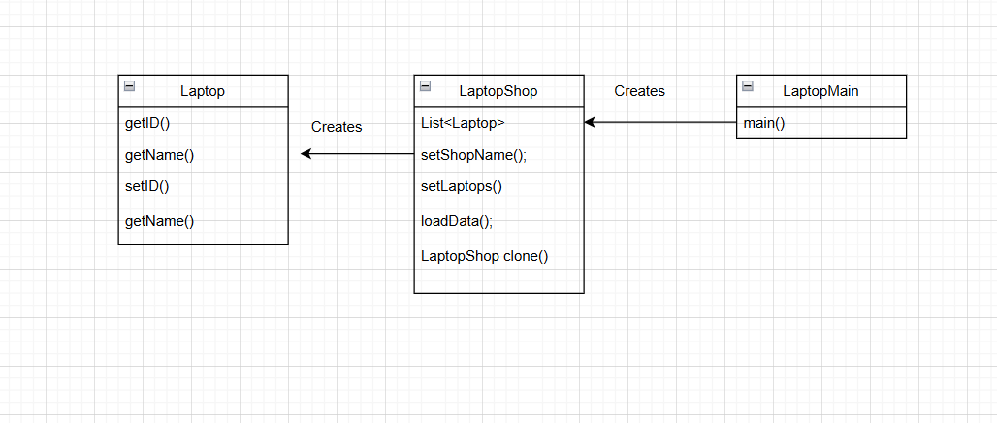
CODE:
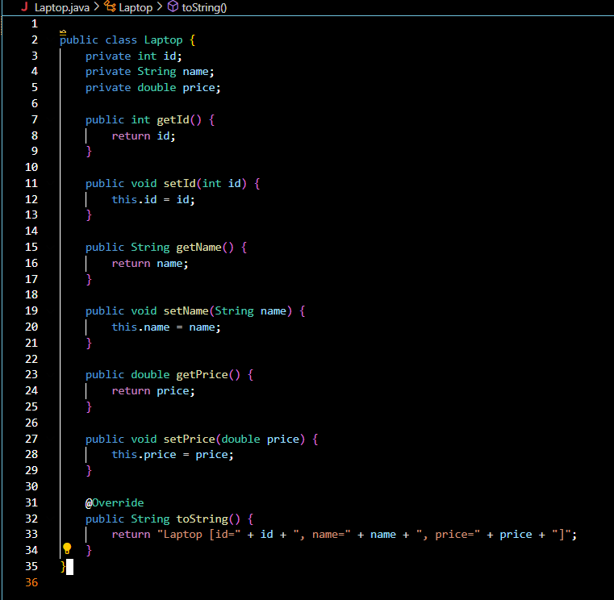

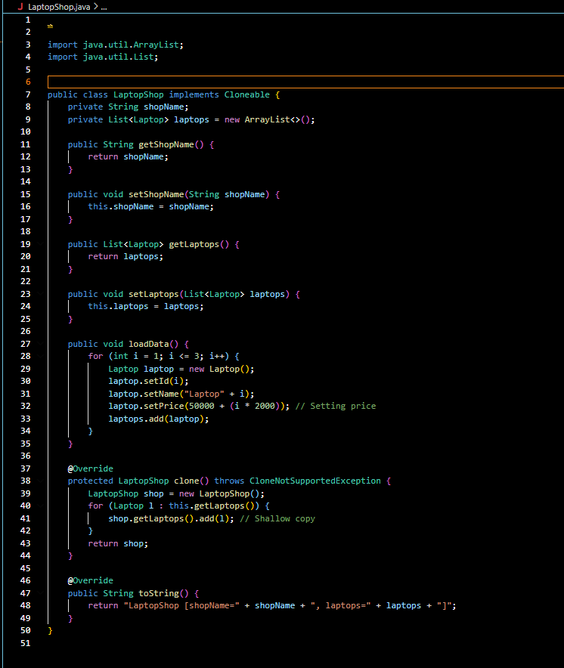

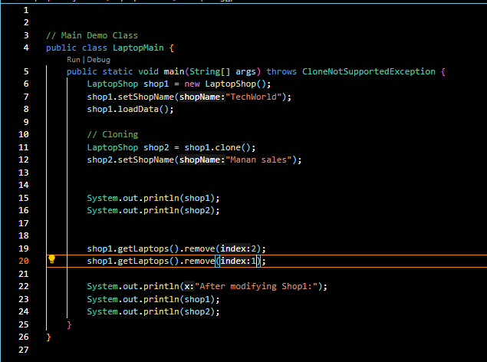

OUTPUT:
