 | Course Name: Design Patterns/Thinking LAB | EXPERIMENT NO. 1
 | Course Code: 20CP210P  Faculty: Dr. Ketan Sabale | Branch: CSE | Semester: IV
Submitted by: Manan Kapkar
Roll no: 23BCP336

Objective: To familiarize students with standard Creational design patterns.
Experiment: Explain the singleton design pattern and write a program using any object-oriented programming language to demonstrate the working of a singleton design pattern.
The Singleton Design Pattern ensures that a class has only one instance throughout the application and provides a global access point to that instance. It is commonly used in scenarios where maintaining a single, consistent object is essential, such as logging, database connections, configuration management, and thread pools.

Advantages of Singleton Design Pattern:
- Ensures a Single Instance
  - Prevents multiple objects from being created, ensuring controlled resource usage.
- Global Access Point
  - Provides a centralized way to access an instance without repeatedly creating new ones.
- Efficient Memory Usage
  - Reduces memory overhead by preventing multiple unnecessary object creations.

Problem Statement:
Design a Singleton pattern that allows the user to login using a name and password. The code checks that if the instance already exists, return that instance only, else in id does not exist, create an instance of login. An authenticate feature is also added.

CODE:

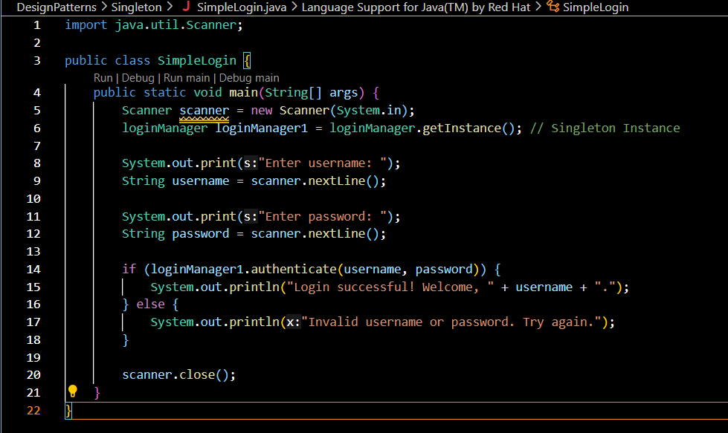

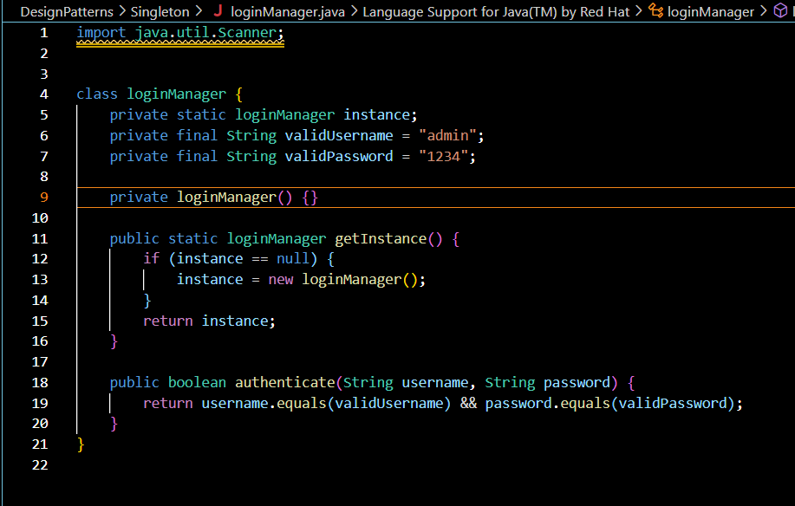

OUTPUT:


