 | Course Name: Design Patterns/Thinking LAB | EXPERIMENT NO. 1
 | Course Code: 20CP210P  Faculty: Dr. Ketan Sabale | Branch: CSE | Semester: IV
Submitted by: Manan Kapkar
Roll no: 23BCP336

Objective: To familiarize students with standard Structural design patterns.
Experiment: Explain the composite design pattern and write a program using any object-oriented programming language to demonstrate its workin
Composite Design Pattern: The Composite Pattern lets you treat individual objects and groups of objects uniformly. It is used to represent tree-like structures (e.g., folders/files, UI components, company hierarchies).
Advantages:
- Simplifies Client Code: Clients can treat individual objects and groups of objects uniformly.
- Scalability: New component types can be added easily without affecting existing code.
- Hierarchical Structures: Efficient for representing tree-like structures (e.g., file systems, menus).
Disadvantages:
- Overhead: Can introduce complexity with a large number of components.
- Type Safety: It may be harder to enforce specific behaviors for leaf vs. composite objects.
- Difficult Debugging: Complex hierarchies can make debugging and testing more challenging.

DIAGRAM:
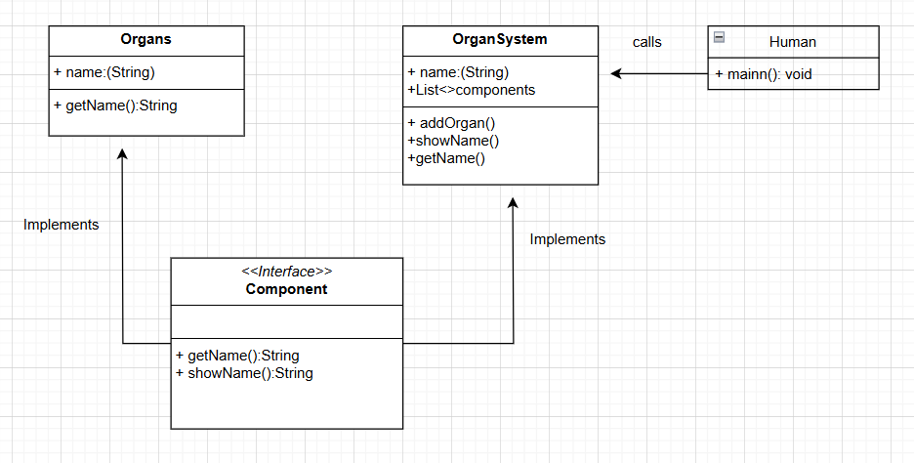

CODE:

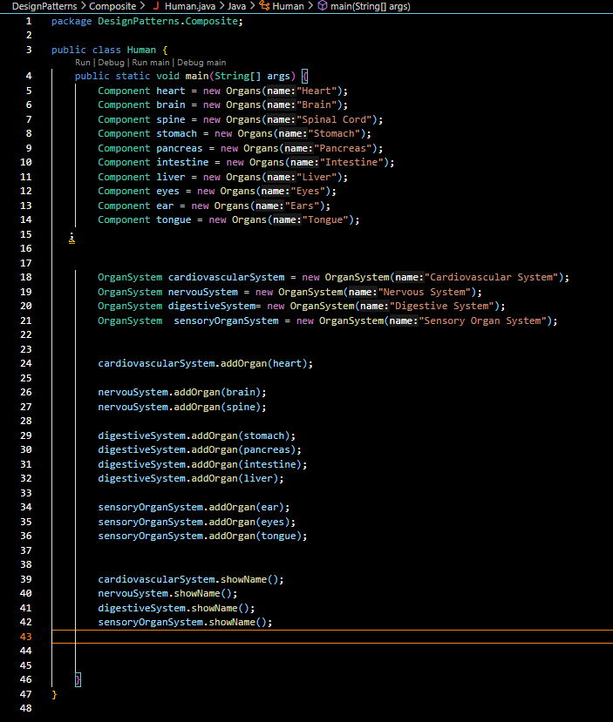
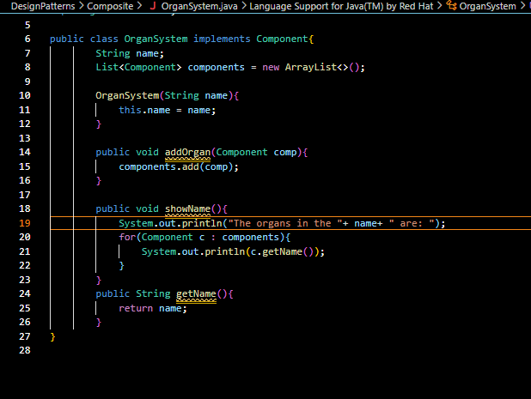
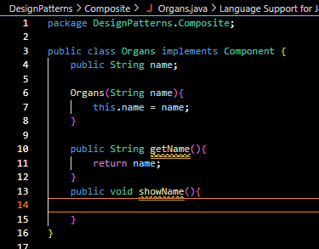

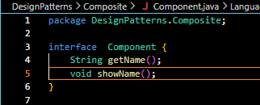

OUTPUT:
