 | Course Name: Design Patterns/Thinking LAB | EXPERIMENT NO. 1
 | Course Code: 20CP210P  Faculty: Dr. Ketan Sabale | Branch: CSE | Semester: IV
Submitted by: Manan Kapkar
Roll no: 23BCP336

Objective: To familiarize students with standard Structural design patterns.
Experiment: Explain the facade design pattern and write a program using any object-oriented programming language to demonstrate the working of it.
The Facade Design Pattern is a structural pattern that provides a simplified interface to a complex subsystem. It hides the complexities of the system and exposes only what is necessary for the client, making the interaction easier.
Advantages:
- Simplifies Usage: Provides a simple interface for complex systems.
- Loose Coupling: Reduces dependencies between client code and subsystems.
- Improved Readability: Makes code easier to read and maintain.
Disadvantages:
- Limited Flexibility: Can limit access to powerful subsystem features by hiding them.
- Overhead: An additional layer may introduce unnecessary complexity for simple systems.
- Risk of God Object: The facade can become too large if it tries to handle too many responsibilities.

CODE:

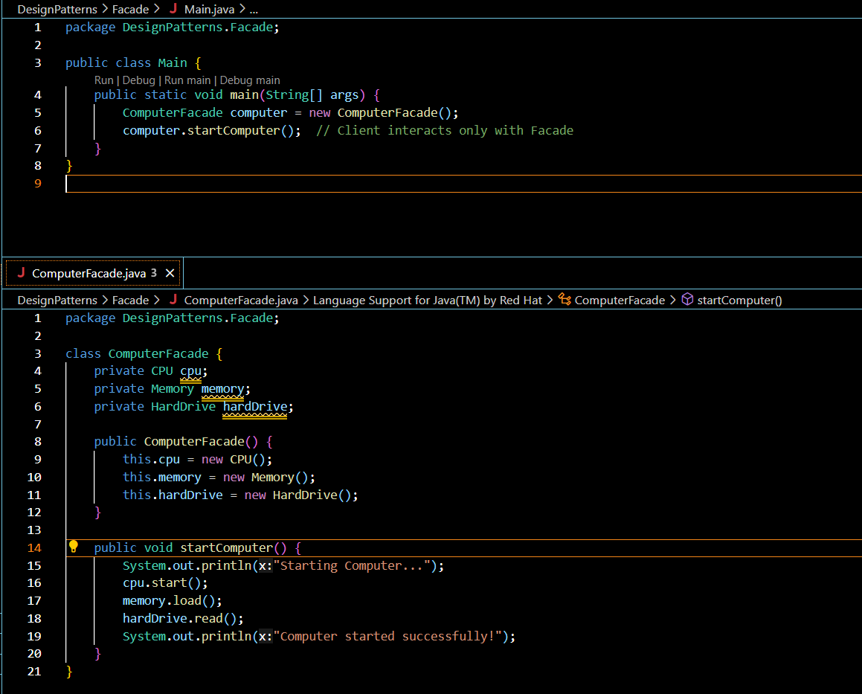

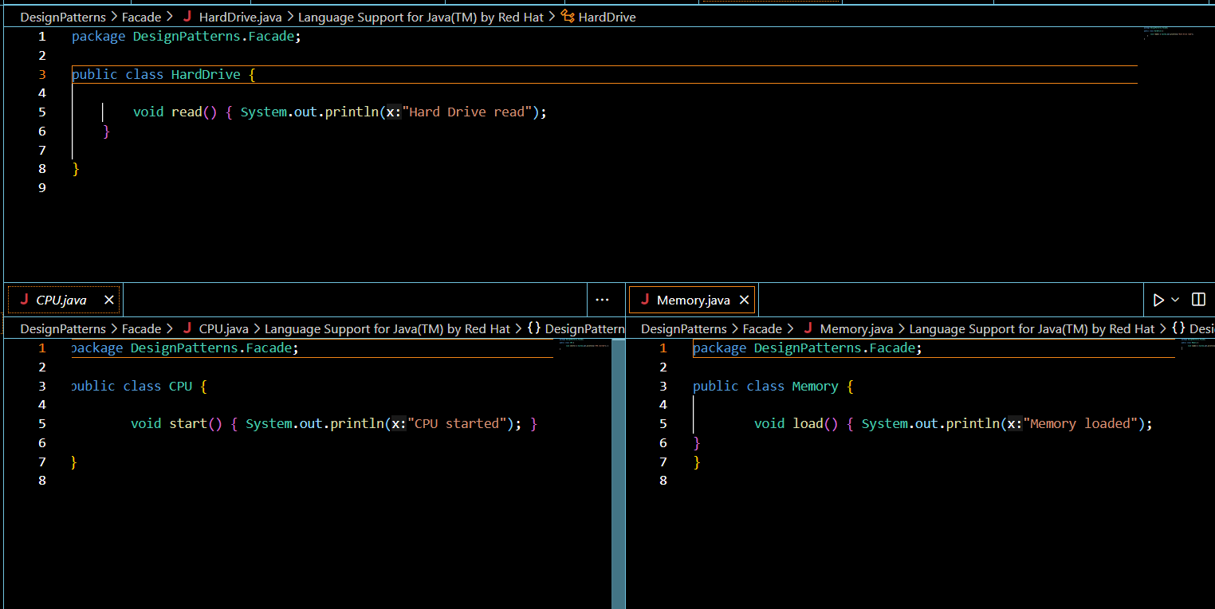

OUTPUT:
