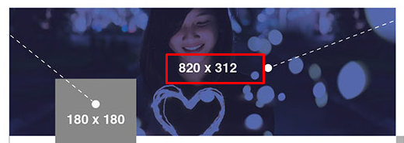

Fb cover pic size: 820\*312

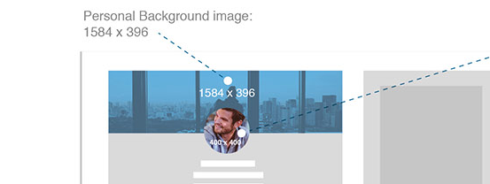

Linkedin cover picture:1584\*396

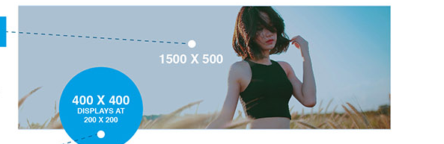

Cover picure twitter:1500\*500