**Kulpunai Zheenbekova**

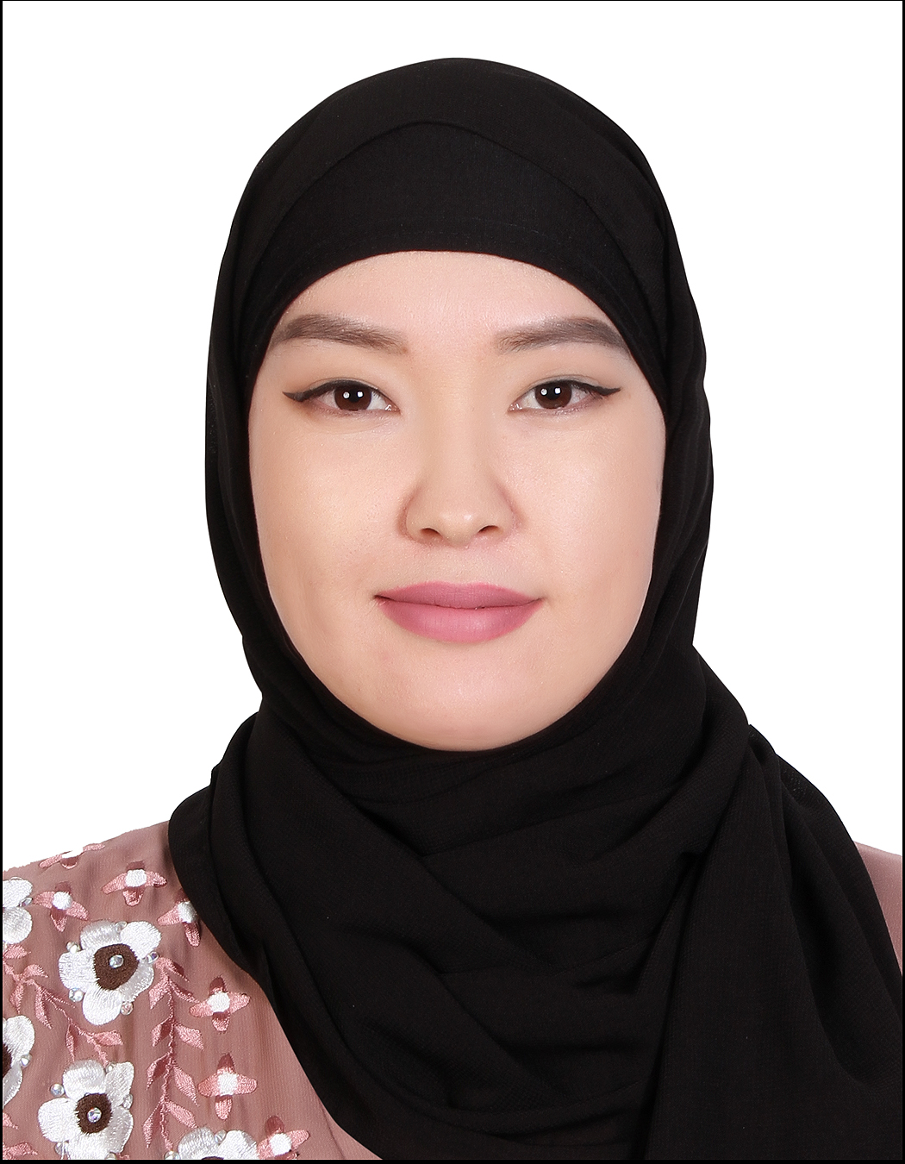

**PERSONAL INFO**

**Phone number in UAE: 0543470157**

**E-mail: zheenbekovak@gmail.com**

**Education : Foreign Linguistics**

**Languages: English-Fluent, Russian-Fluent, Turkish-Fluent**

**Visa exp: 31.12.2020**

**Nationality: Kyrgyz Republic**

**PROFESSIONAL SUMMARY**

*An ambitious, highly motivated, rapidly trainable, responsible and energetic young specialist with managerial skills. Experience in consultation and research for more than 3 years and in retail for 3 years. Very good in adjusting to any international and diverse environment, fast* and *willing learner, very smooth in communicating and problem solving.*

**EXPERIENCES**

|  |  |
| --- | --- |
| **December 2017/ December 2019** | ***Sales Associate, Calvin Klein***  ***Dubai,UAE*** |
| *Mission:*  *http://media5.picsearch.com/is?Ls8Atn2b9yB2IZBEJihdUt8BQd438st-EV1AgmGdycs&height=320* | - Maintaining an enthusiastic and upbeat personality;  - Providing honest and positive feedback to customers regarding the best products that fit the customers’ expectations  - Keeping the work environment neat and clean;  - Ensuring that all products or merchandise are placed in their respective areas as per the brand guide and store standards;  - Communicating with managers regarding customer concerns and employee matters; |

|  |  |
| --- | --- |
| **November 2014/ March 2015** | ***Hostess/Texas Roadhouse***  ***Abu Dhabi,UAE*** |
| *Mission:* *http://media4.picsearch.com/is?wRqC754YsLudvmdSBhSeyuoDLGnsQiEYrjQZliYH6UI&height=200* | -Greeting customers with a genuine smile  -High level of guest service  - Maintaining basic restaurant services  -Answering phone calls and receiving orders |

|  |  |
| --- | --- |
| **2013/2014**  *Mission :*  ÐÐ°ÑÑÐ¸Ð½ÐºÐ¸ Ð¿Ð¾ Ð·Ð°Ð¿ÑÐ¾ÑÑ "design kenzo logo" | ***Sales Assosiate,***  ***Kenzo,Moskow-Russia***  -Seeking and following up on new customers  -Adapting handling style to each client need in order to offer the appropriate service  - Taking care of each case in accordance with Brand’s rules |