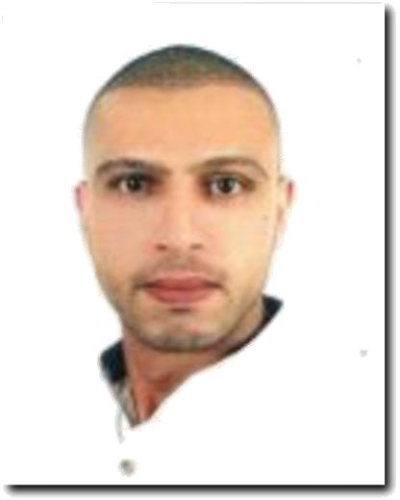***ZEYAD ALI MOHAMMED ALMASRI***

|  |  |
| --- | --- |
| **Address:** | *Deira Dubai, UAE* |
| **Mobile no.:** | *+971566211797* |

**Email Address:** [zeyad-almasri@hotmail.com](mailto:zeyad-almasri@hotmail.com)

**PROFESSIONAL PROFILE**

Seeking a challenging position with a progressive organization that will eﬀectively utilize my knowledge and expertise, where I can grow with the organization and prove to be an asset for its eﬀective functioning, be a team player for the achievement of organizational goals and its success.

**QUALIFICATIONS**

❖Excellent customer service skill.

* Strong communication skills
* Motivated and hardworking
* Flexibility in working conditions
* Individual, skilled in problem solving
* Responsible, eﬃcient with an excellent work ethics.
* Excellent interpersonal and communication skills.
* Proven ability to work under pressured environment with less supervision.

**WORK EXPERIENCE/S**

***Senior sales associate***

*Carter & White, Dubai, UAE*

* April 2019 – up to now

- Tariq and Amy were trained goods are well displayed.

- Receiving and inspecting freight shipments.

- Performing clerical and administrative duties to support the sales manager.

- Ensuring that all customers are welcomed in an appropriate & timely manner.

- Achieving sales targets set by the company and Sales Manager.

- Reporting any issues of concern to senior manager.

- Responsible for making sales reports, daily, weekly, and monthly

- Preparing presentations and Attending international / local Exhibitions.

***Senior Sales Associate***

*Galleries Lafayette, Dubai, UAE*

November 2016 - 2019

* Provides prompt support to store management in assisting with store promotions and visual merchandising
* Assists in distributing work assignments to Associates and ensures store maintenance, cleaning and appearance is up to company standards at all times
* Maintains store-level compliance with company standards of safety, security, facility maintenance, postings/notifications and other administrative duties
* Successfully address customer complaints and resolve problems
* Assists the GSM and where applicable the Senior Assistant Store Manager in managing the special programs
* Other duties as assigned

***Salesperson***

*Swiss Arabian Perfumes, Dubai, UAE*

2014 - 2016

* Promote and sell perfumes of the company to customers who walk – in
* Extend extensive beauty product knowledge to customers.
* Attend and respond to customer queries on perfumes to enhance sales.
* Meet and maximize sales targets and established goals.
* Prepare reports on returned and / or damaged beauty products.
* Accountable for routine administrative operations.
* Offer extensive information to customers and assist them in choosing right products.
* Maintain appearance, inventories and reports of the department.
* Create effective displays to sell seasonal and promotional products.
* Responsible for receipt of payment through automatic debits, vouchers, credit cards, check and cash.
* Ensure money in cash drawers is adequate at the commencement of shifts.
* Maintain clean work areas and ensure adequate staffing is done.
* Assemble and manage other records and reports.

***Salesperson***

*Wanda Outlet*

2000 - 2013

* Working as part of the sales team to develop both new and existing markets
* Liaising with customers & the dealer network to answer and resolve their queries.
* Identifying and then researching potential leads and opportunities.
* Responsible for developing own portfolio of customers
* Writing accurate & informative sales reports and documentation.
* Collecting all the information required to create a request for an estimate.
* Reach and achieving the target as much as possible
* Attending trade shows and exhibition when required

**EDUCATIONAL ATTAINMENT**

*HIGHSCHOOL - 2000*

**PERSONAL INFORMATION**

**NATIONALITY :** *JORDANIAN*

**RELIGION :** *MUSLIM*

**MARITAL STATUS :** *SINGLE*

**LANGUAGES :** *ARABIC & ENGLISH*

**VISA STATUS :** Employment

I hereby certify that the above information mention is true and correct to the best of my knowledge and belief.

ZEYAD ALI MOHAMMED ALMARI

APPLICANT