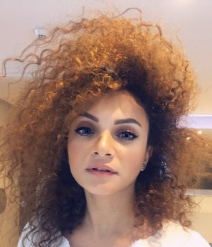

**Sara Ameer**

Dubai, UAE

 (t) 0529504622 (e) saramohamedamer90@gmail.com

* Customer focused senior sales associate with experience in luxury fashion brands.
* Experienced in visual merchandising.
* Experienced in delivering brand guidelines and objectives.
* Eexcellent understanding of the customer and the importance of market leading service always.
* Client, customer and supplier communication skills in my native Arabic and English.
* Able to work collaboratively as part of a team or in silo as an individual dependent on the situation.
* Motivated to overcome obstacles, deliver and create a good working environment.
* Punctual and keen to deliver against the business KPIs and objectives.
* Adaptable to multiple working environments.
* Natural team leader and experienced in operating multiple tasks at once.
* Always willing to learn and better myself within the working environment.



**Relationship Manager**

Damac Real Estate (June 2019 – Present)

* Provide guidance and assist sellers and buyers in marketing and purchasing property for the right price under the best terms.
* Determine clients’ needs and financials abilities to propose solutions that suit them.
* Intermediate negotiation processes, consult clients on market conditions, prices, mortgages, legal requirements and related matters, ensuring a fair and honest dealing.
* Perform comparative market analysis to estimate properties’ value.
* Display and market real property to possible buyers.
* Prepare necessary paperwork (contracts, leases, deeds, closing statements etc)
* Manage property auctions or exchanges.
* Maintain and update listings of available properties.
* Cooperate with appraisers, escrow companies, lenders and home inspectors.
* Develop networks and cooperate with attorneys, mortgage lenders and contractors.
* Promote sales through advertisements, open houses and listing services.
* 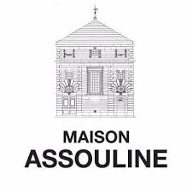Remain knowledgeable about real estate markets and best practices.

**Luxury Advisor**

Maison Assouline, The Dubai Mall Casa Vida (September 2018 – May 2019)

* Ensuring high levels of customer satisfaction through excellent sales service.
* Maintaining outstanding store condition and visual merchandising standards.
* Answered customer’s questions and addressed problems and complaints in person and via phone.
* Exceeded personal sales goals.
* Educate customers on product and service offerings.
* Worked and led within a selling operation to achieve the branch sales targets and objectives
* Responsible for creating an environment in which employees and the team delivered sales targets and maintained high service levels.
* Supported and at times operated as a part of a wider branch management team.
* Delivered at pace, to a high standard across multiple projects whilst maintained a commercial environment with an emphasis on selling and customer experience
* Monitored competition and responsible for presenting the findings to management
* Resolved customer complaints by investigating problems, developing solutions, preparing reports and finally making business recommendations to management.

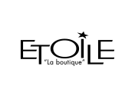

**Luxury Fashion Advisor**

Etoile “La boutique”, Mall of Emirates (May 2017 – September 2018)

* Responsible for contributing to the overall performance of the store by driving sales at every opportunity whilst at the same time making sure every customer receives exceptional levels of service and enjoyed their visit to the store.
* Ensure delivering an outstanding shopping experience to every customer contact via any offered communication channel in store or over the phone.
* Maintained and created high standards of display & visual merchandising to ensure the store is always well presented and merchandised.
* Day to day tasks including the opening and closing till procedure, serving customers both in department and at the cash desk, providing face to face advice to customers on the store’s products based upon the features and benefits and managing store revenue by suggesting upgrades, insurance and add-ons to customers.
* Responsible for processing returns and refunds as required in line with company procedures.
* Super user and training coworker for the stock management system, teaching the store to log, check, locate and move stock both in and out of the store.
* Responsible for the daily management of the till in the absence of the senior members.
* Successfully handled escalated customer complaints in a clam and professional manner always finding a solution suitable for the customer and the business.



**Luxury Sales Representative**

Ralph Lauren, Mall of Emirates (March 2016 – April 2017)

* Ensure high levels of customer satisfaction through excellent sales service.
* Discuss with clients and give advices on general trends in fashion world and development in luxury market, showing passion for fashion and luxury products.
* Maintain outstanding store condition and visual merchandising standards.
* Supported and at times operated as a part of a wider branch management team.
* Maintain a fully stocked store.
* Ascertain customers’ needs and wants.
* Recommend and display items that match customer needs.
* Manage point-of-sale processes.
* Keep up to date with product information.
* Accurately describe product features and benefits



**Sales Representative**

Tommy Hilfiger, Dubai Mall, Apparel Group (February 2014 – February 2016)

* Welcoming Customers by greetings them in person or on the telephone answering or referring inquiries.
* Generate daily sales report.
* Ensure pricing is correct.
* Attend trade shows to identify new products and services.
* Coach, counsel, train, and discipline employees.
* Evaluate on-the-job performance.
* 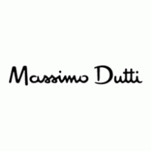Ensure merchandise is clean and ready to display

**Visual Merchandiser**

Massimo Dutti, Azadea Egypt (January 2012 – January 2014)

* Define, design and implement a creative visual merchandising strategy
* Create appealing and eye-catching visual displays that lead the customer through the entire store
* Produce window displays, signs, interior displays, floor plans and special promotions displays
* Identify key messages and set a clear image of the result
* Come up with, revise and present design ideas with assistant merchandisers
* Act in alignment to the organization’s culture, products, image and target market
* Monitor costs and work within budget
* Oversee the production and brief staff on arranging displays

**Personal Details**

* Date of Birth : 1/11/1990
* Visa Statues : Employment Visa
* Civil Status : Single
* Citizenship : Egyptian



**Cairo University, Egypt**

Diploma in Tourism and Hotels

**General Qualifications**

* Diploma of customer service and customer needs.
* Excellent understanding and usage of the complete Microsoft and Google Suit.
* Hobbies & interests: Individual Sports (Swimming) Team Sports ( volley ball ).

**References available upon request**