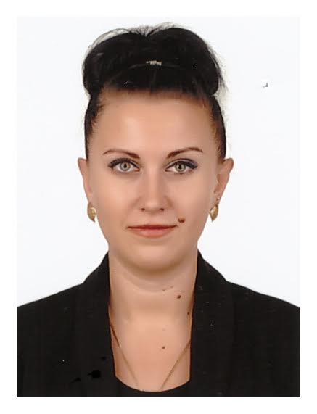 Olena Novak

UAE, Dubai.

Mob.| WhatSapp 050-833-61-39

elena1988n@gmail.com

Summary of Qualifications

I have obtained my Master’s Degree Biotechnology Agriculture University, Ukraine. My experience in Dubai with above mentioned my cv gives me advantages on maintaining contact with partners and people that would help your organization to accomplish the targeted tasks and reach the identified goals successfully and in a profitable manner. I work best in a challenging and demanding environment which merit and success depend on high achievement and prolific sound work. I have a good communications skills and fluent English. Thus, I believe that my commitment, motivation, flexibility and confidence would benefit your organization in making most out of the given time.

Concluding, I would like the application committee to consider all the facts I have brought above, so that I can contribute them for the development of my career and for the benefit you’re Organization.

**CORE COMPETENCIES**

● Meetings Organization ● Calendar Keeping ● Meeting Minutes Taking

● Record Keeping ● Inventory Management ● Correspondence Handling

● Travel Arrangement ● Documentation ● Front Desk Operations

● Database Management ● Payroll Processing ● Files Maintenance

**SELECTED ACHIEVEMENTS**

• Researched and verified missing information about reports which saved $20,000 of company’s expense

• Spearheaded the organization of an international conference consisting of 200+ delegates from all around the world successfully

• Increased customer satisfaction level 40% by educating the staff in customer service etiquette

*Professional Experience*

*Duty Free, Dubai, July 2018-March 2019.*

* Greeting customers who enter the shop.
* Be involved in stock control and management.
* Assisting shoppers to find the goods and products they are looking for
* Being responsible for processing cash and card payments
* Answering queries from customers.
* Giving advice and guidance on product selection to customers.
* Balancing cash registers with receipts.
* Dealing with customer refunds.
* Responsible dealing with customer complaints.
* Working within established guidelines, particularly with brands.
* Provide excellent customer service.

*Hart Berntien Marketing and Advertising ,Dubai,UAE ,July 2016-May 2018.*

*ISP Crew*

* Demonstrate and explain products, methods, or services in order to persuade customers to purchase products or utilize services.
* Identify interested and qualified customers in order to provide them with additional information.
* Keep areas neat while working, and return items to correct locations following demonstrations.
* Practice demonstrations to ensure that they will run smoothly.
* Prepare and alter presentation contents to target specific audiences.
* Provide product information, using lectures, films, charts, and/or slide shows.
* Provide product samples, coupons, informational brochures, and other incentives to persuade people to buy products.
* Record and report demonstration-related information such as the number of questions asked by the audience and the number of coupons distributed.
* Research and investigate products to be presented to prepare for demonstrations.
* Sell products being promoted, and keep records of sales.
* Set up and arrange displays and demonstration areas to attract the attention of prospective customers.
* Train demonstrators to present a company's products or services.
* Wear costumes or sign boards and walk in public to promote merchandise, services, or events.
* Work as part of a team of demonstrators to accommodate large crowds.
* Write articles and pamphlets about products.
* Stock shelves with products.
* Suggest specific product purchases to meet customers' needs.
* Transport, assemble, and disassemble materials used in presentations.
* Visit trade shows, stores, community organizations, and other venues to demonstrate products or services, and to answer questions from potential customers.
* Collect fees or accept donations.
* Contact businesses and civic establishments to arrange to exhibit and sell merchandise.
* Develop lists of prospective clients from sources such as newspaper items, company records, local merchants, and customers.
* Give tours of plants where specific products are made.

***Apparel Group: Beverly Hills Polo Club , Dubai, UAE|APRIL 2015—June 2016,***

***Sales Executive***

* Generated a 15% sales increase within 2 month.
* Received positive personalized letters and feedback from customers and store manager for going “above and Beyond” expectation.
* Motivating and monitoring of team performance and training them to reach the plan.
* Exceeded team goals by linking and building sales, maintaining updated customer database and providing personalized follow up.

***Starlight Convention Center Thalasso & Spa: TAC Store, Turkey****,* ***MAY 2012—NOV 2014***

***Administrative assistant***

* Selling textile, garments and home furniture.
* Scheduling employee trading floor.
* Training trade hall.
* Inventory management and assortment.
* Inventory management and assortment.
* Sales analysis.
* Organization of work for the display of goods (merchandising ) .
* Control and providing quality services to visitors.

***Privatbank,Dnepropetrovsk,Ukraine,NOV 2014-MAR 2015***

***Financial credit analyst***

* Search of new clients.
* Execution of monthly sales plans
* Prepared sales forecasts and sales goals reports.
* Trade negotiations, presentations of the production.
* Preparing business plans.
* Planning investment actives and budget.
* Analyzing data sets collected through all departments.
* Preparing financial forecasts.
* Preparing reports for the board of management.

***Home Building****,* ***Dnepropetrovsk, Ukraine****,* ***OCT 2010—DEC 2011***

***Property Sales Executive***

* Generated a 43% sales increase within one year.
* Collaborated in twice yearly events, attracting 500 customers; authored and designed event

mailings to promote the events.

* Chosen by regional manager to lead online property marketing.
* Commended by regional manager for outstanding performancein handling objection.
* Work with database, searching new project (update base).
* Contact property owners and advertise services to select property sales listing
* Coordinating visits / showings with buyers.
* Offering the properties to the client.
* Negotiating with client on your behalf.
* Show for costumer homes, submit purchase offers, negotiating with the seller.
* Rent and sale of properties is directly .
* Arrange meetings between client and sellers when details of transactions need to be negotiated.
* Writing up the sales agreement and helping to arrange the closing(prepare documents such as representation contracts, purchase agreements, closing statements, deeds and leases).
* Coordinate property closings, overseeing signing of documents and disbursement of funds .
* Rent properties on behalf of clients.
* Knows how to attract the new clients.
* Know how to get new data.
* Good with clients and knows about real estate in Ukraine.

***Marganez private clinic Zarya,Dnepropetrovsk region,Ukraine MAY 2010-OCT2010***

***Assistant Veterinarian***

* Advice on the care and reproduction of animals , relevant content and feeding according to the requirements of zoohygienic.
* Examination of animals and diagnosing their illnesses and injuries.
* Supervising the owners of animals required treatment and preventive measures in the terms defined by regulations , instructions , recommendations for the keeping of animals.
* Medical and surgical treatment of animals.
* The conformity of product quality (milk , meat and meat products ) state .

Standards.

* Conducting veterinary sanitary inspection of meat at slaughterhouses.
* Feed quality control for cattle and drawing rations.
* Document management.
* Therapy.
* Vaccination.

**Education & Professional Development**

|  |  |  |  |  |
| --- | --- | --- | --- | --- |
| |  |  | | --- | --- | |  |  | | Dnepropetrovsk State Agricultural University, Dnepropetrovsk, Ukraine | |   Biotechnology Engineering, 2010(Legal degree). |

**Personal Data**

|  |  |
| --- | --- |
| * **Date of Birth: 21/09/1988** * **Nationality: Ukrainian** * **UAE Residency Visa: Valid** * **Hobbies: Reading, swimming, Exercising** | * **Place of Birth: Ukraine** * **Ukraine Driving License: Valid from UA** * **UAE Driving License : in-Progress** * **Marital Status:Married** * **Religion : Christian** |

.

**Professional skills :** PC user (Microsoft Word, Excel, Internet, 1C ).

People management skills . Intermediate knowledge of English.

**Personal qualities** : Sociability , vigor , stress tolerance , initiative , fast learning ability , organizational skills.