In this project, a console application has been developed which shows the bot solving the minesweeper game.

This given below is the main screen. There are two options as we can see. When entered on “Watch Bot playing”, we can see the bot playing the game and step by step opening all the squares and putting flags wherever necessary. According to the number on a square, the bot calculates and flags a square if it is sure of a mine in that particular square. We will see the bot playing on a 15X20 size rectangular board with all the squares uncovered in the beginning.

Pressing ‘Enter’ key on “Exit” will close the application.

Up/down navigation keys can be used to choose either you want to watch the bot play or exit the application.

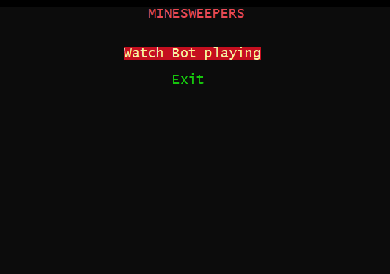

Below is the image of a step in between of the game where we can see the bot playing and putting a certain amount of flags.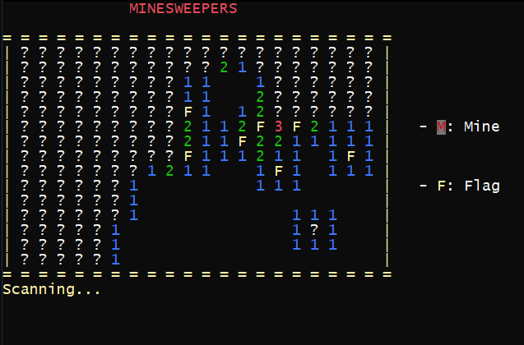

In the above picture, ‘F’ means that the bot has flagged that square as there is a mine below that square. For the square not opened yet, it is displayed by a ‘?’.

Provided below is the picture of the goal test where bot has successfully uncovered all the squares without mine and flagged ‘F’ to those where mine is present.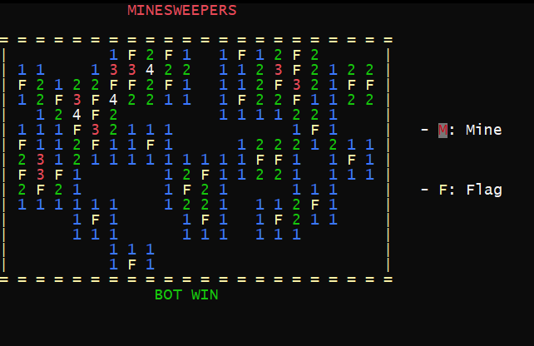

At this stage, we can go back to the main screen by pressing ‘Esc’ or watch the bot play another map by pressing the ‘Enter’ key.

This program takes about 20-25 seconds to solve a board of size 15X20.