# PROBLEM STATEMENT

*EXP.3 : IMPLEMENTING TEMPERATURE SENSOR WITH LCD USING ARDUINO UNO*

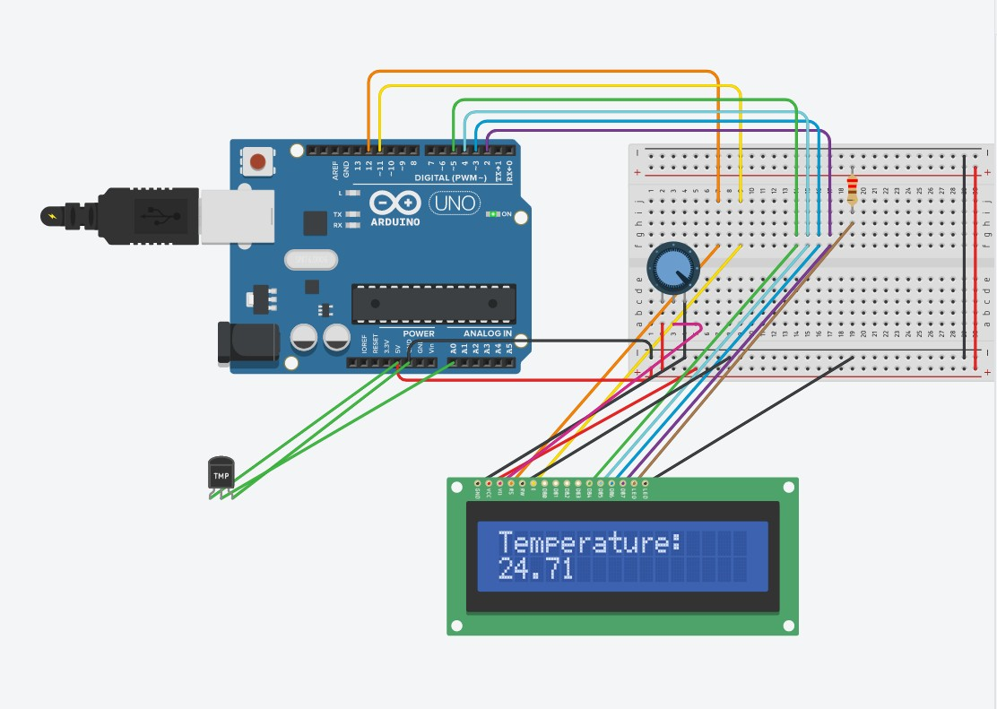

#include <LiquidCrystal.h> LiquidCrystal lcd(12,11,5,4,3,2); #define pinTemp A0

void setup()

{

Serial.begin(9600); pinMode(pinTemp,INPUT); lcd.begin(16,2); lcd.print("Temperature:");

}

void loop() {

float temp = ((analogRead(pinTemp) * (5.0/1024))-0.5)/0.01; lcd.setCursor(0,1);

lcd.print(" "); lcd.setCursor(0,1); lcd.print (temp);

Serial.println(temp); delay(1000);

}

# PROBLEM STATEMENT

*EXP.2 : IMPLEMENTING TEMPERATURE SENSOR USING ARDUINO UNO*

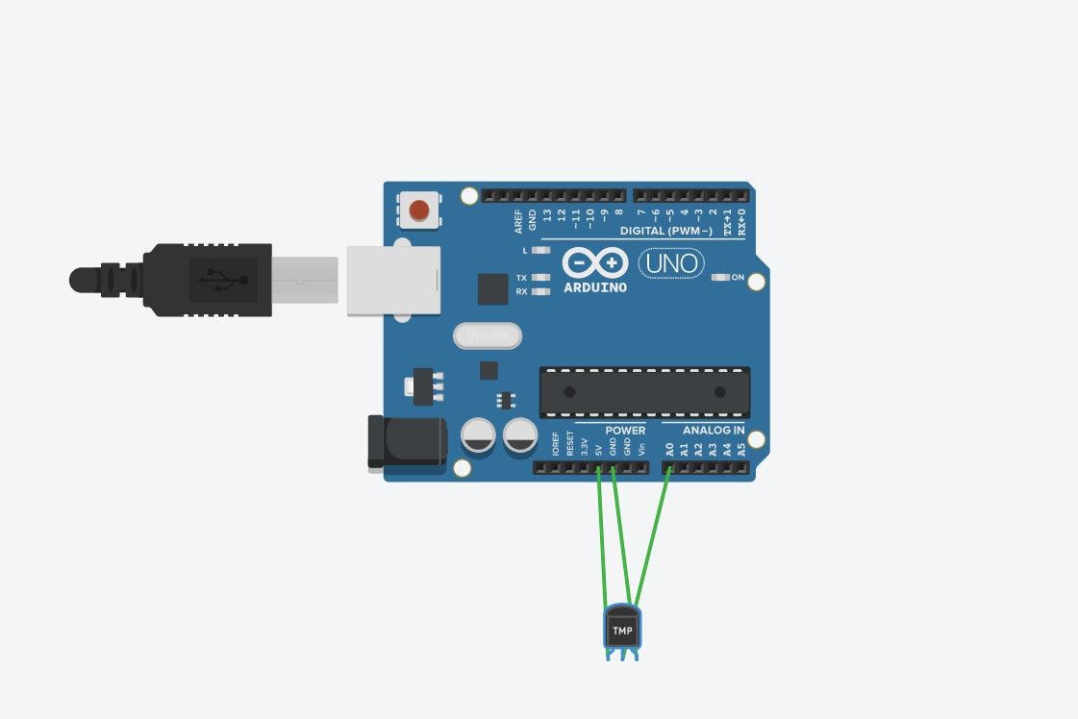

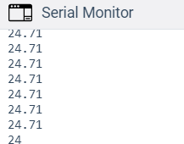

float TempValue, TempValueC, TempValuemv; void setup()

{

pinMode (A0, INPUT);

Serial.begin(9600);

}

void loop()

{

TempValue=analogRead(A0); TempValuemv=TempValue*5000/1024; TempValueC=(TempValuemv/10)+(-50); Serial.println(TempValueC);

}

# PROBLEM STATEMENT

*EXP.1 : IMPLEMENTING LED BLINKER USING ARDUINO UNO*

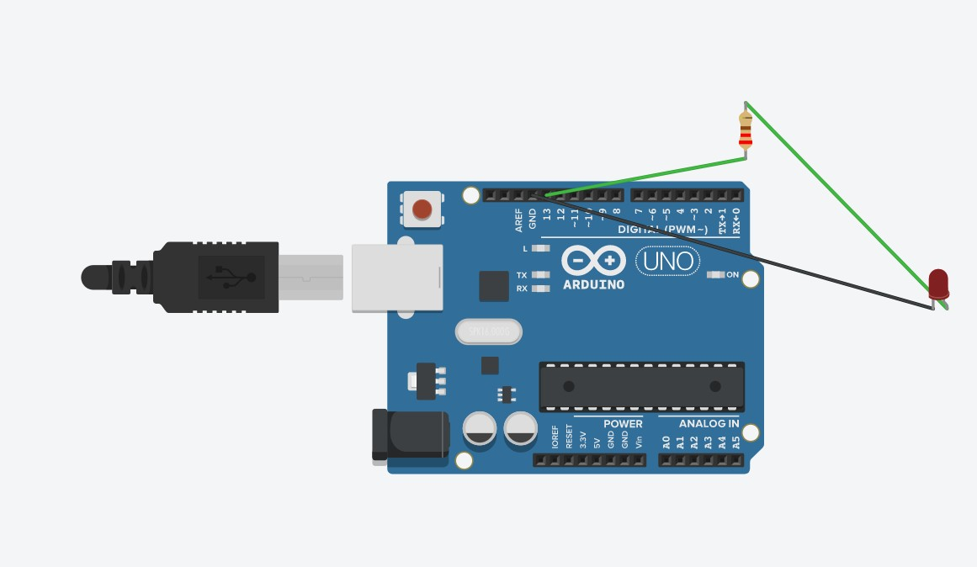

void setup()

{

pinMode(13, OUTPUT);

}

void loop()

{

digitalWrite(13, HIGH); delay(500); digitalWrite(13, LOW); delay(500);

}

# PROBLEM STATEMENT

*EXP.4 : IMPLEMENTING ULTRASONIC SENSOR WITH LCD USING ARDUINO UNO*

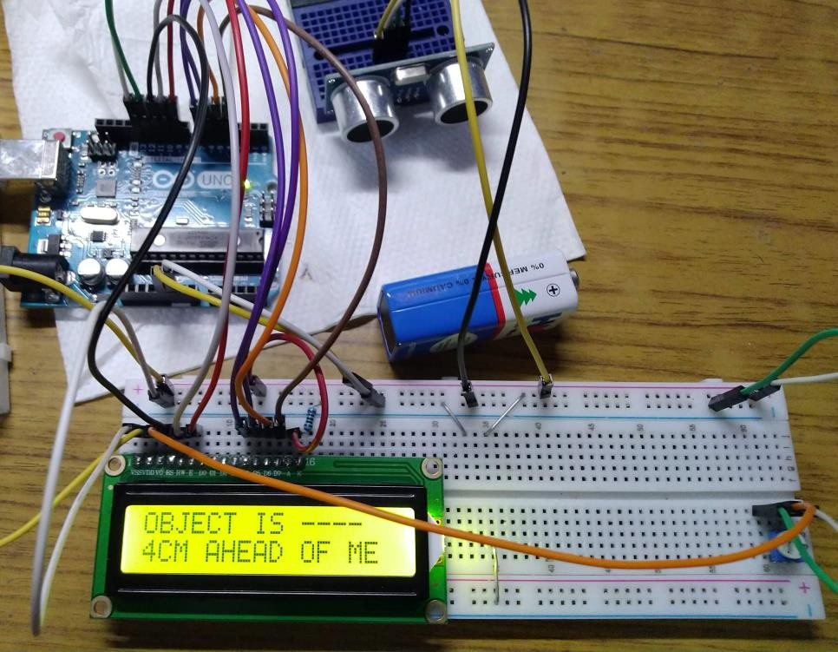*+*

#include <LiquidCrystal.h> LiquidCrystal lcd(11, 10, 9, 7, 6, 5, 4); int pingPin = 13;

int inPin = 12; void setup() { lcd.begin(16, 2);

lcd.clear(); lcd.setCursor(0, 0); lcd.print("---D.M.T.K.T---");

lcd.setCursor(0, 1); lcd.print(" Ver : MK-II"); delay(2500);

}

void loop(){ lcd.clear(); lcd.setCursor(0, 0);

lcd.print(" READING"); lcd.setCursor(0, 1);

lcd.print(" ENVIRONMENT"); delay(1000);

long duration, inches, cm; pinMode(pingPin, OUTPUT); digitalWrite(pingPin, LOW); delayMicroseconds(2); digitalWrite(pingPin, HIGH);

delayMicroseconds(10); digitalWrite(pingPin, LOW); pinMode(inPin, INPUT); duration = pulseIn(inPin, HIGH);

cm = microsecondsToCentimeters(duration);

if (cm > 400){ lcd.clear(); lcd.setCursor(0,0);

lcd.print("$$$$ DANGER $$$$"); lcd.setCursor(0,1); lcd.print("$$$$ BEWARE $$$$");

}

else { lcd.clear();

lcd.setCursor(0, 0); lcd.print("OBJECT IS ");

lcd.setCursor(0, 1); lcd.print(cm);

lcd.print("CM AHEAD OF ME");

}

delay(3000);

}

long microsecondsToInches(long microseconds)

{

return microseconds / 74 / 2;

}

long microsecondsToCentimeters(long microseconds)

{

return microseconds / 29 / 2;

}

# PROBLEM STATEMENT

*EXP.5 : IMPLEMENTING DHT11 SENSOR WITH LCD USING ARDUINO*

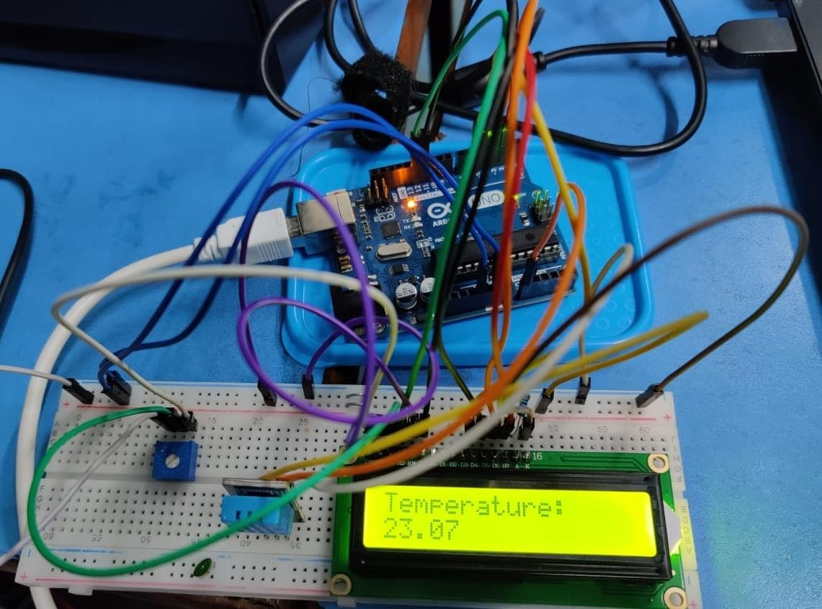

#include <DHT.h> #include <DHT_U.h> #include <LiquidCrystal.h>

#define DHTPIN 8

LiquidCrystal lcd(12, 11, 5, 4, 3, 2); #define DHTTYPE DHT11

DHT dht(DHTPIN, DHTTYPE);

void setup() { lcd.begin(16, 2);

dht.begin(); lcd.print("Temperature(C) :");

}

void loop() { delay(500); lcd.setCursor(0, 1);

float h = dht.readHumidity(); float f = dht.readTemperature();

if (isnan(h) || isnan(f)) {

lcd.print("WAIT"); return; } lcd.print(f);

lcd.setCursor(7,1); }