TO-DO LIST APPLICATION
USING PYTHON AND TKINTER
(Task Manager with File Storage)
A Mini Project Report
A report submitted
In partial fulfilment of the requirements for the Degree of
Bachelor of Technology
In
Information Technology
Semester – V
Subject:
Python Programming
By
Manan Jivani (12402080601073)
Faculty Guide
Nayan Mali
Assistant Professor
Academic Year 2026–27
Department of Information Technology
A D Patel Institute of Technology
New Vallabh Vidyanagar, Vitthal Udyognagar – 388121
Anand (Gujarat), India

CERTIFICATE
This is to certify that the mini project work embodied in this report entitled “To-Do List Application using Python and Tkinter” was carried out by Manan Jivani (12402080601073) at A D Patel Institute of Technology for partial fulfilment of the requirements of the Bachelor of Technology degree in Information Technology awarded by the Charutar Vidya Mandal (CVM) University. This project work has been carried out under the guidance and supervision of the faculty guide and is to the satisfaction of the department.
Project Evaluation Summary
Project Title: To-Do List Application (Tkinter GUI Application)
Core Concepts Verified: Python Functions, Modules, File Handling (JSON), and Tkinter GUI

Date: ______
Place: New Vallabh Vidyanagar
Lab Teacher / Faculty Guide | Head of Department
Keyur Patel | Dr. Priyang Bhatt
Assistant Professor | Associate Professor & Head

ACKNOWLEDGEMENT
I would like to express my sincere gratitude to A D Patel Institute of Technology and the Department of Information Technology for providing the academic environment, computing laboratory facilities, and resources to undertake this mini project entitled “To-Do List Application using Python and Tkinter”.
I am deeply thankful to my faculty guide and laboratory teacher, Keyur Patel, Assistant Professor, for their continuous guidance, constructive suggestions, and encouragement throughout the design and development of this project. I also extend my gratitude to Dr. Priyang Bhatt, Head of the Department of Information Technology, for fostering a practical, project-driven learning culture. Finally, I thank my classmates, friends, parents and family for their testing feedback, support and motivation.
Manan Jivani
(12402080601073)

ABSTRACT
The To-Do List Application is a desktop mini project developed to demonstrate the practical integration of core Python concepts—specifically Functions, Modules, File Handling, and Tkinter Graphical User Interface (GUI) design. Its objective is to provide users with a simple, clean window where daily tasks can be added, marked as completed, deleted and saved, without relying on any external library or server.
The application is split into two Python files. The file task_manager.py contains reusable functions, add_task(), delete_task(), toggle_task(), load_tasks() and save_tasks(), which manage a list of tasks and store it in a JSON file. The main Tkinter program builds a 500×450 window with an input field, an Add Task button, a task list box with a scroll bar, Complete and Delete buttons, and a Clear All button. Empty-input warnings and delete confirmations are shown through tkinter.messagebox.
Key Technical Highlights
Language & GUI: Python 3.x with standard library tkinter, messagebox and json.
Core Logic: Modular task-handling functions that update a list of dictionaries and persist it to a JSON file.

CHAPTER 1: INTRODUCTION

1.1 Background
Every student, professional and household needs to keep track of daily work. Paper notes are easily lost, and general-purpose apps are often heavy, advertisement-driven or need an internet connection. A To-Do List application records pending work, shows what has been completed, and helps the user stay organised. Python offers the built-in json module for storing data and the Tkinter toolkit for building interactive windows, making it ideal for a lightweight, self-contained task manager.

1.2 Problem Statement
The problem addressed in this mini project is to design and implement a user-friendly desktop application that lets a user add tasks, mark them as completed, delete them, and keep them saved between sessions. The task-handling logic must be kept in a separate module so that it can be reused independently of the GUI.

1.3 Objectives
- To design a clean, light-themed GUI using Python’s tkinter module.
- To separate task-handling logic (task_manager.py) from presentation logic (GUI) using modular programming.
- To add, complete and delete tasks using simple, reusable functions.
- To store tasks permanently in a JSON file so they are available when the program is reopened.
- To provide immediate feedback using list updates, warning and confirmation dialogs, and a Clear All option.

1.4 Scope and Applications
The system covers single-user task management on a local desktop. It can be used for daily planning, study schedules, shopping lists and project checklists. It does not support multiple users, reminders, cloud synchronisation or mobile access.

1.5 Existing and Proposed System
Existing System: Beginners often keep tasks in paper notes or in console programs that forget everything when closed, mixing logic with the interface and giving only text messages, which is inconvenient and hard to maintain.
Proposed System: The proposed system stores every task as a dictionary inside a list handled by a dedicated module, saves it to a JSON file, and a Tkinter interface calls these functions on button click, displaying instant visual results.

CHAPTER 2: THEORETICAL BACKGROUND

2.1 File Handling and JSON in Python
JSON (JavaScript Object Notation) is a lightweight text format for storing structured data. Python’s json module provides json.dump() to write a list of dictionaries to a file and json.load() to read it back. Using the with open(...) statement ensures the file is closed automatically, and a try/except block handles the case where the file does not exist yet.

2.2 Data Structures and Functions Used
Item | Structure / Function | Meaning
Task | {"title": "Buy books", "done": False} | Dictionary holding the task text and its completion status
Task list | tasks = [ {...}, {...} ] | List of task dictionaries kept in memory
add_task() | tasks.append(...) | Adds a new pending task to the list
toggle_task() | tasks[i]["done"] = not ... | Marks a task completed or pending
delete_task() | tasks.pop(index) | Removes the selected task
load / save | json.load() / json.dump() | Reads and writes the tasks.json file
Table 1: Data structures and functions used in task_manager.py

2.3 Event-Driven GUI Programming with Tkinter
Tkinter is Python’s standard cross-platform GUI toolkit. Unlike console scripts that block on input(), Tkinter runs an event loop (root.mainloop()) and calls a callback function when the user clicks a button. The widgets used are Label, Entry, Button, Listbox, Scrollbar and the messagebox dialogs, arranged with the pack() geometry manager.

2.4 Time and Space Complexity
Adding a task is O(1) because it is appended at the end of the list, while deleting a task by index takes O(n) in the worst case because the remaining items shift. Refreshing the list box, saving and loading the file each take O(n), where n is the number of tasks. The program stores only the list of tasks, so the space complexity is O(n).

CHAPTER 3: SYSTEM DESIGN AND METHODOLOGY

3.1 System Overview
The system follows a two-layer design: the Presentation Layer (Tkinter GUI) collects input and displays the task list, while the Logic Layer (task_manager.py) holds the task operations and handles file storage. This separation keeps the logic reusable and easy to test.
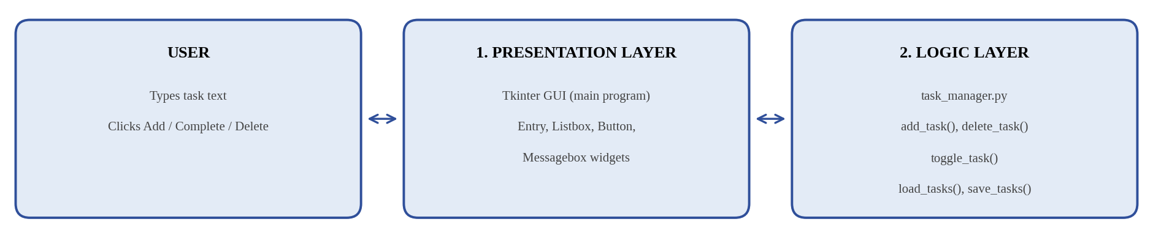
Figure 1: Two-Layer System Architecture of the To-Do List Application

3.2 Working of the System
Workflow: Start → Load tasks from tasks.json → Build window and widgets → Show tasks in the list box → Wait for user event → On Add: read and strip() the entry; if empty, show warning, else add the task, refresh the list and save → On Complete: toggle the selected task, refresh and save → On Delete: ask confirmation, remove the selected task, refresh and save → On Clear All: remove all tasks after confirmation → Exit on window close.

3.3 Algorithm Design
- Add Algorithm: Read the entry text and strip spaces; if it is empty, show showwarning and return. Otherwise call add_task(), clear the entry using delete(0, tk.END), refresh the list box and call save_tasks().
- Complete Algorithm: Get the selected index using curselection(); if nothing is selected, show a warning. Otherwise call toggle_task(), mark the text with a tick (✔) when done, refresh the list box and save.
- Delete Algorithm: Get the selected index, ask confirmation with askyesno, call delete_task() if the user agrees, refresh the list box and save.

3.4 Methodology
The project followed an iterative approach: (1) writing the task functions and JSON storage in task_manager.py; (2) designing the Tkinter window; (3) linking the GUI to the logic module with refresh and save after every change; and (4) testing valid, empty and no-selection inputs, and reopening the program to confirm saved data.

3.5 Data Flow
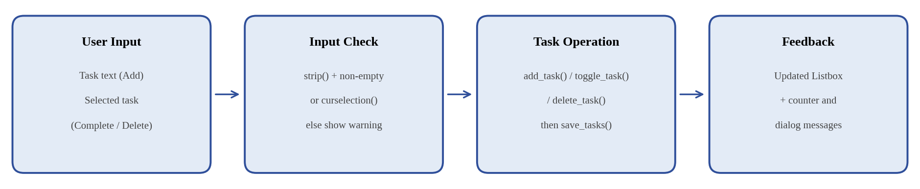
Figure 2: Data Flow Diagram of the To-Do List Application

CHAPTER 4: IMPLEMENTATION AND TESTING

4.1 Technologies Used
Technology / Module | Purpose in the Project
Python 3.x | Core language used to develop the application logic and GUI.
tkinter | Builds the window, labels, entry box, list box and buttons.
tkinter.messagebox | Displays warning and confirmation dialog boxes.
json | Saves and loads the task list using json.dump() and json.load().
task_manager.py | Custom module holding add_task(), delete_task(), toggle_task(), load_tasks() and save_tasks().
Table 2: Technologies and modules used in the project

4.2 Implementation
The application consists of two files. task_manager.py defines the task functions and file handling. The main script imports them with from task_manager import add_task, delete_task, toggle_task, load_tasks, save_tasks, defines the callbacks add_item(), complete_item(), delete_item() and refresh_list(), and then builds the interface and starts root.mainloop().

4.3 User Interface
The window (500x450, non-resizable) uses a soft blue-grey background (#f0f4f8) with a dark-blue bold title. It contains a task entry field, a blue Add Task button, a list box with a scroll bar showing all tasks, a Complete button, a Delete button, a Clear All button, and a task counter at the bottom. Focus starts on the entry field, and pressing the Enter key also adds a task.

4.4 Testing
Functional testing covered empty input, valid input, completion, deletion, persistence, and the Clear All button, as shown in Table 3.
Test Case | Input / User Action | Expected Result
TC-1 | Click Add Task with the entry empty | Warning dialog: “Please enter a task.”
TC-2 | Enter “Submit Python report” and click Add Task | Task appears in the list box; entry is cleared.
TC-3 | Select a task and click Complete | Task is marked with a tick (✔) as completed.
TC-4 | Click Complete again on a completed task | Task returns to the pending state.
TC-5 | Click Complete or Delete with no task selected | Warning dialog: “Please select a task.”
TC-6 | Select a task, click Delete and confirm | Task is removed from the list box.
TC-7 | Close and reopen the program | All previously saved tasks are loaded from tasks.json.
TC-8 | Click Clear All and confirm | All tasks are removed and the counter shows 0.
Table 3: Test cases for the To-Do List Application

4.5 Result and Discussion
All test cases produced the expected output. The list box refreshed instantly after every action, and the JSON file kept tasks safe between sessions. Keeping the task logic in a separate module made it easy to test without the GUI. A limitation is that the application supports only a single user and a plain list, with no due dates, priorities, categories or reminders.

CHAPTER 5: FUTURE SCOPE AND CONCLUSION

5.1 Future Scope
The project can be extended with due dates and reminders, task priorities and categories, a search and filter option, and editing of existing tasks. It can also be connected to an SQLite database or a cloud service to synchronise tasks across devices and grown into a full productivity and planner application.

5.2 Conclusion
The To-Do List Application successfully demonstrates how Functions, Modules, File Handling, and Tkinter GUI development can be combined to solve a practical problem. By keeping all task operations in a separate module and saving data in a JSON file, the application achieves clean, reusable and persistent task management, while the GUI provides instant, user-friendly feedback. This mini project fulfils the syllabus objectives and builds practical proficiency in modular programming, file handling and event-driven GUI design.

CHAPTER 6: REFERENCES
- Lutz, M. Learning Python: Powerful Object-Oriented Programming, 5th Edition, O’Reilly Media, 2013.
- Matthes, E. Python Crash Course, 3rd Edition, No Starch Press, 2023.
- Moore, A. D. Python GUI Programming with Tkinter, 2nd Edition, Packt Publishing, 2021.
- Python Software Foundation. “json — JSON encoder and decoder.” https://docs.python.org/3/library/json.html
- Python Software Foundation. “tkinter — Python Interface to Tcl/Tk.” https://docs.python.org/3/library/tkinter.html

