# Transistor-Transistor Logic (TTL)

Logic Gates like NAND, NOR are used in daily applications for performing logic operations. The Gates are manufactured using semiconductor devices like BJT, Diodes or FETs. Different Gate’s are constructed using Integrated circuits. Digital logic circuits are manufactured depending on the specific circuit technology or logic families.

## Tri-state Logic:

name itself implies there are 3 states of the buffer

high (1)

low (0)

High Impedance (Z)

In electronics, **high impedance** means that a point in a circuit (a node) allows a relatively small amount of current through, per unit of applied voltage at that point. **High impedance** circuits are low current, **high** voltage, whereas low **impedance**circuits are the opposite.

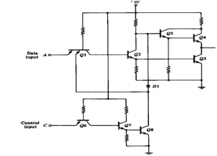

1. Low level state when lower transistor is ON and upper transistor is OFF.
2. High level state when lower transistor is OFF and upper transistor is ON.
3. Third state when both transistors are OFF. It [allows a direct wire connection](https://www.edgefxkits.com/wireless-scada) of many outputs.