Assignment PDC

Name: Manan Madan

Roll No. 2018UIC3087

1.Obtain step response of first order system using Simulink

We’ve assumed transfer function to be be 2/(3\*s+2)

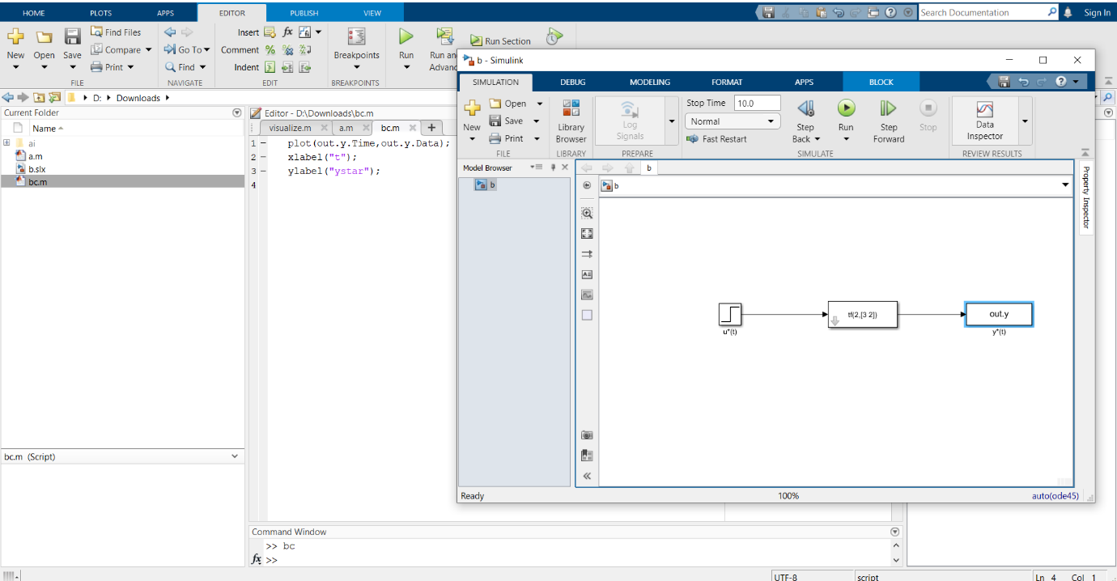

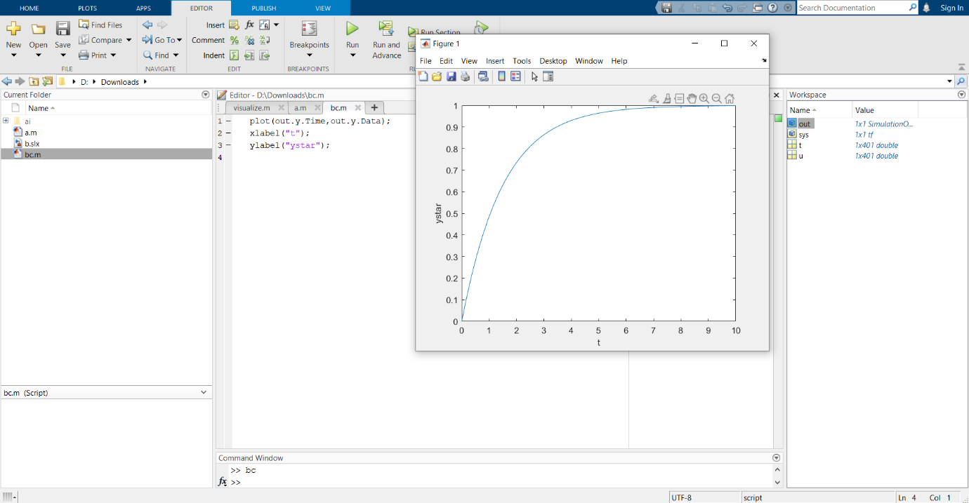

2. Step response of first order system using MATLAB

We’ve assumed transfer function to be 2/(s+5)

