**Assignment PDC**

**PID Tuning**

Name: Manan Madan

Roll No :2018UIC3087

**Aim: PID controller tuning using the process reaction curve based Ziegler Nichols approximate model approach**

**Theory**

The Ziegler-Nichols rule is a heuristic PID tuning rule that attempts to produce good values for the three PID gain parameters:

1. *Kp* - the controller path gain
2. *Ti* - the controller's integrator time constant
3. *Td* - the controller's derivative time constant

given two measured feedback loop parameters derived from measurements:

1. the period *Tu* of the oscillation frequency at the stability limit
2. the gain margin *Ku* for loop stability

with the goal of achieving good regulation (disturbance rejection).

kp, ki and kd are calculated as shown below:

kp=1.2*(T/L)

ki=kp/(2*L)

kd=kp*0.5*L

**Process Reaction Curve**

In the **process reaction curve method**, a **process reaction curve** is generated in response to a disturbance. This **process curve** is then used to calculate the controller gain, integral time and derivative time. The **method** is performed in open loop so that no control action occurs and the **process** response can be isolated.

**Procedure**

1. First we calculate the step response of the given system 6/((2*s+1)*(4*s+1)*(6*s+1))

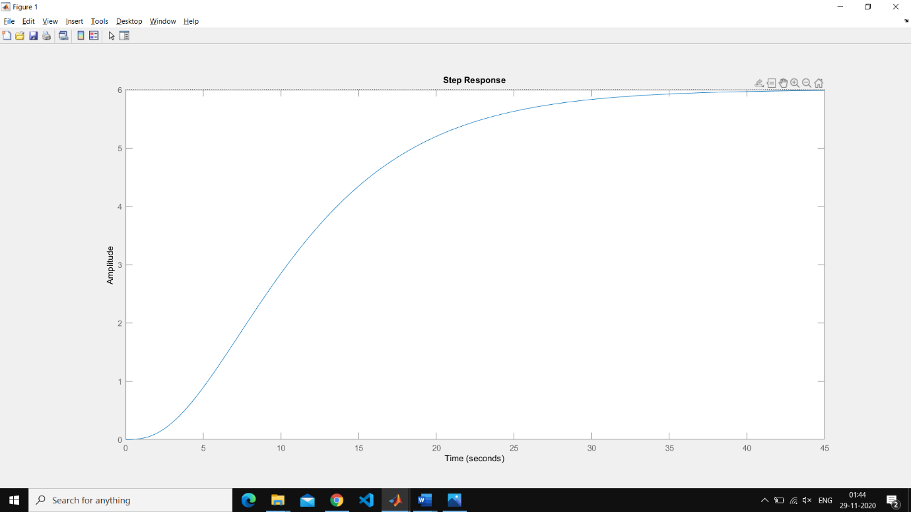

1. Then we mark tangent to this curve and calculate L,K and T

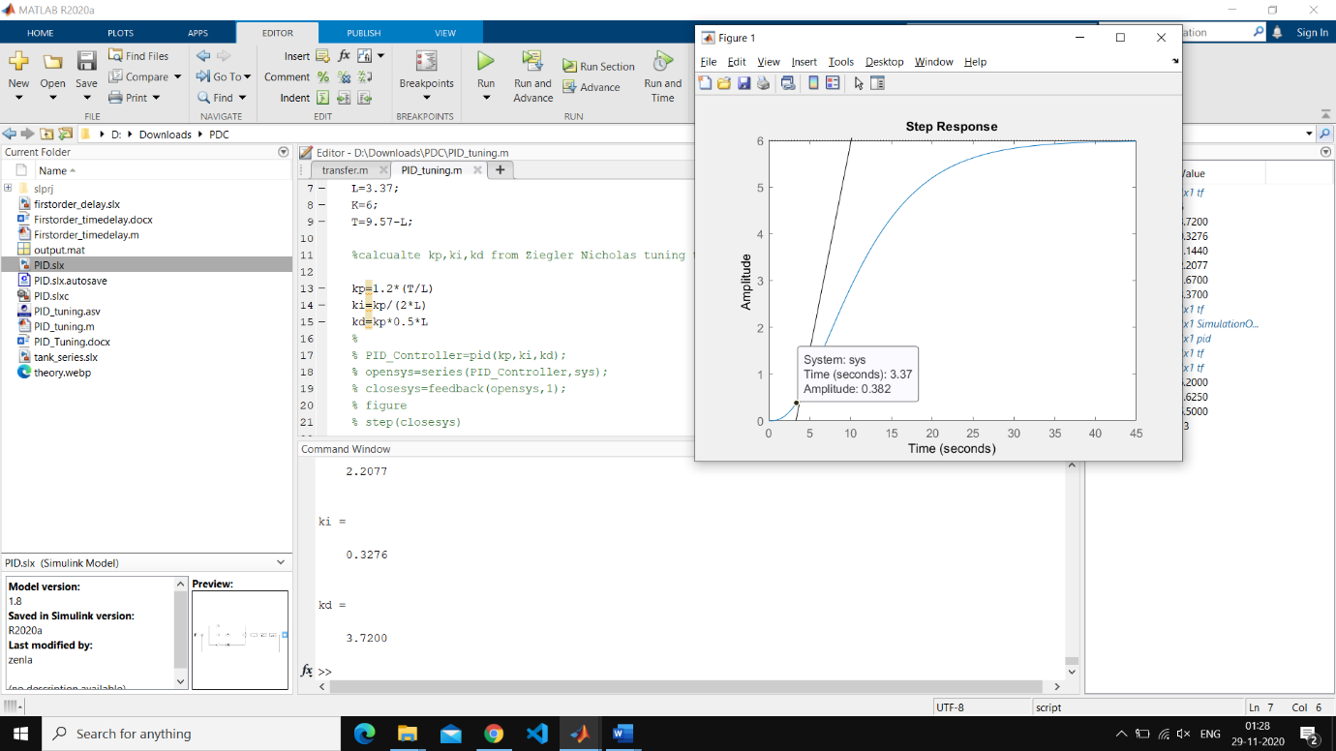

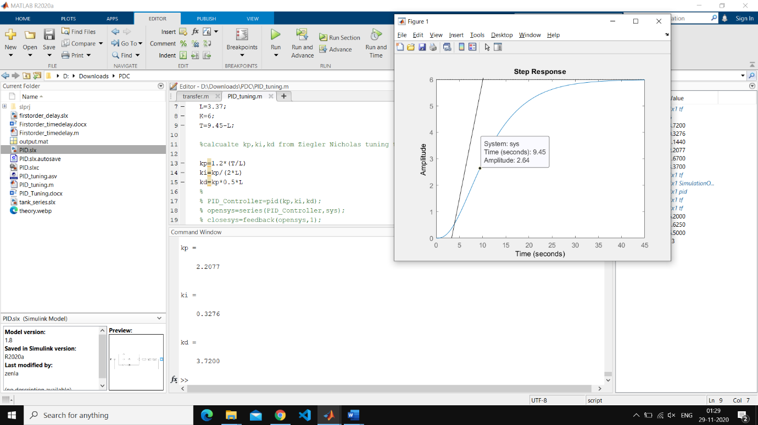

1. We use the Ziegler Nichols tuning table and find the value of kp, ki and kd respectively

Kp=2.2077,ki=0.3276,kd=3.7200

1. Then we develop a Simulink model for Ziegler Nichols tuning technique as shown below

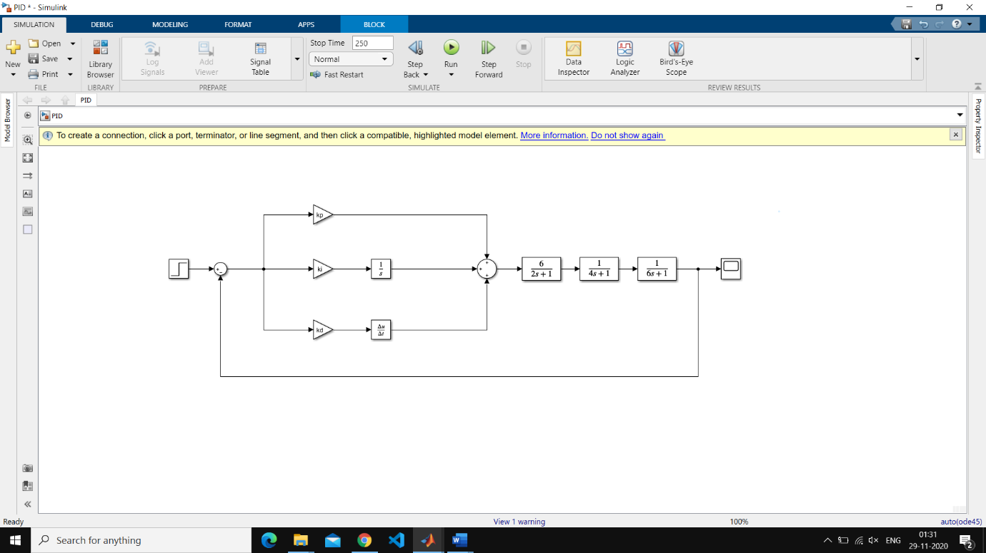

1. We substitute kp, ki and kd to obtained the tuned response of PID controller

