**PDC Assignment**

**Feedforward and Feedback Controller**

Name: Manan Madan

Roll No:2018UIC3087

**Aim: To implement feed forward and feedback controllers for the given process using Simulink**

**Given Process:**

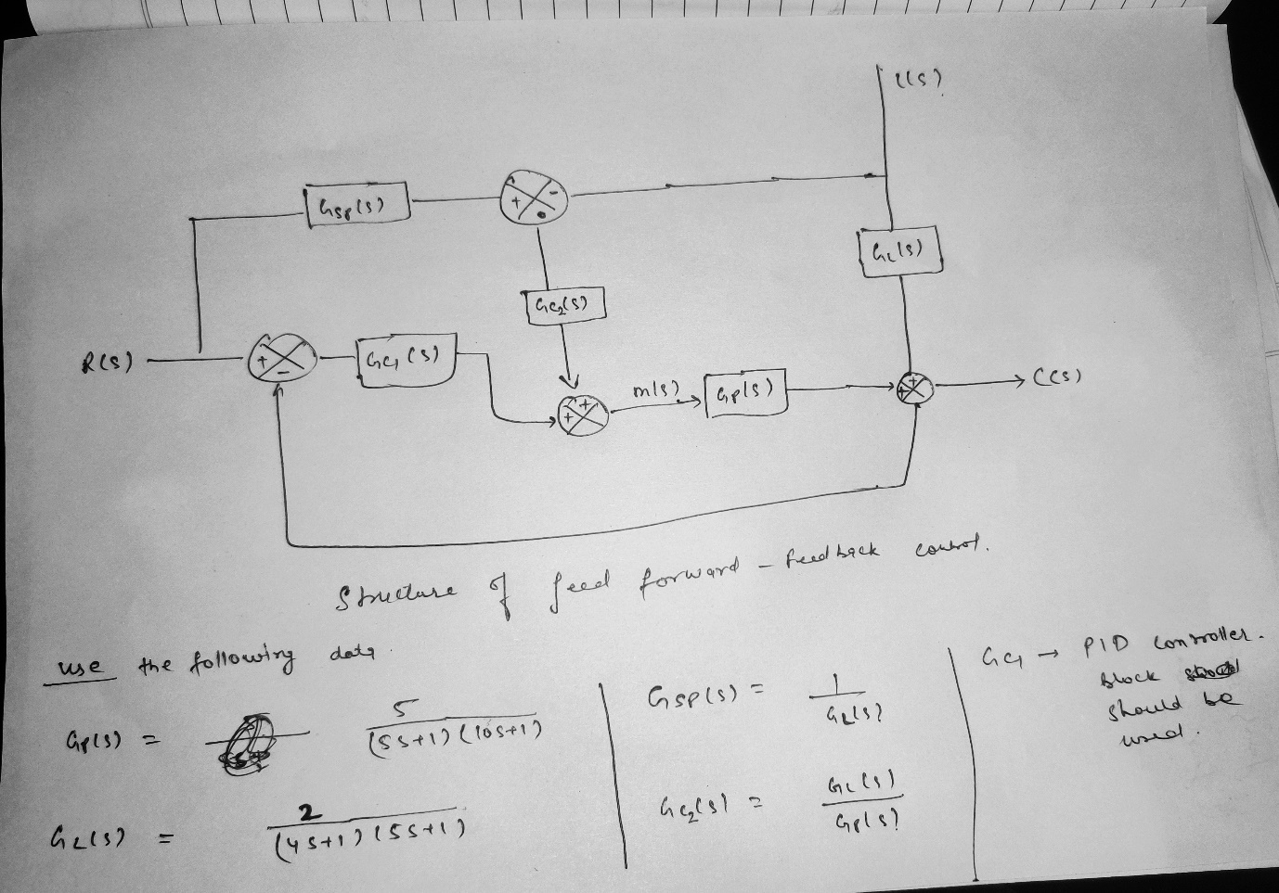

**Procedure:**

1. First we design the same model in Simulink and obtain the untuned response of the process as shown below

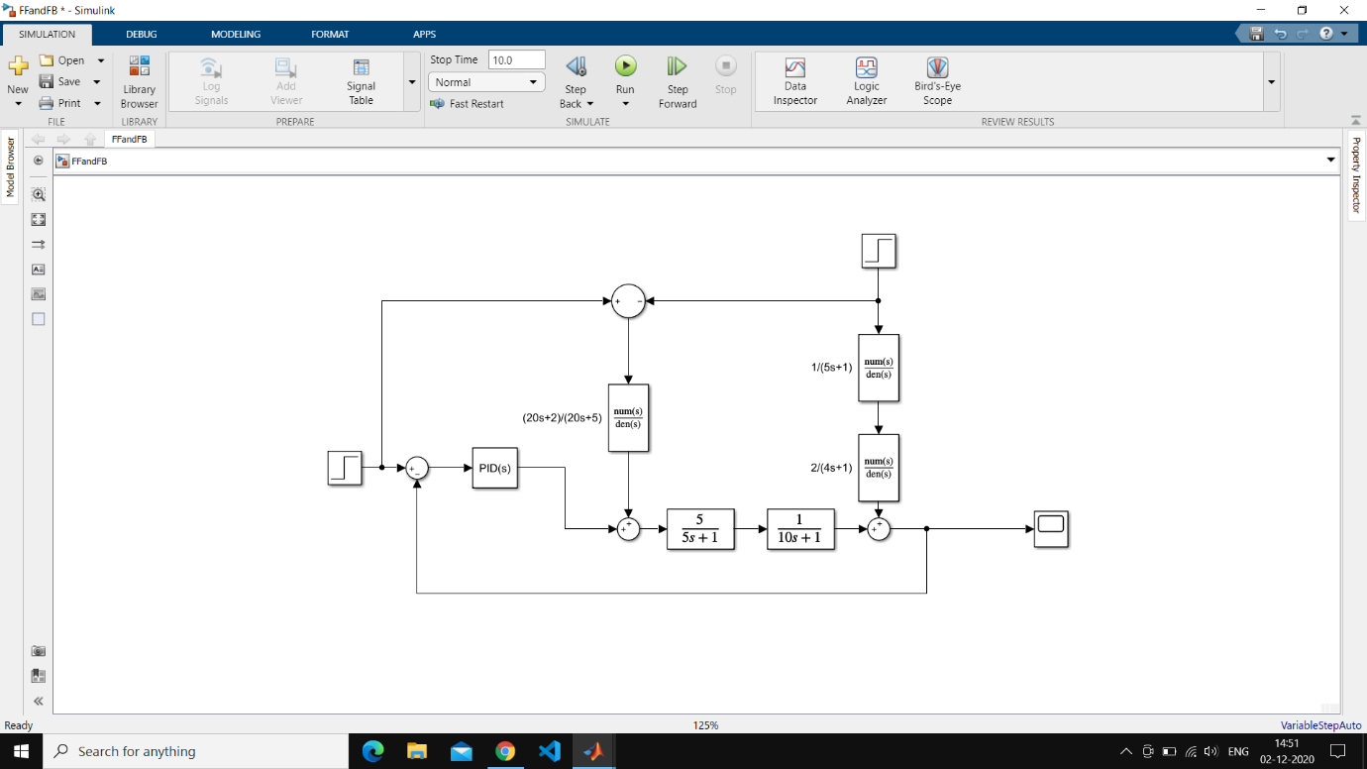

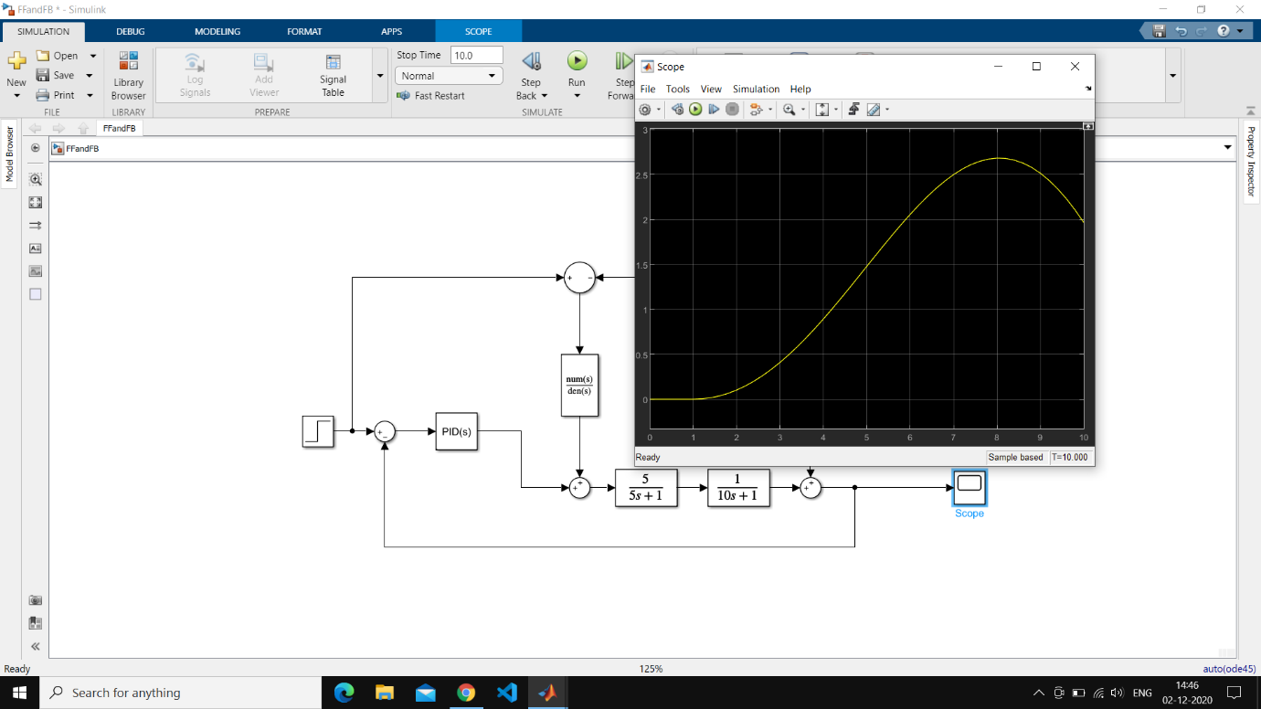

1. Then we tune the PID controller and obtain the tuned response of the above process

