**PDC Assignment**

**First order Time Delay**

**Name: Manan Madan**

**Roll No:** 2018UIC3087

**Aim:** Consider the first order + time delay system 2/(5*s+1) with time delay e^-(5s). Perform the simulation process output and manipulated input for unit step changes in the set points

**Theory:**

**Dead Time**

Dead time is something we mostly don’t want to have in a control system.

In the simplest of terms it is a delay in the response to a control action. So, there is a time lapse between the moment you apply the control action and the moment you see its effect on the process variable.

**Settling Time**

As a crude definition : Settling time is the time taken by the process variable to reach the set point.

In the figure below t2-t1 is the dead time while t3-t1 is the settling time. You can say that the settling time includes dead time !

**Procedure**

1. First we find the step response of the system without using any time delay as shown below

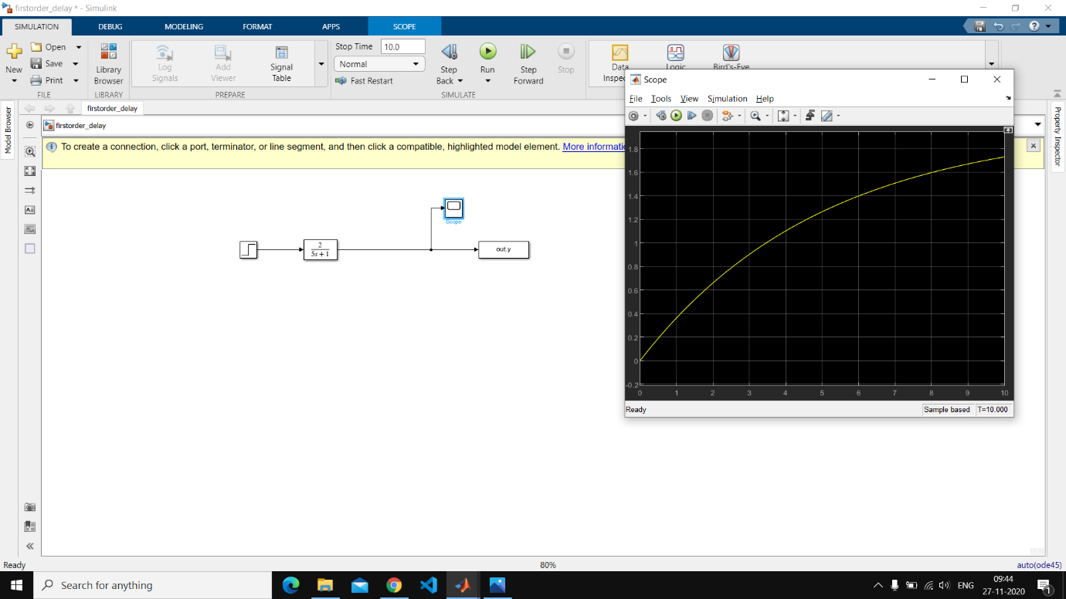

1. We also find the response parameters of the above system(without time delay)

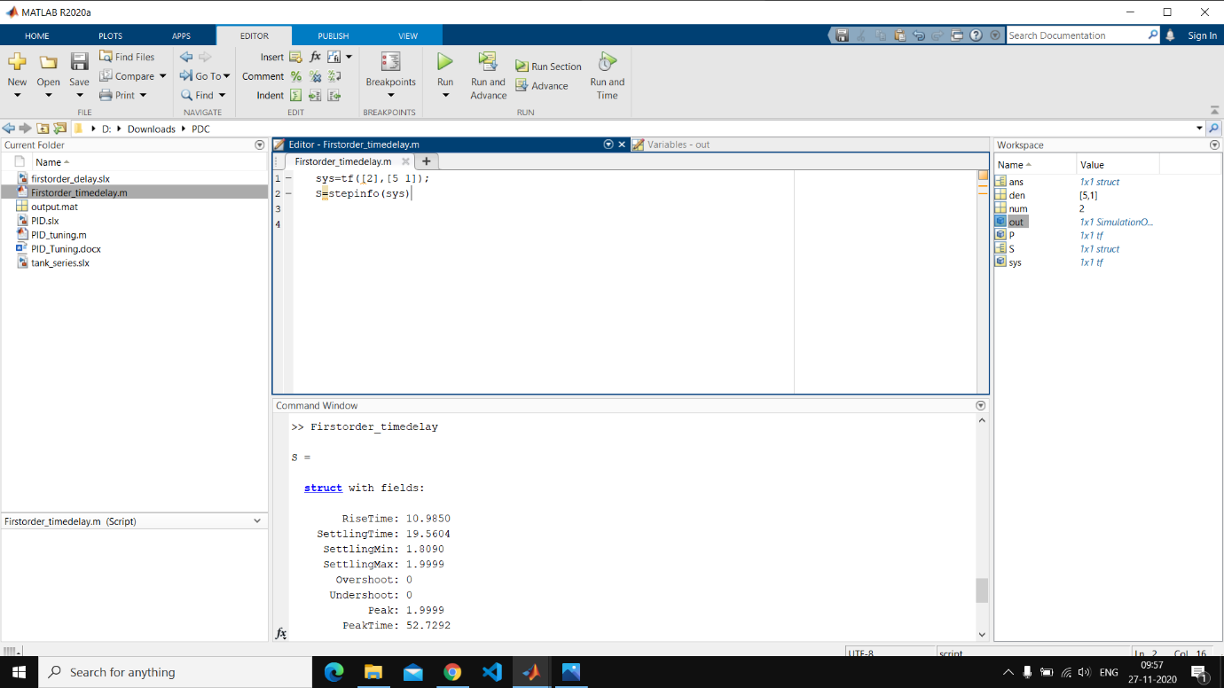

Rise Time: 10.9850

Settling Time: 19.5604

Settling Min: 1.8090

Settling Max: 1.9999

Overshoot: 0

Undershoot: 0

Peak: 1.9999

Peak Time: 52.7292

1. Then we introduce the time delay i.e. e-5s factor by introducing transport delay in the Simulink model as shown below

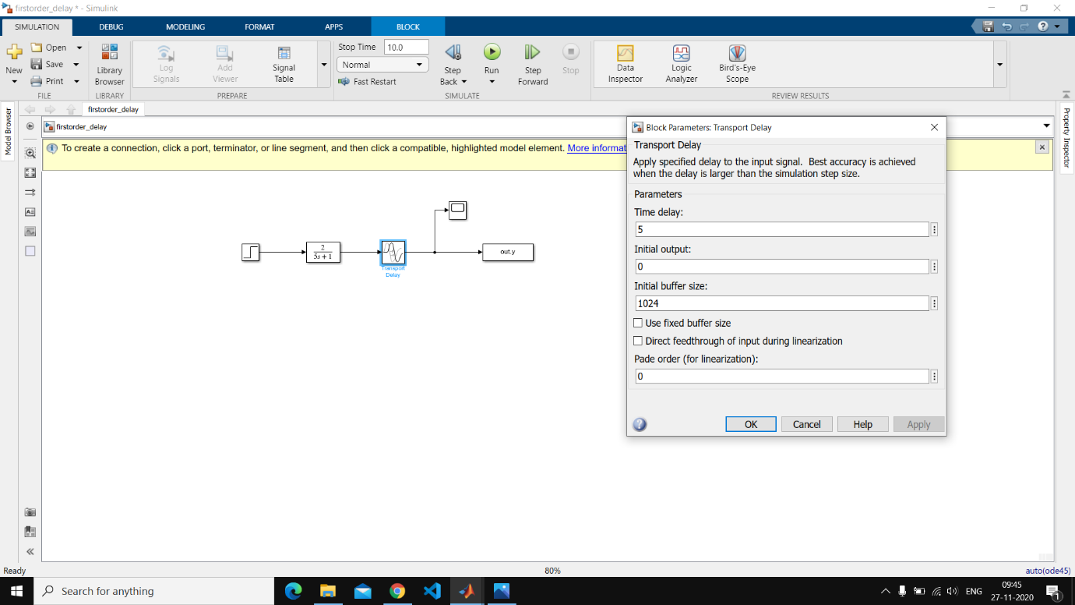

We obtain the step response after introducing the delay which is shown below

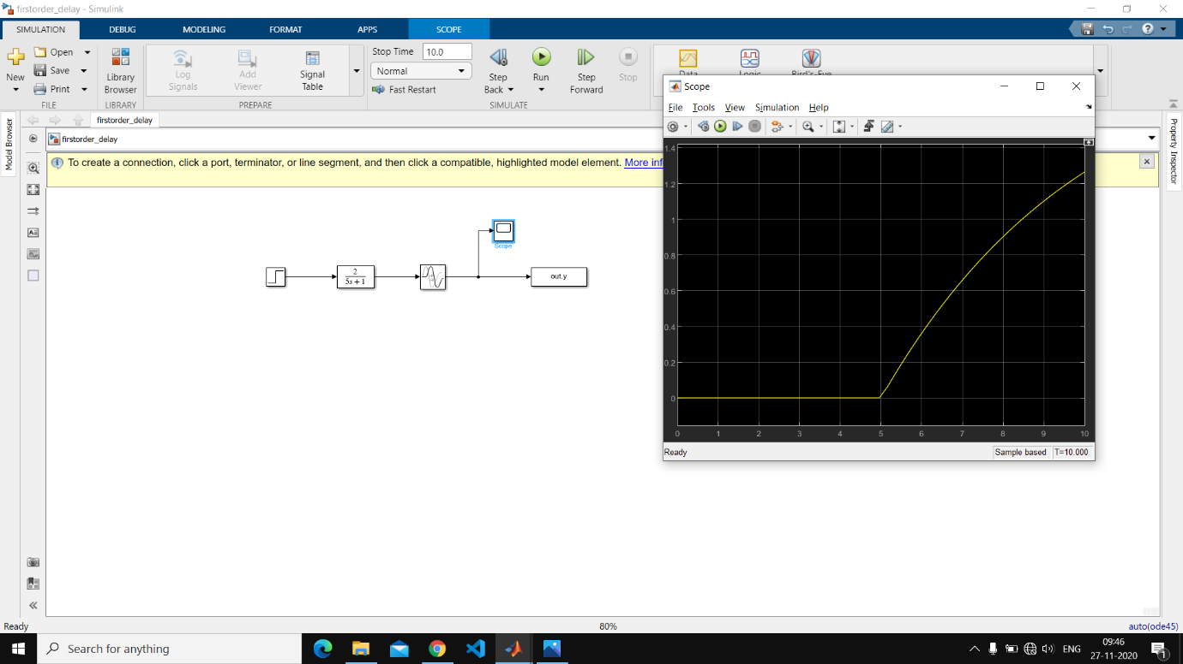

1. Response parameters are also obtained

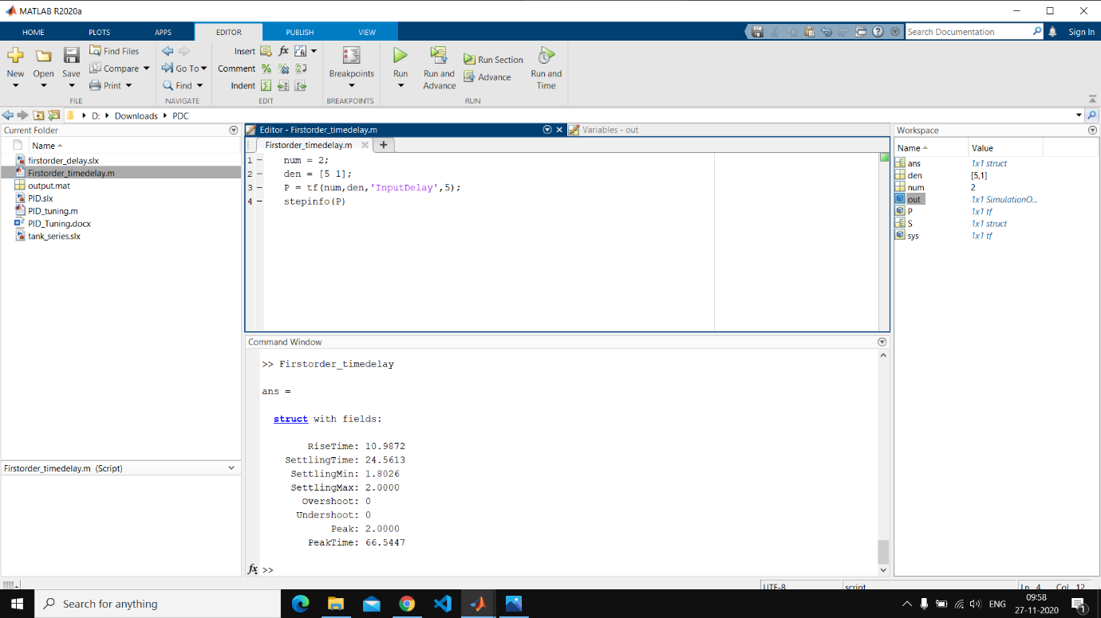

Rise Time: 10.9872

Settling Time: 24.5613

Settling Min: 1.8026

Settling Max: 2.0000

Overshoot: 0

Undershoot: 0

Peak: 2.0000

Peak Time: 66.5447

**Result**

We’ve successfully obtained the step response and response parameters of the given system with and without introducing a time delay.

.