**Entrepreneurship Assignment**

**Name of student- Mudit Khandelwal**

**Roll No.- 2018UIC3110**

**Start-up- Airbnb**

**Airbnb is one of the world’s largest marketplaces for unique, authentic places to stay and things to do, offering over 7 million accommodations and tens of thousands of handcrafted activities, all powered by local hosts. An economic empowerment engine, Airbnb has helped millions of hospitality entrepreneurs monetize their spaces and their passions while keeping the financial benefits of tourism in their own communities. With more than three quarters of a billion guest arrivals to date, and accessible in 62 languages across 220+ countries and regions, Airbnb promotes people-to-people connection, community and trust around the world.**

**About entrepreneur-**

**Founders of Airbnb are-**

**Brian Chesky : Co-founder & CEO**

**Joe Gebbia : Co-founder & Head of Samara**

**Nathan Blecharczyk : Co-Founder, CSO, Chairman of Airbnb China**

**History of start up-**

**The Airbnb founder story is one of persistence, determination, fear and most of all, hustle.**

**Let's go back to the start. It's late 2007 in San Francisco. Airbnb founders Brian Chesky and Joe Gebbia just moved from New York. Without employment, they were having trouble paying their rent and were looking for a way to earn some extra cash. They noticed that all hotel rooms in the city were booked, as the local Industrial Design conference attracted a lot of visitors.**

**The youngsters saw an opportunity. They bought a few airbeds and quickly put up a site called “Air Bed and Breakfast.” The idea was to offer visitors a place to sleep and breakfast in the morning. They charged $80 each a night. The idea succeeded and the first Airbnb guests were born: a 30-year-old Indian man, a 35-year-old woman from Boston and a 45-year-old father of four from Utah sleeping on their floor.**

**Soon after, Harvard graduate and technical architect Nathan Blecharczyk joined the team as the third co-founder. They faced a major problem: the site only had two users, one of them was Chesky. They initially launched at SXSW, and only received two bookings.**

**After changing the website, the company launched again in August 2008, not long before the Democratic National Convention in Denver. Over 20,000 people were going to the convention, and all hotels were booked out. The first comment on the launch publication on TechCrunch illustrates what people thought of the idea.**

**Product and services offered-Airbnb is an online marketplace which lets people rent out their properties or spare rooms to guests.**

**Type of Entrepreneurship- Private Company**

**Entrepreneurship journey-**

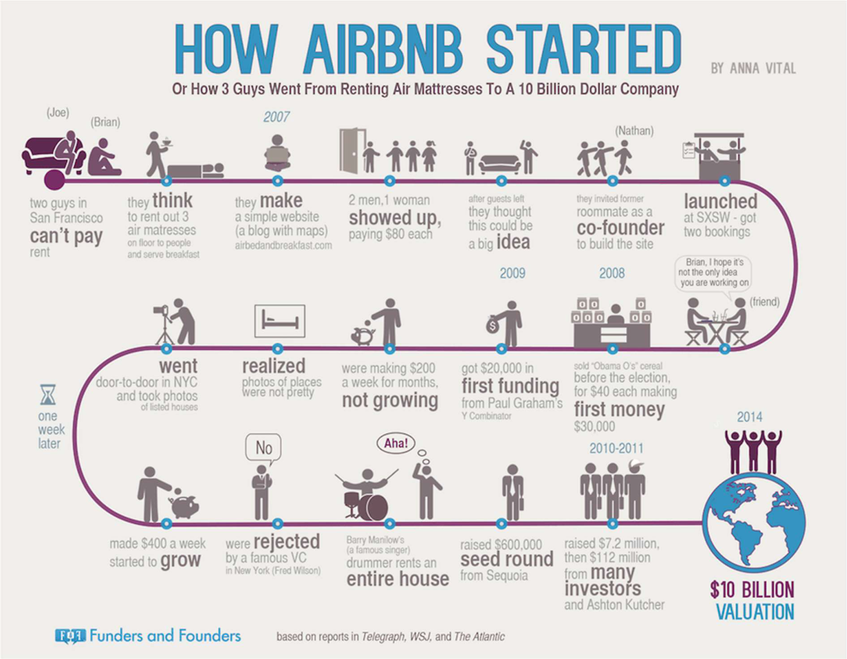

**Entrepreneurship traits-**

1. **Don’t brainstorm startup ideas, solve a problem.**
2. **Surround yourself with role models.**
3. **If you believe in your idea, you will find a way to make it work.**
4. **Building a platform is tough; both sellers and buyers need to be on board.**
5. **Being your own customer is the best way to learn.**
6. **Focus on a small but loyal customer base.**
7. **Get informed about your industry’s laws and regulations.**
8. **The first employee is like bringing in new DNA.**
9. **There’s no learning curve for people who are in war or in startups.**
10. **A company’s culture is what defines it.**

**Entrepreneurship risk and rewards (SWOT analysis)**



**STRENGTHS**

**Well-established Brand – Airbnb is a well-established brand and has a good image in public where it is operating**

**Product Expansion –** **Airbnb has** **expanded**

**its products outside its core accommodations, thereby aiming to set up an end to end travel platform.**

**A Cheaper Alternative to Hotels – Airbnb is considered as a cheaper alternative to other resorts and hotels.**

**Global Recognition – Airbnb has been recognized at the global level, and they see many users that include hosts and guests.**

**Airbnb Collections – Airbnb Collections that was launched by Airbnb during the year 2018, features homes that are ideal for any specific occasions.**

**Social Media Presence – Airbnb has its presence on many social media platforms to gain maximum visibility among the customers.**

**Good Customer** **Service –** **Airbnb**

**provides goods customer service 24/7 that is one of the main strengths of the company.**

**OPPORTUNITIES**

**Expand into Emerging Markets – Airbnb can expand into emerging markets having less competition. This provides a huge business opportunity.**

**Expand its product – Airbnb can expand its product mix and offerings. This will help them to serve the customers better. For example, it can**

**WEAKNESSES**

**Laws and Regulations Violations – Airbnb faces problems from violating various housing laws and regulations.**

**Being Poor Hosts – Being a poor host can damage the company’s reputation. If in any case, the host does not follow the Airbnb guidelines, they can face the consequences.**

**Easy to Copy its Business Model – Airbnb business model is easy to copy, and it is a huge weakness for its success.**

**The Objectivity of Guest Review System – Airbnb has structured a review system, wherein the guests and hosts can rate each other after they are done with their stay. Hosts and guests are not able to see reviews when both have given a review.**

**Criticized for Higher Prices – Airbnb has been criticized for resulting in a high price for the stay. The rental prices in a few areas have increased due to keeping their properties off the long-term rental market and instead of that get higher rental rates for short-term housing through Airbnb.**

**THREATS**

**Laws and Regulations in every Country – Airbnb services are available across in about 192 countries. Each state and country have got its laws and regulations to obey.**

**expand its product by providing travel guides, car rentals, etc.**

**MobileApp Usage – As the usage of mobile app increases, Airbnb has initiated a mobile app that will facilitate the hosts and guests to get connected easily.**

**Low Price and Personal Touch – Airbnb’s low price and personal touch-enabled them to get their visibility across and gain more revenue.**

**Lawsuits – The company is already facing some lawsuits and fines across the world in places like New York, Florida, etc.**



**Competitors – There sees a lot of competitor for Airbnb like VRBO, tripping, tripping.com, and many more. This can give a tough time for the Airbnb company.**

**Competitors**

1. **Homestay**
2. **Vrbo**
3. **Booking.com**
4. **Vacasa**
5. **Wimdu**
6. **Kid and Coe**
7. **HomeExchange**
8. **TripAdvisor Rentals**

**Future outlook**

**We don’t know exactly when travel will return. When travel does return, it will look different. While we know Airbnb’s business will fully recover, the changes it will undergo are not temporary or short-lived. Travel in this new world will look different, and we need to evolve Airbnb accordingly. People will want options that are closer to home, safer, and more affordable. But people will also yearn for something that feels like it’s been taken away from them — human connection. This crisis has sharpened our focus to get back to our roots, back to the basics, back to what is truly special about Airbnb — everyday people who host their homes and offer experiences. This means that we will need to reduce our investment in activities that do not directly support the core of our host community. We are pausing our efforts in Transportation and Airbnb Studios, and we have to scale back our investments in Hotels.**