**Assignment PDC**

**PID Tuning**

Name: Manan Madan

Roll No :2018UIC3087

**Aim: Simulation of Ziglar Nichols closed loop method to tune PID gains using MATLAB**

**Block Diagram:**

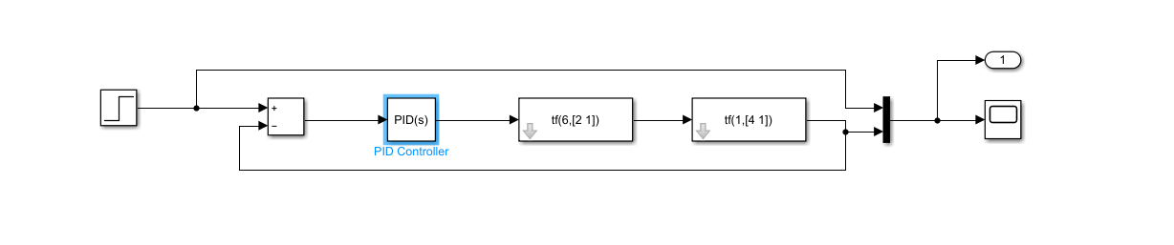Transfer function for the above system is ((6/(2*s+1))*(1/(4*s+1))) i.e. 6/8*s2+6*s+1

First we obtain step response of the system without PID controller as shown below

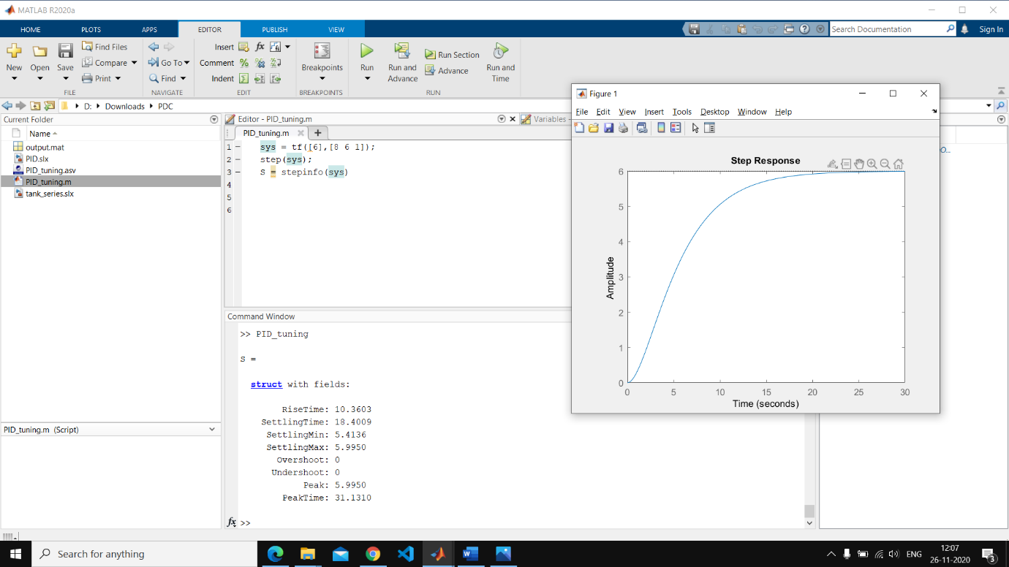

**Different response parameters:**

Rise Time: 10.3603

Settling Time: 18.4009

Overshoot: 0

Peak: 5.9950

Then we introduce the PID controller with P,I,D as 5 for example to obtain block response as shown below

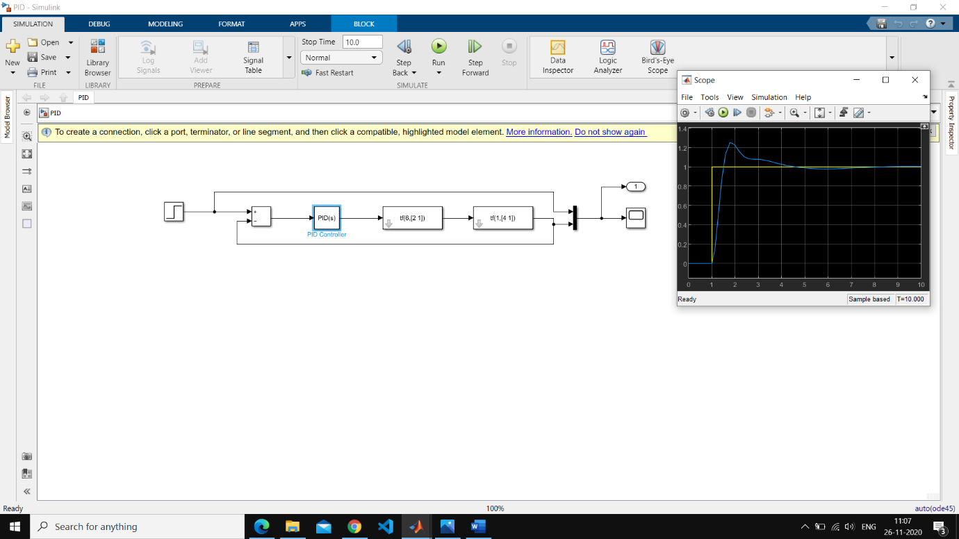

**Different response parameters:**

Rise Time: 0.335

Settling Time: 5.25

Overshoot: 25.6%

Peak: 1.26

Gain Margin: Inf

Phase Margin: 50 deg

Then we tune the PID controller to obtain the tuned step plot and observe the change in response parameters

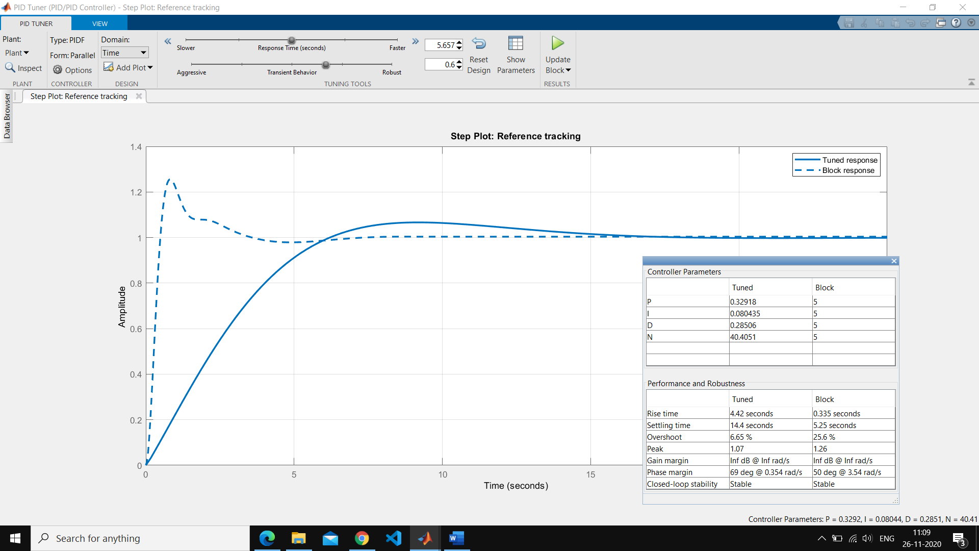

**Different response parameters:**

Rise Time: 4.42

Settling Time: 14.4

Overshoot: 6.5%

Peak: 1.07

Gain Margin: Inf

Phase Margin: 69 deg