**Digital Circuit and Systems - 5**

**Submitted by-: Manan Madan (2018UIC3087)**

1. **Explain in detail R-2R DAC.**

The following circuit diagram shows the basic 2-bit R-2R ladder DAC circuit using op-amp. Here only two values of resistors are required i.e. R and 2R. The number of digits per binary word is assumed to be two (i.e. n = 2). The switch positions decide the binary word ( i.e. B1 B0 )

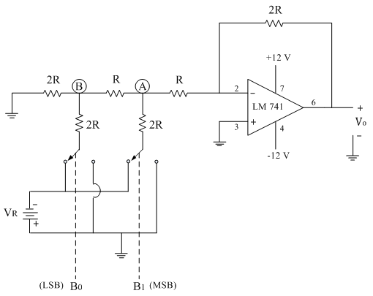

The typical value of the feedback resistor is Rf = 2R. The resistance R is normally selected any value between 2.5 kΩ to 10 kΩ.

The generalized analog output voltage equation can be given as

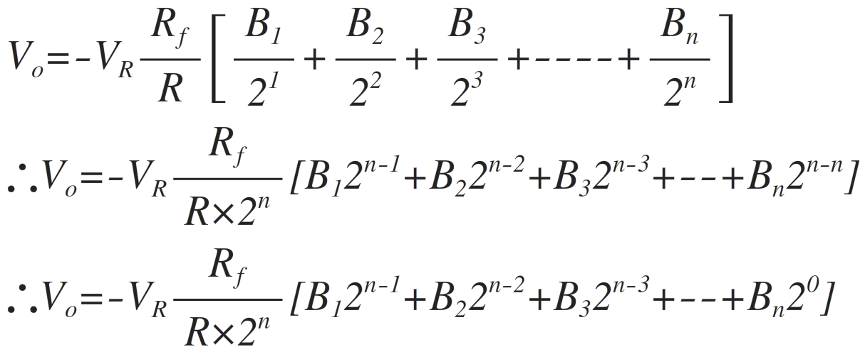

The voltage at point A i.e. VA is applied as input to the op-amp which is in inverting amplifier mode as shown in the figure below:

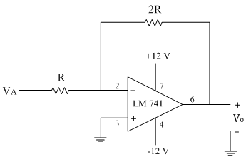

The output voltage of the complete setup

∴Vo=-(2R/R) VA

∴Vo=-(2R/R)(-VR/8)

∴Vo=VR/4

Similarly for the other three combinations of digital input, the analog output voltage Vo is calculated as follows

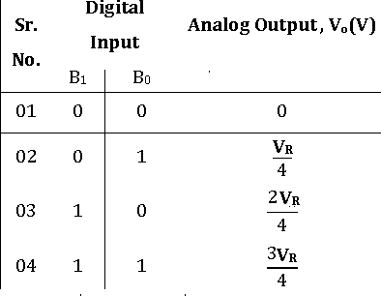

1. **Explain in detail the Weighted resistor DAC.**

In the weighted resistor type DAC, each digital level is converted into an equivalent analog voltage or current.

The following figure shows the circuit diagram of the binary-weighted resistor type DAC.

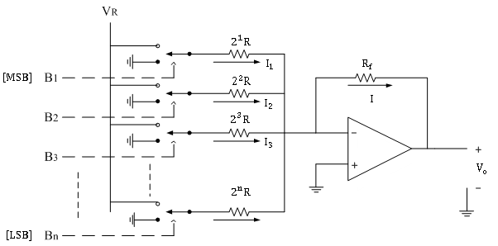

It consists of a parallel binary weighted resistor bank and a feedback resistor Rf.

The switch positions decide the binary word ( i.e. B1 B2B3…Bn ).

In the circuit, the op-amp is used as a current to voltage converter.

Analysis:

Let us analyze the circuit using normal analysis concepts used in the op-amp. When the switches are closed the respective currents are flowing through resistors as shown in the circuit diagram above.

Since input current to the op-amp is zero, the additional current flows through the feedback resistor.

∴I=I1+I2+I3+ …………+In

The inverting terminal of an op-amp is virtually at ground potential.

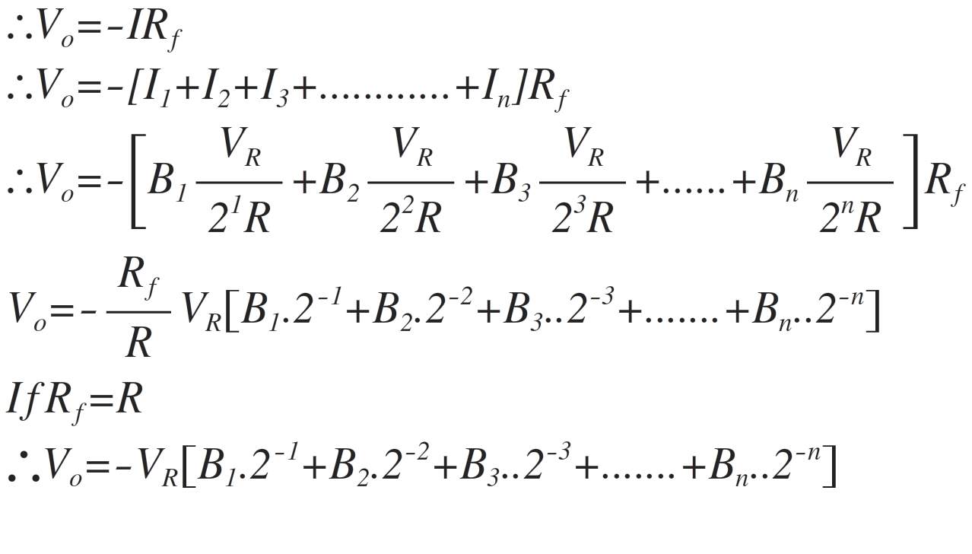

Consider the example of 3-bit DAC.

When input binary sequence is B1 B2 B3 = 001

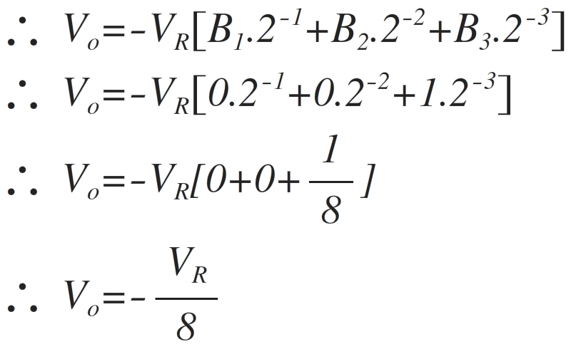

If the reference voltage is positive i.e. + VR, then the output voltage is positive.

Similarly for the other six combinations of digital input, the analog output voltage Vo is calculated as follows:

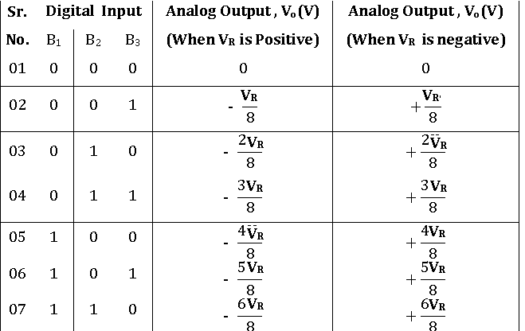

*Disadvantages of Binary-Weighted Resistor*

1) When the number of binary inputs increases, it is not easy to maintain the resistance ratio.

2) Very wide ranges of different values of resistors are required.

For high accuracy of conversion, the values of resistances must be accurate.

3) Different current flows through resistors, so their wattage ratings are also different.

4) Accuracy and stability of conversion depend primarily on the absolute accuracy of the resistors and the tracking of each other with temperature.

eg. For 10 digit converter

small resistance value = 10 kΩ and

large resistance value = 5.12 MΩ

It is very difficult and expensive to obtain stable precise resistances of such value.