INDOOR TRACKING SYSTEM

A PROJECT REPORT

Submitted by

MANAN PATEL - 230203204038
In partial fulfilment for the award of

Diploma
in

Computer Engineering



Vidhyadeep Institute of
Engineering and Technology
(Diploma)


Vidhyadeep University, Surat, Gujarat

A.Y 2025-26

INDOOR TRACKING SYSTEM

Submitted by

MANAN PATEL - 230203204038

Department: Computer Engineering

Institute: Vidhyadeep Institute of Engineering and Technology (Diploma)

University: Vidhyadeep University, Anita-Kim, Surat, Gujarat

Academic Year: 2025–26




VIDHYADEEP UNIVERSITY

VIDHYADEEP INSTITUTE OF ENGINEERING AND TECHNOLOGY(DIPLOMA)

DECLARATION

I hereby declare that the Project report submitted along with the Project entitled INDOOR TRACKING SYSTEM submitted in partial fulfilment for the degree of Diploma of Engineering in Computer Engineering to Vidhyadeep University, Anita, Kim, Surat, is a bonafide record of original project work carried out by us and internal guidance of Ms. Aeni Parmar. And that no part of this report has been directly copied from any students’ reports or taken from any other source, without providing due reference.
Name Of Student | Enrollment Number | Signature Of Student
Patel Manan | 230203204038




VIDHYADEEP UNIVERSITY

VIDHYADEEP INSTITUTE OF ENGINEERING AND TECHNOLOGY(DIPLOMA)

CERTIFICATE

This is to certify that the project report submitted along with the project entitled “Indoor Tracking System” has been carried out by Manan Patel (230203204038) under my guidance in partial fulfilment for Diploma in Computer Engineering, 6th Semester of Vidhyadeep University, Anita-Kim, Surat during the academic year 2025-26.

__________ _________________
Internal Guide Head of the Department

ACKNOWLEDGEMENT

I would like to express My deepest gratitude to everyone who contributed to the successful completion of this project. First and foremost, I extend my heartfelt thanks to my internal guide, Ms. Aeni Parmar, for their invaluable guidance, constant encouragement, and insightful feedback throughout the development of this project.
I sincerely thank Mr. Jaydeep Baria, Head of the Department, for the opportunity and continuous support, and Dr. Vikas J. Patel, my principal, for providing the resources and academic environment that made this project possible.
Lastly, I would like to acknowledge my family and friends for their unwavering support, patience, and encouragement throughout this journey

Yours Sincerely
Name :- Manan Patel
Enrollment No:- 230203204038

ABSTRACT

This project presents an IoT-based Indoor Tracking System designed to track individuals in zone-wise indoor environments such as classrooms, buildings, underground areas, and mining locations where GPS is not effective.
In this system, mobile devices act as Bluetooth Low Energy (BLE) beacons using the nRF Connect application. These devices continuously broadcast signals containing unique device IDs. ESP32-based nodes equipped with SX1278 (Ra-02) LoRa modules are deployed in different zones such as rooms, floors, and lobby areas. These nodes scan BLE signals, capture RSSI (signal strength), and transmit the data to a central server using LoRa communication.
The server collects and stores raw data in a database and applies a custom-designed algorithm to calculate the most accurate device location. The algorithm includes RSSI averaging, weak signal filtering, node-to-room mapping, multi-node confirmation, strongest signal fallback, and stability checks to avoid incorrect location changes.
A web-based dashboard is developed to visualize the tracking data. It provides features such as real-time tracking (live mode), device search, zone-wise classification (building, floor, class), and individual device monitoring. The dashboard helps users quickly identify the location and movement of specific individuals.
The system is especially useful in underground environments such as mining, tunnels, and emergency shelters, where tracking human movement is critical for safety. Additionally, a backup mechanism is implemented to store data in JSON format for reliability and future analysis.
This system provides a cost-effective, scalable, and real-time solution for indoor tracking applications.

LIST OF FIGURES

FIGURE 2.1 System Architecture of Indoor Tracking System 16
FIGURE 2.2 Flowchart of Indoor Tracking Process 18
FIGURE 2.3 Block Diagram of Indoor Tracking System 19
FIGURE 2.4 Use Case Diagram 20
FIGURE 2.5 Location Decision Algorithm 21
FIGURE 3.1 Location Decision Logic Flow 32
FIGURE 3.2 Algorithm Execution Flow 34
FIGURE 3.3 Real System Workflow 38
FIGURE 3.4 Zone-Based Movement Model 39
FIGURE A.4.1 Data Flow Diagram 70

LIST OF TABLES

TABLE 1.1 Technical Scope 04
TABLE 1.2 Technical Objectives 06
TABLE 2.1 Overview of Existing Technologies 08
TABLE 2.2 Technology Stack 10
TABLE 2.3 Hardware Components 13
TABLE 2.4 Node Configuration Details 13
TABLE 2.5 Software Requirements 14
TABLE 3.1 Decision Strategy Table 31
TABLE 3.2 Module Description 36
TABLE 3.3 Faults and Remedies 40
TABLE 4.1 RSSI Value Interpretation 41
TABLE 4.2 Sample Device Tracking Data 42
TABLE 4.3 Final Calculated Location 42
TABLE 4.4 Sample Test Case 42
TABLE 4.5 Device Detection Test Case 43
TABLE 4.6 Movement Tracking Test Case 43
TABLE 4.7 Performance Analysis Table 49
TABLE 5.1 Advantages vs Limitations 52
TABLE A.1.1 Tables Used 65

LIST OF ABBREVIATION

ABBREVIATION | FULL FORM
GPS | Global Positioning System
RSSI | Received Signal Strength Indicator
BLE | Bluetooth Low Energy
UWB | Ultra-Wideband
LoRa | Long Range Communication
ESP32 | Espressif 32-bit Microcontroller
SX1278 | LoRa Transceiver Module (Ra-02)
DB | Database
UI | User Interface
API | Application Programming Interface
JSON | JavaScript Object Notation
PHP | Hypertext Preprocessor
HTML | HyperText Markup Language
CSS | Cascading Style Sheets
JS | JavaScript
SQL | Structured Query Language

TABLE OF CONTENTS
ACKNOWLEDGEMENT i
ABSTRACT ii
LIST OF FIGURES iii
LIST OF TABLES iv
LIST OF ABBREVIATION v

CHAPTER 1: INTRODUCTION 01
  - PROBLEM STATEMENT AND PROJECT SUMMARY 01
  - PURPOSE AND SCOPE OF THE PROJECT 03
  - NOVELTY / INNOVATION OF THE PROJECT 05
  - OBJECTIVES OF THE PROJECT 06

CHAPTER 2: SYSTEM ANALYSIS AND DESIGN 08
  - LITERATURE REVIEW 08
  - TECHNOLOGY 10
  - REQUIREMENT ANALYSIS 13
  - SYSTEM DESIGN 16
  - TECHNOLOGY AND LITERATURE REVIEW 23
  - SIGNAL DETECTION AND LOCATION LOGIC 25

CHAPTER 3: SYSTEM IMPLEMENTATION 27
  - IMPLEMENTATION ENVIRONMENT 27
  - SYSTEM IMPLEMENTATION 30
  - REAL SYSTEM WORKING 37
  - REAL SYSTEM CONCEPT 38
  - FAULTS AND REMEDIES 39

CHAPTER 4: RESULTS AND DISCUSSION 41
  - TESTING AND RESULTS 41

CHAPTER 5: CONCLUSION AND FUTURE WORK 51
  - CONCLUSION 51
  - FUTURE SCOPE 52
  - ADVANTAGES OF THE SYSTEM 55
  - LIMITATIONS OF THE SYSTEM 56
CHAPTER 6: BIBLIOGRAPHY AND REFERENCES 57
  - Books and Study Materials 57
  - ONLINE RESOURCES AND DOCUMENTATION 58
  - RESEARCH PAPERS AND ARTICLES 59
  - TOOLS AND TECHNOLOGIES REFERENCED 59

CHAPTER 7: FUTURE ENHANCEMENTS / RECOMMENDATIONS 60
  - INTRODUCTION 60
  - FUTURE ENHANCEMENTS 60
  - CONCLUSION 64

APPENDIX 65

CHAPTER 1: INTRODUCTION

PROBLEM STATEMENT AND PROJECT SUMMARY

PROBLEM STATEMENT
In recent years, tracking systems have become essential for monitoring the location of people and assets in various environments. Most of the existing tracking systems are based on the Global Positioning System (GPS), which provides accurate results in outdoor conditions. However, GPS technology has a major limitation when used in indoor environments.
GPS signals are transmitted from satellites and require a clear line of sight to function properly. When a device is located inside a building, basement, or any covered structure, these signals become weak or unavailable. As a result, GPS-based systems fail to provide accurate location information in such environments.
This limitation creates several practical problems. In educational institutions, it becomes difficult to track students within classrooms and different floors. In hospitals, monitoring the movement of patients and staff is challenging. Similarly, in offices and commercial spaces, there is no reliable system to track individuals inside buildings.
In addition to this, existing indoor tracking solutions are often expensive and complex to implement. They may also face difficulties in handling multiple devices simultaneously and managing continuously generated data.
Therefore, there is a need for an efficient system that can overcome these limitations and provide accurate tracking within indoor environments. The proposed Indoor Tracking System addresses this issue by using Bluetooth signal detection and LoRa communication, enabling reliable indoor tracking without depending on GPS.

KEY PROBLEMS ADDRESED

GPS Not Working in Indoor Environments
PROBLEM: GPS signals cannot penetrate buildings, basements, or covered areas effectively
SOLUTION: Use Bluetooth signals and LoRa communication instead of GPS
EXPLANATION: This enables accurate tracking of devices inside rooms and buildings

Lack of Accurate Indoor Location Detection
• PROBLEM: It is difficult to determine the exact location (room or floor) inside a building
• SOLUTION: Use RSSI (signal strength) with multiple nodes
• EXPLANATION: Comparing signals from different nodes helps identify the nearest location more accurate
- Difficulty in Tracking Multiple Devices
• PROBLEM: Managing and tracking many devices at the same time becomes complex
• SOLUTION: Use a centralized server and database system
• EXPLANATION: The server processes data efficiently and handles multiple devices simultaneously

High Cost of Existing Systems
• PROBLEM: Many indoor tracking systems require expensive hardware and infrastructure
• SOLUTION: Use cost-effective components like ESP32 and LoRa modules
• Explanation: Reduces overall system cost while maintaining good performance

Continuous Data Generation and Overload
• Problem: Devices send data frequently, which creates a large amount of data
• SOLUTION: Implement filtering and efficient data handling
• EXPLANATION: Helps in reducing unnecessary data load and improves system performance

Data Storage and Management Issues
• PROBLEM: Storing large amounts of historical data can slow down the system
• SOLUTION: Use a backup mechanism to store old data separately
• EXPLANATION: Maintains database efficiency and ensures long-term data storage
The system effectively addresses these problems by providing a reliable, cost-efficient, and scalable solution for indoor tracking.

PROJECT SUMMARY
The Indoor Tracking System is designed to provide accurate and real-time tracking of devices inside buildings where GPS-based systems fail. The system uses a combination of Bluetooth signal detection, ESP32-based nodes, and LoRa communication to determine device locations efficiently.
In this system, mobile devices broadcast Bluetooth signals containing unique device identifiers. Multiple nodes, built using ESP32 microcontrollers and SX1278 LoRa modules, are installed at different locations such as classrooms and lobby areas. These nodes continuously scan nearby Bluetooth signals and collect important data including device ID, RSSI (signal strength), node ID, and timestamp.
The collected data is transmitted to a central server every 5 seconds using LoRa communication. The server processes this data using intelligent decision logic to determine the most accurate location of each device.
The location is calculated using techniques such as RSSI averaging, filtering weak signals, mapping nodes to rooms, grouping detections per room, multi-node confirmation, strongest signal fallback, stability control (hysteresis), and time-based validation.
The processed data is stored in a MySQL database and displayed on a web-based dashboard. The dashboard provides real-time tracking, search functionality, and filtering based on device name or location.
Additionally, the system includes a backup mechanism that stores tracking data in JSON format for future use and system reliability. The proposed system is cost-effective, scalable, and suiTable for real-world indoor environments.
In the future, the system can be enhanced using Ultra-Wideband (UWB) technology for higher accuracy.

PURPOSE AND SCOPE OF THE PROJECT

PURPOSE
The main purpose of this project is to develop an efficient system that can track the location of devices inside buildings where GPS-based systems are not effective. The system aims to provide reliable indoor tracking by using Bluetooth signals and LoRa communication.

The key purposes of the project are as follows:

To provide accurate tracking of devices in indoor environments

To overcome the limitations of GPS-based tracking systems

To enable real-time monitoring of users such as students, staff, or assets

To develop a system that is cost-effective and easy to implement

To provide a user-friendly dashboard for viewing tracking data

To manage tracking data efficiently using database and backup mechanisms

The system is designed to improve monitoring, safety, and management in indoor environments such as schools, hospitals, offices, and malls.

SCOPE

The scope of this project defines the range and boundaries within which the system operates. The proposed Indoor Tracking System is designed for indoor environments and can be expanded as needed.

OPERATIONAL SCOPE
- The system works inside buildings such as classrooms, offices, and hospitals
- It tracks multiple devices simultaneously
- It provides real-time location updates

TECHNICAL SCOPE
AREA | DESCRIPTION
Detection | Bluetooth signals from mobile devices
Communication | LoRa (ESP32 + SX1278 module)
Processing | Server-side logic using PHP
Storage | MySQL database
Interface | Web dashboard using HTML, CSS, JavaScript
TABLE 1.1 Technical Scope

FUNCTIONAL SCOPE
- Display device location in tabular format
- Provide search functionality for specific devices
- Allow filtering by building, floor, and class
- Support live tracking mode for real-time updates

FUTURE SCOPE
- Integration of Ultra-Wideband (UWB) for higher accuracy
- Implementation of map-based tracking system
- Development of mobile application
- Cloud-based data storage and analytics
The system is scalable and can be extended to larger environments with more devices and nodes.

  - NOVELTY / INNOVATION OF THE PROJECT
The Indoor Tracking System introduces several innovative features that improve accuracy, efficiency, and usability compared to basic tracking systems.
The system uses a hybrid approach combining Bluetooth signal detection with LoRa communication, enabling both accurate detection and long-range data transmission.
A key innovation is the use of intelligent location calculation logic, which includes RSSI averaging, weak signal filtering, multi-node confirmation, strongest signal fallback, and stability control (hysteresis). This reduces incorrect location detection and improves reliability.
The system is designed to simulate real-world movement by ensuring logical transitions such as passing through a lobby before entering another room.
Another important feature is the modular testing approach, where different components like data receiving, location calculation, and dashboard display are tested separately using dedicated backend files.
Additionally, the system includes a JSON-based backup mechanism, which improves data management and ensures long-term storage without affecting database performance.
These features make the system more practical, scalable, and suiTable for real-world indoor tracking applications.

OBJECTIVES OF THE PROJECT
The main objective of this project is to design and develop an efficient Indoor Tracking System that can accurately track devices inside buildings where GPS-based systems fail.

MAIN OBJECTIVES
- To develop a system capable of tracking devices in indoor environments
- To overcome the limitations of GPS-based tracking systems
- To provide accurate location detection using signal strength (RSSI)
- To enable real-time monitoring of devices
- To support tracking of multiple devices simultaneously
- To design a user-friendly web dashboard for data visualization
- To manage and store tracking data efficiently
- To implement a backup system for historical data

TECHNICAL OBJECTIVES
OBJECTIVE | DESCRIPTION
Signal Detection | Use Bluetooth signals to detect nearby devices
Communication | Use LoRa modules for long-range data transfer
Processing | Implement server-side logic using PHP
Storage | Store data using MySQL database
Interface | Develop dashboard using HTML, CSS, JavaScript
TABLE 1.2 Technical Objectives

FUNCTIONAL OBJECTIVES
- To display device location in real time
- To provide search functionality for specific devices
- To enable filtering by building, floor, and class
- To implement live mode for automatic data updates

FUTURE OBJECTIVES
- To improve accuracy using Ultra-Wideband (UWB) technology
- To implement a map-based tracking system
- To develop a mobile application for tracking
- To integrate cloud-based storage and analytics

The overall objective of the project is to provide a reliable, scalable, and cost-effective solution for indoor tracking in various environments such as schools, hospitals, offices, and malls

CHAPTER 2: SYSTEM ANALYSIS AND DESIGN

LITERATURE REVIEW
Indoor tracking systems have been widely studied to overcome the limitations of GPS in indoor environments. Since GPS signals do not work effectively inside buildings, researchers have developed different technologies to achieve accurate indoor positioning.
OVERVIEW OF EXISTING TECHNOLOGIES
Various technologies are used for indoor tracking. Each has its own advantages and limitations.
TECHNOLOGY | WORKING METHOD | ADVANTAGES | LIMITATIONS
Wi-Fi | Uses signal strength  from routers | Easy to deploy | Medium accuracy
RFID | Uses tags and readers | High accuracy | Expensive and limited  range
Bluetooth (BLE) | Uses RSSI signal strength | Low cost and  flexible | Moderate accuracy
UWB | Uses time-based signals | Very high accuracy | High cost and  complexity
TABLE 2.1 Overview of Existing Technologies
DISCUSSION
- Wi-Fi-based systems use existing infrastructure but do not provide high accuracy for room-level detection.
- RFID systems are accurate but require dedicated hardware, making them costly.
- Bluetooth-based systems are widely used because they are affordable and easy to implement. They use RSSI (signal strength) to estimate the distance between devices and nodes.
- UWB technology provides very high accuracy but is expensive and not suiTable for low-cost applications.

SELECTION OF TECHNOLOGY
After analyzing the available technologies, Bluetooth and LoRa are selected for this project due to the following reasons:
✔ Cost-effective solution
✔ Easy to implement and maintain
✔ SuiTable for real-time tracking
✔ Scalable for large environments
✔ Compatible with mobile devices

Conclusion
The literature study shows that no single technology is perfect for indoor tracking. However, a combination of Bluetooth (for detection) and LoRa (for communication) provides an efficient and practical solution. This approach balances cost, performance, and scalability, making it suiTable for real-world indoor tracking applications.
This literature review forms the foundation for designing the proposed Indoor Tracking System.

TECHNOLOGY
The proposed Indoor Tracking System is developed using a combination of hardware and software technologies. These technologies work together to detect devices, transmit data, process information, and display results to the user.

OVERVIEW OF TECHNOLOGIES USED
TECHNOLOGY STACK
TECHNOLOGY | PURPOSE IN SYSTEM
Bluetooth (BLE) | Used by devices to broadcast signals
ESP32 | Acts as node controller
SX1278 (Ra-02) LoRa | Used for long-range communication
PHP | Server-side data processing
MySQL | Database storage
HTML, CSS, JavaScript | Frontend dashboard
Arduino IDE | Programming ESP32
C / C++ | Coding language for ESP32
TABLE 2.2 Technology Stack

HARDWARE TECHNOLOGIES
1. Bluetooth (BLE)
Bluetooth Low Energy is used for broadcasting signals from mobile devices.
- Devices continuously send signals
- Each signal contains a unique device ID
- Helps in detecting nearby devices

2. ESP32 Microcontroller
ESP32 is used as the main controller in nodes.
- Receives Bluetooth signals
- Processes signal data
- Sends data to LoRa module
3. LoRa (SX1278 - Ra-02)
LoRa is used for long-distance communication between nodes and server.
- Low power consumption
- Long communication range
- Reliable data transfer

SOFTWARE TECHNOLOGIES
4. Arduino IDE & C/C++
- Used to program ESP32 nodes
- Controls signal processing and LoRa communication
- Provides easy development environment
5. PHP (Backend)
- Processes incoming data from nodes
- Implements location calculation logic
- Communicates with database
6. MySQL Database
- Stores device data and location history
- Maintains structured data
- Supports fast data retrieval

7. Frontend (HTML, CSS, JavaScript)
- Displays data on dashboard
- Provides search and filtering
- Enables live tracking mode
8. nRF Connect Application
- Used to simulate Bluetooth devices
- Broadcasts signals from mobile phones
- Helps in testing the system

TECHNOLOGY INTEGRATION
The system works by integrating all technologies together:
- Bluetooth → Device signal generation
- ESP32 → Signal detection
- LoRa → Data transmission
- PHP → Data processing
- MySQL → Data storage
- Dashboard → Data visualization

SUMMARY
The combination of Bluetooth, ESP32, LoRa, and web technologies provides a cost-effective, scalable, and efficient solution for indoor tracking systems.

REQUIREMENT ANALYSIS

Requirement analysis defines the necessary hardware and software components required to design and implement the Indoor Tracking System. It helps in understanding what resources are needed to make the system work efficiently.

HARDWARE REQUIREMENTS
The hardware components are responsible for detecting signals, processing data, and transmitting information within the system.
HARDWARE COMPONENTS
COMPONENT | DESCRIPTION | ROLE IN SYSTEM
ESP32 | Microcontroller board | Controls node operations
SX1278 (Ra-02) | LoRa module | Sends data to server
Mobile Devices | Smartphones | Broadcast Bluetooth signals
Power Supply | Battery/Adapter | Powers nodes
TABLE 2.3 Hardware Components

Node ID | Room | Floor | Building
room116_1 | 116 | 1 | A
room116_2 | 116 | 1 | A
lab115_1 | 115 | 1 | A
lab115_2 | 115 | 1 | A
room218_1 | 218 | 2 | A
room218_2 | 218 | 2 | A
lobby1 | lobby | 1 | A
TABLE 2.4 Node Configuration Details

HARDWARE WORKING
- Mobile devices broadcast Bluetooth signals
- ESP32 nodes receive these signals
- LoRa module transmits data to the server
- Power supply ensures continuous operation

SOFTWARE REQUIREMENTS
The software components are responsible for processing data, storing information, and displaying results.
SOFTWARE COMPONENTS
SOFTWARE | DESCRIPTION | ROLE IN SYSTEM
XAMPP | Local server environment | Runs PHP & MySQL
PHP | Backend language | Processes data
MySQL | Database | Stores tracking data
HTML | Structure of dashboard | Displays content
CSS | Styling | Improves UI design
JavaScript | Dynamic functions | Handles live updates
Arduino IDE | Development tool | Programs ESP32
C / C++ | Programming language | Controls ESP32 logic
nRF Connect | Mobile app | Sends Bluetooth signals

TABLE 2.5 Software Requirements

SOFTWARE WORKING
- PHP processes data received from nodes
- MySQL stores device and location data
- Dashboard (HTML/CSS/JS) displays tracking information
- JavaScript enables live updates and filtering
- Arduino IDE + C/C++ controls ESP32 nodes
The combination of required hardware and software ensures that the system can detect, process, transmit, and display indoor tracking data efficiently.

SYSTEM DESIGN

System design describes how all components of the Indoor Tracking System are organized and how they work together to achieve accurate indoor tracking. It includes architecture, flow, diagrams, and user interaction.

SYSTEM ARCHITECTURE
The system architecture shows the overall structure and communication between different components such as devices, nodes, server, database, and dashboard.
Architecture Explanation
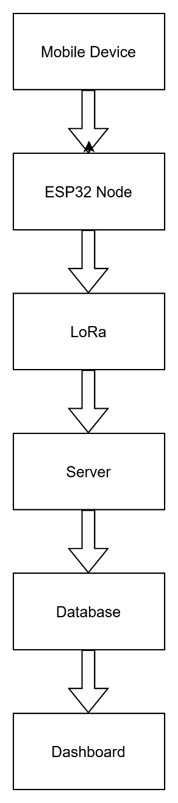
FIGURE 2.1 System Architecture of Indoor Tracking System
The system works in multiple layers:
- Device Layer (Mobile Devices)
- Devices broadcast Bluetooth signals
- Each device has a unique ID
- Node Layer (ESP32 + LoRa)
  - Nodes receive Bluetooth signals
  - Measure RSSI (signal strength)
  - Send data to server via LoRa
- Communication Layer (LoRa)
- Transfers data over long distance
- Low power and reliable
- Server Layer
- Receives data from nodes
- Processes data using logic (RSSI comparison, multi-node detection)
- Database Layer
- Stores device logs and location data
- Presentation Layer (Dashboard)
    - Displays data to users
    - Provides search, filter, and live tracking

FLOW CHART

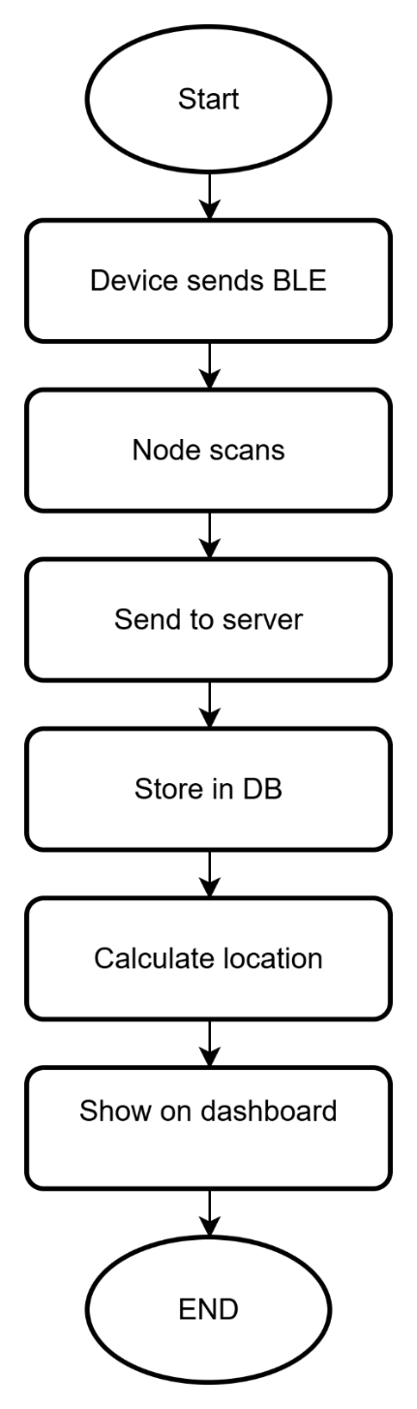

FIGURE 2.2 Flowchart of Indoor Tracking Process

BLOCK DIAGRAM



FIGURE 2.3 Block Diagram of Indoor Tracking System

Step-by-Step Workflow
- Device Block
Sends Bluetooth signal.
- Node Block
Receives and processes signal (RSSI).
- Communication Block (LoRa)
Transfers data to server.
- Server Block
Processes data and calculates location.
- Database Block
Stores tracking information.
- Dashboard Block
Displays final output to user.

USE CASE DIAGRAM:

Step-by-Step Workflow:

User Interaction
User accesses the dashboard.

View Data
User views all tracking information.

Search Device
User searches for a specific device.

Apply Filters
User filters data by building, floor, or class.

Enable Live Mode
User activates real-time tracking.

View History
User checks previous device locations.

FIGURE 2.4 Use Case Diagram

    - LOCATION CALCULATION LOGIC

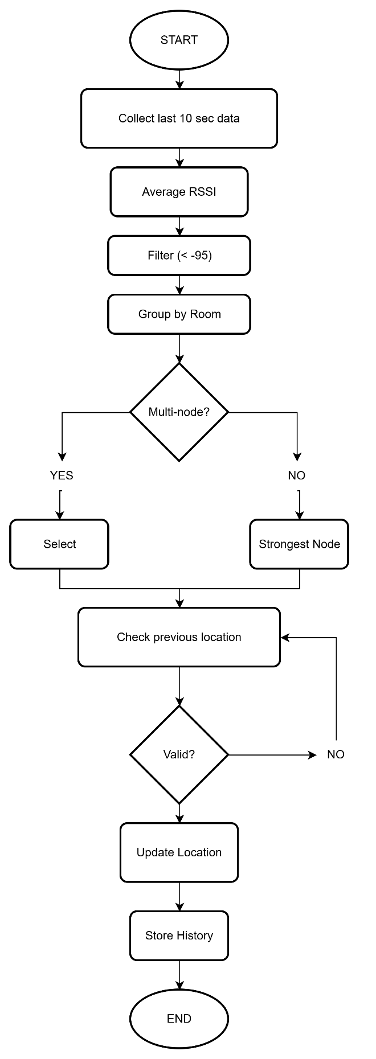

FIGURE 2.5 Location Decision Algorithm
ADVANCED LOCATION CALCULATION ALGORITHM
The Indoor Tracking System uses an intelligent server-side algorithm implemented in PHP to determine the accurate zone (room/floor/building) of each device.

Step 1: Recent Data Filtering
The system collects only the last 10 seconds of data to ensure real-time accuracy.

Step 2: RSSI Averaging
RSSI values from each node are averaged to reduce fluctuation and noise.

Step 3: Weak Signal Filtering
Signals weaker than -95 dBm are ignored to avoid incorrect detection.

Step 4: Node-to-Room Mapping
Each node is mapped to its respective room, floor, and building using the nodes Table.

Step 5: Multi-Node Confirmation
If two or more nodes from the same room detect the device, that room is selected.

Step 6: Strongest Signal Fallback
If multi-node confirmation is not available, the node with the strongest RSSI is selected.

Step 7: Stability Check
The system compares the previous location and avoids frequent incorrect changes unless strong signals are detected.

Step 8: Movement Validation
The system ensures logical movement (e.g., passing through lobby before another room).

Step 9: Location Storage
The final location is stored in device_location and changes are recorded in device_history.

This algorithm improves accuracy, stability, and real-time tracking performance.

TECHNOLOGY AND LITERATURE REVIEW

This section describes the technologies used in the Indoor Tracking System and provides a comparison with existing systems. It also highlights the concepts adopted from previous research in indoor positioning.

TECHNOLOGY USED

The proposed system integrates both hardware and software technologies to achieve accurate indoor tracking.

Bluetooth Technology
Bluetooth Low Energy (BLE) is used in this system for broadcasting signals from mobile devices. Each device continuously transmits signals containing a unique device identifier. These signals are received by nearby ESP32 nodes, which measure the signal strength (RSSI). Bluetooth is chosen because it is low-cost, energy-efficient, and widely supported by smartphones, making it suiTable for indoor tracking applications.

Embedded System (ESP32)
The ESP32 microcontroller acts as the core component of the node system. It is responsible for receiving Bluetooth signals, measuring RSSI values, and preparing data for transmission. The ESP32 provides high processing capability, built-in Wi-Fi and Bluetooth support, and low power consumption. It is programmed using Arduino IDE with C/C++, enabling efficient handling of signal processing and communication tasks.

LoRa Communication (SX1278)
The system uses the SX1278 (Ra-02) LoRa module for long-range communication between nodes and the server. LoRa technology is designed for low-power, long-distance data transmission, making it suiTable for large indoor environments such as buildings and campuses. It ensures reliable communication even in areas where Wi-Fi signals are weak or unavailable.

Server-Side Processing (PHP)
The server is developed using PHP, which handles all backend processing tasks. It receives data from nodes, processes RSSI values, and determines the location of devices using logic such as multi-node comparison and signal strength evaluation. PHP also manages communication between the database and the dashboard, ensuring smooth data flow.

Database Management (MySQL)
MySQL is used to store all tracking data, including device ID, node ID, location, and timestamps. It provides structured storage and efficient data retrieval. The database supports real-time updates as well as historical data storage, which is useful for tracking movement over time.

Web Dashboard (HTML, CSS, JavaScript)
The dashboard is developed using HTML, CSS, and JavaScript to provide a user-friendly interface. It displays tracking data in a structured format and includes features such as search, filtering, and live tracking mode. JavaScript is used to dynamically update data without refreshing the page, improving user experience.

Development Tools (Arduino IDE & nRF Connect)
Arduino IDE is used to program the ESP32 nodes using C/C++ language. It provides an easy environment for writing, compiling, and uploading code. The nRF Connect mobile application is used to simulate Bluetooth devices by broadcasting signals, which helps in testing and development of the system.

LITERATURE SUPPORT
The design of this system is based on widely used concepts in indoor tracking research.
Key Concepts Adopted
- Use of RSSI to estimate device location
- Multi-node detection to improve accuracy
- Use of Bluetooth (BLE) for low-cost signal transmission
- Use of LoRa for long-range communication
- Implementation of real-time dashboard systems

Explanation
In indoor tracking systems, RSSI is commonly used to estimate the distance between devices and nodes. However, signal strength may vary due to obstacles and environmental conditions.
To improve accuracy, multiple nodes are used, and their signal values are compared.
The proposed system follows this approach by collecting data from different nodes and processing it at the server level. The integration of LoRa communication ensures reliable data transmission over long distances, making the system efficient and scalable.

SIGNAL DETECTION AND LOCATION LOGIC
This section explains how the system detects devices and determines their location using signal strength and processing logic. The system uses Bluetooth signals and RSSI-based techniques to estimate the position of devices inside the building.

Bluetooth Signal Detection
The system uses Bluetooth Low Energy (BLE) signals to detect nearby devices. Mobile devices continuously broadcast signals containing a unique device ID. These signals are received by ESP32 nodes installed at different locations such as rooms and corridors.
Each node captures the following data:
- Device ID
- Node ID
- RSSI (signal strength)
- Timestamp
The strength of the received signal (RSSI) helps in estimating the distance between the device and the node.

RSSI-Based Distance Estimation
RSSI (Received Signal Strength Indicator) is used to determine how close a device is to a node. A stronger signal indicates that the device is closer to the node, while a weaker signal indicates greater distance.
However, RSSI values may fluctuate due to obstacles such as walls, furniture, and interference. Therefore, additional logic is required to improve accuracy.

Detection Logic (System Processing)
The server applies a set of logical steps to determine the most accurate location of the device based on the received data.

Detection Process
- Data Collection
The system collects signal data from the last few seconds (e.g., 10 seconds).
- RSSI Averaging
The average RSSI value is calculated for each node to reduce fluctuations.
- Node Grouping
Nodes are grouped based on their location (room, floor, building).
- Multi-Node Confirmation
If multiple nodes in the same location detect the device with strong signals, that location is selected.
- Strongest Signal Selection
If multi-node confirmation is not available, the node with the strongest RSSI is selected.
- Stability Check
The system checks previous locations to avoid sudden incorrect changes.
- Final Location Decision
The most accurate location is determined and saved in the database.

Real-Time Processing
The system continuously processes incoming data to provide real-time tracking. As devices move, new signals are received and processed, updating their location dynamically on the dashboard.

Summary
The system uses RSSI-based detection combined with multi-node logic and server-side processing to achieve accurate indoor tracking. This approach reduces errors caused by signal fluctuations and improves reliability.

CHAPTER 3: SYSTEM IMPLEMENTATION
The implementation environment consists of all the technologies, tools, and hardware required to develop and run the system. It includes programming languages, software tools, hardware components, and testing conditions.

IMPLEMENTATION ENVIRONMENT
The system is designed to handle continuous data transmission from multiple devices, process signal strength values, and display accurate location information without delay. The environment supports integration of embedded hardware, wireless communication, server-side processing, and web-based visualization.

The development and testing environment was carefully designed to simulate real indoor conditions such as multiple rooms, obstacles, and device movement. Special attention was given to system stability, data accuracy, and real-time performance.

The implementation environment supports:
- Continuous real-time tracking without system interruption
- Reliable communication between ESP32 nodes and server
- Accurate RSSI-based location detection logic
- STable LoRa communication across different indoor locations
- Efficient data storage and retrieval from database

The modular design of the system allows each component (device, node, server, dashboard) to be tested independently before full integration. This improves debugging efficiency and ensures system reliability.
Additionally, the system is scalable and flexible. More nodes, devices, or features such as map visualization and UWB technology can be integrated without major changes to the existing system.
Overall, the implementation environment ensures that the Indoor Tracking System operates efficiently, reliably, and accurately in real indoor conditions.

PROGRAMMING LANGUAGES
The Indoor Tracking System uses multiple programming languages for different parts of the system, ensuring efficient operation and flexibility.
C/C++ is used for programming the ESP32 microcontroller, which acts as the core of the node system. These languages provide fast execution, low-level hardware control, and efficient memory usage, which are essential for embedded systems. The ESP32 firmware handles Bluetooth signal detection, RSSI measurement, and LoRa communication.
PHP is used for server-side processing. It receives data from nodes, processes RSSI values, and implements location detection logic. It also manages communication between the database and the dashboard.
JavaScript is used on the frontend to enable dynamic behavior such as live data updates, filtering, and searching. HTML and CSS are used to structure and design the web dashboard.
This combination of languages ensures smooth integration between hardware, server, and user interface.

SOFTWARE TOOLS

Arduino IDE:

Used for writing, compiling, and uploading C/C++ code to the ESP32 microcontroller. It provides a simple interface and supports required libraries for Bluetooth and LoRa communication.

XAMPP:
Used as a local server environment. It includes Apache and MySQL, which are required for running PHP scripts and managing the database.

nRF Connect Application:
Used to simulate Bluetooth devices by broadcasting signals from mobile phones. It helps in testing the system without requiring dedicated hardware devices.

Web Browser:
Used to access and test the dashboard interface. It allows users to view tracking data, apply filters, and monitor real-time updates.

Serial Monitor:
Used for debugging ESP32. It displays real-time data such as RSSI values, device IDs, and communication status.

HARDWARE SETUP
The hardware setup of the Indoor Tracking System consists of ESP32 nodes, LoRa modules, and mobile devices acting as signal transmitters.
The ESP32 microcontroller acts as the central unit of each node. It is connected with the SX1278 (Ra-02) LoRa module, which is used for long-range communication. The ESP32 scans for Bluetooth signals from nearby devices and measures their RSSI values.

Key hardware integration details include:
- ESP32 receives Bluetooth signals using its built-in BLE capability
- SX1278 LoRa module is connected to ESP32 for data transmission
- Mobile devices broadcast signals using Bluetooth (nRF Connect)
- Nodes are placed in different rooms to ensure proper coverage
- Power supply is provided using USB or battery

Proper placement of nodes is important to achieve accurate tracking. At least two nodes are placed in each room to improve reliability using multi-node detection logic.
The hardware setup is designed to be simple, cost-effective, and scalable for larger environments.

ENVIRONMENTAL CONDITIONS FOR TESTING
To evaluate system performance, testing was conducted under various indoor conditions to simulate real-world scenarios.

The testing environments include:
- Indoor Room Testing:
Used to verify signal detection, RSSI accuracy, and node performance inside classrooms and rooms
- Multi-Device Testing:
Multiple devices (D1 to D8) were used to simulate real-world tracking conditions
- Obstacle Testing:
Walls, furniture, and partitions were considered to analyze signal variation and accuracy
- Movement Testing:
Devices were moved between rooms (through lobby) to test tracking logic and location updates
- Continuous Operation Testing:
Signals were transmitted every 5 seconds to test real-time tracking and system stability
These testing conditions helped in analyzing system accuracy, optimizing RSSI logic, and improving overall performance.

SYSTEM IMPLEMENTATION

This section describes the actual working of the Indoor Tracking System. It explains how the system processes incoming data, applies decision logic, and determines the accurate location of devices. The implementation is based on real-time data collection, signal strength analysis, and server-side processing.

Decision Logic Implementation

The Indoor Tracking System uses a decision-making mechanism based on RSSI values and multi-node detection to determine the accurate location of a device.

The logic is implemented on the server side using PHP, where data received from multiple nodes is analyzed and processed.

Key Decision Logic

The system collects signal data from multiple nodes for each device

RSSI values are used to estimate proximity between device and node

Data from the last few seconds is considered to reduce noise

Average RSSI is calculated for each node

Nodes are grouped based on location (room, floor, building)

If multiple nodes in the same location detect strong signals → location is confirmed

If not → node with strongest RSSI is selected

Previous location is considered to avoid sudden incorrect changes

Decision Strategy
Condition | Action
Multiple strong nodes in same room | Confirm that room
Single strong node | Select that node
Weak or unsTable signals | Use previous sTable location
Continuous updates | Refresh location in real time

TABLE 3.1 Decision Strategy Table

This logic improves accuracy and reduces errors caused by signal fluctuations.

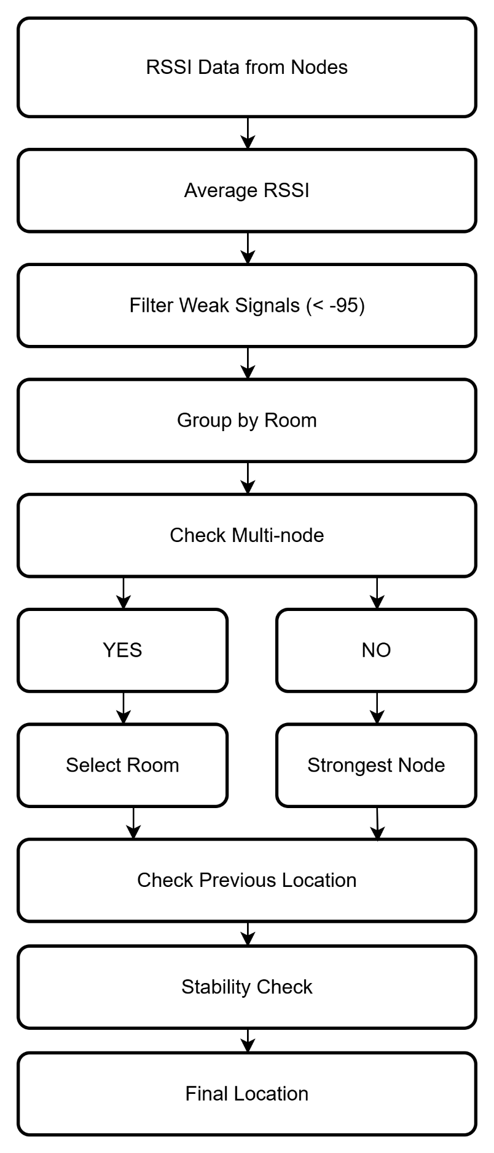

FIGURE 3.1 Location Decision Logic Flow

ALGORITHMS / PROCESS STEPS

The Indoor Tracking System follows a real-time processing algorithm based on actual server-side implementation.

Step-by-Step Algorithm
Step 1: Data Receiving
Nodes send device_id, node_id, RSSI, and timestamp to the server (receive_data.php).

Step 2: Data Storage
Received data is stored in the device_logs Table.

Step 3: Trigger Calculation
After storing data, calculate_location.php is automatically executed.

Step 4: Recent Data Selection
Server selects last 10 seconds of data for each device.

Step 5: RSSI Processing
Average RSSI is calculated for each node.

Step 6: Room Grouping
Nodes are grouped based on their assigned room.

Step 7: Decision Logic
• Multi-node confirmation is checked
• If not, strongest RSSI node is selected

Step 8: Stability Check
Previous location is compared to avoid incorrect updates.

Step 9: Update Location
Final location is stored in device_location Table.

Step 10: History Tracking
If location changes, it is stored in device_history.

Step 11: Dashboard Display
Dashboard fetches updated data and displays it to users.

This process runs continuously to provide real-time tracking.

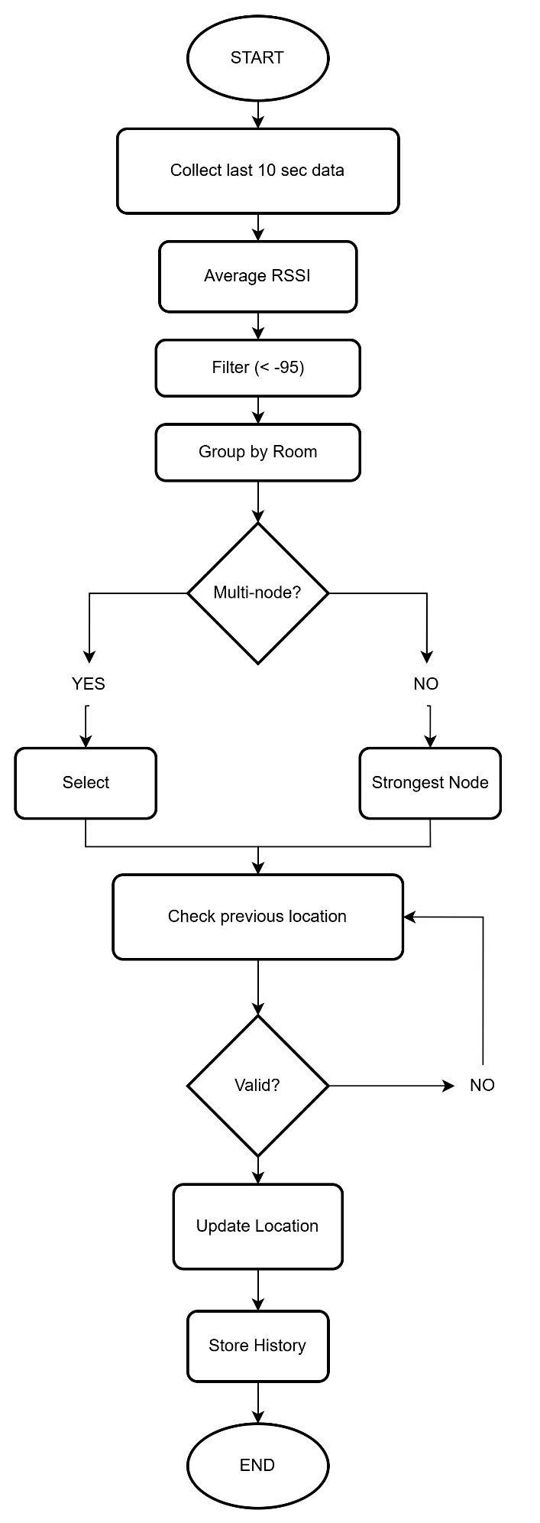
FIGURE 3.2 Algorithm Execution Flow

MODULE-WISE EXPLANATION.
The system is divided into multiple modules, each responsible for a specific function.

1. Device Module
- Mobile devices act as signal transmitters
- Use Bluetooth (nRF Connect) to broadcast signals
- Each device has a unique ID

2. Node Module (ESP32 + LoRa)
- Receives Bluetooth signals
- Measures RSSI values
- Sends data to server using LoRa

3. Server Module
- Receives data from nodes
- Processes data using decision logic
- Determines device location

4. Database Module
- Stores raw data (device_logs)
- Stores processed location (device_history)
- Maintains historical records

5. Dashboard Module
The dashboard is designed to display tracking data in a user-friendly and structured format.
Features:
• Real-Time Tracking (Live Mode)
A live button is provided to show only the latest device location instead of all historical data.
• Search Function
Users can search for a specific device or student to view their current location.
• Zone-Based Classification
Data is organized based on building, floor, and class (room-wise tracking).
• Individual Device Details
Displays device ID, room, floor, and building.
• Data Summary
Each Table displays total number of devices at the top.
• Historical Data
Tracks movement history of devices.
Importance:
The dashboard helps users easily monitor and track individuals in real time, making the system practical for real-world applications.
Module | Function
Device | Sends BLE signal
Node | Detects RSSI
Server | Calculates location
Database | Stores data
Dashboard | Displays output
TABLE 3.2 Module Description
  - REAL SYSTEM WORKING
The Indoor Tracking System operates in real time using a combination of hardware and software components.

Step-by-step working:
- Device Signal Broadcasting
Mobile devices continuously broadcast Bluetooth signals containing unique device IDs.
- Signal Detection by Nodes
ESP32 nodes installed in different locations scan and detect nearby Bluetooth signals.
- Data Collection
Each node collects device ID, RSSI (signal strength), node ID, and timestamp.
- Data Transmission
The collected data is transmitted to the server using LoRa communication every 5 seconds.
- Server Processing
The server receives data and processes it using RSSI-based logic and multi-node detection.
- Location Calculation
The system determines the most accurate location using averaging, filtering, and stability logic.
- Data Storage
The processed data is stored in the MySQL database.
- Dashboard Display
The dashboard displays real-time device location with search and filtering options.
This process runs continuously to provide live indoor tracking of multiple devices.
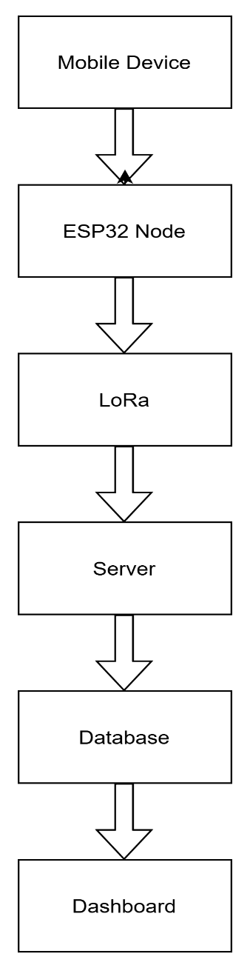
FIGURE 3.3 Real System Workflow

  - REAL SYSTEM CONCEPT
The system is designed to track individuals based on zones instead of exact coordinates.

Working Concept:
• Mobile phones act as BLE transmitters using nRF Connect
• ESP32 + LoRa nodes act as receivers
• Nodes scan signals and send data to server
• Server calculates the most accurate zone

Zone Structure:
• Rooms (Class level)
• Floors
• Lobby (transition area)

The system ensures logical movement tracking. For example, a device must pass through the lobby before entering another room.
This approach makes the system suiTable for underground environments such as mining, tunnels, and emergency shelters where GPS does not work.

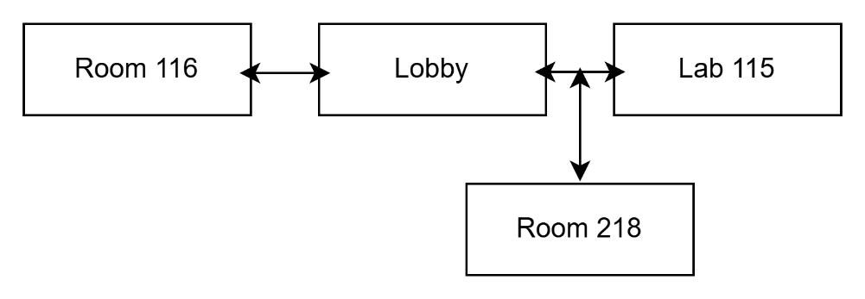
FIGURE 3.4 Zone-Based Movement Model

3.5 FAULTS AND REMEDIES

During the implementation of the Indoor Tracking System, several practical issues were observed related to signal detection, communication, and system performance. These faults were analyzed and appropriate remedies were applied to improve system accuracy and reliability.

FAULT | CAUSE | REMEDY
Signal Fluctuation (RSSI Variation) | Obstacles like walls and interference | Use RSSI averaging and multi node logic
Incorrect Location Detection | Weak or unsTable signals | Apply stability check using previous location
Data Delay | Network or processing delay | Optimize server processing and queries
Missing Data from Nodes | Communication failure | Ensure sTable LoRa communication and retry mechanism
Overlapping Signals | Multiple nodes detecting same device | Use strongest signal and grouping logic
High Data Load | Frequent data updates (every 5 sec) | Use filtering and backup system
Node Placement Issues | Poor positioning of nodes | Place minimum 2 nodes per room
Dashboard Lag | Continuous data refresh | Use optimized JavaScript and live mode control

TABLE 3.3 Faults and Remedies

Signal fluctuation is one of the major challenges in indoor tracking systems, as RSSI values vary due to obstacles and interference. This issue is resolved by calculating average RSSI values and using multiple nodes for better accuracy.

Incorrect location detection may occur when signals are weak or unsTable. To handle this, a stability check is applied using previously detected locations.

Communication issues such as missing data can occur due to LoRa transmission errors. This is minimized by ensuring proper module configuration and reliable communication setup.

High data generation can slow down the system, especially when updates occur every few seconds. This problem is handled by implementing efficient database queries and backup mechanisms.

Proper placement of nodes is also important to ensure accurate detection. Placing multiple nodes in each room improves reliability and reduces errors.

CHAPTER 4: RESULTS AND DISCUSSION

This chapter presents the results obtained after the successful implementation and comprehensive testing of the Indoor Tracking System. Each module of the system was tested individually to verify its functionality and accuracy, followed by complete system testing to evaluate overall performance in real indoor environments.

The results demonstrate that the system is capable of continuously detecting Bluetooth signals, processing RSSI values, determining device location, and displaying real-time tracking information on the dashboard. The system successfully tracks multiple devices simultaneously and updates their location dynamically.
The results are analyzed based on key performance parameters such as tracking accuracy, response time, communication reliability, system stability, and real-time usability. Various test scenarios were executed to simulate real-world conditions, including device movement between rooms, signal fluctuation due to obstacles, and multiple device tracking.

The discussion highlights the strengths of the system, such as real-time tracking, cost-effectiveness, and scalability, while also identifying limitations related to RSSI fluctuations and node placement.

TESTING AND RESULTS

To validate the performance and reliability of the Indoor Tracking System, systematic testing was carried out using structured test cases. These test cases were designed to evaluate signal detection, data transmission, location calculation, and dashboard visualization.

RSSI Range | Signal Strength | Meaning
-50 to -65 | Strong | Device very near
-65 to -75 | Medium | Same room
-75 to -85 | Weak | Nearby area
Below -85 | Very Weak | Ignore
TABLE 4.1 RSSI Value Interpretation

Device ID | Room | Floor | RSSI | Time
D1 | 116 | 1 | -65 | 10:01
D2 | Lobby | 1 | -70 | 10:02
D4 | 115 | 1 | -68 | 10:03
D5 | 218 | 2 | -70 | 10:03
TABLE 4.2 Sample Device Tracking Data

Device ID | Final Room | Floor | Status
D1 | 116 | 1 | STable
D2 | Lobby | 1 | Moving
D4 | 115 | 1 | STable
D5 | 218 | 2 | STable
TABLE 4.3 Final Calculated Location

Testing was performed in multiple stages:
- Module-level testing – each component tested individually
- Integration testing – all modules tested together
- Field testing – real indoor environment testing

The modular approach helped in identifying issues such as signal fluctuation, communication delay, and incorrect location detection, which were later optimized using improved logic.
The results confirm that the system performs reliably in both controlled and real indoor environments.

TEST CASES

Sample Test Case (Node & System Initialization)

Test Case Name | System Initialization
Description | Verify node startup and communication with server
Test Scenario | Check ESP32 + LoRa communication and data sending

TABLE 4.4 Sample Test Case

Device Detection Test Case

Step | Step Details | Expected Result | Actual Result | Status
1 | Device broadcasts signal | Signal detected | As Expected | Pass
2 | Node measures RSSI | RSSI value recorded | As Expected | Pass
3 | Send to server | Data stored | As Expected | Pass
TABLE 4.5 Device Detection Test Case

Movement Tracking Test Case

Step | Step Details | Expected Result | Actual Result | Status
1 | Device in room | Correct room detected | As Expected | Pass
2 | Move via lobby | Location updates step-by-step | As Expected | Pass
3 | Enter new room | New location updated | As Expected | Pass

TABLE 4.6 Movement Tracking Test Case

TESTING METHODOLOGY

The testing methodology followed a structured approach to evaluate system performance under realistic indoor conditions.

Testing Stages
- Laboratory Testing
  - Node setup and communication testing
  - RSSI data validation
  - Server processing verification
- Field Testing
  - Testing in rooms, corridors, and lobby
  - Device movement tracking
  - Multi-device scenario (D1–D8)

- System Testing
  - Live dashboard monitoring
  - Real-time updates
  - Continuous operation testing

MODULE-WISE TESTING AND OBSERVATIONS

To ensure proper functioning of the Indoor Tracking System, each module was tested individually under controlled as well as real indoor conditions. This modular testing approach helped in identifying issues at an early stage and improving overall system reliability.

A. Device Module
The device module consists of mobile devices that broadcast Bluetooth signals using applications such as nRF Connect. Each device continuously transmits a unique device ID.

Observations
- Devices successfully broadcast Bluetooth signals without interruption
- Unique device IDs were correctly transmitted and detected
- Signal transmission interval (every 5 seconds) was maintained consistently
- No packet loss was observed during continuous operation

Results
- Reliable signal broadcasting achieved
- SuiTable for real-time tracking applications
- STable performance even with multiple devices (D1–D8)

B. Node Module (ESP32 + LoRa)
The node module is responsible for detecting Bluetooth signals and sending data to the server using LoRa communication.

Observations
- ESP32 successfully detected signals from nearby devices
- RSSI values were measured accurately
- Multiple nodes detected the same device when in range
- LoRa communication remained sTable across indoor distances

Results
- Accurate signal detection achieved
- Reliable data transmission to server
- Multi-node detection improved tracking accuracy

C. Server Module
The server module processes incoming data and applies decision logic to determine device location.

Observations
- Data from nodes was received without delay
- RSSI averaging reduced signal fluctuations
- Multi-node logic improved location accuracy
- Stability checks prevented sudden incorrect location changes

Results
- Accurate location detection achieved
- Efficient processing of real-time data
- Improved reliability through decision logic

D. Database Module
The database module stores both raw and processed data.

Observations
- Data insertion was successful without errors
- No data loss observed during continuous updates
- Historical data was maintained correctly
- Query performance remained sTable

Results
- Efficient data storage and retrieval
- Supports real-time and historical tracking

E. Dashboard Module
The dashboard provides visualization of tracking data.

Observations
• Data displayed correctly in structured Table format
• Search function worked accurately for specific devices
• Zone-based filtering (building, floor, class) worked efficiently
• Live mode displayed only the latest tracking data
• No significant delay in real-time updates

Results
• Easy monitoring of individual devices
• Clear visualization of zone-wise tracking
• Improved usability with live tracking feature
• Efficient data management and display

The dashboard plays a key role in converting raw tracking data into useful information for users.

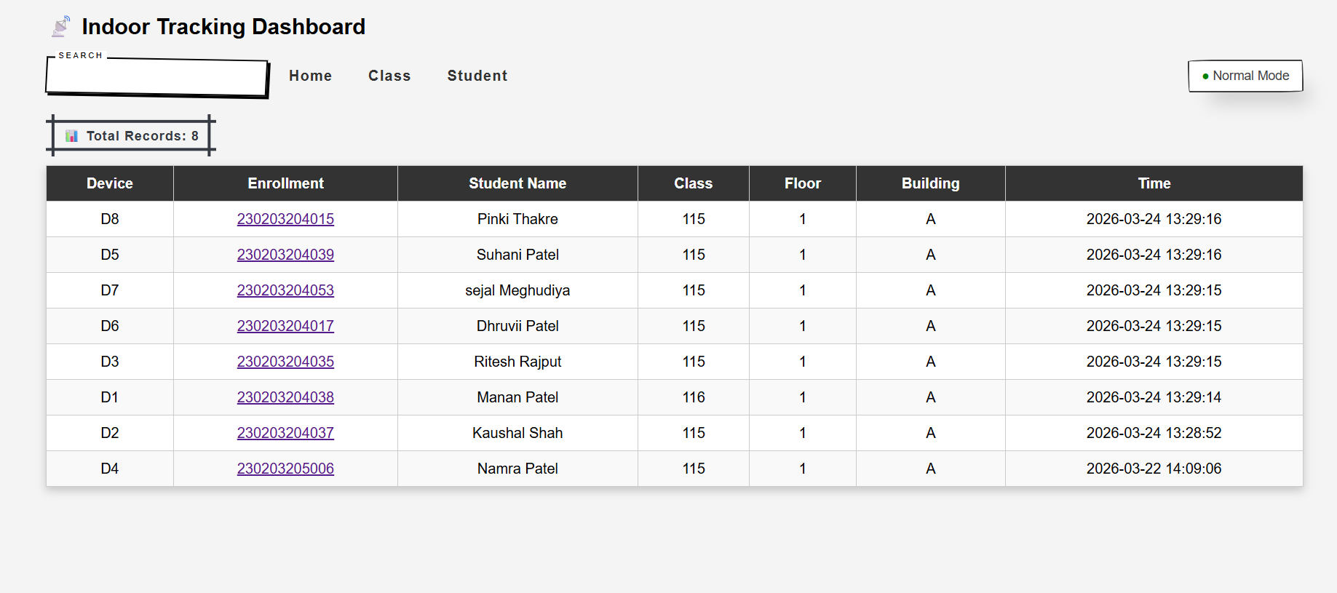
Figure 4.1: Dashboard Interface

4.1.4. TESTING USING SYSTEM MODULES

To ensure proper functioning of the Indoor Tracking System, testing was performed using different system modules and backend files. Each part of the system was tested individually to verify accuracy, performance, and real-time behavior.

1. Node Data Testing (Data Receiving)
The system was tested by sending data from nodes to the server using simulated and real inputs. The data included device_id, node_id, RSSI, and timestamp.
File Used: receive_data.php

Observation:
Data was successfully received and stored in the database without loss. Continuous data updates every 5 seconds were handled efficiently.

- Location Calculation Testing
The core logic of the system was tested using the calculate_location.php file. Different scenarios were tested by varying RSSI values and node combinations.
File Used: calculate_location.php

Observation:
The system correctly calculated location using RSSI averaging, multi-node confirmation, and strongest signal fallback. Stability logic prevented incorrect sudden location changes.

3. Dashboard Data Testing
The dashboard was tested for real-time data display, filtering, and search functionality.
Files Used: fetch_data.php, dashboard interface

Observation:
Data was displayed correctly in Table format. Search by device name and filtering by class/location worked efficiently. Live updates were smooth without page reload issues.

4. Multi-Device Testing
Multiple devices (D1 to D8) were tested simultaneously to evaluate system scalability.

Observation:
The system handled multiple devices without performance issues. Each device maintained separate tracking data and correct location updates.

5. Movement Testing
Devices were moved between rooms through the lobby to test logical tracking.

Observation:
The system successfully tracked movement path and updated locations step-by-step. Devices always passed through the lobby before entering another room as per system logic.

6. Backup and Data Storage Testing
The backup system was tested by storing data in JSON format.

Observation:
Data was successfully saved in structured JSON files, ensuring reliability and future data analysis

OVERALL SYSTEM PERFORMANCE
The overall system performance was evaluated based on multiple parameters such as accuracy, response time, scalability, and system stability under real indoor conditions.

Performance Analysis
Parameter | Performance | Description
Response Time | Fast | Location updates within few seconds
Accuracy | Good | Room-level accuracy achieved
Stability | High | Continuous operation without failure
Scalability | High | Supports multiple devices
Data Processing | Efficient | Server handles real-time data smoothly
TABLE 4.7 Performance Analysis Table

Performance Highlights :

Real-Time Tracking
The system continuously updates device location using live mode. Data refresh occurs automatically without requiring manual interaction.

Fast Response Time
The system detects and updates device location within a few seconds, ensuring minimal delay in tracking.

Multi-Device Handling
The system successfully tracks multiple devices (D1–D8) simultaneously without performance degradation.

Reliable Communication
LoRa communication ensures sTable data transmission even across different rooms and floors.

Cost-Effective Implementation
The use of ESP32 and LoRa modules makes the system affordable and suiTable for large-scale deployment.

Limitations Observed
- RSSI values fluctuate due to obstacles such as walls and furniture
- Accuracy depends on proper placement of nodes
- Slight delay may occur during movement between locations
- Signal interference may affect detection in crowded environments

RESULT SUMMARY
The results obtained from the implementation and testing of the Indoor Tracking System confirm that the system successfully meets its intended objectives.

Key Achievements
- Accurate indoor tracking without relying on GPS
- Real-time monitoring of device location
- Successful tracking of multiple devices simultaneously
- Efficient data processing using server-side logic
- Reliable communication using LoRa technology
- User-friendly dashboard with live tracking and filtering

System Effectiveness
The system effectively detects device signals, processes RSSI values, and determines location using intelligent decision logic. The integration of hardware and software components ensures smooth operation and accurate results.

Practical Applicability
The system can be used in various real-world environments such as:
- Schools and colleges
- Hospitals
- Offices
- Shopping mall.

CHAPTER 5: CONCLUSION AND FUTURE WORK

CONCLUSION
The Indoor Tracking System developed in this project successfully achieves its primary objective of tracking devices within indoor environments where traditional GPS-based systems fail. The system utilizes Bluetooth signal broadcasting, ESP32-based nodes for signal detection, and LoRa communication for reliable data transmission to the server.
The implementation demonstrates that RSSI-based tracking, when combined with multi-node detection and server-side processing, can provide accurate and reliable location information at the room level. The use of multiple nodes and averaging techniques helps reduce errors caused by signal fluctuations, improving the overall stability of the system.
The system is capable of tracking multiple devices simultaneously and updating their location in real time. The web-based dashboard provides an intuitive interface for monitoring device location, applying filters, and enabling live tracking mode. The integration of backend processing, database management, and frontend visualization ensures smooth and efficient operation.
One of the key advantages of the system is its cost-effectiveness and scalability. The use of affordable hardware components such as ESP32 and LoRa modules makes the system suiTable for deployment in large environments like schools, hospitals, and offices.
Although the system performs efficiently, certain limitations such as RSSI fluctuations and dependency on node placement were observed. However, these limitations are common in signal-based indoor tracking systems and do not significantly affect the overall performance.
In conclusion, the proposed Indoor Tracking System provides a practical, efficient, and scalable solution for indoor location tracking. The system successfully demonstrates real-time monitoring, reliable data processing, and user-friendly visualization, making it suiTable for real-world applications.
The system is particularly useful in underground and GPS-denied environments such as mining, tunnels, and emergency shelters. The zone-based tracking approach ensures reliable monitoring of individuals and improves safety in critical situations.
Advantages | Limitations
Real-time tracking | RSSI fluctuation
Low cost | Node placement needed
TABLE 5.1 Advantages vs Limitations

FUTURE SCOPE
The Indoor Tracking System developed in this project provides a reliable and cost-effective solution for indoor tracking using Bluetooth and RSSI-based techniques. However, there is significant scope for improvement in terms of accuracy, visualization, scalability, and advanced features. Future enhancements can make the system more precise, intelligent, and suiTable for large-scale real-world deployment.

1. Integration of Ultra-Wideband (UWB) Technology
The most important future improvement is the integration of Ultra-Wideband (UWB) technology, which offers very high accuracy compared to RSSI-based systems.

Need for UWB
In the current system, location is estimated using RSSI values, which can fluctuate due to obstacles such as walls, furniture, and interference. This limits accuracy to room-level detection. UWB technology can overcome this limitation.

Advantages of UWB
- Provides centimeter-level accuracy
- Less affected by obstacles and interference
- More reliable than RSSI-based methods
- SuiTable for precise indoor positioning

How UWB Will Improve the System
- Replace RSSI-based detection with distance-based measurement
- Enable exact positioning of devices inside rooms
- Improve tracking in complex environments
- Reduce false location detection

Future Implementation Idea
- Use UWB modules instead of Bluetooth nodes
- Install UWB anchors in different locations
- Calculate position using triangulation
- Integrate results with existing server and dashboard

UWB integration will transform the system from room-level tracking to high-precision indoor positioning system.

2. Map-Based Visualization System
Currently, the system displays tracking data in a Table format. In future, a graphical map-based interface can be developed.

Improvements
- Display real-time device location on building map
- Show movement path of devices
- Improve user understanding and visualization
This will make the system more interactive and user-friendly.

3. Mobile Application Development
A mobile application can be developed to provide easy access to tracking data.

Features
- Real-time tracking on mobile devices
- Push notifications for updates
- Remote monitoring capability

4. Cloud-Based System
The current system uses a local server (XAMPP). Future versions can use cloud infrastructure.

Benefits
- Access system from anywhere
- Improved data storage and backup
- Better scalability for large systems

5. Smart Alert System
The system can be enhanced with automatic alerts.

Features
- Alert when device enters restricted area
- Notification when device leaves defined zone
- Emergency tracking alerts

6. Data Analytics and Reporting
Collected data can be used for analysis and decision-making.

Applications
- Movement pattern analysis
- Attendance tracking
- Space usage optimization

7. Power Optimization
Future improvements can focus on reducing power consumption.

Improvements
- Use low-power modes in ESP32
- Optimize communication intervals
- Improve battery efficiency

5.3 ADVANTAGES OF THE SYSTEM

The Indoor Tracking System provides several advantages in real-world applications:
- Low Cost Implementation
The system uses affordable hardware such as ESP32 and LoRa modules, making it cost-effective.
- Real-Time Tracking
Provides continuous location updates every 5 seconds.
- Scalable System
Supports multiple devices and nodes in large indoor environments.
- Efficient Communication
LoRa ensures reliable long-range data transmission with low power consumption.
- Accurate Location Detection
Uses RSSI averaging and multi-node confirmation to improve accuracy.
- User-Friendly Interface
Dashboard provides easy search, filtering, and real-time monitoring.

- Data Backup Support
Stores data in JSON format for safety and future analysis.

5.4 LIMITATIONS OF THE SYSTEM

- RSSI Signal Fluctuation
Signal strength may vary due to obstacles like walls, furniture, and interference.
- Dependency on Node Placement
Accuracy depends on proper placement and number of nodes in each area.
- Room-Level Accuracy
The system provides room-level tracking, not exact position inside a room.
- Signal Interference
Multiple devices and environmental noise can affect signal quality.
- Delay During Movement
Small delay may occur when devices move between locations.

CHAPTER 6: BIBLIOGRAPHY AND REFERENCES

This section presents the list of books, research papers, online resources, and technical documentation that were referred to during the development of the Indoor Tracking System. These references provided essential knowledge about wireless communication, embedded systems, indoor positioning techniques, and web-based application development.
The study of these materials helped in understanding concepts such as Bluetooth Low Energy (BLE), RSSI-based location detection, LoRa communication, and real-time data processing. Additionally, official documentation and online resources played a crucial role in implementing and debugging the system.

6.1 Books and Study Materials
The following books were referred to for gaining theoretical knowledge and understanding core concepts:

- Principles of Wireless Communication – Andrea Goldsmith
Used for understanding wireless signal behavior and communication principles

- Internet of Things: A Hands-On Approach – Arshdeep Bahga & Vijay Madisetti
Provided knowledge about IoT system architecture and real-world applications

- Embedded Systems: Real-Time Interfacing to ARM Cortex-M Microcontrollers – Jonathan W. Valvano
Helped in understanding microcontroller programming and embedded system design

- Computer Networks – Andrew S. Tanenbaum
Used for understanding data communication and network concepts

6.2 Online Resources and Documentation
Various official websites and online resources were used for implementation, coding support, and troubleshooting:

- ESP32 Official Documentation
https://docs.espressif.com
Used for ESP32 configuration, Bluetooth, and hardware features

- Arduino Official Website
https://www.arduino.cc
Used for programming ESP32 and library support

- Semtech LoRa Documentation (SX1278)
https://www.semtech.com
Used for understanding LoRa communication and module specifications

- PHP Official Documentation
https://www.php.net
Used for backend development and server-side scripting

- MySQL Documentation
https://dev.mysql.com/doc
Used for database design and query optimization

- MDN Web Docs (HTML, CSS, JavaScript)
https://developer.mozilla.org
Used for frontend development and UI design

- Stack Overflow (Developer Community)
https://stackoverflow.com
Used for debugging and solving implementation issues

6.3 Research Papers and Articles
The following research papers and articles were studied to understand indoor tracking techniques and technologies:

- “RSSI-Based Indoor Localization Techniques” – IEEE
Provided insights into signal strength-based positioning methods

- “Indoor Positioning Using Bluetooth Low Energy” – International Journal
Helped in understanding BLE-based tracking systems

- “LoRa-Based Communication Systems for IoT Applications” – IEEE Journal
Explained long-range communication for IoT systems

- “Indoor Localization Systems and Technologies: A Survey”
Provided comparison of different indoor tracking approaches

6.4 Tools and Technologies Referenced
The following tools and technologies were used during development and testing:
- Arduino IDE – For programming ESP32
- XAMPP Server – For local server and database management
- nRF Connect Application – For Bluetooth signal simulation
- ESP32 Microcontroller – Core hardware for node system
- SX1278 (Ra-02) LoRa Module – For wireless communication
- Web Browser – For testing dashboard interface

CHAPTER 7: FUTURE ENHANCEMENTS RECOMMENDATIONS

INTRODUCTION
The Indoor Tracking System developed in this project provides an effective solution for tracking devices within indoor environments using Bluetooth and LoRa communication. The system successfully overcomes the limitations of GPS-based tracking and demonstrates reliable performance in real-time monitoring.
However, with the advancement of technology and increasing demand for higher accuracy and scalability, there is scope for further improvements. Future enhancements can focus on improving positioning accuracy, system efficiency, user interface, and overall system intelligence.
This chapter discusses possible enhancements and recommendations that can upgrade the system into a more advanced and industry-level indoor positioning solution.

FUTURE ENHANCEMENTS

The Indoor Tracking System developed in this project provides a reliable and cost-effective solution for indoor positioning using Bluetooth and RSSI-based techniques. However, with advancements in wireless technologies and increasing demand for higher accuracy and scalability, several enhancements can be implemented to significantly improve the system.

1. Integration of Ultra-Wideband (UWB) Technology
The most significant enhancement for the system is the integration of Ultra-Wideband (UWB) technology. Unlike RSSI-based methods, which estimate location based on signal strength, UWB uses precise time-based measurements to calculate the exact distance between devices.

Why UWB is Needed
The current system relies on RSSI values, which are highly affected by environmental factors such as walls, furniture, and signal interference. This results in limited accuracy, typically at the room level. UWB can overcome these limitations by providing much higher precision.

Advantages of UWB
- Provides centimeter-level accuracy
- Less affected by obstacles and signal interference
- Offers sTable and consistent positioning
- SuiTable for high-precision indoor applications

Implementation Approach
- Install UWB anchors at fixed positions inside the building
- Equip devices with UWB tags
- Use triangulation or trilateration algorithms to calculate exact position
- Integrate location output with existing server and dashboard

Expected Improvement
- Accurate positioning within rooms (not just room-level)
- Reduced false detections
- Better performance in complex indoor environments

2. Map-Based Visualization System
Currently, the system displays tracking data in a tabular format. This can be enhanced by introducing a graphical map-based interface.

Enhancements
- Display real-time location on floor maps
- Show device movement paths
- Highlight zones and restricted areas

Benefit
- Improves user understanding and visualization
- Makes system more interactive and user-friendly
3. Mobile Application Integration
A dedicated mobile application can be developed to improve accessibility and usability.

Features
- Real-time tracking on smartphones
- Push notifications for important events
- Remote monitoring from anywhere

Benefit
- Enhances user convenience
- Provides porTable access to system data

4. Cloud-Based Deployment
The current system uses a local server environment. Future systems can be migrated to cloud platforms.
Enhancements
- Store and process data on cloud servers
- Enable remote access across locations
- Improve scalability for large deployments

Benefit
- High reliability and data availability
- SuiTable for enterprise-level systems

5. Intelligent Alert and Notification System
The system can be enhanced by adding automated alert mechanisms.

Features
- Alerts when device enters restricted area
- Notifications for unusual movement patterns
- Emergency alerts for critical situations

Benefit
- Improves safety and monitoring
- Enables proactive system response

6. Advanced Data Analytics and Reporting
The collected tracking data can be utilized for advanced analysis.

Enhancements
- Analyze movement patterns of users
- Generate attendance and activity reports
- Optimize space utilization

Benefit
- Supports decision-making
- Adds value beyond tracking

7. Power Optimization
For long-term deployment, power consumption needs to be optimized.

Enhancements
- Use low-power modes in ESP32
- Optimize data transmission intervals
- Implement energy-efficient communication

Benefit
- Longer battery life
- Reduced maintenance

8. Improved Signal Processing Techniques
RSSI-based systems can be improved using advanced filtering techniques.

Enhancements
- Apply Kalman filter or smoothing algorithms
- Reduce noise in signal data
- Improve stability of detection logic

Benefit
- Increased accuracy
- Reduced false location detection

CONCLUSION
The Indoor Tracking System demonstrates a practical and efficient approach for indoor location tracking using Bluetooth and LoRa technologies. It successfully provides real-time tracking, reliable communication, and user-friendly data visualization.
Although the current system performs effectively, the proposed future enhancements can significantly improve its accuracy, scalability, and usability. The integration of advanced technologies such as UWB, cloud computing, and intelligent analytics can transform the system into a high-precision indoor positioning solution.
In conclusion, the system has strong potential for further development and can be adapted for various real-world applications such as smart buildings, healthcare, and security systems.

APPENDIX:

The appendix provides additional technical details related to the implementation of the Indoor Tracking System. It includes database structure, important code modules, system configuration, data flow, and backup format.

A.1 Database Structure
The system uses a MySQL database to store device data and tracking information.

Tables Used
Table Name | Description
devices | Stores device details (ID, student info)
device_logs | Stores raw signal data from nodes
device_history | Stores processed location data
nodes | Stores node details (room, floor, building)
TABLE A.1.1 Tables Used

Sample Fields
device_logs Table:
- device_id
- node_id
- rssi
- created_at

device_history Table:
- device_id
- room
- floor
- building
- created_at

A.2 Important Code Modules
The system consists of multiple backend (PHP) and frontend (JavaScript) modules.

A.2.1 Database Connection (db.php)
<?php
$host = "localhost";
$user = "root";
$password = "";
$database = "indoor_tracking";

$conn = new mysqli($host, $user, $password, $database);

if ($conn->connect_error) {
die("Connection failed: " . $conn->connect_error);
}
?>
Explanation:
This script establishes a connection between the application and the MySQL database. It is included in all backend files.

A.2.2 Data Receiving Module (receive_data.php)
<?php
include 'db.php';

$data = json_decode(file_get_contents("php://input"), true);

$device_id = $data['device_id'];
$node_id = $data['node_id'];
$rssi = $data['rssi'];

$sql = "INSERT INTO device_logs (device_id, node_id, rssi, created_at)
VALUES ('$device_id', '$node_id', '$rssi', NOW())";

$conn->query($sql);
?>
Explanation:
This module receives JSON data from ESP32 nodes and stores raw signal data into the device_logs Table.

A.2.3 Location Calculation (calculate_location.php)
<?php
include 'db.php';

$sql = "SELECT device_id, node_id, rssi
FROM device_logs
WHERE created_at >= NOW() - INTERVAL 10 SECOND";

$result = $conn->query($sql);

while ($row = $result->fetch_assoc()) {
$device_id = $row['device_id'];
$node_id = $row['node_id'];

$node_query = "SELECT room, floor, building FROM nodes WHERE node_id='$node_id'";
$node_result = $conn->query($node_query);
$node = $node_result->fetch_assoc();
$room = $node['room'];
$floor = $node['floor'];
$building = $node['building'];

$insert = "INSERT INTO device_history (device_id, room, floor, building, created_at)
VALUES ('$device_id', '$room', '$floor', '$building', NOW())";

$conn->query($insert);
}
?>
Explanation:
This script processes raw RSSI data and determines the device location using node information. The result is stored in device_history.

A.2.4 Fetch Data for Dashboard (fetch_data.php)
<?php
include 'db.php';

$sql = "SELECT * FROM device_history ORDER BY created_at DESC LIMIT 10";
$result = $conn->query($sql);

$data = [];

while ($row = $result->fetch_assoc()) {
$data[] = $row;
}

echo json_encode($data);
?>
Explanation:
This module retrieves the latest processed location data and sends it to the frontend dashboard in JSON format.

A.2.5 Frontend Auto Refresh (main.js)
setInterval(() => {
fetch('fetch_data.php')
.then(response => response.json())
.then(data => {
console.log(data);
});
}, 5000);
Explanation:
This script refreshes dashboard data every 5 seconds, enabling real-time tracking updates.
A.3 System Configuration

Hardware Setup
- ESP32 connected with SX1278 (LoRa module)
- Nodes placed in rooms and lobby
- Mobile devices broadcasting Bluetooth signals

Software Setup
- XAMPP server (Apache + MySQL)
- Arduino IDE for ESP32 programming
- nRF Connect for Bluetooth testing

A.4 Data Flow Summary
- Device broadcasts Bluetooth signal
- Node detects signal and measures RSSI
- Data sent to server using LoRa
- Server processes data and determines location
- Data stored in database
- Dashboard displays results

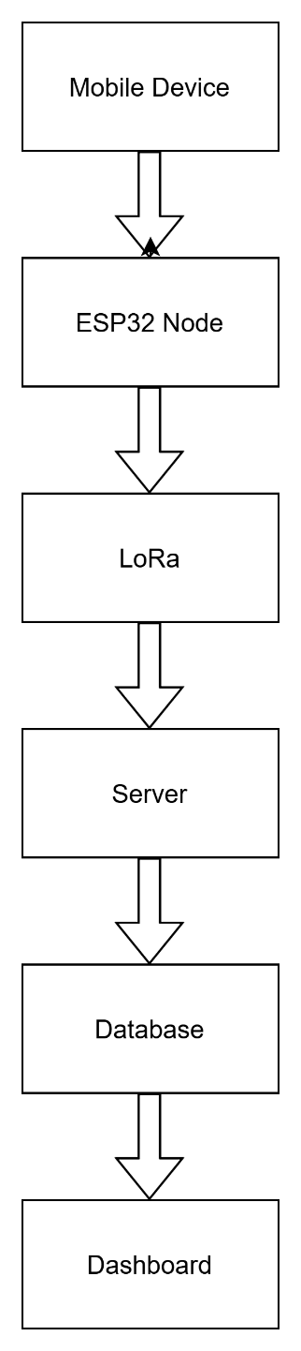

FIGURE A.4.1 Data Flow Diagram
Explanation:
The system follows a real-time pipeline where signal data is captured, transmitted, processed, stored, and visualized.

A.5 Testing Setup
- Multiple devices (D1–D8) used
- Signal interval: every 5 seconds
- Indoor environment with obstacles
- Nodes placed in each room
A.6 JSON DATA BACKUP FORMAT
The system includes a backup mechanism to store tracking data in JSON format for safety and analysis.

Sample JSON format:
{
"device_id": "D1",
"node_id": "N3",
"rssi": -65,
"location": "Classroom A",
"timestamp": "2026-03-20 10:15:30"
}

Backup Script
<?php
include 'db.php';

$sql = "SELECT * FROM device_history";
$result = $conn->query($sql);

$data = [];

while ($row = $result->fetch_assoc()) {
$data[] = $row;
}

file_put_contents("backup.json", json_encode($data, JSON_PRETTY_PRINT));
?>
Explanation:
This script exports tracking data into a JSON file, which helps in backup, analysis, and reducing database load.

CODE GITHUB:-
https://github.com/mananptl/indoor-tracking-system.

